A Direct-Conversion Based High Resolution Spectrum Analyzer
for Medium Frequency

M. R. MALEK MOHAMMADI, M. H. ALAVI, H. MOHSENI
Electrical Engineering
Sharif University of Tech.
Azadi St., Tehran
IRAN
www.sharif.edu

Abstract: - This paper presents design and implementation of a direct-conversion based high resolution spectrum analyzer in the frequency range of 50Hz to 100MHz, with 1Hz to 100kHz resolution bandwidth and a calibration circuit which compensates offset due to mixer and baseband amplifiers. To achieve such a high resolution band-width, a digital narrow band filter bank is used.

Key-Words: - Spectrum analyzers, Direct Conversion, Offset Compensation, Resolution Bandwidth, FFT

1 Introduction

Signal measurement in frequency domain is the most important task in radio communication. Spectrum analyzers (called herein “SA” for brevity) are therefore the most versatile and widely used RF measuring instruments. They are used in all applications of wireless and wired communication in development, production, installation and maintenance efforts [1].
SAs according to their architecture are categorized in two classes. Fast Fourier Transform analyzers, digitize input signal. And then perform a FFT to display the signal in frequency domain. The maximum frequency limit of input signal in this architecture is restricted to the maximum operating frequency of the high resolution ADC. So these SAs are used in frequencies below 1MHz. The second architecture is super heterodyne, super heterodyne based SAs convert the input signal into intermediate frequency (IF). The converted signal is further filtered, processed (amplified and perhaps logged), rectified by envelope detector, digitized and finally displayed.
Direct conversion was invented many decades ago, has been tried many times and has failed almost every time [2]. Inherent monolithic integration (no need to IF stages), lower power dissipation and lower cost has again caused direct conversion receivers (DCRs) to be a hot topic for research.
Basically SAs are wideband high dynamic range receivers, so we can utilize direct conversion topology in implementing lower cost, lower power consumption SAs. The implemented SA can work in the frequency range of 50Hz to 100 MHz with input signal power from -70dBm to 0dBm (70dB dynamic range) and with resolution band-width from 1Hz to 100 kHz.
The goal of this paper is to describe some issues and techniques in the design of DCRs (especially SAs). In section 2, we briefly study direct conversion architecture and its design issues such as DC offset. In section 3, we describe designing and implementing the SA and propose solutions for compensating DC offset and finally in section 4, we present some measurements made by the SA.

Fig. 1. Direct-conversion architecture

2 Direct Conversion Architecture
Direct conversion basically means downconverting the RF signal directly to baseband. A DCR translates the band of interest without any IF stage to DC and employs a LPF to suppress interferences, as shown in Fig. 1.
Direct conversion has several advantages over super heterodyne. First, there is no image in this architecture because the IF is zero (remember that in heterodyne architecture image was at ω_{LO}-ω_{IF}). Second, the high-Q IF filter and subsequent stages are replaced with LPF and baseband amplifiers that are amenable to monolithic integration [2].
Direct conversion has some design issues that do not exist or are not serious in super heterodyne.
DC offsets: since in a DCR, the translated band comes around zero-frequency, offset voltages can corrupt the signal and even more, saturate the following stages.
The DC offset can arise from offset voltages of baseband amplifiers and self mixing phenomenon in the mixer (leakage of the LO signal to the RF port mixes with LO and produces DC voltage at the output of the mixer which changes with LO frequency). I/Q mismatch, even-order distortion, flicker noise and LO leakage are other considerations in designing a DCR [2]. But these issues are not our concern in this work. We will propose two methods for compensation DC offset in section 3.

3 Design & Implementation Issues
According to direct conversion architecture, our SA consist of these building blocks (as shown in Fig. 2): 1) frequency synthesizer or local oscillator; 2) mixer; 3) baseband stage; 4) digital signal processing unit; 5) display.
In the following subsections we will study these building blocks, in detail

Fig. 2. SA building blocks

3.1 Frequency Synthesizer
In usual DCRs, only fixed oscillators are need for down-converting the input signal, but in SAs in which input signal is wideband, the LO should sweep the whole band (in our SA, from 50Hz to 100MHz). It means that LO bandwidth is greater than 6 decades! , whereas if super heterodyne architecture is used sweeping oscillator should sweep from f₀ to f₀+100MHz (in our example). Choosing f₀ high enough, reduces LO band-width to the extent which makes implementation possible with a single PLL.
In this case, which we need a 50Hz to 100MHz tunable oscillator, choosing a DDS (Direct Digital Synthesizer) satisfies our design need. To increase the maximum operating frequency of the SA, complex techniques for frequency synthesis can be used.
Frequency synthesizer consists of an Analog Devices DDS chip (AD9854) which can operate from DC to 150MHz with frequency resolution of micro hertz [3], and a 9-th order elliptic LPF for attenuating images from the output spectrum of the DDS. The DDS is fed with a 49.152 MHz crystal oscillator. And the DDS internal frequency multiplier multiplies it by 6 and produces a 294.912 MHz clock, as the DDS reference clock.

  - Mixer
The most important issue in downconversion stage is that the input signal and therefore the LO are wideband. To mix them we should use an active mixer (Gilbert cell). Other mixer features that should be considered are 1) low distortion; 2) high isolation between RF, IF and LO ports; 3) low offset. We have chosen AD831 (Analog Devices). This mixer is wideband (DC to 500 MHz), has low distortion (IP₃=+24dBm, P_{1dB}=+10dBm, IP₂= +62dBm) and low offset [4].

  - Base Band
The baseband stage should filter, amplify and digitize the downconverted signal while keeping the overall DC offset less than given value.

3.3.1 Filtering
It will be shown that to realize resolution filters digitally; we need two antialiasing filters for two sampling frequencies. When the sampling frequency is 1kHz, a third-order 150Hz active filter is used, and when the sampling frequency is 400kHz, a third-order Gaussian passive filter is used. As shown in Fig. 5, as sampling frequency changes, suitable filter will be at the signal path. The filters furthermore remove unwanted mixed products from the mixer output spectrum.

    - Amplification
Since mixer conversion gain is 1 (0dB), the downconverted signal amplitude changes from -70dBm (100μV peak) to 0dBm (316mV peak). We have used AD9224 (Analog Devices) 40MHz,12 bit A/D converter with 1½ bit INL [5]. For a given .2dB amplitude error (includes quantization error and integral nonlinearity), minimum signal amplitude in the A/D input was calculated 86.7mV. Since the maximum acceptable signal amplitude in A/D input is 2V, so we designed a 4-stage variable gain amplifier with the following specifications:
100μV<V_{in}<364μV Gain=G₁+ G₂+ G₃+ G₄= 74.8dB
364μV <V_{in}<4.4mV Gain=G₁ + G₂ + G₃ = 53dB
4.4mV <V_{in}<86.7mV Gain= G₁ + G₂ = 26dB
86.7mV <V_{in}<316mV Gain= G₁ = 16dB
Where G₁=16dB, G₂=10dB, G₃=17dB, G₄=31.8dB.
These four stage are implemented using OP27 (Analog Devices), with 1% feedback resistors. Also analog switches for entering and bypassing gain stages are used.

3.3.3 Offset Compensation
In our case, mixer and opmaps are sources of DC offset. Mixer produces two kinds of offset. First, fixed offset due to its output amplifier. Second, frequency dependent offset due to selfmixing which changes with LO frequency. Opamps are another source of offset, mismatch in input stage causes a DC voltage at the output of amplifier.
Offset compensation methods are categorized in two classes. First class methods cancel offset while the receiver is operating, that is dynamically remove offset voltage. Second class methods cancel offset while the receiver is idle, that is the receiver periodically enters idle mode and offset compensation circuits remove DC offset while input is grounded.
In our case, offset change with the frequency of LO. So with any change in LO frequency, compensation circuits cancel DC offset and are in idle mode until a future change in LO frequency.
We describe two efficient methods; first method can only be used in offset cancellation of opamps. This method has been implemented and amazing results has been achieved, but not used in the SA. Second method is implemented and used in our SA.
Method I: this method uses offset adjustment pins of the opamp to cancel output offset voltage. As shown in Fig. 5 any mismatch between two branches of input stage produces different DC voltage at output nodes. Biasing the two branches with different current, in a manner which the difference of bias currents is a little fraction of I_{ss}, can compensate mismatch and remove output offset voltage.
It is known that V_{os} is proportional to $\text{ln}\frac{I_{c1}}{I_{c2}}$ (I_{c1} and I_{c2} are bias currents of the two branches). Changing the ratio I_{c1}/ I_{c2} over a ±3% range, results in an input offset voltage nulling range greater than 1.5mV at 25°C. We have implemented this idea as shown in Fig. 4.
An 8-bit DAC with complementary output current sources is used for changing bias current of the two branches, while input of the opamp is properly grounded and the output offset is measured with a window comparator. The counter continues counting and DAC changes the bias currents until the output offset voltage lies between acceptable values. This implementation method searches for bias currents that produce an offset lower than acceptable offset voltages in all 256 situations. So this method is slow, but does not need any microprocessor to control the loop.
Unfortunately this method has disadvantages of hardware complexity and sensitive analog part (i.e. comparators). So good layout techniques should be employed for maximum accuracy.
Method II: this method is the natural approach to cancel DC offset. An adder is placed in signal path and proper DC voltage is applied to it. In our SA as shown in Fig. 3, we have used this method in two stages. First after the second gain stage, to compensate the DC offset which arises from first and second gain stages. The second one is placed after 4-th gain stage to compensate the offset of third and 4-th gain stages. It should be emphasized that, these offset compensation circuits operate before any measurement and are inactive during measurements.

3.4 Digital Signal Processing Unit
Tasks of this unit are: digital realization of resolution filters, gain control, activation and inactivation of offset compensation circuits and programming the frequency synthesizer. For brevity, only digital realization of resolution filters is studied here. The main reason for realization of resolution filters digitally is parallel processing.
The settling time of a filter is$\frac{k}{\text{BW}}$, where k depends on filter type (e.g. for Gaussian filter k is 2 to 3). Decreasing bandwidth results in increasing settling time. In SAs, sweep time (the time needed for measuring spectrum from start frequency to stop frequency) can be calculated as follows [6]:

$\text{sweeptime}=\frac{(f_{\text{stop}}−f_{\text{start}})}{\text{BW}}⋅\frac{k}{\text{BW}}=k⋅\frac{Δf}{{\text{BW}}^{2}}$ (1)

Fig. 3. Baseband stage including filters, amplifiers and offset compensation circuits.

Fig. 4. Input stage of an opamp and offset adjustment pins

Where f_{stop}, f_{start} is the stop frequency and the start frequency of spectrum measurement respectively.
For high resolution bandwidth, sweep time will be intolerable (e.g. if Res. BW=1Hz, f_{stop}- f_{start}=100kHz and k=1, sweep time will be 1ksecond!). For this reason in modern SAs, in spite of a single resolution filter, a bank of digital filter is used. Our DSP unit consists of a TI TMS320C50.
To implement a 5-th order IIR low pass filter and in worst case, 50 instructions per input sample is needed (with sampling frequency of 1kHz, and .5Hz cut off frequency for Res. BW of 1Hz). If 100 filters of this kind are implemented simultaneously, maximum allowable sampling frequency will be about 1kHz (our DSP speed is 20MIPS). This sampling frequency can be used for resolution bandwidth up to 300Hz (the reason of using a 150Hz low pass filter in baseband stage). Another sampling frequency is 400kHz for resolution bandwidth up to 100kHz. It should be mentioned that bandwidth of the baseband downconverted signal is half the bandwidth of the signal before downconversion.

Fig. 5. Offset compensation method I

3.5 Display
A PC is used to display measurement results. A computer program which is written in Visual Basic interfaces to DSP unit via parallel port. Besides, measurement entries such as resolution bandwidth, start frequency, … are entered by the user and transferred to DSP unit.

4 Experimental Results
Since we did not use any calibration circuit to compensate the frequency response of different stages of the SA, amplitude accuracy is about ±1dB in desired input power range.
As shown in Fig. 6 & Fig. 7 sensitivity of the SA is better than -70dBm at low and high frequencies. In these measurements resolution B.W. is 30kHz & 10Hz respectively.
Also fig. 8 show a measurement made in frequency of 9kHz with -10dBm input signals.

5 Conclusion
Direct conversion advantages for implementing compact, low power receiver, can be used in implementing low cost (and perhaps portable) spectrum analyzers. While direct conversion systems entail new design issues, some techniques should be employed to overcome the difficulties which arise in this architecture.
We have implemented a medium frequency spectrum analyzer using this architecture. More sophisticated design techniques should be used for implementing high frequency spectrum analyzers.

Acknowledgment
This research is supported by Iran Telecommunication Research Center (ITRC).

References:
[1] Ch. Rauscher, “Fundamental of spectrum analysis.”, Rohde & Schwarz GmbH & Co. KG, 2001
[2] B. Razavi, “Design considerations for direct-conversion receivers,” IEEE Trans. On Circuits and Systems II, vol. 40, no. 6, JUNE 1997
[3] Analog Devices, AD9854 data sheet, 2002
[4] Analog Devices, AD831 data sheet, 1995
[5] Analog Devices, AD9224 data sheet, 1999
[6] “Agilent spectrum analysis basics,”, Agilent Technologies Application Note 150, 2000

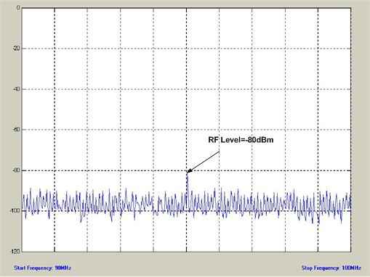
Fig. 6. f_{RF}=95MHz, RF Power=-80dBm, R.B.W.=30kHz

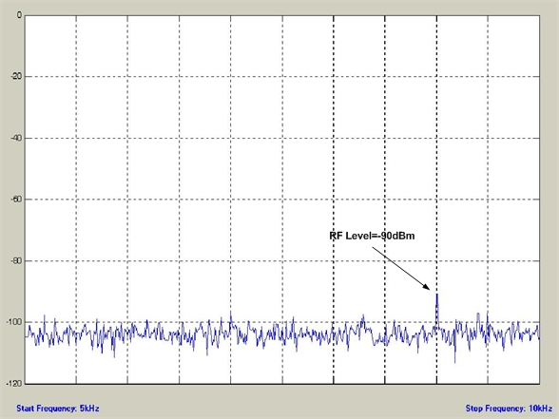

Fig. 7. f_{RF}=9kHz, RF Power=-90dBm, R.B.W.=10Hz

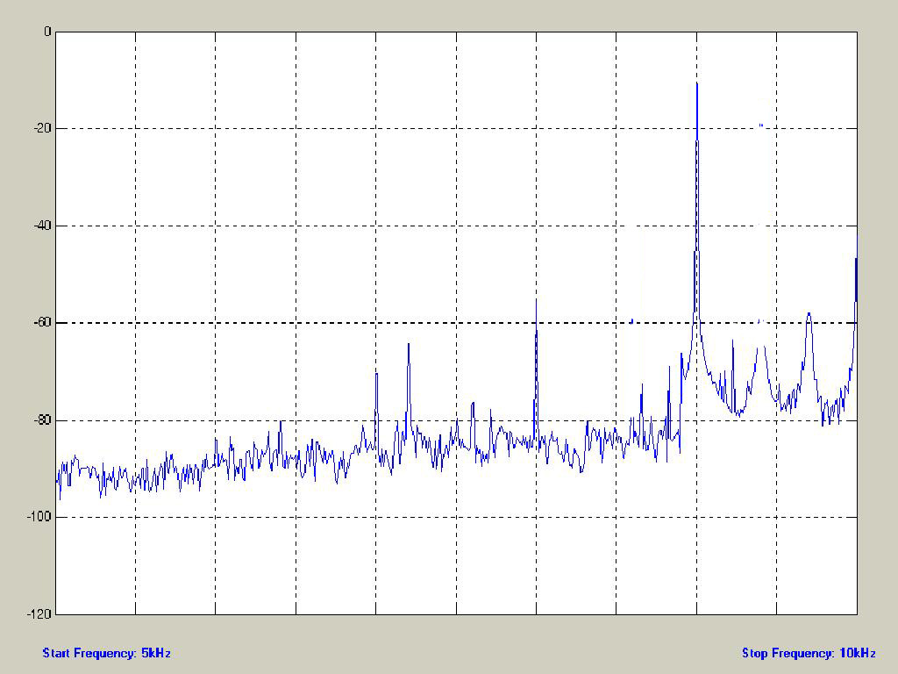

Fig. 8. f_{RF}=9kHz, RF Power=-10dBm, R.B.W.=10Hz

