Adaptive Fuzzy PID Controller: Design, Performance and Application for Travelling-wave Ultrasonic Motor

SHEBEL ASAD ALSABBAHª, EDUARDO MENDES^{b}, Eric BERTHELOTª
Department of Electrical Engineering
University Paris Sud
ª LGEP, 11 rue Joliot-Curie, Supélec, 91192 Gif-sur-Yvette
Tel. : +33 1 6985 1656, +33 1 6985 1659; Fax : +33 1 6941 8318
^{b} LCIS, ESISAR-INPG, 50 rue B. de Laffémas - BP 54, 26902 Valence Cedex 9
Tel. : +33 4 7575 9409 ; Fax (Ecole) +33 4 7543 5642, (Lab.) +33 4 7575 9450
FRANCE
http://www.lgep.supelec.fr

Abstract: - Conventional controllers such as PID have poor performances when controlling highly non-linear systems such as a travelling-wave ultrasonic motors (TWUSM). This paper deals with the design of an Adaptive Fuzzy PID Controller (AFPIDC) in order to improve the performances in both steady state and transient state of the classical PID controller when highly non-linear processes, such as a TWUSM, have to be controlled. The scaling factors, of the proposed Adaptive Fuzzy PID Controller, are tuned on line at different working conditions (i.e. different loads and driving frequencies). Simulations and experimental results are presented when applying the proposed controller to a TWUSM of type Shinsei USR 60.

Key-Words: - Adaptive fuzzy controller, simplified hybrid model, self-tuning controller.

1 Introduction
Traveling-wave ultrasonic motors (TWUSM) have structural and operational advantages compared to conventional electromagnetic motors, such as compact size, lighter weight, very low speed operation, high torque, nonmagnetic operation, freedom of constructional design, very low inertia, high speed response, possibility of electromagnetic noise reduction and miniaturization. However, some important technical problems remain to be solved in the context of large-scale industrial adoption of TWUSM related to efficiency, performances and precise control. Fuzzy logic control systems can be proposed to enhance the capabilities of control systems to deal with processes having high nonlinearities, such that the friction effect on the interface contact between the stator and the rotor in ultrasonic piezoelectric motor drive mechanism (PEM), and parameter un-certainties at different operating conditions (i.e. load torque changes and temperature variation) [9].
Although PID controller's performances are restricted, they are very popular in real-world applications because of their merits of being simple, reliable and effective with linear systems. With systems such as PEM, it makes sense to enhance the PID performances by making up for the areas in which the PID gains do not do so well. Consequently, these last years, the use of fuzzy control theory in industrial systems has accelerated and rule-based fuzzy-PID control systems (FPID) have been designed [6,7]. Moreover, studies [2,4,8] have used adaptive methods to handle time-delay effects, nonlinearities and uncertainties of the given system.
In this work, an adaptive fuzzy proportional-integral-derivative (AFPID) controller has been designed [7]. It is a self-tuning system (STS) that enhances the FPID controller capabilities to capture well the nonlinearities in piezoelectric motor drive systems.
It will be seen that although the adaptive fuzzy -PID controller is designed by fuzzy mathematics, its final form, as controller, is a conventional one. As such, it can be used to directly replace the conventional one in applications.
After demonstrating the design aspects, the performances of the proposed controller have been evaluated. First, a numerical (simulation) work is done to validate our proposition. For that, a simplified hybrid model (SHM) was designed in [1] and used to capture, with accuracy and simplicity at the same time, the PEM dynamics needed for different control systems design [1,9].
Finally, the proposed AFPID control system has been applied experimentally to drive an ultrasonic piezoelectric motor of type Shinsei (USR60) [10].

2 Fuzzy PID Control System
Firstly, a fuzzy PID speed controller is designed for the TWUSM drive system, and its performance is evaluated by simulation.

  - Design
To get a fuzzy controller (FC) having the fine characteristics of a PID controller, a fuzzy PID control system is designed as shown in Fig.1. In this diagram, the three main actions performed by a Fuzzy Reasoning System are presented, i.e. pre-processing (normalization by gains G_{o} and G₁ of the speed error and its derivative), Fuzzy Logic Control (FLC : fuzzification, fuzzy processing and defuzzification), and finally post-processing (denormalization by gains G₂ and G₃) and integration of the control variable dV_{in}.
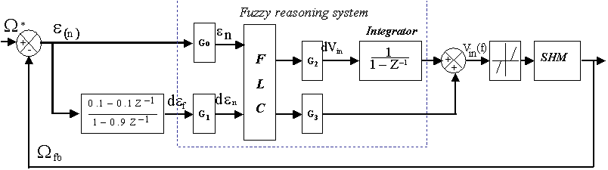

Fig.1.Fuzzy PID control system.

In Fig. 1, the speed error ε(t)=Ω*-Ω_{fb} is the first input, with Ω* the reference speed and Ω_{fb} is the calculated speed from the SHM. The second input is dε(t) the filtered error derivative. The output variable of the fuzzy PID controller is V_{in}(t) which is converted in a driving frequency to be applied to the TWUSM drive system.

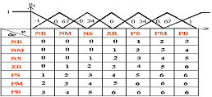

Fig.2. The combined input region, the fuzzy rule-base and the (Is/O) membership functions (MF).
In figure.2, the combined input region, the rules base and the inputs/output membership functions (MF) are given.
A fuzzy relation Ř of the FC is expressed as:

Ř=If {e is ZR and de is NS} then {dVin is NS} (1)

where the linguistic input variables are e & de, which take in this particular rule the linguistic values ZR & NS respectively.
The “and” operator is associated with the “min” operator, and the Mamdani fuzzy implication method is used. Finally, the fuzzy control output is determined from the method of the center of gravity [6].
The equivalent control expression which defines the fuzzy PID Control output V_{in}(t) and the fuzzy PID gains are given by equations(2) and (3-5), respectively:

V_{in}(t) = G₃dV_{in} + G₂ dV_{in} .dt (2)

K_{FP} = G₃G₀P + G₂G₁D (3)

K_{FI} = G₂G₀P (4)

K_{FD}= G₃G₁D (5)

where dV_{in} = PK_{p} . e + DK_{d} . de/dt, G₀, G₁, G₂ and G₃ are the control gains that have been defined as given in [3].

  - Simulation
Based on [9], a simplified hybrid model SHM has been designed and tested in terms of the forced stator model and the spinning motion model [1].

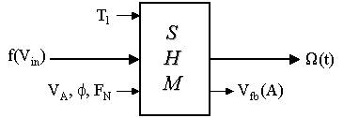

Fig.3. Simplified hybrid model (I/O).

As shown in Fig.3, the SHM has 5 inputs and 2 outputs. It has two main inputs: the load torque T_{l} (0-0.3 N.m) and the driving frequency (control variable) f(V_{in}(t)) (40-42 KHz). The other inputs are constants: The amplitude of the two terminal voltages V_{A} (100 Vrms), the phase shift φ (π/2) and the normal force F_{N} (160 N). While, the two outputs are the motor speed Ω(t) (controlled variable) and the feedback signal in volts V_{fb}(A) that has a proportional relationship to the amplitude of travelling-wave A.
Using the SHM, the performance of the FPID-speed controlled PEM has been evaluated with G_{o}=0.5, G₁=0.01, G₂=250 and G₃=100, see figure.4.
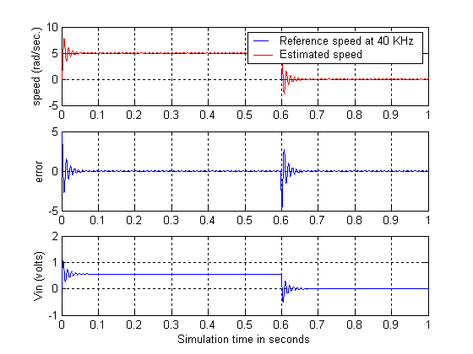

Fig.4. Simulated dynamics of PEM drive System controlled by FPID controller at T_{l}=0.3 N.m, sampling time=77µs and settling time t_{s}=0.05 s.

It can be noted, in figure 4, that although a large settling time (t_{s}=0.05sec.) has been chosen, the dynamic response is not well damped, i.e. a large overshoot is obtained.

3 Adaptive FPID Control System

3.1 Design
In order to improve, the transient response of the system with the Fuzzy-PID controller presented in figure 1, an adaptive Fuzzy-PID controller is now designed as shown in figure 5; some control gains are now self-tuned by an adaptive technique in function of real speed in order to improve the transient response.

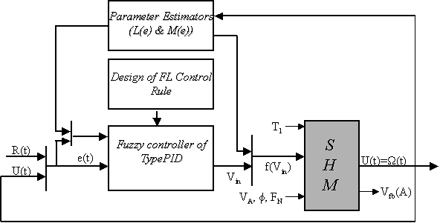

Fig.5. Adaptive FPID control system.

The adaptive technique consists in a parameters estimator block that has one input (the real speed Ω(t)) and two outputs connected to the FPID input/output terminals (see figure 5).
The self-tuning algorithm is presented in equations 6, 7, and 8.

V_{in}(f) = (G₃G₀P + L(e) M(e) D)e + L(e) G₀Pe.dt + G₃ M(e) D(de/dt) (6)

L(e) = G_{2a} ( abs(e(t)) + L(e_{min})) (7)

M(e) = G_{1c} ( (1 – abs(e(t))) + M(e_{max})) (8)

where G_{2a}=G₂.a, G_{1c}=G₁.c, and the gains a, c, L(e_{min}) and M(e_{max}) are constants adjusted with respect to the steady and transient states [5]. L(e) and M(e) can be roughly adjusted with error [e_{min} e_{max}] to get a well expanded region of tuning.
Lastly, the output function membership (OMF) shape may need to be adjusted, as shown in figure 6, in order to remove steady state error.
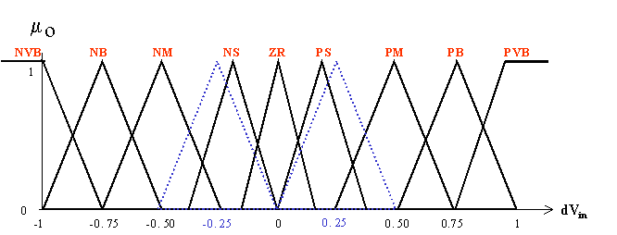

Fig.6. Output membership function

In other words, by adjusting the OMF and expanding the region of self-tuning of scaling factors, the stability of the system can be enhanced and the transient response of the control system modified.

3.2 Simulation and Experimental Results
Again, the SHM has been used for simulation. The obtained results, shown in figure 7, show clearly, in comparison with figure 4, the improvement in the dynamic response: well damped response with a response time less than 25 msec.
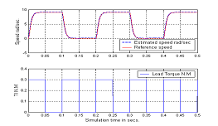

Fig.7. Simulation results at different operating conditions with the Adaptive FPID Controller.
The proposed adaptive-fuzzy-PID controller has been validated experimentally. For that, a computer-based AFPID control system is designed and an ultrasonic piezoelectric motor drive system is fabricated in order to drive the Shinsei USR 60 PEM. The motor dynamics have been measured for positive and negative speeds with different load conditions (load torque between 0.0 and 0.3 N.m).
As an example, Fig.8 shows that adaptation of gain G₂ improves the system behaviour (i.e. case A, mismatch case) and modifies at the same time the reaction of the control system against the error (i.e. cases B & C, matched cases).
This means that dealing with systems having extreme nonlinearities and parameter uncertainties, such that PEM; a robust and smooth adaptive controller can be designed and validated experimentally.

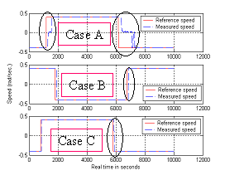

Fig.8. Measured dynamics of controlled motor USR60 in function of G_{2a} at different targets and load torque T_{l} = 0.3 N.m. The speed scale is 20 rad/s / division, thus the reference speed varies between ±8 rad/s.

4 Conclusion
Low PEM performances are obtained when controlled by PIDs. So, it makes sense to enhance these performances by making up for the areas in which the PID gains do not do so well. For that, a rule-based fuzzy PID control system has been designed.
First, the speed of a PEM has been drive using a fuzzy PID controller. It has been seen that even with a large response time, a large overshoot is obtained. Then, an adaptive fuzzy PID controller has been proposed. Simulations and experimental results with a Shinsei USR 60 PEM have shown that the proposed self-tuned fuzzy PID controller gives shorter response time with no-overshoot.
It has also been seen that although the fuzzy PID controller is designed by fuzzy mathematics, its final form as controller is conventional one. So we can benefit by the merits of the conventional (classical) proportional, integral and derivative control.
The performances of the proposed adaptive fuzzy PID controller are still modifiable, and this task should be accomplished in the future.

References:
[1] S.A. Alsabbah., E. Mendes, and Y. Bernard, Derivation of simplified hybrid model and speed control for travelling Wave ultrasonic motor, International Journal of Applied Electromagnetics and Mechanics, Vol. 19, 2003, pp. 581-585, IOS Press.
[2] R. Bandyopadhyay, U.K. Chkraborty and D. Patranabis, Autotuning a PID controller: A fuzzy-genetic approach, Journal of Systems Architecture, Vol. 47, 2001, pp. 663-673.
[3] M. Braae and D.A. Rutherford, Selection of parameters for a fuzzy logic controller, Fuzzy Sets and Systems, Vol. 2, 1979, pp. 185-199.
[4] R.E. Kalman, Design of a self-organising control system, Trans. ASME, Vol. 86D, 1985, pp. 51-60.
[5] W. Li,, X.G. Chang, F.M. Wahl and Jay Farrell, Tracking control of a manipulator under uncertainty by Fuzzy P+ID controller, Fuzzy Sets and Systems, Vol. 122, 2001, pp. 125-137.
[6] T. Lubin, E. Mendes and C. Marchand, Fuzzy controller in A.C. servo motor drive, IEE, conference publication No. 412, 1995, pp. 320-324.
[7] H. Malki, H.Li and G.Chen, New design and stability analysis of a fuzzy proportional-derivative control system, IEEE Transactions on Fuzzy Systems, Vol. 2, 1995, pp. 245-254.
[8] L. Zheng, A practical guide to tune of proportional and integral (PI) like fuzzy controllers, IEEE International Conference on Fuzzy Systems, 1992, pp.633-640.
[9] N.El Ghouti, Hybrid Modeling of a Travelling Wave Piezoelectric Motor, PhD thesis, Aalborg University, department of control engineering, Denmark, May 2000.
[10] USR60 – Shinsei motor data sheet.

