Current Mode Multifunction biquad using single CDBA

ALI ÜMIT KESKIN, MEHMET SAID YÜKSELTEN
Department of Electrical Engineering
Yeditepe University
Kayisdagi, 34755, Istanbul
TURKEY
http://www.yeditepe.edu.tr

Abstract: - In this paper, a single current differencing buffered amplifier (CDBA)-based current-mode multifunction biquadratic filter is presented. The circuit is analyzed and examples are given. Limitations of the proposed configuration are also discussed.

Key-Words: - Multifunction filters, CDBA, Current-mode circuits, Continuous time filters

1 Introduction
Current differencing buffered amplifier,CDBA, is a newly introduced active element [1]. The circuit symbol of the CDBA is shown in figure 1, and its terminal relationships can be described as
V_{w}=V_{z} , I_{z}=I_{p}-I_{n ,} V_{p}=0 , V_{n}=0 (1)
Here, current through z-terminal follows the difference of the currents through p-terminal and n-terminal. Input terminals p and n are internally grounded. The difference of the input currents are converted into the output voltage V_{w} , therefore CDBA element can be considered as a transimpedence amplifier.

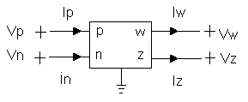
Figure 1 . Symbol for the CDBA

Multi-function type active filters are especially versatile, since the same topology can be used for different filter functions. Multi-function current mode filters containing more than one CDBA element have already been published in literature.[4-6]
In a recent paper [2] , realization of an nth order current transfer function by an active RC circuit involving one or two CDBAs is introduced. It is shown that the general transfer function can be realized using a single CDBA.

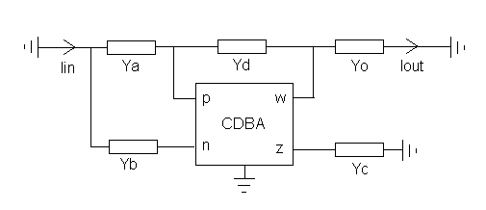Figure 2. Single CDBA-based circuit realizing nth-order current
transfer function.

As an application of this general current mode circuit that realizes an nth order current transfer function by an active RC circuit, the study here presents a current mode multifunction biquad using a single CDBA, and reports the properties, and also disadvantages of using such a configuration.

2 Proposed Circuit
The current transfer function of the circuit in figure 2 using only a single CDBA has the following form in the case that the CDBA is ideal and Y_{o}=Y_{a}+Y_{b}:
$H(s)=\frac{I_{o}(s)}{I_{i}(s)}=\frac{Y_{a}−Y_{b}}{Y_{c}−Y_{d}}$ (2)
where Y_{i} are positive real admittance functions of passive two terminal elements. One of their
terminals is either grounded or internally grounded.
Based upon this configuration, figure 3 displays the proposed current mode, single CDBA-based multifunction filter.
If R_{w2}=R_{b}=R_{d}, C_{w2}=C_{b}=C_{d}, C_{w1}=C_{a} and R_{w1}=R_{a} ,the circuit is a low pass filter, if p1-N terminals and w1-w3 terminals are shorted together;$\frac{I_{o}}{I_{\text{in}}}=\frac{R_{c}}{R_{a}}⋅\frac{\frac{1}{R_{b}C_{b}R_{c}C_{c}}}{s^{2}+\left(\frac{1}{R_{b}C_{b}}+\frac{1}{R_{c}C_{c}}−\frac{1}{R_{d}C_{c}}\right)s+\frac{1}{R_{b}C_{b}R_{c}C_{c}}}$ (3)

It becomes a high pass filter, in the case that p2-N terminals and w2-w3 terminals are shorted. $\frac{I_{o}}{I_{\text{in}}}=\frac{C_{a}}{C_{c}}⋅\frac{s^{2}}{s^{2}+\left(\frac{1}{R_{b}C_{b}}+\frac{1}{R_{c}C_{c}}−\frac{1}{R_{d}C_{c}}\right)s+\frac{1}{R_{c}C_{c}R_{b}C_{b}}}$ (4)

One will have a band pass filter, if p1, p2, w1 and w2 terminals are “open”.

$\frac{I_{o}}{I_{\text{in}}}=\frac{1}{R_{b}C_{c}}⋅\frac{s}{s^{2}+\left(\frac{1}{R_{b}C_{b}}+\frac{1}{R_{c}C_{c}}−\frac{1}{R_{d}C_{c}}\right)s+\frac{1}{R_{b}C_{b}R_{c}C_{c}}}$ (5)

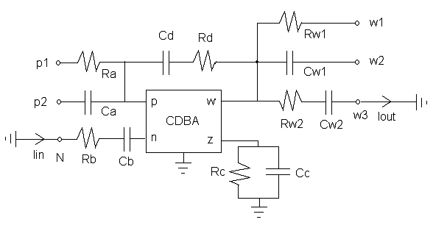Figure 3. Single CDBA-based current mode multifunction
biquad

When p1, p2, and n terminals are shorted, and w1, w2, w3 terminals are also connected together, a notch (BSF) filter is obtained if R_{a}=R_{c}=2R_{b}, C_{b}=2C_{c}=2C_{a} . The same configuration can be used as an all pass filter, if R_{a}=R_{c}=4R_{b}, C_{b}=2C_{c}=4C_{a .} Note that, C_{a} is omitted (C_{a} =0) for the low pass configuration, R_{a} is omitted (Ra= ∞) for the high pass filter realization. On the other hand, both R_{a} and C_{a} are omitted for the band pass configuration, while R_{d} is omitted for the all pass case. The natural angular frequency ω_{ο} and the pole Q-factor of this multifunction filter are
$ω_{o}=\frac{1}{(R_{b}R_{c}C_{b}C_{c})^{1/2}}$ (6)

$Q=\frac{(R_{b}R_{c}C_{b}C_{c})^{1/2}}{R_{b}C_{b}+R_{c}C_{c}−\frac{R_{b}R_{c}C_{b}}{R_{d}}}$ (7)

3 Examples
3.1. Low Pass Filter, Butterworth :
Ra=Rb=Rc=Rd=10kΩ,Cb=Cd=70.7nF, Cc=141.4nF,$H_{\text{LPF}}(s)=\frac{I_{o}(s)}{I_{\text{in}}(s)}=\frac{{\text{10}}^{6}}{s^{2}+\sqrt{2}×{\text{10}}^{3}s+{\text{10}}^{6}}$ (8)

3.2. HighPassFilter, Butterworth:
Ca=Cb=Cc=Cd=100nF, Rc=7070Ω, Rb=Rd=14140Ω,

$H_{\text{HPF}}(s)=\frac{I_{o}(s)}{I_{\text{in}}(s)}=\frac{s^{2}}{s^{2}+\sqrt{2}×{\text{10}}^{3}s+{\text{10}}^{6}}$ (9)

3.3 Band Pass Filter, Butterworth:
Cb=141.4nF, Cc= Cd= 70.7nF, Rb=Rc= 10kΩ, Rd=20kΩ,$H_{\text{BPF}}(s)=\frac{I_{o}(s)}{I_{\text{in}}(s)}=−\frac{\sqrt{2}×{\text{10}}^{3}s}{s^{2}+\sqrt{2}×{\text{10}}^{3}s+{\text{10}}^{6}}$ (10)

3.4. Symmetric notch fılter,

Rb=7070Ω ,Ca= Cc=70.7nF, Cb=2Cc , Ra=Rc=14140 Ω ,
$H_{\text{BSF}}(s)=\frac{I_{o}(s)}{I_{\text{in}}(s)}=\frac{s^{2}+{\text{10}}^{6}}{s^{2}+2×{\text{10}}^{3}s+{\text{10}}^{6}}$ (11)

3.5. All Pass Filter:
Rb=12.5kΩ ,Ca= Cc=20nF, Cb=80nF , Ra=Rc=50 kΩ , Rd=∞,
$H_{\text{APF}}(s)=\frac{I_{o}(s)}{I_{\text{in}}(s)}=\frac{s^{2}−2×{\text{10}}^{3}s+{\text{10}}^{6}}{s^{2}+2×{\text{10}}^{3}s+{\text{10}}^{6}}$ (12)

Fig. 4 displays simulation results using Current Feedback Amplifier equivalent circuit for the CDBA [1,7].

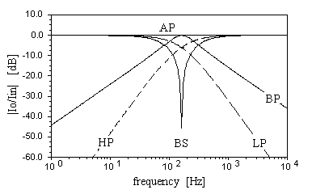
Figure 4. Simulation results for single CDBA-based current
mode multifunction biquad.

4 Conclusion
In this paper, a single CDBA-based current-mode multifunction biquadratic filter is presented. It is apparent that its Q can be controlled by varying R_{d} without affecting ω_{o}. However, this is possible in a limited range due to low-Q nature of the circuit. This filter employs capacitors that are grounded or virtually grounded, which is an important aspect regarding integrated circuit implementation. All five current transfer functions (LP, BP, HP, Notch and AP) can be realized using this single active element multifunction biquad, and it is a universal filter in the sense that it realizes LP, HP, BPs. The circuit can be cascaded, provided that Y_{o}=Y_{a}+Y_{b} condition is met for each stage. The resulting circuit has no canonical structure and reduces the number of active components considerably in contrast to a previously reported one [3]. (Here, only n/2 CDBAs are required in stead of n+1 CDBAs, where n is the order of current transfer function)
On the other hand, limitations of this circuit are the following: The circuit requires relatively large number of passive R-C components and fulfillment of component matching conditions, demanding careful control of sensitivity issues due to cancellations of poles and zeroes in the transfer function of the circuit.

References:
[1] Acar,C., Özoguz, S. , “A versatile building block: current differencing buffered amplifier suitable for analog signal processing filters”. Microelectronics Journal, 30, 1999, 157-160.
[2] Acar,C., Sedef,H., “Realization of nth-order current transfer function using current-differencing buffered amplifiers”. International Journal of Electronics, 90, 4, 2003, 277-283.
[3] Acar,C., Özoguz, S. “nth order transfer function synthesis using current differencing buffered amplifier: signal-flow graph approach”. Microelectronics Journal, 31, 2000, 49-53.
[4] Özcan,S.; Kuntman,H.; Çicekoglu,O., “Cascadable current mode multipurpose filters employing CDBA”. AEÜ International J of Electronics and Communications, vol.56, 2 , 2002, pp: 67-72 .
[5] Toker,A. , Özoguz,S. and Acar,C.: “Current-mode KHN-equivalent biquad using CDBAs” , Electronics Letters, Vol. 35, No.20, 1999, pp. 1682-1683.
[6] Özoguz,S., Toker,A. and Acar,C., “Current-mode continuous-time fully-integrated universal filter using CDBAs”, Electron. Letters, vol. 35, No. 2,1999, pp.97-98.
[7] Keskin, A.Ü., “Cascade approach for the realisation of high order VM filters using single CDBA-based first and second order sections”. Frequenz, vol. 58, (7-8), 2004, pp:188-194

