Surface versus lateral illumination effects on an Interdigitated Si Planar PIN Photodiode
SUSTHITHA MENON AND SAHBUDIN SHAARI
Photonics Technology Laboratory, Institute of Micro Engineering and Nanoelectronics(IMEN)
National University of Malaysia
43600 UKM Bangi, Selangor
MALAYSIA

Abstract: - The planar PIN Photodiode (PD) has profound advantages compared to the vertical surface/edge illuminated PIN PD. A two dimensional interdigitated silicon PIN PD with a 58 μm x 80 μm active area and finger width/spacing of 2μm /10μm respectively was modeled and simulated using Silvaco ATHENA and ATLAS software. The device was illuminated from the surface and laterally and comparison analysis was performed. At reverse bias of 10V, the dark current was 1ps. Photocurrent of 500nA was obtained for a 5 Wcm⁻² optical beam power for both the surface and lateral illumination at –10V reverse bias. The total quantum efficiency, η of the laterally illuminated PIN PD at wavelength of 850nm was 95% (responsivity=0.65A/W) and 75% (responsivity=0.52A/W) respectively. The –3dB cutoff frequency of the surface illuminated device is at ~10kHz and for the lateral illuminated PIN PD, the frequency is at ~0.1Mhz. Lateral illumination in an interdigitated Si planar PIN PD produces higher photocurrent contributing to higher quantum efficiency, responsivity and frequency response as compared to surface illumination.

Key-Words: -PIN, photodiode, planar, diffusion, surface illumination, lateral illumination, interdigitated

1 Introduction
A photodiode is an amplitude modulation envelope photo detector, insensitive to phase or small changes in wavelength. It generates an electrical output that reproduces the envelope of the received optical signal [1]. The most widely deployed PD for all lightwave applications is the PIN PD where its performance and characteristics are well understood and documented [2].
Silicon PIN PDs is still in high demand for applications operating up until the 1100nm wavelength range. The emergence of the Fast Ethernet and Gigabit Ethernet require the usage of silicon PDs operating at a wavelength of 770-860nm. Applications requiring PDs in array form are also driving factors towards the development of silicon lateral PIN PDs that can be fabricated and integrated with ease. They are also advantageous for monolithic integration of waveguide-based devices such as AWG (arrayed waveguide grating) and OADM (optical add-drop multiplexer). The low-cost, high reliability and established manufacturability process make silicon an attractive material for the fabrication of a planar PIN PD[1]. The success in the development of silicon based PIN PDs provides a stepping stone towards achieving development of PIN PDs using III-V materials such as GaAs, InGaAs and InGaAsP.
A planar PIN PD is created in such a way that the p, i and n regions are all in one plane. It has the same properties as the edge detecting where detection is made through the intrinsic layer but the fabrication method is much simpler using standard CMOS processing techniques where the p and n regions are doped unto the substrate wafer using either diffusion or ion implantation techniques [3]. Costly epitaxial layers are needed to form the p, i and n regions in a vertical structure using fabrication techniques such as MOCVD (metalorganic chemical vapor deposition) and MBE (molecular beam epitaxy). Fig. 1(a)-(d) shows various structures of the PIN PD.
Silvaco ATHENA and ATLAS were used to model and simulate a two-dimensional interdigitated Si PIN planar PD [4,5]. The simulation procedure in ATHENA is as follows: define device mesh, initiate silicon structure, diffusion masking oxide deposition, selective oxide etching to expose the diffusion windows, p+ well diffusion, oxide etching, diffusion masking oxide deposition, selective oxide etching to expose the diffusion windows, n+ well diffusion, oxide etching, anti-reflection oxide deposition,
(b) Vertical planar structure with surface illumination

p
i
n
hv
(c) Vertical planar structure with edge illumination

p
i
n
(d) Planar structure with surface illumination
p
i
n
(a) Vertical mesa structure with surface illumination
n
i
p

Fig. 1 PIN Photodiode structures

selective oxide etching to expose opening for the metallization windows, Aluminum (Al) deposition and finally Al etching to form the electrodes. The simulated interdigitated Si planar PIN PD structure is shown as in Fig.2.
ATLAS was used to extract the electrical and optical characteristics such as the current-voltage (IV), external quantum efficiency, responsivity, and frequency response characteristics of the simulated model of a silicon planar PIN PD when it is illuminated from the surface and laterally.

2 Results and Discussion
The following semiconductor processes was performed using ATHENA. Silicon with resistivity of 1000 Ω/cm² and <100> orientation was used as the substrate material. An oxide layer of 0.34μm thickness was deposited for diffusion masking purposes. Next, successive etch steps followed by diffusion were used to define the p⁺ and n⁺ wells. The p⁺ wells were formed by diffusing Boron for 70 minutes with a temperature of 1200º Celsius and a dose of 4.38 x 10¹⁸ cm^{–3}. The n⁺ wells were formed by diffusing Phosphorous for 50 minutes with a temperature of 1000º Celsius and a dose of 6.75 x 10¹⁸ cm^{–3}. After the oxide-etching step, Aluminum with thickness of 3μm was deposited and etched to form electrodes; anode (p⁺ well) and cathode (n⁺ well).
The simulated interdigitated device with two p⁺ wells and two n⁺ wells has an intrinsic region width of 10μm with p⁺/n⁺ well widths of 2μm. Common anode and cathode names were used for the fingers so that the simulated current comprises of the total current generated from all the electrodes. The wavelength of the optical source was 850nm, and the input beam for surface illumination was located between the p and n wells with a width of 9μm, roughly the core diameter of a single-mode fiber probe whereas for lateral illumination, the 9μm-width beam was placed at the left hand edge of the device. Fig 2(a) shows the net doping for the surface illuminated device and Fig 2(b) for the laterally illuminated device.
ATLAS was used to obtain the electrical characteristics of the simulated device. Fig. 3(a) and 3(b) shows the reverse dark and photo I-V curves of the device for surface and lateral illumination. Illumination of the device with an optical beam with increasing optical power from P=1Wcm⁻², 3Wcm⁻² and 5Wcm⁻² generated an increased photocurrent in the devices. At a reverse bias of 10V, the reverse bias dark current is at ~1 pA for both devices.

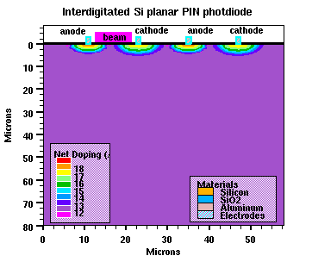
(a)
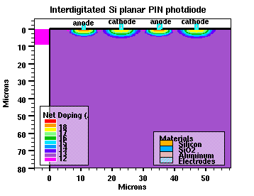
(b)

Fig. 2: Interdigitated Si Planar PIN PD illuminated from (a) the surface and (b) laterally
(a)
(b)
Fig. 3: Dark/Photo IV of the devices when illuminated from (a) the surface and (b) laterally

Upon illumination of a 1Wcm⁻² optical beam, the generated photocurrent increased to 40nA and 50nA respectively for the surface and laterally illuminated PIN PDs. Optical beam of 3Wcm⁻² produced photocurrents of 200nA and 300nA respectively. Further increment of 400nA and 500nA is observed when devices are illuminated with an optical beam power of 5Wcm⁻². The higher photocurrent generated in the laterally illuminated PD is due to the higher photogeneration rate occurring closer to the device electrodes and within the absorption region of silicon therefore producing more free electron/hole pairs.
The total quantum efficiency, η of the laterally illuminated PIN PD is much higher than the surface illuminated device, where at a wavelength of 850nm, η was 95% and 75% respectively. The incident optical power was 5Wcm⁻² and applied reverse bias of 10V. This is shown in Fig 4.
The responsivity curves are exhibited in Fig 5. The wavelength of the optical beam was increased gradually from 400nm till 1000nm and responsivity values at each wavelength were extracted. The laterally illuminated PIN PD device achieved a responsivity of 0.65A/W at 850nm versus 0.52A/W for surface illuminated PIN PD.

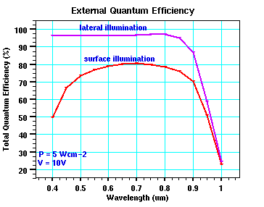
Fig. 4: External Quantum Efficiency of surface versus laterally illuminated Si planar PIN PD

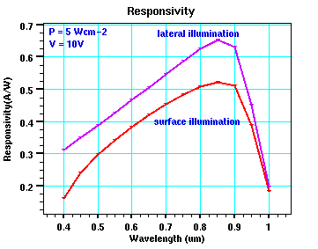
Fig. 5. Responsivity of the devices with different illumination location

Fig 6 shows the frequency response of the devices with the same optical spot power (P=5Wcm⁻²) and reverse bias voltage (10V). The –3dB cutoff frequency of the surface illuminated device is at ~10kHz whereas for the lateral illuminated PIN PD, the frequency is higher at ~0.1Mhz. Lateral illumination produces a larger photogeneration-area closer to the electrodes compared to the surface illuminated device thus a higher rise time (as compared to surface illumination) is obtained.

Fig. 6. Frequency response of PD devices with different illumination location

The frequency response of the device is not able to achieve GHz speed due to the existence of weak electric fields at locations deep below the substrate. Therefore these carriers need to travel a further distance to reach the electrodes hence producing larger rise times and lower bandwidth. The weak electric field phenomena can be reduced or eliminated to a certain extent by using SOI substrates.

3 Conclusion
An interdigitated silicon planar PIN PD was successfully modeled and simulated using Silvaco ATHENA and ATLAS software. This novel approach towards planar PIN PD device modeling was achieved using standard physical and numerical modeling methods. The effects of surface versus lateral illumination on the characteristics of the device were analyzed and discussed. Based on the obtained data, when the device is illuminated laterally, higher photocurrent is generated in the device producing higher quantum efficiency, responsivity and frequency response as compared to surface illumination.

References:
[1] Ru Li, Design and Development of High performance, monolithically integrated silicon-based optical receivers, The University of Texas, August 2000, pp. 14.
[2] J.C. Campbell, PDs for optoelectronic integrated circuits, Integrated Optoelectronics, Academic Press, 1995.
[3] Abang Anuar Ehsan, Sahbudin Shaari, Burhanuddin Yeop Majlis, Silicon Lateral p-i-n PD for OEIC, 2001 IEEE National Symposium on Microelectronics, November 2001, pp. 316.
[4] ATHENA user’s manual, Silvaco International, 2000.
[5] ATLAS user’s manual, Silvaco International, Vol 1, 2000.
[6] B Jalali, PD Trinh, S Yegnanarayanan, F Coppinger, Guided Wave optics in silicon-on-insulator technology, IEE Proc-Optoelectronics, Vol 143, No. 5, October 1996.
[7] Bongyong Lee, Ilgu Yun, Effect of different etching processes on edge breakdown suppression for planar InP/InGaAs avalanche PDs, Microelectronics Journal, Vol 33, 2002. pp. 646.
[8] B. E. A. Salleh & M.C. Teich, Fundamentals of Photonics, John Wiley & Sons Inc, 1991.
[9] O. Baltuch, V. Lee, & S. Wong, Efficient coupling of optical fiber to silicon PD, IEEE Electron Device Lett., Vol. 10, No. 6, 1989, pp 255-256.
[10] Gerd Keiser, Optical Fiber Communications, McGraw-Hill International Editions, 2000, pp. 244-245.
[11] H. Zimmerman, A. Ghazi, T. Heide, R.Popp and R.Buchner, Advanced Photo Integrated Circuits in CMOS Technology, 1999 Electronic Components and Technology Conference, 1999, pp 1032.
[12] John Powers, An introduction to Fiber Optic Systems, McGraw-Hill International Editions, 1999, pp. 165-166.
[13] Clint Lee Schow, Development of high Speed monolithically integrated silicon optical receivers, The University of Texas, May 1999.
[14] P Susthitha Menon, Mohd Hairul Faizal Ahmad, Adila Tugi, Abang Anuar Ehsan and Sahbudin Saari, Dark Current-Voltage(I-V) Characteristic of a Silicon PIN Lateral PD, IEEE National Symposium on Microelectronics, 2003, pp 207-210.
[15] Esther Loo Chee Hong, P Susthitha Menon and Sahbudin Saari, Generation of Dark Current in a Lateral High Speed and High Sensitivity Si PIN Photodetector, IEEE National Symposium on Microelectronics, 2003, pp 270-274.

