Edge Detection in Images Using Clustering Algorithms

TUBA SIRIN¹, MEHMET IZZET SAGLAM², ISIN ERER³, MUHITTIN GOKMEN⁴
¹Informatics Institute, Advanced Technologies in Engineering,
Computer Science and Engineering,
²Informatics Institute, Advanced Technologies in Engineering,
Satellite Communication and Remote Sensing Program,
³Faculty of Electrical and Electronic Engineering,
Electronics and Communication Department,
⁴Faculty of Electrical and Electronic Engineering,
Computer Engineering Department,
Istanbul Technical University,
Maslak, Istanbul, 34469, TURKEY

Abstract: Edge detection is an important topic in image processing and a main tool in pattern recognition and image segmentation. Many edge detection techniques are available in the literature. ‘A number of recent edge detectors are multiscale and include three main processing steps: smoothing, differentiation and labeling’ (Ziau and Tabbone, 1997). This paper, presents a proposed method which is suitable for edge detection in images. This method is based on the use of the clustering algorithms (Self-Organizing Map (SOM), K-Means) and a gray scale edge detector (Canny, Generalized Edge Detector (GED)). It is shown that using the grayscale edge detectors may miss some parts of the edges which can be found using the proposed method.

Key Words: Edge detection, Canny, GED, Clustering, K-Means, SOM.

1 Introduction
Edge detection plays an important role in various areas of image analysis and computer vision. Edge points are pixels at which abrupt gray-level changes occur because of changes in surface orientation, depth or physical properties of materials. The aim of edge detection is providing a meaningful description of object boundaries which are due to discontinuities manifesting themselves as sharp changes, in a scene from intensity surface.
Any edge detector should tackle with the tradeoff between good localization property forcing the location of the detected edges to be close as much as possible to the real edges and good noise rejection property forcing the intensity surface to be smooth. Without a priori assumption, one can not select the best tradeoff. In fact, deciding whether a pixel belongs to a contour is an ill-posed problem.
There are many ways to fulfill edge detection requirements. There are two major classes of filtering based methods; gradient and Laplacian. Consider the signal (1-D function) in Fig. 1 with an edge shown by the jump in intensity below. At this point, the first derivative has a local extremum (maximum or minimum), and second derivative has a zero crossing.
In the gradient- based methods the edges are found by looking for the maximum and minimum in the first derivative of the image. Usually, the edges obtained are thick and that an edge thinning algorithm may be necessary to improve the results. These methods may also cause discontinuities in the detected edge contours.
In Laplacian-based methods, choosing all zero-crossing points as edges tends to generate too many edge points, and many false edge contours may be generated. One of the advantages of Laplacian-based methods is that edge thinning algorithms are not needed as the edges found are thin.
An optimization theory to edge detection was developed by Canny [1]. He considered three main criteria for the edge operator:

- Good detection
- Good localization
- Only one response to one edge
Considering these constraints in mathematical form, an edge detector is a specific kind of edge function. Canny uses the first derivative of a Gaussian function as the optimal edge detection operator. After convolving the image with the optimal filter, edges are marked at maximum in gradient quantity.
The Generalized Edge Detector (GED) is a more recent technique, which combines most of the existing edge detector in a unified framework [2]. It is based on a two-dimensional hybrid model of the linear combination of membrane and thin-plate functionals.

Fig. 1. Input signal, its first derivative, and its second derivative for a typical 1-D edge.

This paper is organized as in the following; GED is discussed in the next section. In section 3 clustering algorithms are discussed. Section 4 describes the proposed algorithm. The comparative experimental results are discussed in Section 5. Conclusions are given in the last section.

2 Generalized Edge Detector
The Generalized Edge Detector explores the relationship between regularization theory and convolution with filters. Regularization theory is a general framework used to convert an ill-posed problem to well-posed by restricting the class of admissible solutions using the constraints such as smoothness [3].The edge detection operators may be separated into two groups. In the first group, the operators are related to minimizing the membrane functional, . The operators in the second group are related to minimizing the plate functional, . The hybrid energy functional is considered in 1-D and the corresponding filter associated with it is found. The related functions are

(1)

(2)

The function that minimizes the one-dimensional hybrid functional

(3)

can be found by solving the associated Euler-Lagrange equation given by

(4)

The GED algorithm is the same as Canny’s edge detection algorithm except that the Gaussian and its first derivative are replaced by more general functions and [2].

3 Clustering
To reduce the amount of data by categorizing or grouping similar data items together is the goal of clustering. One of the motivations for using clustering algorithms is to provide automated tools to help in constructing categories or taxonomies. Regions of an image clustering should be uniform and homogeneous with respect to some characteristic such as gray tone or texture.

3.1 K-Means
K-means clustering is a commonly used partitional clustering method, [4]. Clustering the criterion function is the average squared distance of the data items from their nearest cluster centroids, in K-means.

(5)
where is the index of the centroid that is closest to . For minimizing the cost function one possible algorithm begins by initializing a set of K cluster centroids denoted by

  - Self-Organizing Map
The self-organizing map (SOM) which has been used for a wide variety of applications is a neural network algorithm [5]. The procedure for learning a SOM is as follows:
Initialization: Initialization, whose types are shown in below, is used to obtain a faster algorithm.
- Random initialization is the method in which the weight vectors are initialized with small random values.
- Sample initialization is the method in which the weight vectors are initialized with random samples drawn from the input data set.
- Linear initialization is the method in which the weight vectors are initialized in an orderly fashion along the linear subspace spanned by the two principal eigenvectors of the input data set.
Before training with the SOM, the weight vectors are initialized with random values.
Training: There are two stages in the training:
- First, a sample vector is chosen from the input data vectors randomly. Then, the similarity between this vector and all the weight vectors of the map is calculated and a winner is chosen by
(6)
Up to this point, the training process is called winner node search stage.
- In the adaptation stage, the weight vectors, in the map are updated as shown below:
(7)
This adaptation procedure moves the prototypes of the best matching unit (BMU) and its topological neighbors towards the sample vector.
Stages one and two are repeated during the training process. The clusters that correspond to characteristic features are formed into the map automatically. A number of clusters are generated.

4 Proposed two-stage edge detection algorithm
A two stage edge detection method is applied on the images. Novelty in our study is the use of GED. The stages of our algorithm as follow:
Stage 1: Clustering of the data (K-Means, SOM)
Stage 2: Gray scale edge detection (Canny, GED)

5 Experimental Results
First, to be able to measure the success of the proposed algorithm, the checkerboard image is used. Clustering algorithms are applied on this image, then, the grayscale edge detectors are applied on the resulting image of the first stage.

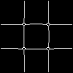
(a) (b) (c)

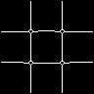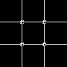
(d) (e) (f)
(g) (h)
Fig. 2. (a)The checkerboard image, (b)Exact edges, (c)Result of Canny operator, (d)Result of K-Means-Canny, (e)Result of SOM-Canny, (f)Results of GED, (g)Results of K-Means-GED, (h)Results of SOM-GED

Fig. 2. shows the checkerboard image and its edge images obtained by the described methods.

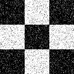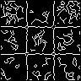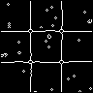
(a) (b) (c)

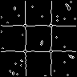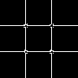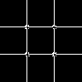
(d) (e) (f)

(g)
Fig. 3. (a) Noisy checkerboard image (b)Result of Canny operator, (c)Result of K-Means-Canny, (d)Result of SOM-Canny, (e)Result of GED, (f)Result of K-Means-GED, (g)Result of SOM-GED

Rates of determining false edges are given in the Table 1. As it is clear on the table, using K-Means-Canny or using SOM-Canny works less erroneously than using Canny alone. Although GED is a very successful edge detector, K-Means-GED and SOM-GED work less erroneously. At high noise, GED by itself shows better performance.

Table 1. Error Analysis on the checkerboard image.
% | Error Rate
Noise Ratio | %0 | %20
Canny | 4.1667 | 13.4766
K-Means-Canny | 2.8212 | 5.3277
SOM-Canny | 4.1667 | 5.8594
GED | 0.3906 | 1.3455
K-Means-GED | 0.3906 | 1.0525
SOM-GED | 0.3906 | 1.5625


Fig. 4. The bridge image

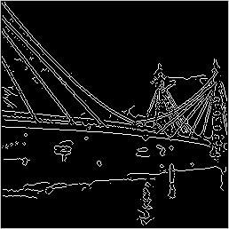
Fig. 5. Result of Canny

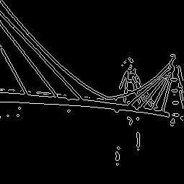
Fig. 6. Result of K-Means-Canny

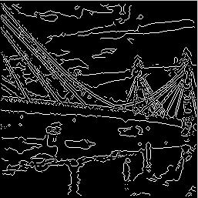
Fig. 7. Result of SOM-Canny

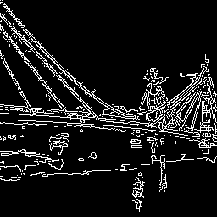
Fig. 8. Result of GED

Finally, our algorithms are tested on the bridge image, which is more complex. The image is chosen so that the results of the edge-detection could be perceived through the naked eye. Results of the test are presented.

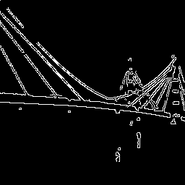
Fig. 9. Result of K-Means-GED

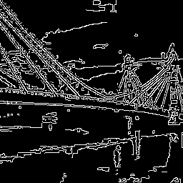
Fig. 10. Result of SOM + GED

6 Conclusion
A two-stage edge detection algorithm is presented. The clustering stage (K-Means, SOM) is followed by the gray level edge detection stage (Canny, GED). The resulting edge images show that the performance of the proposed method is superior to the one stage edge detection.

References:
[1] J.F. Canny, “A Computational Approach to Edge Detection,” IEEE Trans. On Pattern Analysis and Machine Intelligence, Vol. 8, 1986, pp. 679-698.
[2] M. Gokmen and A.K. Jain, “-Space Representation of Images and Generalized Edge Detector,” IEEE Trans. on Pattern Analysis and Machine Intelligence, vol.9, 1997, pp. 545-563.
[3] M. Bertero, T. Poggio, and V. Torre, “Ill-posed Problems in Early Vision,” Technical Report, MIT AI
Lab., AI Memo 924, 1987.
[4]MacQueen, “Some methods for classification and analysis of multivariate observations,” Proceedings of Fifth Berkeley Symposium on Math. Statist. and Prob., 1967, pp. 281-297.
[5] Kohonen, T. The Self-Organizing Map, Proc. IEEE, vol. 78, no. 9, Sept. 1990, pp. 1464-1480.

