Position Location Using A Minimum Square Error Method:
An Indoor Environment Implementation*

Stelios A. Mitilineos^{1, 2}, Stelios C. A. Thomopoulos¹ ,
Dimitrios K. Bougoulias¹, and Christos N. Capsalis²

¹National Center for Scientific Research “Demokritos”,
Institute of Informatics and Telecommunications,
Patriarxou Ioakeim & Neapoleos str., Agia Paraskevi,
Athens 153 10, Greece

²National Technical University of Athens, NTUA,
Department of Electrical and Computer Engineering,
Division of Information Transmission Systems and Material Technology,
9, Iroon Polytechneiou str.,
Athens 157 73, Greece

http://users.ntua.gr/smitil
http://www.iit.demokritos.gr

Abstract: Wireless position location has received significant attention during the past few years, since it is a key factor to military as well as to commercial applications. Radio frequency (RF) techniques are an attractive alternative to satellite location systems. In this paper, a RF location algorithm is proposed. The algorithm is based on one-to-one mapping of the possible positions of the mobile station to vectors of the signal strength space. Simulation results are extracted and the performance of the algorithm is discussed. A position location system has been implemented for indoor environments and statistical measurements results are presented.

Key-words: Position location, Signal Space, Position Mapping.

1 INTRODUCTION

Wireless localization has received considerable attention during the past few years. The increasing accuracy requirements of military as well as commercial applications have boosted research in wireless and radio frequency (RF) position location.
Position location (PL) systems can be implemented server-side or terminal-side. With the former approach, a set of static receivers, with known position, detect the signal transmitted by the mobile station (MS). The position location algorithm is implemented in receivers’ side (usually by a network server). The receivers may be the base stations (BS’s) in the case of a GSM or 3G cellular network, or the access points (AP’s) in the case of an indoor wireless local area network (WLAN). In the server-side approach, the MS’s position is transparent to the network administrator and legal issues may arise. With the latter approach, the MS detects the signals transmitted by the BS’s or AP’s, and the location algorithm is performed by the MS handset.
Radio frequency PL systems can be classified into two broad categories: Direction finding (DF) and range-based (RB) systems [1]. DF systems estimate the position of the MS by measuring the Direction-of-Arrival (DOA) of the source (MS) signal, using smart antenna arrays methods. Triangulation is used to form a location estimate of the source at the intersection of these Lines-of-Bearing (LOB). RB systems may be categorized as either ranging, range-sum or range-difference [1]. Range estimation is the key attribute of these systems. Range estimation is performed either based on received signal strength (RSS) [2], [3], or time delay measurements [1], [3].
It should be noted that despite the high accuracy and efficiency of global positioning system (GPS) and time-difference of arrival (TDOA) techniques, these methods are not adequate for position location in indoor environments. The GPS system is not capable of operating indoors due to large signal attenuation introduced by buildings’ walls. TDOA techniques suffer from various impairments, such as multipath propagation and fading.
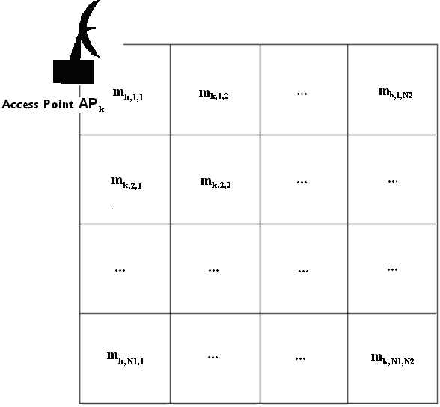
Fig.1: A $N_{1}×N_{2}$ cell grid

This phenomenon may result in angular estimates that vary greatly from the real location of the MS [1]. Anyway, the estimation of the angle of arrival of the incoming signal is only performed by smart antennas systems, which are not available in off-the-shelf and inexpensive systems.
During the past few years, several researchers have contributed on RF position location. Weiss proposed a scheme for a cellular location system [4]. RADAR is one of the first approaches to position location in indoor environments using RSS measurements [5]. Youssef et al, [6], proposed a probabilistic location system, based on the analysis of the probability distribution of the RSS. The method is based on clustering of the MS’s location, according to the signal characteristics. Youssef and Agrawala [7] presented a method for mitigating the deviation introduced to location systems by small-scale fading. Prasithsangaree et al [8], proposed a deterministic approach on position location for indoor environments. Further processing of [8] by Kaemarungsi and Krishnamurthy, as presented in [9], resulted to analytic expressions for the probability of correctly estimating the position of a MS, within a grid of possible locations, at zero accuracy.
In this paper, an algorithm that uses measurement contours of the signal strength in indoor environments is proposed. A position location testbed has been set up in the National Center for Scientific Research, in Athens, Greece. The testbed is based upon WLAN equipment, and the signal strength measurements and position location statistical analysis of the system is performed by IEEE 802.11 compatible AP’s and client cards. The main advantage of the implemented testbed is its independence from specific WLAN equipment implementation, since it is based on received signal strength indicator (RSSI) measurements and is compatible with IEEE 802.11b/g WLAN standards.
The contribution of the paper is a new location triangulation scheme, which is based on averaging the most probable location estimates. Averaging locations is also proposed in [5] but with minor impact on accuracy. With the proposed technique, weighting is performed using the probability of each possible locaiton. With the proposed technique, a location estimate of the MS is available in a continuous sense. The theoretical model and the implementation of the positioning system are presented, together with statistical simulation and measurements results.

2 THEORETICAL MODEL

Consider a WLAN and a grid, formed by $N_{1}×N_{2}$ cells, applied over its coverage area. The network is assumed to consist of $n_{\text{ap}}$ AP’s, each of which is identified as ${\text{AP}}_{k},k=1,\text{.}\text{.}\text{.},n_{\text{ap}}$.
The proposed algorithm is based on the assumption that the mean value of the signal transmitted by the AP’s and received by the MS, at the central point of each cell of the grid, is known. In practical implementations, the mean value of the RSS is approximated by the time average of a very large sample of measurements (ideally an infinite sample). These measurements are collected during the so-called offline phase of the system implementation.
The RSS amplitude for each MS position is assumed to follow either Rayleigh or Rice probability distribution function (pdf), depending on whether there is a line-of-sight (LOS) or non-line-of-sight (NLOS) environment between the MS and the corresponding AP. This assumption is intrinsic to the propagation channel, as described in [10],[11].
Consider a rectangular coverage area which is split into a grid of $N_{1}×N_{2}$ cells, as in fig.1. The AP with identifier ${\text{AP}}_{k}$ is represented here as a directional antenna. The number of the available AP’s,$n_{\text{ap}}$, may vary. The mean value of the amplitude of the RSS, at the center of each cell grid, is denoted by
$m_{k,i,j},k=1\text{.}\text{.}\text{.}n_{\text{ap}},i=1\text{.}\text{.}\text{.}N_{1},j=1\text{.}\text{.}\text{.}N_{2}$ (1)
where k indicates the AP identifier, and $i,j$ indicate the cell identification. The mean values of (1) may correspond to a Rayleigh or Rician distribution. During the offline phase of the system implementation, the Matrix of Mean Values (MMV), with dimensions$n_{\text{ap}}×N_{1}×N_{2}$, is populated. The elements of MMV are defined by (1). For simulation purposes, or during the operation of the system (online phase), the MMV is considered to be known and constant.
During the online phase, the MS may be positioned anywhere in the coverage area, which is a common Bayesian assumption [15]. A RSS sampling is performed by the MS for each AP’s. The sample size for all AP’s is assumed to be $n_{s}$. The RSS average, which is an unbiased estimator of the mean value of the RSS’s, is calculated for each AP. The RSS averages are stored in $\overset{\text{\sim }}{μ}$, a vector of size $n_{\text{ap}}$. The $\overset{\text{\sim }}{μ}$ elements, namely$μ_{k},k=1,\text{.}\text{.}\text{.},n_{\text{ap}}$,are the RSS averages (the element $μ_{k}$ corresponds to the AP with identifier${\text{AP}}_{k}$).
The vector ${\overset{\text{\sim }}{m}}_{i,j}$ is formed by the MMV for all possible grid locations $i,j$. The elements of ${\overset{\text{\sim }}{m}}_{i,j}$, namely$m_{k,i,j},k=1\text{.}\text{.}\text{.}n_{\text{ap}}$, constitute of the RSS means for each AP and for the cell $i,j$. The error distance between a grid cell and the vector $\overset{\text{\sim }}{μ}$ is defined by a Euclidean norm:
$\begin{aligned}e_{i,j}=\left\|\overset{\text{\sim }}{μ}−\overset{\text{\sim }}{m_{i,j}}\right\|=\sum_{k=1}^{n_{\text{ap}}}{{\left(\overset{\text{\sim }}{μ_{k}}−\overset{\text{\sim }}{m_{k,i,j}}\right)}^{2}}, \\ \text{where}i=1\text{.}\text{.}\text{.}N_{1},j=1\text{.}\text{.}\text{.}N_{2}\end{aligned}$ (2)
The Matrix of Distances in the Signal Space (MDSS),$E$, is a matrix with dimensions $N_{1}×N_{2}$ whose elements are signal space distances, as defined by (2).
If the MS is compromised to be placed only at the central points of the cells, then, the estimation of the MS’s position, with zero-meter accuracy, is given by
$\left(i,j\right)\text{:min}\left(e_{i,j}\right),i=1\text{.}\text{.}\text{.}N_{1},j=1\text{.}\text{.}\text{.}N_{2}$ (3)
The term “zero-meter accuracy” refers to the fact that the estimation of the MS’s position is either a success or not a success. The algorithm returns either a true or a false statement about the position of the MS. It should be noted that the term position accuracy is usually reported as the error distance deviated from the actual position while the term location precision is reported in percentages of position information that are within the distance of accuracy [9].
In the case where the MS may be anywhere within the WLAN coverage area, as suggested by [15], the matrix $E$ will contain all signal space distances referring to the cell central points. Equation (3) may still be used for position location, but with minor accuracy. The reason is that, even if the estimation of the MS’s cell is correct, there is still deterioration of accuracy, because of the finite size of grid’s cells. Consider, as an example, the case where the MS is placed in the middle between two adjacent cells. Even if the cell estimation is correct, the accuracy may still be low, since the MS is placed far from the cell’s center.
The proposed technique takes into account that the distance $e_{i,j}$ is inversely proportional to the probability that the MS is placed within the cell $i,j$. The inverse distance $1/{e_{i,j}}$ is used as a measure of the eligibility of the specific cell. The three most eligible locations of matrix $E$ are selected. If these locations are denoted as$L_{1}:x_{1},y_{1}$, $L2:x_{2},y_{2}$ and $L3:x_{3},y_{3}$ with signal distances $e_{1},e_{2},e_{3}$ respectively, then the location estimation of the MS is given by
$\begin{aligned}x_{\text{estimation}}=\frac{\frac{1}{e_{1}}x_{1}+\frac{1}{e_{2}}x_{2}+\frac{1}{e_{3}}x_{3}}{\frac{1}{e_{1}}+\frac{1}{e_{2}}+\frac{1}{e_{3}}}, \\ y_{\text{estimation}}=\frac{\frac{1}{e_{1}}y_{1}+\frac{1}{e_{2}}y_{2}+\frac{1}{e_{3}}y_{3}}{\frac{1}{e_{1}}+\frac{1}{e_{2}}+\frac{1}{e_{3}}}\end{aligned}$ (4)
The term “zero-meter accuracy” is no longer valid. The position location system should be evaluated by using an empirical cumulative distribution function (cdf) of the spatial distance error instead of the precision at zero-meter accuracy.

3 SIMULATION RESULTS

A MATLAB tool has been developed for the simulation of the position finding algorithm, in the case where the MS is assumed to be placed only at the cells’ central points. The noise is assumed to be negligible. This is a simplistic case, and the tool is used in order to demonstrate some of the algorithm’s aspects instead of constituting a representation of a realistic system. However, the tool presented herein, may be used in order to simulate the precision performance of the algorithm, as defined in [9].
A quadrangle cell grid, with dimensions$N×N$, is used to represent the coverage area of the simulated network.

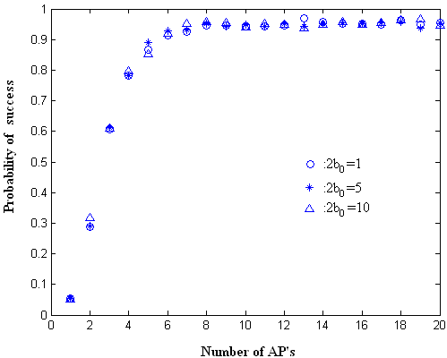
Fig.2: Probability of success vs. $n_{\text{ap}}$,$N=\text{22},n_{s}=\text{100}$.

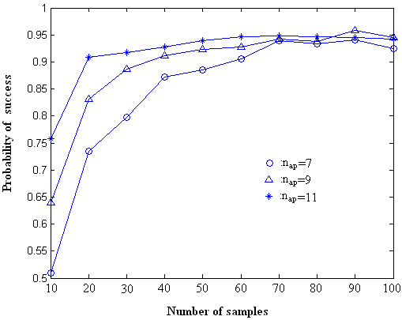
Fig.3: Probability of succes vs. $n_{s}$, $N=\text{22},2b_{0}=1$.

In a real environment, the path loss of the RSS is defined by using
$\text{PL}(\text{dB})=\text{PL}(d_{0})+\text{10}n\text{log}(\frac{d}{d_{0}})+X_{σ}$ (5)
where$\text{PL}(\text{dB})$ is the path loss in dB, $\text{PL}(d{}_{0}^{}{})$ is the path loss in a reference distance $d_{0}$,$n$ is the path loss exponent and $X_{σ}$ represents a normal random variable with zero mean and standard deviation of $σ$dB [12]. From (5), it is obvious that the local mean of the signal is a log-normally distributed random variable with mean equal to$\text{PL}(d_{0})+\text{10}n\text{log}(\frac{d}{d_{0}})$. The path loss exponent, $n$, depends on the surroundings of the AP and the MS and the existence of clear LOS between them.
For the needs of the simulator, and without loss of generality, it is assumed that the value of $\text{PL}(d_{0})+\text{10}n\text{log}(\frac{d}{d_{0}})$ follows a uniform distribution,$U[0,2b_{0}]$, across the cell grid ($X_{σ}$ is not taken into account). Thus, a model is constructed, where the RSS amplitude follows a Rayleigh distribution whose mean value follows a uniform distribution across the grid cells’ central points. The instantaneous RSS amplitude distribution,$p_{a}(x)$, is thus defined using [16]
$p_{a}(x)=\frac{x}{b}\text{exp}(−\frac{x^{2}}{2b}),b∈U(0,b_{0})$ (6)
After the MMV is constructed, using the proposed model, the MS is assumed to be placed at the center of a randomly selected cell. A number of $n_{s}$ samples by each AP is generated using (6) and the position location algorithm is executed. The procedure is repeated for a great number of times (ten thousands or more) and the results are stored.
The simulation is executed for multiple values of the grid size, the number of access points, the sample size and the maximum mean RSS power ($N,n_{\text{ap}},n_{s},2b_{0}$ respectively) .The swept values of these parameters are
$\begin{aligned}N=(2,6,\text{10},\text{14},\text{18},\text{22}) \\ n_{\text{ap}}=(1,2,3,\text{.}\text{.}\text{.},\text{20}) \\ n_{s}=(\text{10},\text{20},\text{30},\text{.}\text{.}\text{.},\text{100}) \\ 2b_{0}=(1,5,\text{10})\end{aligned}$ (7)
The probability of successful position estimation vs. the number of available AP’s is depicted in fig.2. The sample size of the RSS during the online phase and the grid resolution are set at $n_{s}=\text{100},N=\text{22}$, respectively. From fig.2 it is shown that the maximum mean RSS power, $2b_{0}$, does not have an impact on the precision. This is true because the noise is assumed to be negligible. Furthermore, it is shown that the performance of the algorithm is not improved after a maximum number of AP’s, specifically$n_{\text{ap}}=7$. This result can also be found in [9].
The probability of successful position estimation vs. the RSS sample size,$n_{s}$, is depicted in fig.3. It is assumed that$N=\text{22},2b_{0}=1$. From fig.3, it is shown that the deployment of a larger number of AP’s implies a more precise estimation with a much smaller sample size. The total number of samples,$n_{\text{ap}}⋅n_{s}$, which are necessary for a successful estimation, decreases as the number of AP’s increases. Thus, the deployment of a larger number of AP’s implies a trade off between cost and algorithm execution time (money-cost vs. computational cost).

4 MEASUREMENTS RESULTS

A position location system has been implemented within the building of the Institute of Informatics and Telecommunications, NCSR, Greece. In fig.4, the layout of the 2nd floor of the building, where the network was deployed, together with the AP’s placements, are shown. A cell grid, with resolution$1\text{.}8m×\text{2m}$, is applied over the coverage area. The grid is not shown in fig.4 for distinctness. The five AP’s used are of the type AP-10D PRO.11 by BreezeCOM. A standard laptop PC equipped with a PCMCIA client adaptor, SA-PCR PRO.11 by BreezeCOM, is used during measurements. The AP’s transmitted power is adjusted to 17dBm while transmit diversity is employed. The antennas of the AP’s are simple omnidirectional dipoles with a gain of 2dBi.
A large sample of RSS’s from all AP’s is retrieved for every cell of the grid during the offline phase. The measurements are taken with respect to the orientation of the user, as dictated by [5], [13]. The Matrix of Mean Values (MMV) is populated, including the information about the mean values for different orientations of the user at the same position. During the online phase, a RSS sample measurement of size $n_{s}=\text{100}$ is obtained and the position location algorithm is executed using the averaged estimation described by (4).
The position finding system has been tested with 100 different locations and orientations. In fig.5, the cdf of accuracy in terms of the spatial error between the estimation and the actual location of the MS is illustrated. It is shown that the 90th percentile of the empirical distribution is somewhat lower than 2m. In [5, Table 1] the 75th percentile is 4.69m while in [6, fig.7] the 90th percentile is somewhat greater than 6 feet. Compared to relative results from previous work on the field, the proposed location technique exhibits satisfying performance.

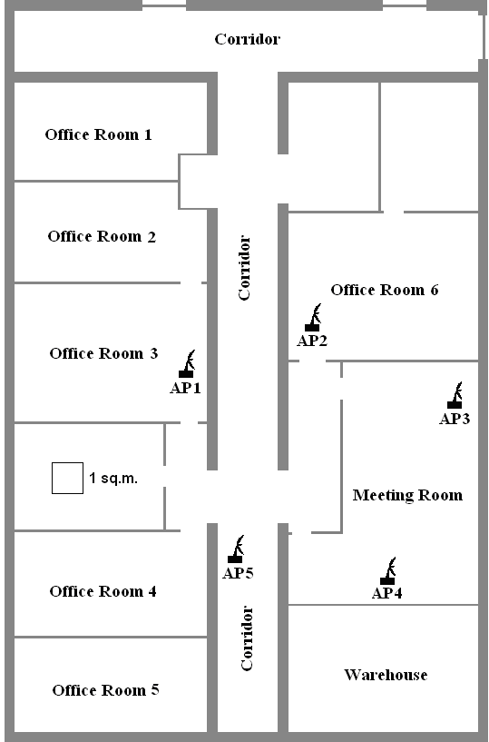
Fig 4: Layout of the network

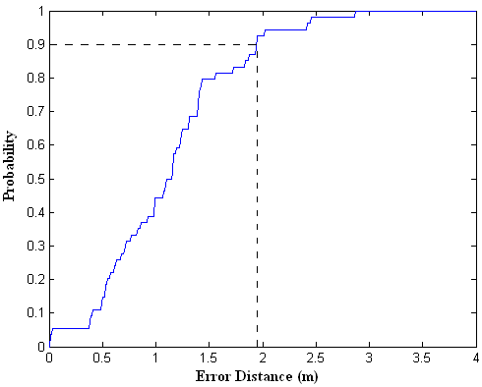
Fig.5: Probability vs. error distance

5 CONCLUSION

Position location in indoor environments is considered a very important characteristic of WLAN’s as location based services rapidly evolve. In this paper, a position location algorithm based on RSS measurements, together with a model for RSS distribution in indoor environments, is proposed. Simulation as well as measurements results are presented. The performance of the algorithm is superior compared to relative work on the field. Further research should include improvement of the simulation model in order to include path loss characteristics as well as amelioration of the position location algorithm in order to achieve better accuracy.

References:

[1] Liberti, J, and Rappaport, T. S., Smart Antennas for Wireless Communications: IS-95 and Third Generation CDMA Application, Prentice Hall PTR, April 1999.
[2] Caffery, J. J., Jr., and Stuber, G. L., “Overview of radiolocation in CDMA cellular systems”, IEEE Communications Magazine, April 1998.
[3] Pahlavan, K., Xinrong, L., Ylianttila, M., Chana, R., and Latva-aho, M., “An overview of wireless indoor geolocation techniques and systems”, Lecture Notes in Computer Science, Vol. 1818: Mobile and Wireless Communication Networks.
[4] Weiss, A. J., “On the accuracy of a cellular location system based on RSS measurements”, IEEE Transaction on Vehicular Technology, Vol. 52, No. 6, November 2003.
[5] Bahl, P., and Padmanabhan, V. N., “RADAR: An in-building RF-based user location and tracking system”, IEEE INFOCOM 2000: 19th Annual Joint Conference of the IEEE Computer and Communications Societies, 2000, Vol. 2, pp. 775-784.
[6] Youssef M. A., Agrawala, A., and Shankar, A. U., “WLAN location determination via clustering and probability distributions”, Proceedings of the 1st IEEE International Conference on Pervasive Computing and Communications, March 2003, pp. 143-150.
[7] Youssef, M., and Agrawala, A., “Small-scale compensation for WLAN location determination systems”, IEEE Wireless Communications and Networking Conference, March 2003, Vol. 3, pp. 16-20.
[8] Prasithsangaree, P., Krishnamurthy, P., and Chrysanthis, P. K., “On indoor position location with wireless LANS”, The 13th IEEE International Symposium on Personal, Indoor and Mobile Radio Communications, September 2000, Vol. 2, pp. 15-18.
[9] Kaemarungsi, K., and Krishnamurthy, P., “Modeling of indoor positionings systems based on location fingerprinting”, IEEE INFOCOM 2004: 23rd Annual Joint Conference of the IEEE Computer and Communications Societies, March 2004, Vol. 2, pp. 1012-1022.
[10] Pahlavan, K., and Levesque, A. H., Wireless Information Networks, John Wiley & Sons, 1995.
[11] Sklar, B., “Rayleigh fading channels in mobile digital communication systems part I: Characterization”, IEEE Communications Magazine, July 1997.
[12] Rappaport, T. S., Wireless Communications: Principles and Practice, Prentice Hall, 1996.
[13] Kaemarungsi, K., Krishnamurthy, P., “Properties of indoor received signal strength for WLAN location fingerprinting”, MobiQuitous 2004: Proceedings of the 1st Annual International Conference on Mobile and Ubiquitous Systems: Networking and Services, August 2004, pp. 14-23.
[14] Youssef, M., Agrawala, A., “Continuous space estimation for WLAN location determinatin systems”, The IEEE 13th International Conference on Computer Communication and Networks, October 2004.
[15] Ladd, A.M., Bekris, K. E., Rudys, A., Marceau, G., Kavraki, L. E., and Wallach, D. S., “Robotics-based location sensing using wireless ethernet”, MOBICOM 2002, September 2002, pp. 227-238.
[16] Stuber, G. L., Principles of Mobile Communication, Kluwer Academic Publishers, 2001.

___________________
ACKNOWLEDGMENT: ∗This work is part of the research project “ΑTHENS: Athletic Information Inside a Stadium.” The research is supported by the Grant EPAN ΑΘ/13-4.5.1(2003-2005) co-financed by the Greek Ministry of Development (GSRT) and private industry in the context of the Information Society Program.

