Ring gage’s design using the computer

CARMEN SIMION, SORIN BORZA, LUCIAN VINŢAN
Manufacturing Engineering Department
University “Lucian Blaga” from Sibiu, Faculty of Engineering “Hermann Oberth”
4 Emil Cioran Street, 550025 Sibiu
ROMANIA

Abstract: - For quality monitoring and control, a number of low-technology and high-technology gages (gauges) equipment are being used today in manufacturing applications. To check workpiece features in mass and batch production, usually, limit gages are used as standards to determine whether or not one or more dimensions of a manufactured part are within specified limits. Consistent use of go/no-go gages provides manufacturers with an indisputable method of determining part consistency and quality. The paper deals with the designing of a ring gage and a software application as an executable program was created, which enables to determine quickly the ring gage dimensions, depending on the part dimension being gauged.

Key-Words: limit gages, ring gages, Go side, NOT-GO side.

1 Inspection role in quality assurance
Since quality decisions are based on inspection, undesirable consequences may result if this task is not performed properly. Inspection is the judging of a product’s conformance to specifications with feedback on the quality provided to the producer, to permit short-term corrections or long-term improvements to be made. Inspection has always been a vital part of manufacturing since the industrial revolution and form today the basis for both product and process control.
As illustrated in figure 1 inspection for quality occurs at the three major points in the production system: at the receipt of incoming materials and purchased parts, during production and at the finished product stage.
Product specifications
Inputs
Outputs
Production process
Product improvements
Process improvements

Inspection
Process capability
Process adjustment
Fig.1

2 Fixed gages (gauges)
For quality monitoring and control, a number of low -technology and high-technology gages/inspection equipment are being used today in manufacturing applications. Gages can generally be divided into two basic categories: variable gages (line graduated, dial, digital and optical gages), used for variable inspection and fixed gages, used for attribute inspection.
Variable gages are adjusted to measure each individual part or dimension being inspected. Fixed gages are preset to a certain dimension and parts being measured are classified according to whether or not they meet this dimension. The terms GO and NOT(NO)-GO are often used to signify this classification.

Fixed gages are much simpler than variable gages. Once they are set for a particular dimension, no adjustment is required as long as wear or deposits on the measuring surfaces are negligible. However, some fixed (snap) gages are adjustable.
Fixed gages are limit gages, so they have no graduated scale and require no readings to be taken, and so their use increases checking rates. Gages of this kind are especially common in mass and batch production, when they are used to check workpiece features for size, form and relative position. Limit gages are used as standards to determine whether or not one or more dimensions of a manufactured part are within specified limits. Their measurements are included in the construction of each gage. Limit gages are used for a wide range of work, from rough machining to the finest tool and die making. The accuracy required of the same type of gage will be different, depending of the use.
Examples of fixed gages are plug gages, ring and snap gages, contour gages, thread gages, limit length gages, assembly gages etc.
Plug gages are used for checking an inside diameter, respectively a hole (bore). They have a machined diameter on one or both ends corresponding to GO/NOT-GO side dimensions that have been specified for the bore being inspected. The GO side of the plug gage is made to the minimum limit of size of the hole being checked and the NOT-GO side to the maximum limit.
Ring gages are used to check outside diameters of parts (shafts) using the same go/not-go principle. Typically, they are made in pairs, with a NOT-GO ring being used for the minimum dimension and a GO ring being used for the maximum size limit.
Snap gauges are similar to ring gages in purpose but operate in a different fashion. They are also used to measure outside diameters of parts but have an open-ended construction so that they can snap onto the diameter of the parts. The GO side is made to the maximum dimension of the shaft to be checked and the NOT-GO side to its minimum dimension.

3 Ring gages
So, the ring gage is a cylindrical measuring device with a precision lapped, nearly perfect geometry and a precisely determined internal diameter (see fig.3). Ring gages have two primary functions in manufacturing: a point of reference for setting other measuring instruments, or indirect gauging, and checking the size and roundness of manufactured parts, or direct gauging.
The process of indirect gauging with a ring gage involves using the tool in conjunction with another precision measuring device. In this application, the gage is frequently used with measuring tools such as bore gages and air gages. In this set-up, the manufacturer uses a master ring gage. A master ring is a gage that has been manufactured with a bilateral tolerance. By definition, a bilateral tolerance applies to one half of the specified tolerance plus and minus from the designated size (ring gage’s nominal size). The use of a ring gage establishes a point of reference for a comparative measurement process in which the size of the manufactured work piece is directly compared to the known and certified value of the ring. Because of the light wear produced by indirect gauging, ring gages should be recalibrate approximately once per year to ensure the continued integrity of the gage and its measuring accuracy.
Ring gages used for direct gauging, or fixed-limit gauging, aid the manufacturer in establishing a physical limit for the maximum acceptable outer diameter of a work piece. In addition, ring gages help determine a lack of roundness in the part that may not be picked up by a micrometer or other commonly used comparators. In this instance, the part may measure correctly in size with a micrometer but will not fit through the ring gage. Detecting such defects will ensure that all manufactured parts fit correctly in high-precision tool holders and bearing races used by manufacturers.
Ring gages are used for go/no-go assessment. Go and not-go (no-go) ring gages provide a precision tool for production comparative gauging based on a fixed limit. A GO ring gage's dimensions are based on the maximum outside diameter tolerance of the part being gauged (a shaft) and it should be specified to a minus gagemakers' tolerance from the maximum part tolerance. A NOT-GO ring gage's dimensions are based on the minimum outside diameter tolerance of the part being gauged and it should be specified to a plus gagemakers' tolerance from the minimum part tolerance.
When working with a go gage, a correctly sized part will pass completely through the gage, whereas an oversize part will not pass through the gage. Conversely, if a part passes through the no go gage, it is considered undersized and is unacceptable. In conclusion, the part should pass through the GO side of the gage and not pass through the NOT-GO side.
Because direct gages tend to have frequent contact with work pieces and are exposed to the everyday shop environment, it is important that they maintain a higher recalibration recall than gage masters.

4 Ring gage’design for direct gauging
To design a ring gage, a software application as an executable program was created, which enables to determine quickly the ring gage dimensions, depending on the part dimension being gauged.
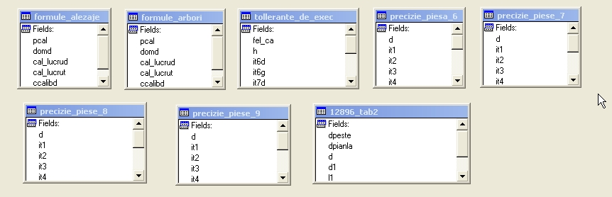
We considered the gage database presented in figure 2, where are memorized all needed information for a gage application.
Fig.2.

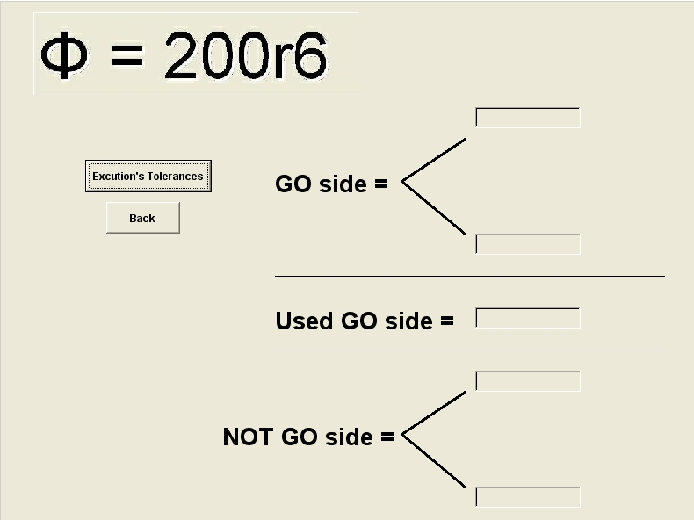
From the window application presented in figure 3, we choose the adequate standard to check a part outside diameter, for instance STAS 12896-90.
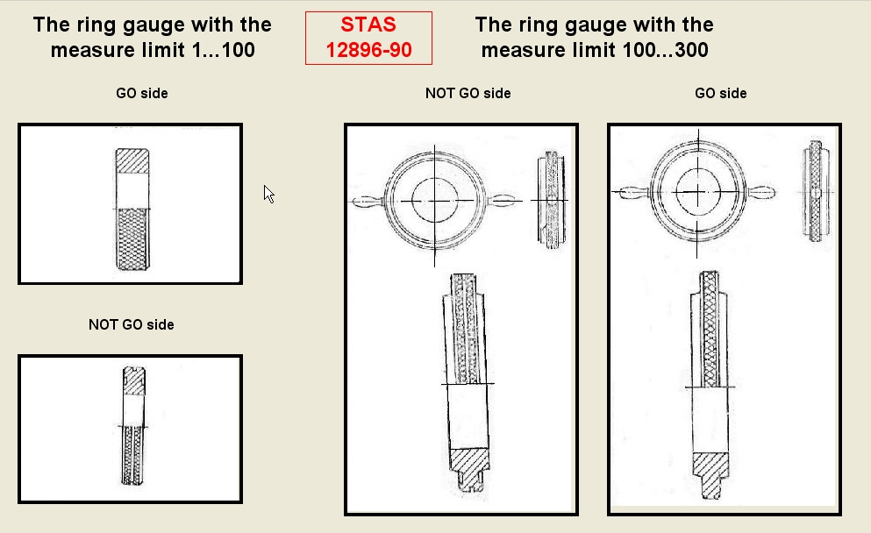
Fig.3
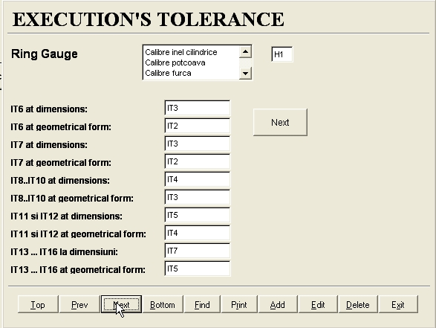
Then, depending on the part dimension being gauged (for instance φ100...300 mm), we choose the standardized drawing for the ring gage (fig.4).
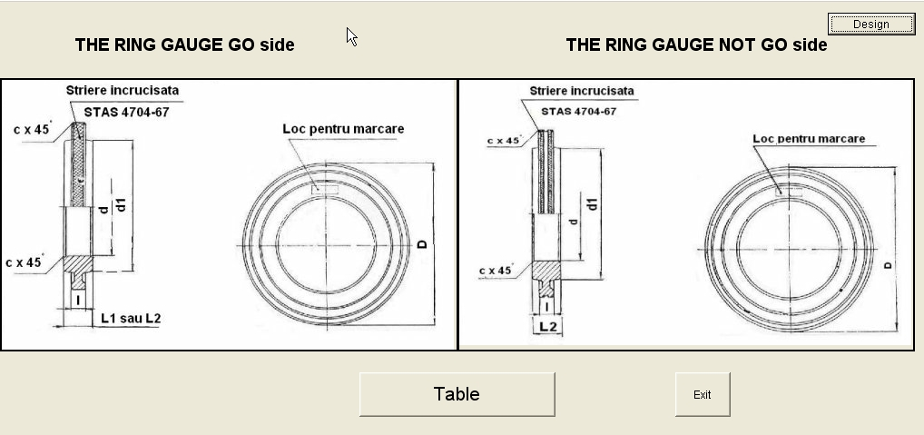
Fig.4
Operating the Design button, it is possible to calculate all the ring gage dimensions (fig.5). Operating Table button, it is possible to visualized all the data from the standard STAS 12896.
Pushing the Execution’s tolerances button, a window for choosing the ring gage type appears (fig.6)

Fig.5

Fig.6
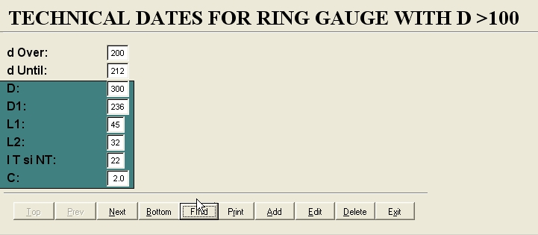
Then we must operate the Next button. In the window that appears (fig.7) we choose the desired dimension, afterwards we push the Calculate button and it is possible to calculate the GO side, used GO side and NOT-GO side of the ring gage, according to standard STAS 8222-68.
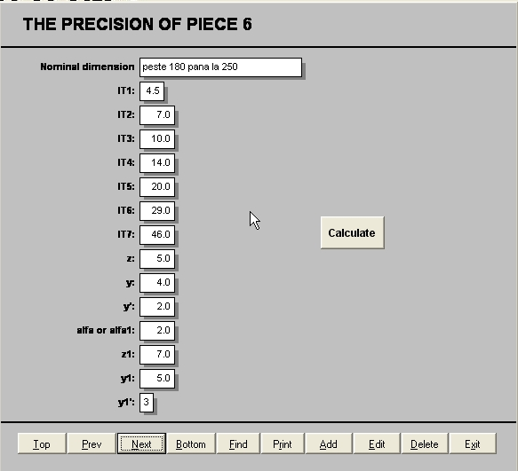
Fig.7

The calculated results for the GO diameter, used GO diameter and NOT-GO diameter of the ring gage that inspects a shaft with a diameter of φ200 r6 are shown in figure 8.
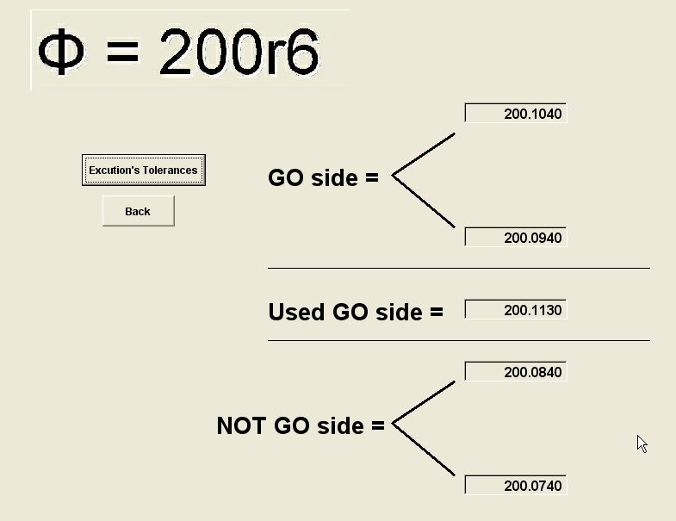
Fig.8

Pushing the Table button from the figure 4, it is possible to visualize all the ring gage dimensions. For a ring gage inspecting a part with a diameter of φ200 r6 the results are shown in figure 9.

Fig.9

5 Conclusion
To check workpiece features in mass and batch production, usually, limit gages are used as standards to determine whether or not one or more dimensions of a manufactured part are within specified limits. Consistent use of an executable program, like the software application presented in this paper, provides an indisputable method of determining quickly the ring gage dimensions depending on the part dimension being gauged.

References:
- S. Agrawal, S. Chaudhuri, V.R. Narasayya, Automated Selection of Materialized Views and Indexes in SQL Databases, VLDB Conf. 2000.
- G. Alvarez, K. Keeton, A. Merchant, E. Riedel, J.Wilkes, Storage Systems Management, Tutorial, SIGMETRICS Conf. 2000.
- J. R. Evans, W.M. Lindsay, The Management and Control of Quality, West Publishing Company, St. Paul-Minneapolis, U.S.A., 1993.
- G. Griffith, G., Quality Technician’s Handbook, John Wiley, New York, U.S.A., 1986.
- D. Shasha, P. Bonnet: Database Tuning, Principles, Experiments, and Troubleshooting Techniques, Morgan Kaufmann, 2002.
- Reference standards: STAS 2980/1-87, STAS 12896/90, STAS 8222/68.

