DC-DC CONVERTERS VIA MATLAB/SIMULINK

MOHAMED ASSAF, D. SESHSACHALAM, D. CHANDRA, R. K. TRIPATHI
Electrical Engineering Department
Motilal Nehru National Institute of Technology
Allahabad, Utter Pradesh- 211004
INDIA

Abstract— the design of power electronic converter circuit with the use of closed loop scheme needs modeling and then simulating the converter using the modeled equations. This can easily be done with the help of state equations and MATLAB/SIMULINK as a tool for simulation of those state equations. An attempt has been made in this paper to simulate all basic non-isolated power converters. So that these models can be readily used for any close loop design (say using PI, fuzzy, or sliding mode control etc.).

Index Terms—Switching converters, MATLAB/SIMULINK, system modeling, cascade control, subsystems

1 Introduction

Controller design for any system needs knowledge about system behavior. Usually this involves a mathematical description of the relation among inputs to the process, state variables, and output. This description in the form of mathematical equations which describe behavior of the system (process) is called model of the system. This paper describes an efficient method to learn, analyze and simulation of power electronic converters, using system level nonlinear, and switched state- space models. The MATLAB/SIMULINK software package can be advantageously used to simulate power converters. This study aims at development of the models for all basic converters and studying its open loop response, so these models can be used in case of design of any close loop scheme. Also as a complete exercise a closed scheme case has been studied using cascaded control for a boost converter.

2 Simulink Model Construction of DC-DC Switching Converter
System modeling is probably the most important phase in any form of system control design work. The choice of a circuit model depends upon the objectives of the simulation. If the goal is to predict the behavior of a circuit before it is built. A good system model provides a designer with valuable information about the system dynamics. Due to the difficulty involved in solving general nonlinear equations, all the governing equations will be put together in block diagram form and then simulated using Matlab’s Simulink program. Simulink will solve these nonlinear equations numerically, and provide a simulated response of the system dynamics.

A. Modeling Procedure
To obtain a nonlinear model for power electronic circuits, one needs to apply Kirchhoff's circuit laws. To avoid the use of complex mathematics, the electrical and semiconductor devices must be represented as ideal components (zero ON voltages, zero OFF currents, zero switching times). Therefore, auxiliary binary variables can be used to determine the state of the switches. It must be ensure that the equations obtained by the use of Kirchhoff's laws should include all the permissible states due to power semiconductor devices being ON or OFF.
The steps to obtain a system-level modeling and simulation of power electronic converters are listed below.
1) Determine the state variables of the power circuit in order to write its switched state-space model, e.g., inductor current and capacitor voltage.
2) Assign integer variables to the power semiconductor (or to each switching cell) ON and OFF states.
3) Determine the conditions governing the states of the power semiconductors or the switching cell.
4) Assume the main operating modes of the converter (continuous or discontinuous conduction or both) or the modes needed to describe all the possible circuit operational modes. Then, apply Kirchhoff's laws and combine all the required stages into a switched state-space model, which is the desired system-level model.
5) Write this model in the integral form, or transform the differential form to include the semiconductors logical variables in the control vector: the converter will be represented by a set of nonlinear differential equations.
6) Implement the derived equations with "SIMULINK" blocks (open loop system simulation is then possible to check the obtained model).
7) Use the obtained switched space-state model to design linear or nonlinear controllers for the power converter.
8) Perform closed-loop simulations and evaluate converter performance.
9) The algorithm for solving the differential equations and the step size should be chosen before running any simulation. The two last steps are to obtain closed-loop simulations [2].

3 Simulation Open-Loop Modeling of DC-DC Converters
A. Buck Converter Modeling
The buck converter with ideal switching devices will be considered here which is operating with the switching period of T and duty cycle D Fig. 1, [1]. The state equations corresponding to the converter in continuous conduction mode (CCM) can be easily understood by applying Kirchhoff's voltage law on the loop containing the inductor and Kirchhoff's current law on the node with the capacitor branch connected to it. When the ideal switch is ON, the dynamics of the inductor current and the capacitor voltageare given by,

and when the switch is OFF are presented by,

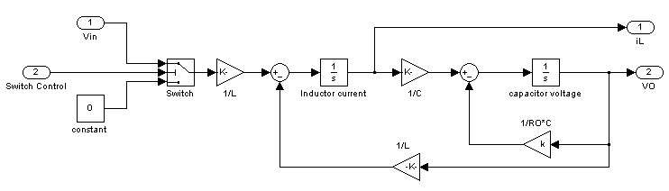
Fig 2 Open-loop modeling of Buck DC-DC converters
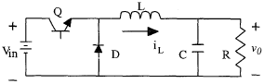

Fig.1 DC-DC Buck Converter

These equations are implemented in Simulink as shown in Fig. 2 using multipliers, summing blocks, and gain blocks, and subsequently fed into two integrators to obtain the states and [2][3] [4].

Fig. 3 DC-DC Boost Converter

Fig. 3 DC-DC Boost Converter

B. Boost Converter Modeling
The boost converter of Fig. 3 with a switching period of T and a duty cycle of D is given. Again, assuming continuous conduction mode of operation, the state space equations when the main switch is ON are shown by, [1].

and when the switch is OFF

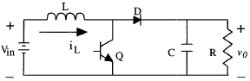
Fig. 4 shows These equations in Simulink using multipliers, summing blocks, and gain blocks, and subsequently fed into two integrators to obtain the states and , [2][3][4]

Fig. 4 Open-loop modeling of Boost DC-DC converters

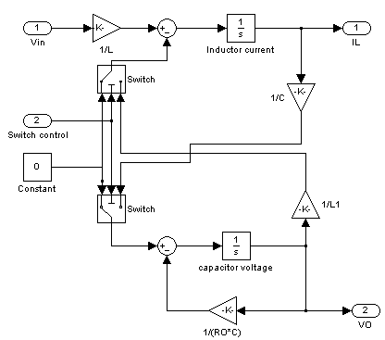

C. Buck-Boost Converter Modeling
In Fig. 5 a DC-DC buck-boost converter is shown. The switching period is T and the duty cycle is D. Assuming continuous conduction mode of operation, when the switch is ON, the state space equations are given by, [1]
and when the switch is OFF

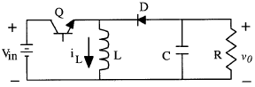

Fig. 5 DC-DC Buck-Boost Converter

These equations are implemented in Simulink as shown in Fig. 6 using multipliers, summing blocks, and gain blocks, and subsequently fed into two integrators to obtain the states and , [2] [3] [4].
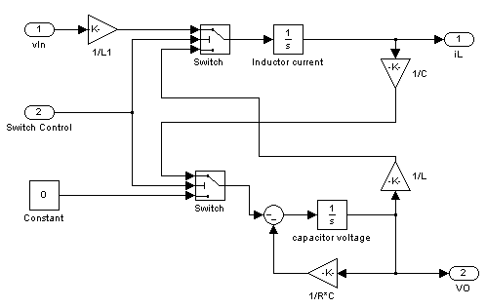

Fig. 6 Open-loop of Buck-Boost DC-DC Converters
D. Cuk Converter Modeling
The Cuk converter of Fig. 7 with switching period of T and duty cycle of D is considered. During the continuous conduction mode of operation, the state space equations are as follows, [1]

When the switch is OFF the state space equations are represented by

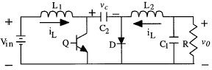

Fig.7 DC-DC Cuk converter

these equations are implemented in Simulink as shown in Fig. 8 using multipliers, summing blocks, and gain blocks, and subsequently fed into two integrators to obtain the states and , [2] [3] [4].

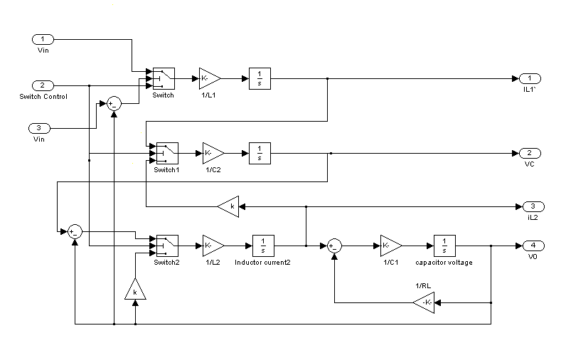

Fig. 8 Open-loop modeling of Cuk DC-DC converters

E. Subsystems
Each of the power electronic models represents subsystems within the simulation environment. These blocks have been developed so they can be interconnected in a consistent and simple manner for the construction of complex systems. The subsystems are masked, meaning that the user interface displays only the complete subsystem, and user prompts gather parameters for the entire subsystem. Relevant parameters can be set by double-clicking a mouse or pointer on each subsystem block, then entering the appropriate values in the resulting dialogue window [4].
To facilitate the subsequent simulation analysis and feedback controller verification, the pulse-width-modulation signal to control the ideal switch can also be built into the masked subsystem Fig. 9(a) and Fig. 9(b). For each converter to verity it’s working in open loop configuration trigger pulses have been derived using a repeating sequence generator and duty cycle block. Function block compares the duty cycle and saw tooth from repeating sequence- derived trigger pulses are connected as

an input to the switch control. Hence inputs for the masked subsystem are duty ratio and input voltage, and the outputs are chosen to be inductor current, capacitor voltage, and output voltage. When double-clicking the pointer on the masked subsystem, one enters parameter values of the switching converter circuit in a dialogue window. The intuitive signal flow interface in SIMULINK makes this mathematical model and its corresponding masked subsystem very easy to create.

4 Simulation Closed-Loop of DC-DC Converters Using Cascaded Control
The simulation model for cascaded control of DC-DC switching converters is build using the above-mentioned steps is as shown in Fig. 10. The DC-DC buck, boost, buck-boost, and Cuk converters was previously designed, and simulated on digital computer using Matlab package with the parameters given in Table 1, and Table 2. Inductor current and capacitor voltage for open loop simulation of all converters are as shown in Fig.11 (a, b, c, and d).
Table 1 Buck, Boost, and Buck-Boost converters parameters |  |  |  |  |  |  | Table 2 Cuk converter parameters
24, 10, 24 Respectively | 69 | 220 | 13 Ω | 100 | 12, 20, -24  Respectively |  | 24 | 69 | 19 | 47 | 220 | 100 | 15 Ω | 31.8
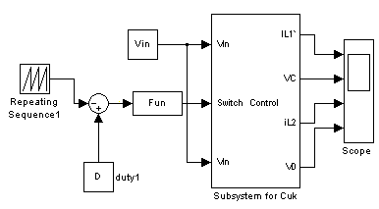
Results of Closed loop using a cascaded control scheme for a boost converter is shown in Fig. 12(a). Here the output voltage rises up to 21.3V (6.5%) for the step variation of load from 10Ω to 13Ω (30%). The output voltage resumes its reference value (of 20V) within 15ms after the transient variation of load. As per fig 12(b), for a step change at the input voltage from 10V to18 V (80%) (at 0.5 Sec instant), a satisfactory performance is obtained in the output voltage which has a rise up to 22.8V (14%), but it is quickly dropped to its set value (20V) within 16 ms. Simulation results verify that the control scheme in this section gives stable operation of the power supply. The output voltage and inductor current can return to the steady state even when it is affected by line and load variation.
Fig. 9(a) Subsystem for Buck, Boost and Buck-Boost converters

5 Conclusions

This paper analysis nonlinear, switched, state-space models for buck, boost, buck-boost, and Cuk converters. The simulation environment MATLAB/SIMULINK is quite suitable to design the modeling circuit, and to learn the dynamic behavior of different converter structures in open loop. The simulation model in MATLAB/SIMULINK for the boost converter is build for close loop. The simulation results obtained, show that the output voltage and inductor current can return to steady state even when it is
Fig.10 Simulink block diagram representing close loop
Scheme of Boost converter using cascaded control

affected by input voltage and load variation, with a very small over shoot and settling time.
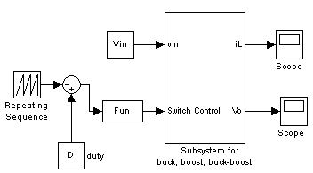

Fig. 9(b) Subsystem for Cuk converters

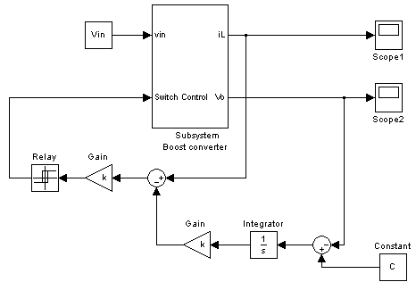

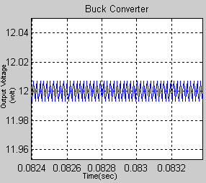

(a)

Ripple (peak-to-peak = 0.11%)

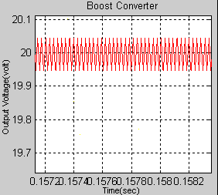

(b)

Ripple (peak-to-peak = 0.43%)
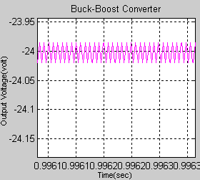

(c)

Ripple (peak-to-peak = 0.12%)
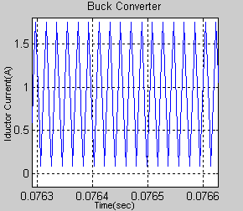

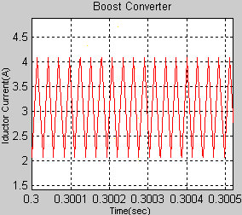

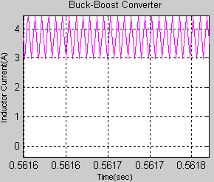

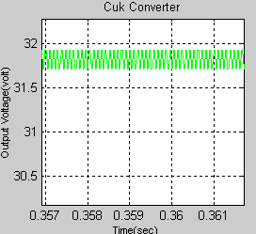

(d)

Ripple (peak-to-peak = 1.96%)

Fig. 11 Output voltage and inductor current Open-loop for (a) Buck (b) Boost (c) Buck-Boost (d) Cuk Converters

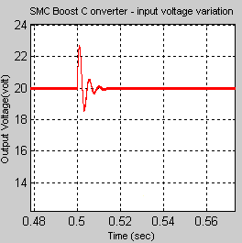

(a)

Fig. 12 Output voltage of SMC Boost Converter when (a) load variation (b) input voltage variation

6 References

[1] J.Mahdavi, A.Emadi, H.A.Toliyat, Application of State Space Averaging Method to Sliding Mode Control of PWM DC/DC Converters, IEEE Industry Applications Society October 1997.
[2] Vitor Femao Pires, Jose Fernando A. Silva, Teaching Nonlinear Modeling, Simulation, and Control of Electronic Power Converters Using MATLAB/SIMULINK, IEEE Transactions on Education, vol. 45, no. 3, August 2002.

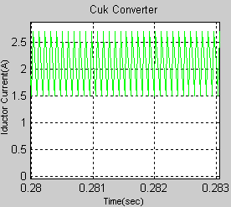

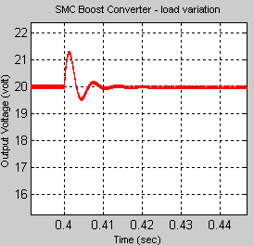

(b)

[3] Juing-Huei Su, Jiann-Jong Chen, Dong-Shiuh Wu, Learning Feedback Controller Design of Switching Converters Via MATLAB/SIMULINK, IEEE Transactions on Education, vol. 45, November 2002.
[4] Daniel Logue, Philip. T. Krein, Simulation of Electric Machinery and Power Electronics Interfacing Using MATLAB/SIMULINK, in 7th Workshop Computer in Power Electronics, 2000,pp. 34-39.
[5] N. Mohan, T. Undeland, W. Robbins, Power Electronics Converters, Applications and Design, ISBN 9814-12-692-6.

