Analysis The Operation of DVR in Voltage Sag Mitigation Using EMTP

H.Monsef B.Tamimi
ECE Dept., Faculty of Eng.,University of Tehran

Abstract
According to the reports, voltage sag is the most probable voltage problem in the network. As the number of sensitive loads increases rapidly the demand for a reliable and cost effective solution also has been increased. In this paper we are going to evaluate DVR performance controlled by an instantaneous algorithm, facing various kinds of voltage sags. We have used ElectroMagnetic Transient Program (EMTP) as a reliable tool for our simulations.

Key words- DVR, Voltage Sag, Custom Power, Distribution Network

Introduction
There are many industrial controllers which use voltage zero crossing instant or even voltage waveform as an essential input for their controlling algorithms. Also there are many industrial applications which the amount and/or quality of their production is directly related to the amplitude of voltage waveform. Thus, supplying the customers with a sinusoidal voltage of constant magnitude is of great importance from an economical point of view.
According to the world wide published reports, voltage sag is the most probable
voltage problem in the network (approximately 85%). Voltage sag means the momentary
decrease of voltage magnitude for duration of between 0.5 to 30 cycles [1] and it becomes

disruptive when the RMS magnitude drops lower than 90% of the nominal voltage [2].
Voltage sags are usually associated with system faults but can also be caused by switching of heavy loads or starting of large motors. Figure 1 shows typical voltage sag that can be associated with a single line-to ground fault (SLG). Also, a fault on a parallel feeder circuit will result in a voltage drop at the substation bus that affects all of the other feeders until the fault is cleared. Typical fault clearing times range from 3 to 30 cycles, depending on the fault current magnitude and the type of over current detection and interruption [3].
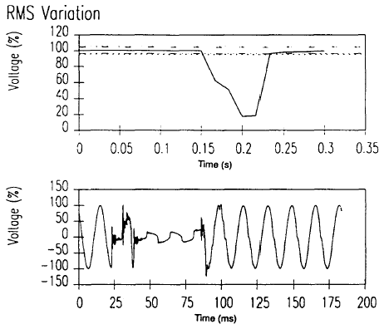

Fig. (1) Typical voltage sag associated with a SLG

Using Constant Voltage Transformers (CVT) or Uninterruptible Power Supplies (UPS) are the common approaches to mitigate or eliminate the voltage sag problem. CVTs are easy and economic to install, but not efficient under variable load condition or large inrush current condition. UPS shows better performance than CVT, but is costly, especially for large ratings, and has some frequent maintenance problems [1].
Dynamic Voltage Restorer (DVR) which is one of the custom power devices (corresponding to the FACTS in distribution network) which has been developed for distribution networks to improve power quality seems to be more effective for maintaining the voltage within limits and balancing it. Figure 2 shows a DVR connected in series with the load, protecting the sensitive load from voltage problems.
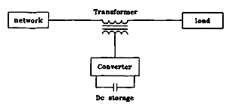
Fig. (2) DVR connected in series with load

Voltage problems generally can be classified into three categories:
- Voltage sag and swell
- Unbalance waveforms
- Distorted waveforms due to harmonics
Inorder to reach the objective(s) of compensation, one can think about the best and most cost effective approach to solve the problem.
As a member of power electronic family, DVR needs a control algorithm to reach its objectives. This algorithm should have some parts. For example on the voltage sag problem, we can think about, how to detect the problem, and also how to determine the reference waveforms, the third, the way to develop our controllers and feedback signals, and finally which switching scheme to use and so on.
Many efforts have been done in analyzing and designing the DVR and its control algorithm. Focusing on the detection procedure and reference point calculation, the previous researches can be classified as follows [1] [4]:
- Network phase tracking method:
  - averaging
  - single phase tracking method
- Symmetrical components:
  - Fortescue transformation
  - instantaneous symmetrical components (dq)
The averaging method is robust against the noise and transients, but it needs at least half of the waveform or something like that to detect the abnormally. Single phase tracking method deals with instantaneous relative ac error value and as the values have time varing characteristics, so the analysis and design is slightly complex, but it has its own advantages which we will see more in the rest.
The Fortescue transformation uses the well-known matrix multiplication to calculate the symmetrical components of three phase system from the complex representation of phase or line voltages. As known, it is phasor based approach and not instantaneous or real time. On the other hand, the instantaneous symmetrical component approach (dq) deals with instantaneous values and also if our waveforms are balanced, the dq values will be somehow constant and time invariant.
It seems that dq method is the best, but there are some drawbacks that can not be ignored. One of them is that, the core of this approach naturally is a PLL (Phase Locked Loop) which it’s dynamic and parameter tuning is arguable. Another point is that the most common fault is SLG, thus usually dq algorithm should handle unbalanced waveforms which leads to time variant values and not constant values as claimed above.
In this paper after a brief discussion on DVR basic structure we consider an instantaneous control algorithm which conceptually can be classified under “single phase tracking” title. The controller based on the proposed algorithm is simple to design and it is tobe noted that, it can be developed and customized according to the load characteristic and project demand, which can be said, it is the novel aspect of this paper . Finally the behavior of the DVR facing different kinds of voltage sags is evaluated via simulations accomplished by EMTP.

DVR Structure
As told before, DVR is a custom power device for series connection into distribution feeder that can control the voltage applied to a load by injecting a voltage of variable amplitude and phase angle, Fig. 2 [5]. Basically it is an inverter (usually three phase voltage source inverter) connected to a DC bus, as shown in Fig 3.
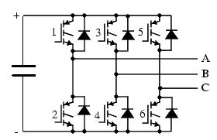

Fig. (3) Three phase voltage source inverter

This device is capable of supplying and absorbing both real and reactive power and also performing phase balancing procedure. Of course, the real power exchange requires energy storage that needs to be supplied externally. Also, for phase balancing, the existence of a path for zero sequence component is necessary. The type of semiconductor switch used in DVR structure depends on the load characteristics and project demands [6].
The behavior of an inverter is somehow well defined and there are many algorithms and procedures, proposed for its control and switching scheme development. However, the needed performance and installation considerations of a DVR make this part of design critical and determinant. In next section we develop an instantaneous control strategy to fulfill the needs fast and simply.

Control strategy
The main idea of the control strategy is to compare the load terminal instantaneous voltage (in each phase) with a reference waveform and make the difference as a reference point for the DVR in each corresponding phases.
Having the reference point for the DVR output, as an inverter, we can use an existing switching pattern to track the reference. Here we use a constant voltage band hystersis procedure to accomplish the switching task [7]. It is a well known switching algorithm, keeping the difference of output and reference waveforms within a predefined band of tolerance, as shown in Fig. 4. Interested in classifying controllers, it can be categorized under ON-OFF controllers, which is the nature of our plant, switching device.
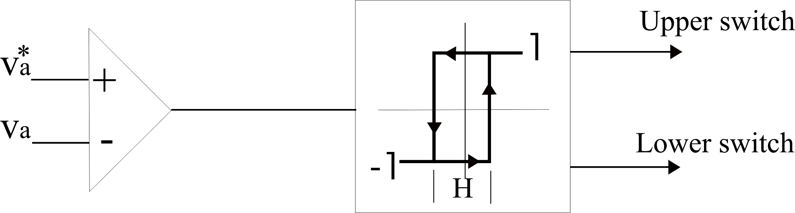

Fig. (4) Band of tolerance

If one wants to have predictable switching harmonics in the output, regardless of tolerance band, the constant frequency hystersis algorithm may be a good choice, Fig. 5.
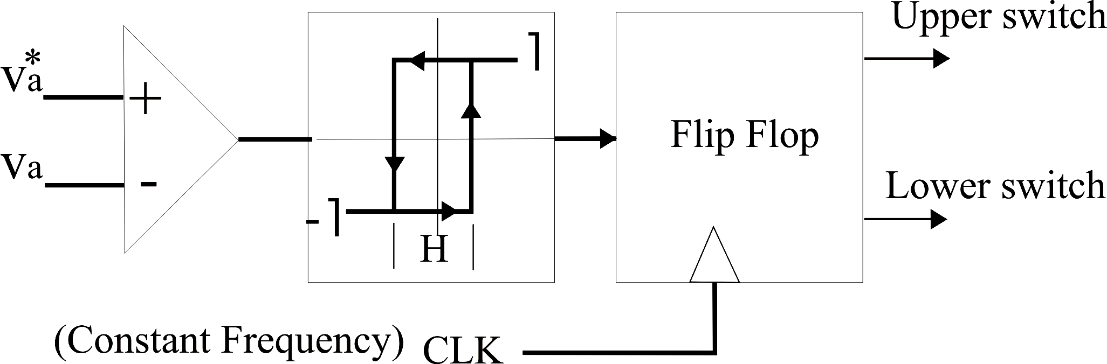

Fig. (5) Based of tolerance

On the reference waveform generation, we consider two basic points; firstly, the magnitude of the load terminal voltage should be kept constant considering an acceptable tolerance, secondly, the frequency of the load voltage should follow the frequency of source voltage, both in pre-fault and post fault conditions. During the fault condition if the frequency of the load was meaningless or unacceptable, the default frequency is the pre-fault frequency. The phase jump problem will be covered in a separate paper.
Using this algorithm, one can say that the harmonic problem is already solved to some extent. Because, it uses instantaneous values and keeps those values close to the reference waveform, regardless of harmonic components exist in the waveform. Another point is that it directly deals with phase (or line) values and no transformation (e.g. dq) is needed and since it considers each phase individually, the zero sequence and unbalance waveforms problems can be handled implicitly and easily.
On the implementation of the control strategy, it seems that a sampling rate of 128 samples per cycle or something like that is sufficient to satisfy the Niquist criterion, supposing the harmonics of order higher than 20 is ignorable. Since there is no extra transformation or more importantly, Fast Fourier Transformation (FFT) to compute harmonics (which is really memory and time wasting) besides its simple and low cost implementation, one can claim that it is real-time and the DVR can response to the events fast and online.

Simulation & Analysis
Electromagnetic Transient Program (ATP EMTP) is a well known simulator among power engineers, for its reliability, effectiveness and coincidence with practice. In this section we use this simulator to examine the performance of a DVR controlled by the mentioned algorithm, in mitigation voltage sag side effects on load.
Among possible voltage sag conditions, we have chosen three common situations:
- single line to ground fault on the parallel feeder
- symmetrical three phase fault
- voltage sag with unbalanced waveforms

1. Single line to ground fault on the adjacent feeder
As mentioned before one of the most common causes of voltage sag is the single line to ground fault on the adjacent feeder, Fig. 6 [8].
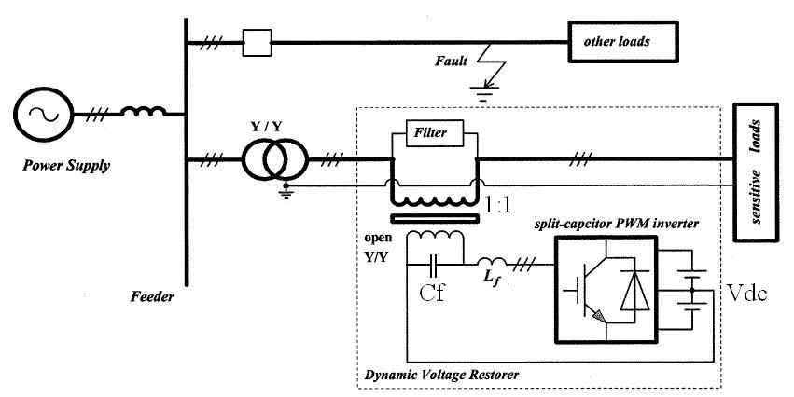

Fig. (6) Single line to ground fault

The phase A equivalent circuit of the above schematic, considering a SLG on phase A is as Fig 7:
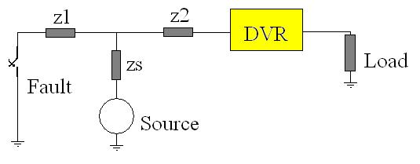
Fig. (7) Equivalent circuit

The parameter values of our simulation were as follows:
L_{f} = 50$\text{mH}$, C_{f} = 0.1$μF$, z₁ = z₂ = z_{s} = 2.5 + j2 ohm, Vdc = 150 V
Source: $\text{220}\sqrt{2}\text{cos}(ωt)$
Load: Resistive load 100 ohm
Filter: RC filter, R = 0.1 ohm, C = 0.1$μF$
An SLG fault will occur at $t=\text{83} m\text{sec}$ and will be cleared at $t=\text{125} m\text{sec}$, Fig. 8.a. As depicted, DVR responds and the load voltage is restored to the nominal value Fig. 8.b.

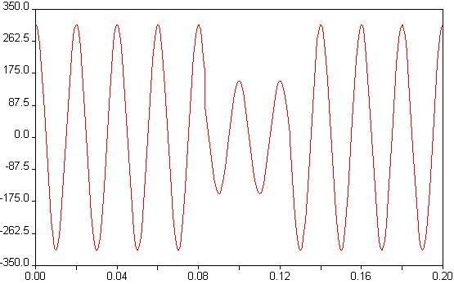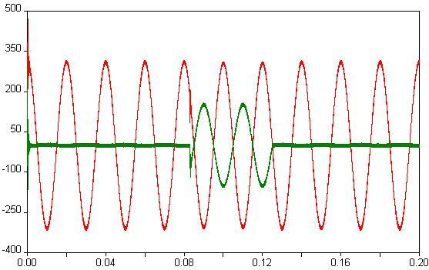
(a) (b)
Fig. (8) SLG a) Load voltage without DVR b) Load voltage and DVR injected voltage with DVR

2. Symmetrical three phase fault on the adjacent feeder

This kind of fault or voltage sag may be called as the worst case. Because all of the three phase voltages come down. We have simulated it by a circuit which its single line diagram is the same as Fig. 7. Other parameters and the fault times are the same also. The simulation results are as follows, Fig. 9.
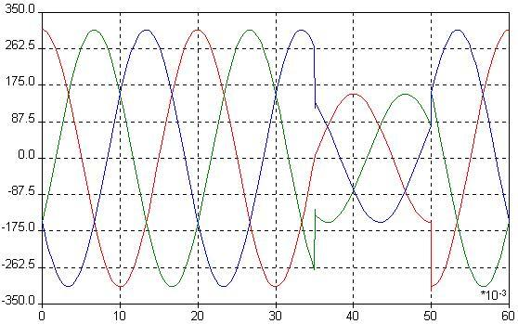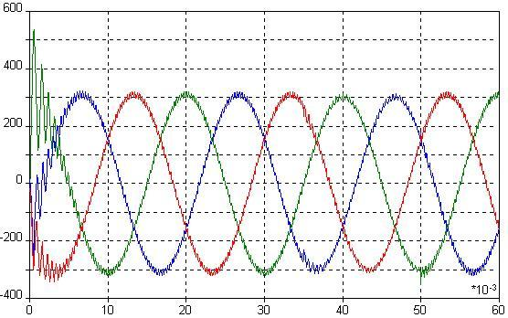
(a) (b)
Fig. (9) TLG a) Load voltages without DVR b) Load voltages with DVR

That initial disturbed waveform is due to initial condition of EMTP program and devices.

3. Voltage sag with unbalanced waveforms
In a distribution network, load terminal voltages are never ideally and perfectly balanced and one can always think about partial unbalanced condition. In this section we simulate an unbalanced voltage sag condition by a three phase to ground fault on the adjacent feeder, with different fault impedances for individual phases.
Considering Fig. 7, all other parameters are the same except $z_{1}$ which is as follows for each phase:
$$\begin{aligned}z_{1A}=2\text{.}5 \\ z_{1B}=1+j2 \\ z_{1C}=\text{10}+j2\end{aligned}$$
This condition leads to an unbalanced condition both in magnitude and phase of voltage waveforms. The load terminal voltages with and without DVR comes in Fig. 10, (a) and (b) respectively. Fig. 10.b also shows the DVR injected voltage for two phases (A and C).
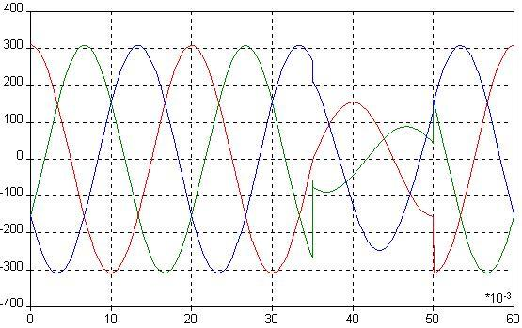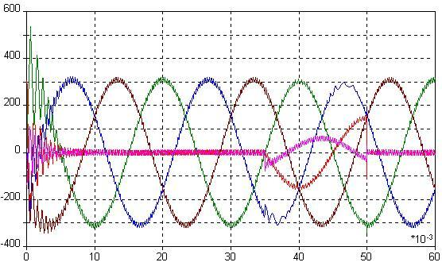
(a) (b)
Fig. (10) Unbalanced voltage sag a) with DVR b) without DVR

As it can be seen, the voltages have come to the nominal and balanced condition in a rather real time manner.

Conclusion
DVR as a member of custom power family is going to be a cost effective solution for voltage quality problems, especially voltage sag problem, as the most common event. In this paper we studied the DVR structure and performance, facing some common types of voltage sag condition, using EMTP as the simulator.
The simulation results showed that, this device can overcome the voltage quality problems, if its control algorithm works in a real time manner and also the passive filters and the other side parts and parameters have been chosen properly.

References
- S. Lee, J. Kim, and J. Choi, “A new Control Algorithm for Instantaneous Voltage Sag Corrector Using Series Compensator”
- S. J. Lee, H. Kim, S. K. Sul, and F. Blaabjerg, “A Novel Control Algorithm for Series Compensators by Use of PQR Instantaneous Power Theory”, IEEE Transactions on Power Electronics, Vol. 19, No. 3, May 2004.
- “IEEE Recommended Practice for Monitoring Electric Power Quality”, IEEE Std 1159-1995.
- E. Otadui, U. Viscarret, S. Bacha, M. Caballero, and R. Reyero, “Evaluation of Different Strategies for Series Voltage Sag Compensation”
- Juan A. Martinez, “Modeling of Custom Power Equipment Using Electromagnetic Transient Programs”
- C. Zhan, V. Kumaran R., A. Arulampuran, C. Fitzer, S. Kromlidis, M. Barnes, and N. Jenkins, “Dynamic Voltage Restorer Based on Voltage-Space-Vector PWM Control”, IEEE Transactions on Industry Application, Vol. 37, No, 6, 2001.
- “Motor Control Technology Handbook”, Analog Device Co. Publication, 1999
- C. Zhan, A. Arulampalam, and N. Jenkins, “Four-WirenDynamic Voltage Restorer Based on a Three-Dimensional Voltage Space Vector PWM Algorithm”, IEEE Transactions on Power Electronics, Vol. 18, No. 4, July 2003.

