Accuracy of air ion field measurement

Tomáš Smutný, Vítězslav Kafka, Pavel fiala
Department of Theoretical and Electrical Engineering
Brno University of Technology
Kolejní 2906/4, BRNO 612 00, Czech republic
http://www.feec.vutbr.cz/UTEE

Abstract: - An analysis of the electric state of air shows the presence of various ion sorts. The therapeutic effect of negative high-mobility ions of proper concentration is known. This positive effect was observed in caves that are used for speleotherapy. This article presents the capability of methods for measuring ion concentration and for ion spectral analysis.

Keywords: - Air ion, conductivity of air, gerdien tube

1 Introduction
Air ion concentration and composition belong to the frequently monitored parameters of the atmosphere [5]. Their influence on living organisms has been the subject of intensive studies. Earlier research has demonstrated the positive influence of light negative ions and air cleanness on human health. The Department of Electrotechnology of Brno University of Technology and the Institute of Scientific Instruments of the Academy of Sciences of the Czech Republic are involved in the research of ion field in office and living spaces. The objective is to increase the concentration of light air ions in these spaces. Another task is to set up a simulated therapy room, with conditions similar to speleotherapy caves. It sets the requirements for accurate measurement of ion field with good repeatability. The article deals with the design of gerdien tube and peripheral measuring devices. An optimal design is important for eliminating the inaccuracy of ion concentration measurement.

2 Measuring method
Several methods are currently used to measure air ion fields: the dispersion method, the ionspectrometer method, the Faraday cage method, and the gerdien tube method, whose principle is shown in Fig.1
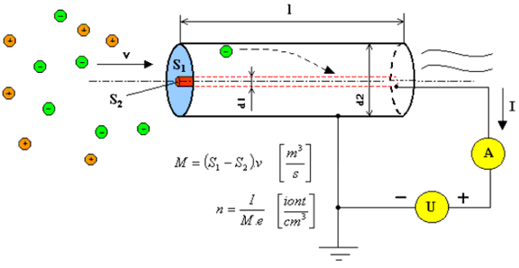
Fig. 1: Principle of gerdien tube method

d₁ – inner electrode diameter, d₂ – outer electrode diameter, l –length of gerdien tube, M – air flow volume rate, v – air flow velocity, e – elementary charge of electron, positive air particle (ion), negative air particle (ion).

The gerdien tube consists of two electrodes. There is an electric field between the inner electrode (the collector) and the outer electrode. The field is imposed by voltage source U. Air ions flow from the fan through the gerdien tube. Negative ions in the electric field impact the collector, and the current produced is measured by a pA-meter. The current measured is proportional to air ion concentration.

The model of the measuring system is shown in Fig.2. The values measured carry systematical measurement errors. This is due to leakage currents and parasitic capacitances (modeled by I_{LEAK} in Fig.2) [6]. We have to consider leakage resistances R_{AK} of gerdien tube, leakage resistances and capacitance of the pA-meter input (R_{EH}, C_{EH}, R_{EL}, C_{EL}), insulation resistance (R_{V}) of the collector voltage source. The current measured is further affected by the input resistance of pA-meter and the input resistance of voltage source (R_{U}, C_{U}).

Fig. 2: Model of a system for measuring air ion concentration – the gerdien tube method

To minimize the measurement error, R_{AK} ,and R_{V} should be much larger than R_{I}, and R_{EH}, and R_{EL} should also be much larger than R_{OUT}. Time constant R_{U}C_{U} has to be much larger than the measuring time.

3 New design of gerdien tube
The inner and outer electrodes are elliptical in shape. This shape ensures that the flow of air is laminar. Air flow turbulence can distort the accuracy of measurement. The surface of the electrodes is required to be as smooth as possible. These aspects make the design of gerdien tube quite demanding (fine grinding, lapping, etc.). The longitudinal section of the new gerdien tube is shown in Figure 3. The new design of gerdien tube is shown in Figure 4.

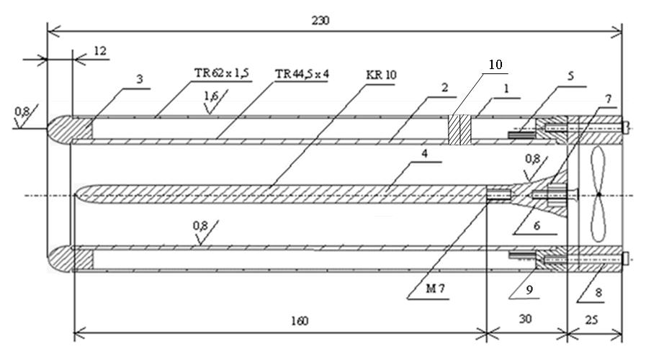

Fig. 3: Longitudinal section of the new gerdien tube

Pictures of the new design of gerdien tube are shown in Figure 4.

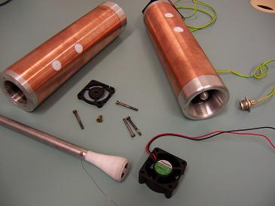
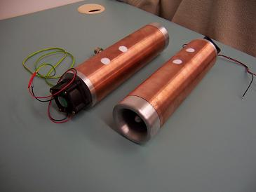
Fig. 4: New gerdien tube

Since in the measurement of air ion concentration very small currents are detected, it is necessary to eliminate the influence of ambient electric charge. The influence of magnetic fields has to be minimized too. To improve magnetic shielding, the following components were added – a permalloy band and a ferrite ring.

4 Weak current amplifier
The current flowing through the gerdien tube consists of ions. Current intensity depends on polarization voltage, on the dimension and parameters of gerdien tube, and on ion concentration. The specific current range for the designed gerdien tube is 10⁻¹⁰ A – 10⁻¹³ A.
For the following measurement it is suitable to convert the current to voltage. Because the current is very weak, it is suitable to do this near the gerdien tube. The transimpedance configuration is used for the conversion and amplification in the first stage.
The transimpedance amplifier is realized with an INA 116 opamp. The INA 116 has a very low input bias current I_{b,max} = 100 fA. The design of the amplifier is shown in Figure 5. The first stage has transimpedance R_{T} = 10 GΩ. The second stage is a variable-gain amplifier. The gain is set by resistor R_{G}. Table 1 shows the values of gain, voltage and current for various gain resistors. The resulting current-to-voltage conversion constant can be set to 0.1 – 1 – 10 pA/V.

Table 1: Amplifier parameters

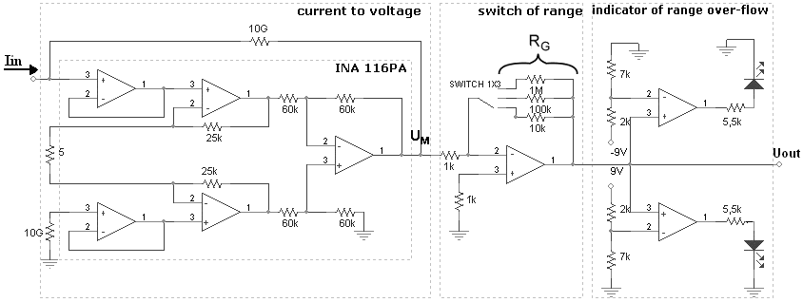
Fig. 5: Design of pA-amplifier
5 Comparison of gerdien tubes
The gerdien tube of new design was compared with two others. Gerdien tube configuration and parameters are shown in Figures 6 – 8.

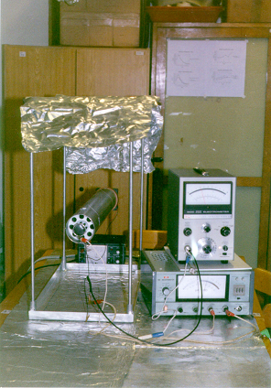
Fig.6: Gerdien tube DETE [5]

r₁ = 20 mm, r₂ = 40 mm, l = 500 mm, M = 10,62 dm³,
v = 4,3 ms⁻¹, I_{leak} = 0,4 pA @ 150V

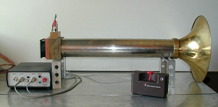
Fig.7: Gerdien tube ISI [5]

r₁ = 7,5 mm, r₂ = 41 mm, l = 500 mm, M =12,14 dm³,
v = 3,75 ms⁻¹, I_{leak} = 0,3 pA @ 150V

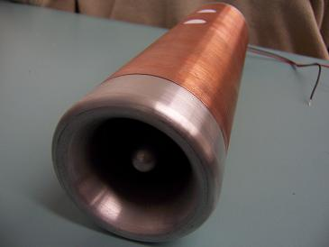
Fig.8: New design of gerdien tube

r₁ = 5 mm, r₂ = 18 mm, l = 230 mm, M = 0,75 dm³,
v = 0,8 ms⁻¹, I_{leak} = 0,05 pA @ 150V

6 Conclusion
The new design of gerdien tube and the optimization of peripheral measuring devices have minimized the systematic error of measurement. The new system allows measuring air ion concentration with a sensitivity > 100 ions/cm³. The ion mobility is in the interval 0.3 – 100 cm²V⁻¹s⁻¹. The system will be used to measure ion field distribution in living and office spaces. Very low leakage currents were achieved in the new design of gerdien tube. It allows higher sensitivity measurement. A long-term research task is to create an environment with suitable ion concentration and humidity in living spaces. The ion distribution in the environment will be simulated.

Acknowledgement
The paper was prepared within the framework of VUT Brno of the Czech Republic and with the support of the research plan MSM 262200011.

References:
[1] Bartušek, K.: Měření speleoterapeutických parametrů jeskyní pro lékařské účely. Interní text UPT AV ČR 1997.
[2] Buřival, Z.: Vliv prostorového náboje v atmosféře na znečištění vzduchu v technologických provozech. Knižnice odborných a vědeckých spisů VUT Brno.
[3] Spurný, Z.: Atmosferická ionizace. Praha. Academia 1985
[4] Puškeilerová, L.: Nové poznatky o měření volných záporných iontů v laboratorním prostředí.
Příspěvek k VŠTČ FEI. Brno 2000
[5] Israël, H.: Atmosphärische Elektrizität. Akademische Verlagsgesellschaft Leipzig 1957.
[6] Smutný, T: Vliv obvodových prvků na přesnost měření iontových polí, Diplomová práce 2004 VUT Brno
[7] Kafka, V: Saturační a spektrální charakteristika iontového pole, Diplomová práce 2004 VUT Brno

