Measurement of gradient magnetic field

TOMÁŠ SMUTNÝ, VÍTĚZSLAV KAFKA, KAREL BARTUŠEK, PAVEL FIALA
Department of Theoretical and Electrical Engineering
Brno University of Technology
Kolejní 2906/4, BRNO 612 00, Czech republic

http://www.feec.vutbr.cz/UTEE

Abstract: - Accurate knowledge of a gradient magnetic field waveform is important for the measurement of diffusion coefficients in NMR. Diffusion coefficients are determined from the decay between an MR signal affected and an MR signal not affected by gradient pulses. Therefore the waveform of the gradients is essential from the point of view of accuracy. Short ramp times, amplitude of generated gradients and symmetry of positive and negative levels (i.e. an integral of two pulses with the same amplitude and inverse polarity is zero) are desirable.

Keywords: - gradient magnetic field, MR tomography, measurement of magnetic field

1 Introduction
MR tomography requires a high precision of generated gradient magnetic field [3]. Different MR techniques are used to measure gradient field. Instantaneous frequency methods (IF – instantaneous frequency, IFSE – instantaneous frequency spin echo, and IFSES – instantaneous frequency sequence spin echo) were developed in the Institute of Scientific Instruments of the Academy of Sciences. These methods are suitable for measuring the time characteristics of gradient magnetic fields [1]. These methods eliminate magnetic vector dephasing of individual nuclei and the consequent loss of MR. These methods can of course be also used when gradient magnetic fields are generated by means of an active shield gradient system.
This system is remarkable for the small length of gradient switching time, approximately less than 1 ms. The IF methods are designed to measure accurately the falling edges of gradient impulses. A disadvantage of IF methods is that they do not enable measuring the whole waveform of gradient impulse [2].
This paper presents an MR method for measuring short magnetic gradient impulse waveform in an MR tomograph. The method is used to measure the integral of gradient magnetic pulses when measuring MR images weighted by the diffusion of the tissues measured.

2 Problem Formulation
The development and design of new impulse MR sequences for diffusion or flow speed weighted MR image require measuring the waveform of gradient impulse with a high accuracy. The basis of these methods is the use of two accurate gradient pulses with positive and negative polarization.
The difference of gradient pulse integral in positive and negative polarization causes a major error. The diffusion coefficient is not accurate. A simple MR measurement technique was developed to improve the IF method. This method is based on gradient field mapping in the active area of MR tomograph [2]. The principle is the measurement of instantaneous frequency changes of MR signal. MR signal is generated by nucleus resonance. Excited nuclei are located in a thin layer outside the centre of gradient field. The measurement sequence (Figure 1) has two phases – preliminary and active. The nuclei are excited by an RF pulse in the preparatory phase. This excitation is performed in a selected layer (gradient G_{rs} selection). The RF pulse of 4 ms duration has a bandwidth of 2700 Hz. Active selection position x_{n} is set by excitation RF pulse offset o:

$x_{n}=\frac{2π\left(f_{\text{vf}}−f_{0}\right)}{γ G_{x}} = \frac{2π o}{γ G_{x}}$ (1)

Fig. 1: Pulse sequence for gradient waveform measurement.
If the magnitude of gradient is 20mT/m, then the layer will have a width of 0.7 mm. The measurement of gradient magnetic field is changed to two measurements of the mean value of induction magnetic field in two positions (± x_{n}).

Fig. 2: Selection of exciting layers

The selection of exciting layer is shown in Figure 2. At time TE after the π/2 impulse, the non-selective π impulse is applied, which during time TE makes the spin echo with the centre at the end of set-up phase. Since due to gradient G_{rs} the magnetization vectors are dephased and the MR signal is lost, two gradient impulses G_{rs} are used which provide for rephasing the magnetization vectors at the end of the preliminary part.
After time TE the magnetization vectors of all excited nuclei have a uniform direction and are phased, and the MR signal values are maximum. During the active part of the measuring sequence it is possible to detect signal of free precession (FID) of all nuclei that are in the selected layer. If the gradient impulse in the active section of measuring sequence is not applied, then the instantaneous frequency of MR signal carries the information about the value of induction magnetic field in the excited layer.
The instantaneous frequency of MR signal is changed by the application of gradient impulses. The frequency of MR signal is proportional to the magnetic induction in the excited layer. The gradient waveform and the change in basic field can be computed on the basis of measuring the positive and the negative offset.

$G_{x}\left(t\right) = \frac{1}{2x_{n}}\left[B\left(x_{n}\text{,t}\right)−B\left(−x_{n},t\right)\right]$ (2)

$B_{0x}\left(t\right) = \frac{1}{2}\left[B\left(x_{n}\text{,t}\right)+B\left(−x_{n},t\right)\right]$ (3)

An example of measured time characteristics of gradient impulse G_{x}(t) is shown in Figure 3. The waveform of magnetic induction B₀x(t) with the G_{x}(t) gradient present is shown in Figure 4.

Fig. 3: Measured gradient G_{x}(t) waveform

Fig. 4: Waveform of basic field B_{0x}(t)in the presence of gradient G_{x}(t)

The measuring method described above is suitable for gradient field mapping [4]. Only a simple modification of the method is required. The principle of this method is to measure the mean induction value in n sections of the scanned area (Figure 5).

Fig. 5: Section location in preliminary area

The methods of selective excitation of a selected section and detection of MR signal are similar to the method of measuring the gradient field.
Section selection is set by RF pulse offset (1).

The values measured for the mapped field area are shown in XY system in Figure 5. By applying the least square method it is possible to compute the gradient and other high-order gradients. Gradient intensity at a given point can be computed from two neighbouring magnetic induction values B(x_{n}), B(x_{n1}):

$G\left(x_{n}\right) =\frac{B\left(x_{n}\right)−B\left(x_{n−1}\right)}{x_{n}−x_{n−1}}$ (4)

The described gradient distribution mapping is relatively simple. It can be performed on a standard MR tomography. This technique will be utilized for measuring the time and spatial characteristics of gradient magnetic field.

3 Conclusion
The method described above has been developed to measure the gradient impulse waveform and to determine the time integral for each impulse. Relative deviation of the first and the second integrals is 0.4%. A drawback of the method is the limited length of gradient impulses (about 5 ms). It is caused by dephasing the magnetization vectors. The main advantages of the method are its simplicity and the possibility of measuring gradient cross-talks. Further, it is possible to measure the amplitude modulation of gradient impulse waveform.

Acknowledgement
The paper was prepared within the framework of VUT Brno of the Czech Republic and with the support of the research plan MSM 262200011.

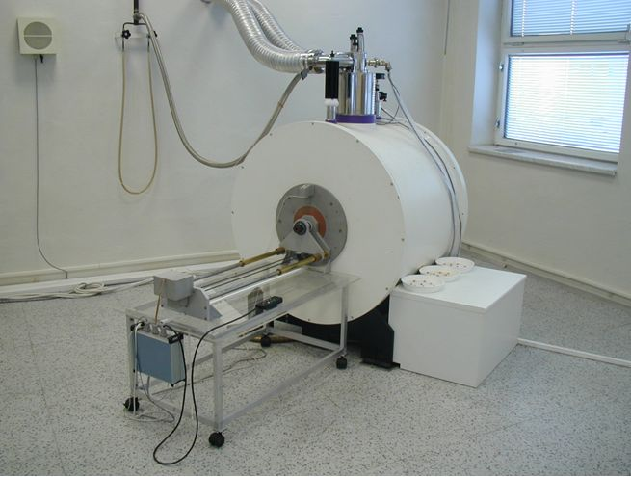
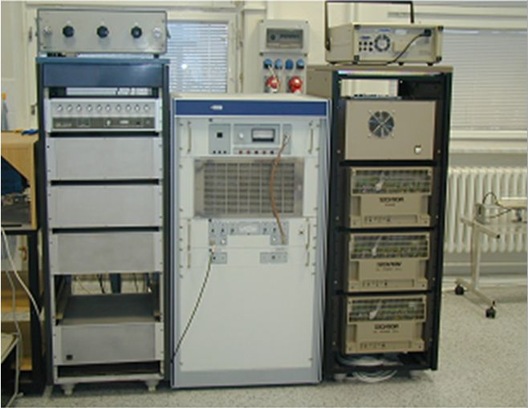

Fig. 6: Experimental MR tomography set-up

References:
[1] Gescheidtová, E., Bartušek, K. A Magnetic Resonance Measurement Technique for Rapidly Switched Gradient Magnetic Fields in a Magnetic Resonance Tomograph. Acta Polytechnica, roč. 2003, č. 4, s. 30 - 35, ISSN 1210-2709, 2003.
[2] Bartušek, K., Gescheidtová, E. Instantaneus Freguency of Spin Echo Method for Gradient Magnetic Fields Measurement on MR Systems. Journal of Electrical Engineering, roč. 53, č. 10/s (2002), s. 49 - 52 ISSN 0013-578X, 2002.
[3] Den Boer J. A., Vlardingerbroek M. T.: Magnetic Resonance Imaging, Second Edition, Springer-Verlag, Berlin-Heidelberg-New York1999.ISBN 3-540-64877-1
[4] Chanankij, J., Lefevre, J. L., BRIQUET, A.: A Method for Mapping Magnetic-Fields Generated by Current Coils. Journal of Physics 18 (12) 1985: pp. 1014 - 1017.

