An Optimization–Simulation Approach for Performance Evaluation of Cellular Layouts

K. ESWARAIAH C. S. P. RAO
Manufacturing Simulation Laboratory
Department of Mechanical Engineering

National Institute of Technology
Warangal – 506 004
INDIA

Abstract: The objective of this paper is to develop and integrate optimization and simulation tools for conversion of functional layouts into cellular layouts and to evaluate the performance measures of such Cellular Manufacturing Systems (CMS). Cellular Manufacturing (CM) applies the concept of group technology and re-configuration of the facilities in the factory. The design of CMS is a multi-objective and multi faceted problem. The paper describes the use of Genetic Algorithms, ProModel software and Excel interface with ODBC for the design of CMS. The proposed model consists of two phases. In the First phase, the existing functional layout is modeled in ProModel, and the various performance measures of the system were studied. In the second phase, the modeled layout is converted into Cellular layout using genetic algorithm optimization technique and the same is simulated in ProModel through interface module. The performance measures like material transportation times, utilization of the resources and cell utilization are compared. The test result indicates that the cellular layouts are viable alternate for effective utilization of resources and enhanced production of an organization.

Key words: Cellular Manufacturing System, Genetic Algorithm, ProModel, Functional layout, Cellular layout, Interfacing, XSUB, Excel, and Simulation.

1. Introduction
The existing global competition requires factories to be more lean and flexible and factory layout plays a vital role to meet the demands. Cellular Manufacturing is applications of Group Technology (GT) utilizes the concept of divide and conquer and involves the grouping of machines, processes and people into cells such that similar parts are processed in the same cell to improve productivity. Each cell has a certain number of machine types, with multiple machines of the same type organized into machine centers[1]. CM combines the advantages of Job shop flexibility and a flow shop’s efficiency and is considered as one of the manufacturing systems that can meet the global competitive changes. The major advantages of Cellular Manufacturing Systems (CMS) are reduced material travel time, throughput time, fewer work-in-processes, easy and systematic plant maintenance and better utilization of resources[2]. The benefits of CMS largely depend on how effectively CMS have been designed. The design of CM involves the following phases i) Grouping of parts and machines into cell [cell formation] (ii) allocation of the machine cells to areas with in the shop floor [Inter cell layout] (iii) Layout of the machines within each cell [Intra cell layout][3]. Our study focus on the integrated issues of optimization and simulation studies of Cellular Manufacturing Systems. Genetic algorithms were used to optimizing the cellular layout design and ProModel is used to study the performance evaluation of Cellular Manufacturing System.

2. Literature Survey
Atul Agarwal et. al. [1998] given a comprehensive review of studies and literature, that focus on the comparative and relative performance of Functional Layouts and Cellular Layouts[4]. They categorized the research work as the comparative performance of Cellular Manufacturing and Functional Layout system into three categories – simulation, empirical and Analytical. A. A. Assad et. al. [2003] reviewed and compared the functional and cellular layout using simulation based standardization. According to their simulation study, the conversation to cellular layouts consistently produces an advantage even in the absence of the gains resulting from lot size redefinition or lower movement or transport times[5]. Conversion of Job shops into manufacturing cells consistently improves flow time by 10 – 20%. Taj et. al. [1998] used simulation to verify the design of manufacturing cells. Flynn and Jacobs (1986) and Greene et al compare the performance of cellular and traditional system configurations[6]. Savsar (1991) describe the use simulation to generate and evaluate alternative layouts as part of a general layout design procedure. Seifoddini et. al. (1997) focused on the effect of changes in the product mix[7]. In recent work on the conversion problem from functional to cellular layouts, Shafer and Charnes (1997), and Suresh et. al. (2000) was studied on flow time reductions[8],[9]. Other works involving manufacturing cell design issues includes (Rao and Gu, 1994, Solianopoulon, 1999 and Gravel et. al. 2000).

3. Genetic Algorithm – Optimization Tool
Genetic Algorithms (GA) are random search and optimization algorithm that imitate the natural selection and biological evolutionary process. Genetic Algorithms combine the notion of survival of the fittest, random and yet structured search, and parallel evaluation of nodes in the search space[10]. GAs are able to search very large space effectively and efficiently to find the overall global optimal solutions. An initial population of individuals is generated randomly. In each generation, the individuals in the population are evaluated according to fitness function. For the next generation individuals are selected based on their fitness. New members of the population are generated by crossover and mutation operations. Each individual in the population receives a measure of its fitness in the environment. Reproduction focuses attention on high fitness individuals, thus exploiting the available fitness information. Recombination and mutation perturb those individuals, providing general heuristics for exploration. In order to speed up the convergence, the elitist strategy is employed to retain some superior individual for the next generation.

3.1 Chromosome Representation
The optimization of GA solution depends on creation of Chromosome representation and development of fitness function. Chromosome coding depends on the specific problem being addressed and commonly direct or indirect coding schemes are used to represent the string. A three-segmented cell number based chromosome representation scheme is applied in the proposed work[11]. An example of the chromosome representation is shown in Fig.1.
213
PF1135
MG1134
PF2246

MG227
PF387
MG356

Fig.1: Chromosome Representation

The first segment places the cell configuration, second segment represents the part families and third segment indicates the machines within the cell. The above Representation indicates 3 cells, 3 part families (PF) and 3 machine groups (MG). A gene in the chromosome may indicate cell number, machine number and part number. Each chromosome is a vector sum of m + p + c integer variables in the range of 1 to number of cells (N_{i}). A repair function is employed in the chromosome to ensure the following constraints.
- Elimination of duplicate machines and parts.
- Number of machines assigned to each cell does not exceed the upper limit of cell size.
- Each machine is assigned exactly to one manufacturing cell.
- Each part is assigned exactly to one part family.

3.1.1 Evaluation function
Each chromosome in the population is evaluated using some measure of fitness. A fitness value is computed for each chromosome in the population and the objective is to find a chromosome with the maximum fitness value. The fitness function used is unique for each problem. In the cell formation and layout design we consider total intercell and intracell transportation cost as the objective

3.1.2 Genetic Operation
Single point and two- point cut cross over with a probability of selection 0.6–0.8 used to create the next generation of chromosomes called off springs, on the positions of the cut points which were randomly selected in each chromosome.

3.1.3 Mutation
Mutation is performed after cross over as random perturbation. It selects a gene randomly and replaces it with in a selected segment of the chromosome. Mutation Probability considered as 0.1.

3.1.4 Selection
Selection strategy is concerned with the problem of how to select chromosomes from the population space. It may create a new population for the next generation based on either parents or off spring or part of them. A mixed selection strategy based on tournament selection and elitist selection is adopted for selection of next generation.

4. Mathematical Model

4.1 Job shop
The pure job shop utilized a functional arrangement of equipment and parts were processed and moved in batches. The Job shop is organized following a functional layout with ‘M’ machines. Each machine may have NM copies of machine types. Upon entry, each batch of part travels from one machine to the next machine following its operations sequence, until all of its operations are completed. The batch flow time is measured from part batch introduction in to the factory to part batch leaving the factory.

4.2 Cellular Manufacturing
While designing cells and plant facilities, the degree of closeness between facilities is considered. It is essential to minimize the total traveling distance of parts. In cellular manufacturing, transportation time and distance have traditionally been considered important factor in layout design. A mathematical model used to evaluate the objective function of total transportation cost and to build the simulation model[12]. Consider a manufacturing resources consists of M different machine types indexed by m = 1, 2, . . . . . M. all machines are unique and available all time at full capacity. The set of parts consists of P and indexed by i = 1, 2, . . . . . I. The parts are formed into F part families indexed by f = 1, 2, . . . . . F. f(i) denotes the family to which part i belongs. The demand D(i) for part i occurs in batches of size B(i) according to a Poisson arrival distribution with mean of D(i)/B(i). Each part ‘p’ has a unique sequence of R(i) operations. For the kth operation of part (i), where k = 1, 2, . . . . . , s(i). O(i, k) specifies the machine type required. The process time for part is t(i, k).

TC_{t} =∑_{i∈p}∑_{j∈l}(T_{i,l}×OC_{i}×TD_{i,l}+(1-T_{i,l})×IC_{i}×TD_{i,l})

OC_{i} = Intercell transportation cost of part i
IC_{i} = Intracell transportation cost of part i
OCD_{k,k} = Distance between cell k and k'
ICD_{k} = Distance within cell k.
T_{i,l} = 1 if the l^{th} and (l+1)^{th} operation of part‘i’ are operated in different cells.
= 0 otherwise
TD_{i,l} = OCD_{k,k'}, if the l^{th} and (l+1)^{th}
Operation and part ‘i’ one operated in
cells k and k' respectively.
= ICD_{k} if the l^{th} and (l+1)^{th} operations
of part type ‘i’ are operated in cell k.

5. Simulation of Plant Layout
Simulation optimization is an area that has attracted the attention of many researchers. Simulation is easy to use and understand and can provide cost-effective total system solutions to many manufacturing systems. It analyzes a system to provide information on performance changes over time and help predict likely out comes. Simulation has proven to be an extremely useful analysis tool widely used for manufacturing system design and analysis[13].

5.1 ProModel
ProModel is a simulation and animation tool of ProModel Corp.1999, designed to model manufacturing system. ProModel is a powerful yet easy to use PC based simulation tool for modeling all types of manufacturing systems ranging from JS to FMS. ProModel provides a visual representation of the various physical components of the systems and links them through routing and processing statements. Simulation model consist of system entities, input variables, performance measure and functional relational ships. The modeling elements of ProModel provide the building blocks for represents the physical and logical components of the system being modeled. The basic building blocks are: locations, entities, parts networks, resources, processing and arrivals. ProModel allows interfacing with external subroutines with DLL. The external subroutine that allows for the run-time model interfaces in XSUB. The ProModel consists of two features for analyze and optimize a model[14]. The first feature is a factorial design of experiments that reveals the effect of a change in up faction on the objective function. The second feature in a multi-variable optimization that tries various combinations of its factors to arrive at the combination that yields the best objective function value. ProModel also includes various statistical distribution types with an additional feature of direct import of data sets. The jobs shop and CMS are modeled using ProModel to identify bottlenecks and evaluate cell performances like machine utilization, Cell utilization, cycle time and WIP. Different scenarios were created where in number of machines and machine routing and layouts were varied. The schematic of work done GA as optimization tool and ProModel as simulation suit has been presented in Fig.2.
Model building
Construct layouts
GA optimization tool
Initialize population
Fitness function Evaluation
Selection of individuals
Apply genetic operators
New population
Check termination.

Factory environment
Product–part–process data, no. of machines, types of machines, capacity of machines, layout type.
Interfacing module

Import data file from GA output
No. of cells, m/c grouping,
part grouping , part sequence

ProModel
Run simulation models
Simulation results
Observe the real time behavior of different layouts and collect the statistics

Fig. 2: Optimization–Simulation Flow Chart
6. Interfacing Module
An interfaced program is developed in VC⁺⁺ to integrate the GA-based plant layout optimization tool and ProModel. ProModel provides the capability to access to external subroutine coded using VC⁺⁺/VB. The subroutines may be linked dynamically to the model and called from anywhere inside the model at runtime. The external subroutine that allows for the runtime model interfaces in XSUB. ProModel provides the necessary DLL file to interact with XSUB and controls simulation at runtime[15]. The data generated by optimization tool can be transferred to Excel and it can be fed to ProModel through XSUB routines. An Excel/Vc++ interface in what the final user will use to develop operation scenarios for system performance analysis. The user simply manipulates the input data on a spreadsheet and the input parameter transfer automatically into the simulation model when executed. Preformatted and customized output sheets are then populated with the relevant statistics from the actual simulation runs. The resource data of locations, entities, resources, process and other model constructions can be retrieved from spreadsheets using ODBC. The integrated module constructs plant model automatically for various layout-input conditions and corresponding simulation are performed in ProModel. The scheme of interfacing module developed is shown in Fig.3. Each layout model is run in ProModel with 12-replications. The output of the simulation run in the form of various reports and graphs can be viewed through Excel.

Interface Module

VC⁺⁺
GA TOOL
Problem definition

O
D
B
C

E
X
C
E
L

ProModel
Automatic
Model Building
Simulation runs
Sim runner

OUTPUT
Reports Tables
ChartsGraphs

X
S
U
B

Fig. 3: Seamless integration of optimization and simulation

7. Case study-Factory environment
A medium scale industry has been considered as the case study to demonstrate the effectiveness of the conversion of functional layout to Cellular Layouts. The organization is basically a machine tool industry and the resources are arranged in a functional layout. The existing shop floor has 20 machines and is used for production of four different products consisting 40 components. The industry is taking longer material transfer times, higher work-in-process (WIP) and low utilization of the resources.
In a significant departure from traditional cell formation input (binary data), we used production related Part-process- product data to build the model. Part routing and sequence, process time, quantity, batch size are collected from the existing environment and the layout was modeled with the following assumptions.
- The work area of the machines is rectangular in shape. Rectilinear distance is considered for calculation of Material transportation time between work centers.
- Each material handling device carries only one part at a time.
- The parts batch arrival rate and queue discipline are assumed as Poisson distribution and first-come first-serve [FCFS] respectively.
- Machines are 100% available at all times.

7.1 Input module

The Basic Product-Part-Process resource information data of the problem is given Table 1 includes number of parts, routing, part sequence, and quantity of each part. Table 2 denotes the machine particulars like machine types, machine dimensions and Capacity of machines in minutes. Table 3 Denotes GA parameters like number of cells, Min. no. of machine in a cell, maximum number of machines in a cell, Pop_size, Prob_Crossover, prob_mutation and, No of _gen.

7.2 Output module
The functional layout model is shown in Fig.4. Simulation is carried under warm up period and actual run period, and the corresponding performance measures, location states and utilization reports are shown in Table 4, Table 5 and Table 6 respectively. The results from the functional layout are given to the Genetic algorithm optimization tool, which generates feasible cellular layouts and is given as input to the ProModel through the interfacing module. All the feasible layouts are simulated in ProModel one such a layout is shown in Fig. 5 and the corresponding performance reports are shown in Table 7. The feasibility of the solutions are observed in simulation using ProModel and if the solution is infeasible it is discarded and the iterative procedure continues until the constraints and objective criteria are satisfied and finally the system arrives at an optimal Cellular layout.

Prt.no Route No. ops Sequence Qty
1 1 4 19 11 16 20 0 4
2 1 2 5 20 0 1
3 1 3 3 4 6 0 4
4 2 5 8 10 12 17 20 0 2
5 1 3 3 4 5 0 3
6 1 3 1 5 20 0 4
7 2 3 18 19 20 0 2
8 1 4 3 4 6 17 0 8
9 1 5 3 5 9 17 20 0 6
10 1 3 11 7 12 0 1
11 2 4 11 4 11 17 0 2
12 1 4 10 11 16 13 0 2
13 1 3 5 6 10 0 4
14 1 4 11 15 16 19 0 2
15 1 4 17 20 21 18 0 2
16 1 2 14 18 0 2
17 2 4 1 2 5 20 0 8
18 1 4 2 3 14 18 0 8
19 1 5 11 12 15 16 19 0 6
20 1 3 6 7 10 0 3
21 1 1 12 0 2
22 1 3 11 7 10 0 3
23 2 2 1 20 0 7
24 2 3 18 19 20 0 6
25 1 6 3 5 6 4 8 9 0 1
26 1 3 10 12 17 0 6
27 1 4 3 4 5 17 0 8
28 1 5 5 6 9 10 20 0 5
29 1 4 3 4 5 22 0 6
30 1 4 11 15 16 9 0 6
31 1 3 10 12 17 0 4
32 1 5 1 7 8 17 20 0 9
33 2 5 2 4 11 4 18 0 5
34 1 3 1 8 17 0 5
35 2 3 10 11 17 0 2
36 1 4 10 11 14 17 0 1
37 1 6 1 2 4 7 8 9 0 1
38 2 4 1 4 7 9 0 3
39 1 6 1 4 7 4 8 7 0 3
40 1 4 3 4 6 17 0 8

Table 1: Product–Part–Process Data

m/c | 1 | 2 | 3 | 4 | 5 | 6 | 7 | 8 | 9
Length | 2 | 1 | 2.5 | 1 | 1 | 2 | 1.5 | 1 | 2
Width | 1 | 2 | 1 | 1 | 1.5 | 1 | 1 | 1.5 | 1
No. m/c | 1 | 1 | 1 | 1 | 1 | 1 | 1 | 1 | 1
capacity | 400 | 380 | 420 | 400 | 380 | 380 | 420 | 400 | 420

m/c | 10 | 11 | 12 | 13 | 14 | 15 | 16 | 17 | 18
Length | 2 | 2 | 2.5 | 2 | 1.5 | 2 | 2 | 2 | 3
Width | 1 | 2 | 1 | 1 | 2 | 1 | 2 | 1 | 2
No. m/c | 2 | 1 | 1 | 1 | 1 | 1 | 1 | 1 | 1
capacity | 360 | 420 | 400 | 400 | 360 | 380 | 400 | 420 | 420

Table 2: Machine Particulars Data

Nc | Mnmc | Mxmc | Pop_size | Prob_cr | Prob_mt | Ngen
4 | 2 | 6 | 50 | 0.8 | 0.1 | 20

Table 3: GA Parameters

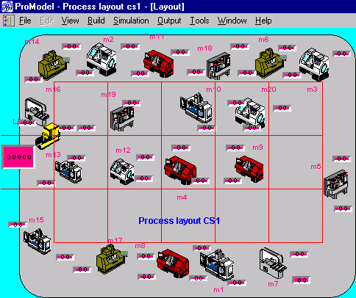

Functional Layout

Fig. 4: Functional Layout

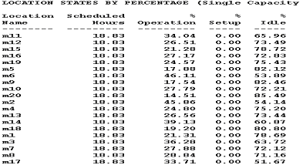

Table 4 :The location states by percentage

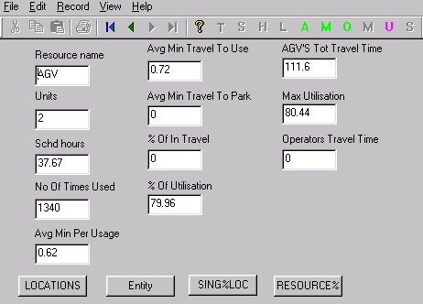
Table 5 Locations states of machines

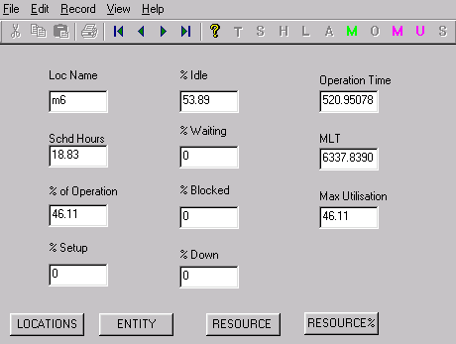
Table 6: Resources Utilization

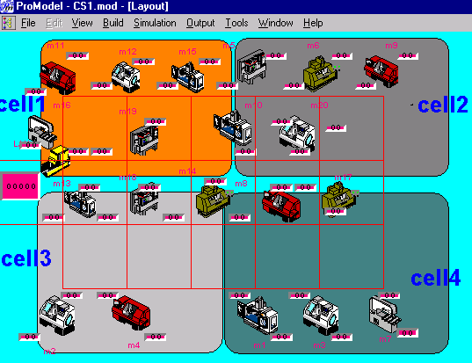

Cellular Layout
Fig. 5: Cellular Layout in ProModel

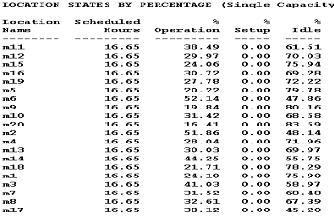

Table 7: Locations states m/cs in CMS layouts

8. Results and Conclusions
- An Integrated GA Optimization simulation tool is developed for conversion of functional layouts into cellular layouts.
- An Excel interfacing with ProModel using XSUB routine has been developed and used for Simulation of a manufacturing system to understand the performance and to elimination of the bottlenecks.
- The results obtained from simulation runs for above case study was analyzed and compared with initial functional layouts. Flow process time and total material handling time are reduced by 30% in cellular layouts. Average machine utilization is improved by 13% in cellular layouts.
- During simulation studies it is found that cellular layouts are performing better with minimum material handling cost over the functional layouts
- It was observed from the simulation results that, as the number of cells were increased the inter cell transportation cost increased.

References

- Heragu S. S. and Kakuturi S. R, Grouping and placement of machine cells, IIE Transactions, 29, 1997, 561-571.
- Wemmerlov, U. and Hyer, N. L., Cellular manufacturing in U.S. industry – a survey of users, International Journal of Production Research, 27(9), 1989, 1511-1530.
- Singh, N and Rajamani, D, Cellular manufacturing systems: Design, planning and control, Chapman & Hall, London, 1996.
- Atul Agarwal et. al., A review and analysis of comparative performance studies on functional and cellular manufacturing layouts, Computers and Industrial Engineering, Vol.34, No.1, 1998, pp.77-89.
- Assad. A. A et al., Comparing functional and cellular layouts: a simulation study based on standardization, International Journal of Production Research, Vol.41, No.8, 1639-1163.
- Flynn, B. B. et al, A simulation comparison of group technology with traditional job shop manufacturing, International Journal of Production Research, 24(5), 1986, 1171-1192.
- Seifoddini.H et al., The threshold values of a quality index for formation of CMS, International Journal of Production research, Vol.34, No.12, 3401-3416.
- Shafer, S. M. and Charnes, J. M., Cellular versus functional layouts under a variety of shop operating conditions, Decision Sciences, 24(3), 1993, 665-682.
- Suresh, N. C., Partitioning work centers for Group Technology: analytical extension and shop-level simulation investigation, Decision Sciences, 23(2), 1992, 267-290.
- Goldberg, D, Genetic algorithms in search, optimization and machine learning, (Reading, M A: Addison Wesley), 1989.
- Evelyn C. Brown et. al., CF-GGA: a grouping genetic algorithm for the cell formation problem, International Journal of Production Research, Vol39, No.16, 3651-3669, 2001.
- Su. C.T et. al., Multi-objective machine part cell formation through parallel simulated annealing, International Journal of Production Research, Vol.36, No.8, 2185-2207.
- Jerry Banks and John S. Carson, Discrete event system simulation, Prentice Hall, New York, 1992.
- ProModel-Users Manual, ProModel Corporation, USA, 1999.
- Harriet Black Nembhard, Integrating discrete-event simulation with SPC charts, Proceedings of WSC, 2001.

