Modeling of Tube Heat-Exchangers

LUDĚK ČERNÝ, FRANTIŠEK ZEZULKA, ONDŘEJ HYNČICA
Department of Control and Instrumentation
Brno University of Technology
Kolejní 4, Brno
CZECH REPUBLIC
http://www.feec.vutbr.cz

Abstract: This paper presents a model of tube heat exchanger developed for the purpose of on-line diagnostics. The model combines simple set-up, tuning and low computation needs with sufficient accuracy. Basic principles of the modeling and structure of the model is described and a more detailed analysis of important parameters and physical constants influencing the heat transfer is given. The resulting model was extensively tested against real process data. Here the results of steady-state comparison with real data are presented.

Key-Words: Mathematical modeling, heat exchangers, heat transfer, finite volumes

1 Introduction
Heat exchangers are devices designed to transfer heat between two flowing media. For many industrial processes the heat exchangers are the key components of the technology. Their proper operation cannot be easily monitored and this often makes maintenance planning problematic. The wide use of the heat exchangers and need for their diagnostics makes it important to have reference models for the purposes of monitoring.
The available models used for designing and selecting heat exchangers either focus on modeling of several parameters or model the steady states only [5]. For these reasons the existing models are usually too simple or too specific to be used for on-line diagnostics [1]. There should be mentioned existing and detailed models based on finite elements modeling that are very accurate, but they are complex and cannot be easily generalized. The model described here tries to combine simple set up and tuning of the model, simple computation and general use for a class of heat exchangers with sufficient accuracy.
According to the arrangement, four main types may be distinguished: recuperative, regenerative, contact and mixing. The most common are the recuperative exchangers, where both media are separated by the heat transfer surface. They are used especially in heat distribution network, building air conditioning and industrial applications. The usual media are water, air, steam and oil. The relative movement of the media enables distinguishing parallel-flow, counter-flow, cross flow and combined flow heat exchangers [3].
The different possible types of construction, arrangements or principles of the heat transfer bring very wide variety of various heat exchangers. It is possible to have only one general model of heat exchanger, but it appeared that the construction has great effect on the properties and function of the exchanger. Therefore were developed different models for the principal heat exchanger constructions: shell and tube, plate and water heater.
The models are built using the mathematical-physical modeling. The heat exchanger is divided into elementary finite segments what enables transforming the original partial differential equations into set of ordinary differential equations, using the “finite volumes method”. The advantage of this approach is it can be used for a wide range of working conditions, limited only by the range where the implemented physical equations and constants are valid (e.g. below the boiling points of the fluids, etc.). The models built as transfer functions or static models can be usually used for a certain working point only.
In this paper is described the concept of modeling and important parameters for a tube (shell and tube) heat exchanger.

2 Mathematical Model Description
The tube heat exchangers are used in applications where the demands on high temperatures and pressures are significant. Also the tube heat exchangers are employed when the fluid contains particles that would block the channels of a plate heat exchanger.
The tube heat exchanger consists of bundle of pipes located inside a shell. The primary fluid (usually) goes through the pipes, while the secondary fluid goes through the shell. The walls of the tubes realize the heat transfer surface.
Several different processes transfer heat in the heat exchanger. It is conduction where the heat is being transferred among individual particles by their direct contact and the heat convection where the heat is transferred by moving particles. The convection is always attended by heat conduction. The heat transfer by radiation occurs for higher temperatures and is not considered here.
The convection is mainly realized by the flow of the media, in the direction of the flow. The conduction happens through the heat-transfer surface and across the flowing media.

2.1 Model Definition
The modeling is based on the equality between the heat disposed by the hot fluid and the heat accumulated in the wall and gained by the secondary fluid. The accumulation of the heat in the wall, although included in the model, will be left out the simplified description given here. The model of the heat transfer through the wall is a basic task and is not important for the HE model definition. But it should be noted that the accumulation of heat has significant effects on the model dynamics.
The heat power disposed by the hot fluid is equal to the heat power absorbed by the cold fluid. Both are equal to the heat power going through the wall (without accumulation here). Because of the convection in the direction of the flow, the temperatures and therefore the heat transfer differs along the heat transfer surface. Writing the equation for the temperatures along the surface ends with two partial differential equations, for hot and cold side (and a third one for the wall accumulation).

Fig.1 The temperature profile segmentation

To solve the equations the heat exchanger is divided into elementary segments where the fluid temperature is considered to be the same (Fig.1). Calculation of heat transfer over one dx then yields segment:

$\begin{aligned}c_{1}\text{.}ρ_{1}\text{.}S_{1}\text{.} \text{dx}\text{.}\frac{{\text{dT}}_{\text{12}}\left(t\right)}{\text{dt}}=c_{1}\text{.}M_{1}(t)\text{.}\left(T_{\text{11}}(t)−T_{\text{12}}(t)\right)−k\text{.}\text{dx}\text{.}ΔT\left(t\right) \\ c_{2}\text{.}ρ_{2}\text{.}S_{2}\text{.} \text{dx}\text{.}\frac{{\text{dT}}_{\text{22}}(t)}{\text{dt}}=k\text{.} \text{dx}\text{.}ΔT\left(t\right)−c_{2}\text{.}M_{2}(t)\left(T_{\text{22}}(t)−T_{\text{21}}(t)\right)\end{aligned}$(1)

Where c are the specific heat capacities of the fluids, M are the mass flow rates of the fluids, $ρ$ are the densities of the fluids, S are the cross-sections of the segments. $ΔT$ is the mean temperature average and k is the overall heat transfer coefficient for the given segment.
This modification leads to system of ordinary differential equations, according to the number of segments, which can be easily solved.
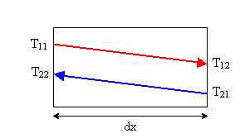
Fig.2 Temperatures over one segment

The heat passed through the wall depends on the average temperature difference on hot and cold side. The temperature is calculated from the temperatures of the fluids in one segment, using either linear or logarithmic average. The logarithmic average is more accurate, but with decreasing length of the segments, the difference is disappearing.
$ΔT=\frac{T_{\text{11}}−T_{\text{22}}+T_{\text{12}}−T_{\text{21}}}{2}$ (2)

${ΔT}_{\text{log}}=\frac{T_{\text{11}}−T_{\text{22}}−T_{\text{12}}+T_{\text{21}}}{\text{ln}\left(\frac{T_{\text{11}}−T_{\text{22}}}{T_{\text{12}}−T_{\text{21}}}\right)}$ (3)

The most important parameter in the equation (1) is the heat transfer coefficient k. The k coefficient for a cylindrical shell can be calculated according to [3, 4]:

$k_{\text{pipe}}=\frac{π}{\frac{1}{α_{1}⋅d_{1}}+\frac{1}{α_{2}⋅d_{2}}+\frac{1}{2\text{.}λ_{w}}\text{ln}\frac{d_{2}}{d_{1}}+\frac{R_{1}}{d_{1}}+\frac{R_{2}}{d_{2}}}$ (4)

Where λ_{w} is the heat conductivity of the tube wall, $d_{1}$ and $d_{2}$ is the internal / external diameter of the tube and R₁ and R₂ is the internal / external heat resistance of fouling.
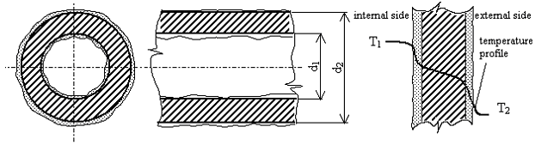Fig. 3 Cylindrical shell with fouling

The coefficients $α_{1}$ and $α_{2}$ describe the heat transfer between the flowing fluid and the wall surface. They depend on many different parameters where many of them can be hardly estimated. This applies especially to the temperatures and properties of the flow near the surface.
For the calculations can be used the empirical dimensionless Nusselt’s number Nu. Basically the Nusselt’s number is expressed with the Reynold’s and Prandtl’s number. The Reynold’s number Re indicates the relative significance of the viscous effect compared to the inertia effect and is linked to the properties of the flow. The Nusselt’s number depends heavily on the type of flow in the fluid. The type of flow can be indicated by the Reynold’s number. For low values of the Reynold’s number the flow is laminar, followed by a transient area and turbulent flow area. For each of the areas different approximations of the Nu on Re dependency are applicable. Nu calculations selected (based on the simulation results evaluation and literature search) for the model are:

1. Laminar flow inside a tube:
$\text{Nu}=\left(3,\text{65}+\frac{0,\text{19}{\left(\text{Re}\text{.}\text{Pr}\frac{d}{l}\right)}^{0,8}}{1+0,\text{117}{\left(\text{Re}\text{.}\text{Pr}\frac{d}{l}\right)}^{0,\text{467}}}\right){\left(\frac{η}{η_{w}}\right)}^{0,\text{14}}$ (5)

2. Turbulent flow inside a tube:
$\text{Nu}=0,\text{037}\left(1+{\left(\frac{d}{l}\right)}^{\frac{2}{3}}\right)\left({\text{Re}}^{0,\text{75}}−\text{180}\right){\text{Pr}}^{0,\text{42}}{\left(\frac{η}{η_{w}}\right)}^{0,\text{14}}$ (6)

3. Laminar flow around tubes (inside of the shell):
$\text{Nu}=0,\text{664}\text{.}{\text{Re}}^{0,5}{\text{Pr}}^{\frac{1}{3}}$ (7)

4. Turbulent flow around tubes (inside of the shell):
$\text{Nu}=0,\text{037}\text{.}{\text{Pr}}^{0,\text{43}}{\text{Re}}^{0,8}{\left(\frac{\text{Pr}}{{\text{Pr}}_{w}}\right)}^{0,\text{25}}$ (8)

Where d is the internal flow segment diameter, l is the segment length. η is the dynamic viscosity for the mean fluid temperature, η_{w} for the wall temperature. Pr_{w} is Prandtl’s number calculated for the wall temperature.
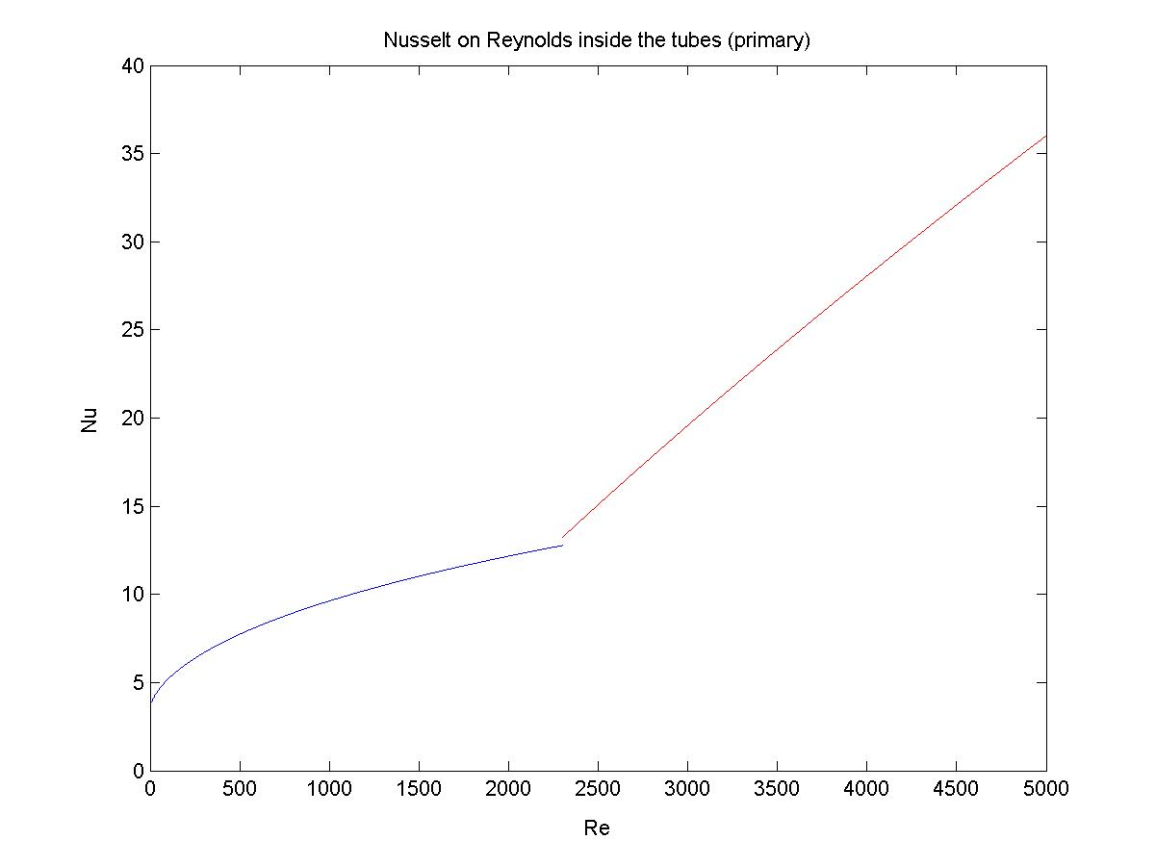
Fig.4 The calculated Nu dependency on Re

The resulting dependency of the Nu on the Re for the primary side is shown in the Fig.4. The illustrated area covers laminar and partially the transient area of flow. In this graph is not shown the temperature dependency of the Nusselt’s number. In the calculation of Re and Pr is hidden a lot of parameters. Significant influence has the dynamic viscosity, thermal conductivity and the specific heat capacity of the fluids. These physical constants are heavily temperature-dependant and as a result the Nu (and therefore the $α$ coefficients) changes with flow and temperature.
The accuracy of the model comes in first place from the accuracy of the estimation of the heat transfer coefficient. The calculation based on the Nusselt’s number is simple and general, but with unknown accuracy. There are available other methods, but it either requires a much more detailed modeling of the heat transfer process or depends on identification or approximation based on measured data. One possible approach to simplify the heat transfer coefficient calculations is approximation of $α$, for example:
$α_{2}=\text{190}{\left(\frac{M_{2}}{0\text{.}\text{4159}}\right)}^{0\text{.}8}$ (9)

Where the $M_{2}$ is the mass flow rate in the secondary circuit. Instead of the mass flow, the Reynold’s number may be used. The equation does not take into account the temperature dependency of and therefore is applicable only for a limited range of temperatures.
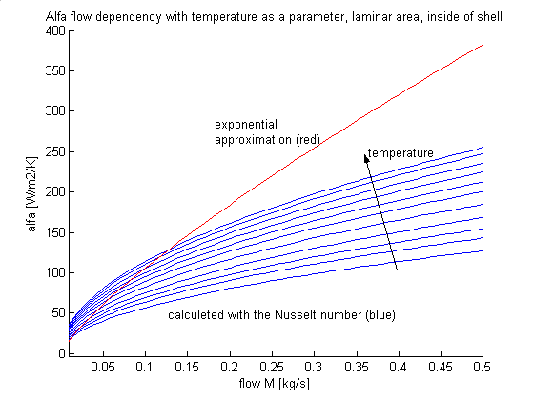
Fig.5 The $α$approximated and calculated with Nu

The difference between the $α$ approximated and calculated using the Nu is illustrated in Figure 5. The verifications have shown that the approximation can be only used for a limited range of flows and temperatures around a selected working point. The results close the working point are then better than with the Nu calculation. The Nusselt’s number approximation can give better results over larger range of flows and temperatures, but the disadvantage is in selection of the appropriate equations. However, in the model is used the Nu calculation, because the model can be set up only with physical constants for the given materials and fluids and no approximation tuning is needed. Provided this advantage the model can be applied to monitoring of an exchanger that is already in operation (no information of its characteristics when it was new is available).
Having the equations for the elementary segment, the model is constructed by combining the segments. The output temperature in on segment becomes the input temperature in the following segment.

2.2 Important Parameters Summary

Several observations from the model evaluations are listed below.
Convection in the fluids is necessary in principle. Conduction from fluids to wall is necessary in principle. Conduction through wall is not necessary, but improves dynamics (no effect on steady state, as the k coefficient includes heat transfer properties of the wall). Conduction across the fluids (the temperature profile in the fluid across the tube) was not considered important and was not implemented or tested. Conduction from the shell to the outside environment - dissipation of the heat from the exchanger, is not important for the modeling principle. Flow modeling was not done. In the model only the kind of the flow is estimated, based on the local value of the Reynold’s number. For more accurate Nu approximations is needed to take into account the detailed properties of the flow near the surface. The k calculation is done locally for each segment. Principal is the calculation of $α$ based on the Nusselt’s number equations. 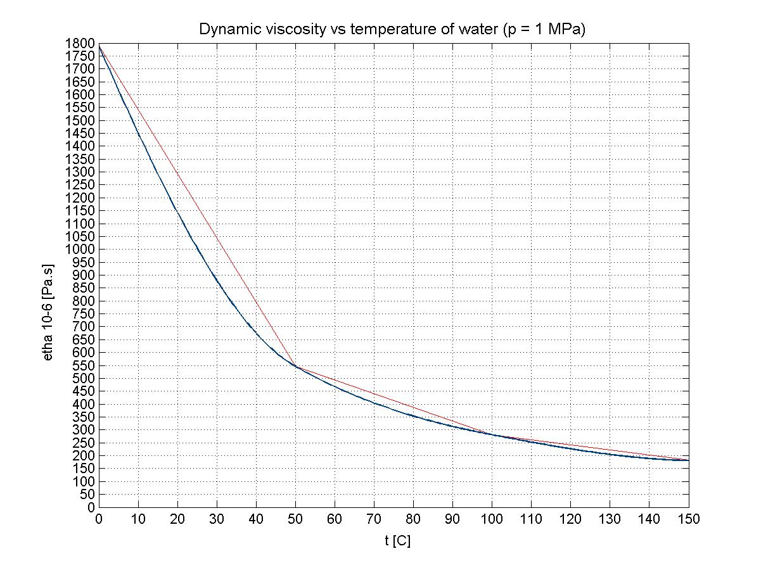
Fig.6 The approximation of the dynamic viscosity temperature dependency

It was seen that for the fluid constants is important their temperature dependency. For which constants the temperature correction is not needed depends on the fluid. For example for water this applies particularly to dynamic viscosity and thermal conductivity. For oil it is in addition density and specific heat capacity. In the model these constants are being updated for each of the segments according to the mean temperature. For example how the dynamic viscosity temperature dependency is approximated in the model see Fig.6.
For exact calculation of the Nu is required the temperature of the wall surface. This value can be hardly estimated, especially when the fouling needs to be taken into account. In the model is used only the mean temperature between the mean temperatures of the wall and the fluid.

2.3 Model implementation
The model, coming from the principles described above is implemented in the Matlab/Simulink. The equations for each segment (1) are implemented as one block, the heat exchanger is then combination of several these blocks. The calculation of the k is integrated inside each of these blocks and is calculated based on the local temperature values and the local constant values of Nu.
The block architecture enables to construct parallel flow or counter flow models only by changing the interconnections. The number of blocks used gives the accuracy of the approximation in the x direction. The temperature profile along the heat transfer surface can be monitored by observing the temperatures in the individual blocks. Example of the Simulink model with five segments in counter flow configuration is shown in Fig.7.

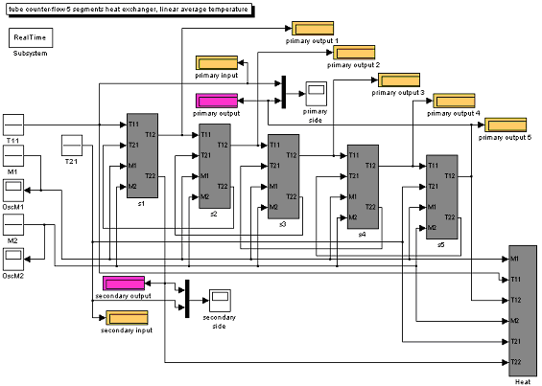
Fig.7 Example of the Simulink model with five segments in counter flow configuration

The Simulink is used as a tool for solving the equations and also for online evaluation of data measured in a real process. It includes the overall k estimation and a power monitor.

3 Results
The first principal evaluation of the model has been done on static data for steady states of a tube water-water heat exchanger, intended for heating applications [2]. The exchanger consists of a bundle of 14 straight, grooved pipes in a shell of a length 1.9 m. This segment is used twice, forming virtually one 3.8 m long tube exchanger. The exchanger arrangement is shown in Fig. 8. The Table 1 lists properties of the exchanger.

Fig.8 Arrangement of the tested exchanger

Table 1 The VV-1RH/R1 water-water heat exchanger
The exchanger properties
One-pass length (2 passes) | 1,9 m
Internal shell diameter | 0.1 m
Number of internal tubes | 14
Internal diameter of a tube | 11 mm
External diameter of a tube | 16 mm
Tube wall conductivity | 283.8 W.m⁻¹.K⁻¹
Properties of media (water)
Specific heat capacity c₁ | 4232 – 4374 J.kg⁻¹.K⁻¹
Density $ρ_{1}$ | 999 – 958 kg.m⁻³
Thermal conductivity $λ_{1}$ | 0,60 – 0,68 W.m⁻¹.K⁻¹
Dynamic viscosity $η_{1}$ | 1,4 – 0,18 .10⁻³ Pa.s

The manufacturer of the heat exchanger defines nominal values of flows for certain temperature profiles. From the possible combinations were six working points selected and used in the evaluations. The following table lists the working point definitions.

Table 2 The Working point parameters
Working point | T₁₁ [°C] | T₂₁ [°C] | M₁[kg.s⁻¹] | M₂[kg.s⁻¹]
1 | 130 | 45 | 0.63 | 4.41
2 | 130 | 70 | 0.87 | 1.74
3 | 110 | 45 | 1.64 | 7.41
4 | 150 | 45 | 0.55 | 4.98
5 | 150 | 70 | 0.78 | 2.35
6 | 130 | 45 | 1.24 | 8.12

The model was then set up provided the geometrical and material information from the manufacturer and the physical constants for water. The model was run with the nominal flows and temperatures and the output temperatures, k coefficient and power were compared. Brief results are listed in the tables 3 and 4.

Table 3 The output temperatures simulation results
 | T12 |  |  | T22
wp | table | model | error | table | model | error
1 | 60 | 63 | 5,0% | 55 | 55 | 0,0%
2 | 90 | 93 | 3,3% | 90 | 89 | 1,1%
3 | 65 | 66 | 1,5% | 55 | 55 | 0,0%
4 | 60 | 63 | 5,0% | 55 | 55 | 0,0%
5 | 90 | 93 | 3,3% | 90 | 89 | 1,1%
6 | 65 | 67 | 3,1% | 55 | 55 | 0,0%

The parameter carrying the most information about the exchanger is the coefficient k. From the model is calculated the overall k coefficient as the average of the coefficients from the segments. The power of the exchanger is calculated from the temperature difference and the mass flow rate for each of the fluids.

Table 4 The k coefficient and power simulation results
 | k |  |  | Q
wp | table | model | error | table | model | error
1 | 4949 | 4479 | 9,5% | 185 | 179 | 3,2%
2 | 5075 | 4334 | 14,6% | 147 | 136 | 7,5%
3 | 8967 | 8390 | 6,4% | 311 | 301 | 3,2%
4 | 4809 | 4330 | 10,0% | 209 | 202 | 3,4%
5 | 5425 | 4767 | 12,1% | 198 | 186 | 6,1%
6 | 8169 | 7664 | 6,2% | 341 | 331 | 2,9%

To observe the influence of the fouling was modeled a 0.5 mm layer of fouling deposit in the secondary circuit. The simulation results for the coefficient k comparing the table-given values, the simulation results and the simulation with the fouling layer is presented in Fig. 9. The same simulation results, but showing the secondary output temperature is shown in Fig.10.

3.1 Simulation Results Summary
According to the results of verification can be summarized that the model based on the introduced modeling principles behavior corresponds well to a real exchanger behavior. The model follows the real data well, but with error in dynamics. The model is sufficiently accurate only for a limited range of conditions, as the calculations of the coefficients α are defined as approximations. Empirically was seen that these limits are in the range of Reynolds number that was estimated to be Re = 500…1500.
The principal part of the model that has the biggest importance is the calculation of the k. The properties of the flows are included in the k via the coefficients α.
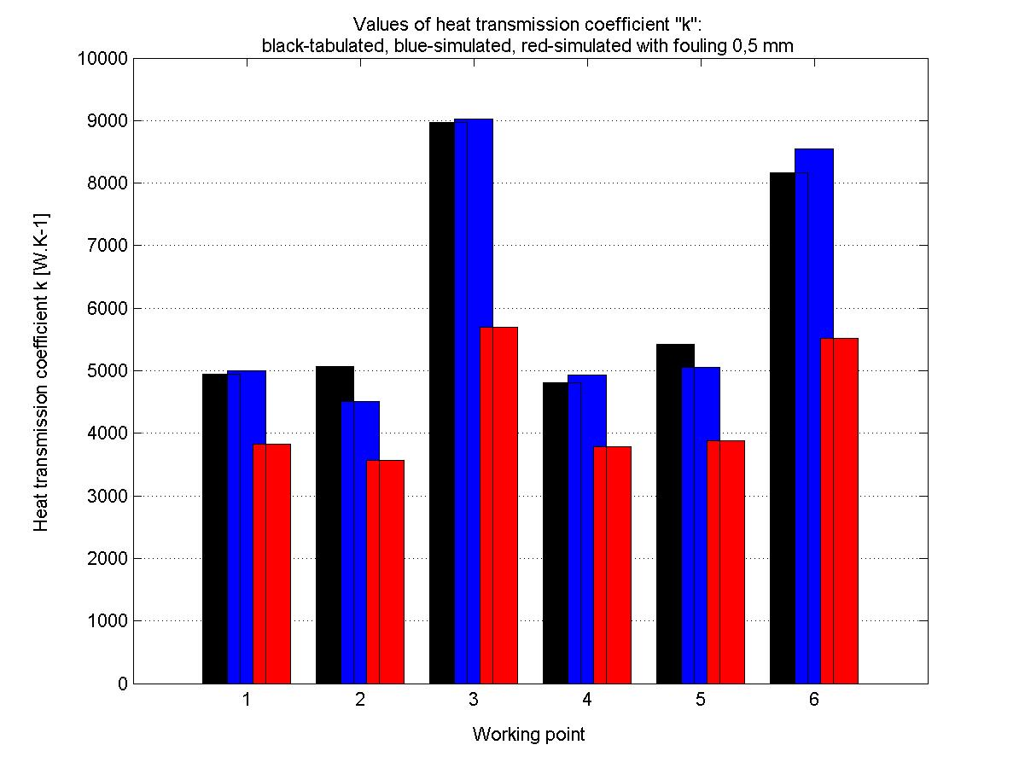
Fig. 9 Real, simulated and simulated with 0.5 mm fouling heat transfer coefficient k

Values of these coefficients are significantly dependent on the characteristics of the flows, which are hard to find. The model exhibits a considerable error in the k estimation that can be as high as 20 %.
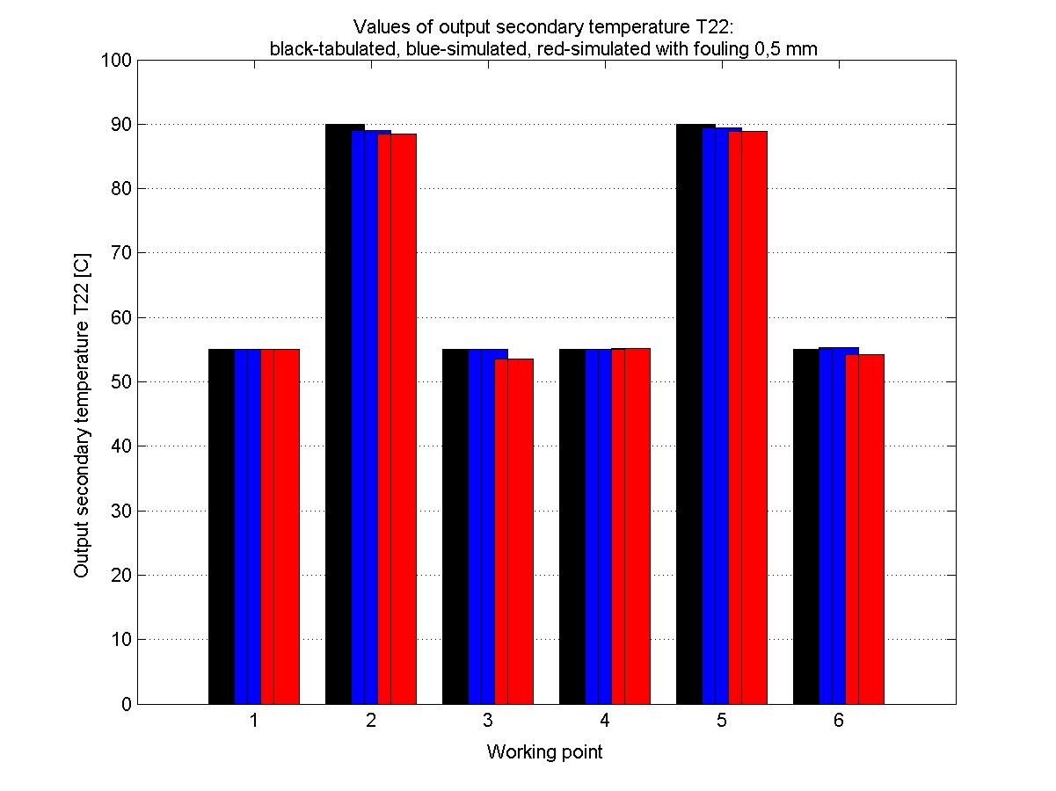
Fig. 10 Real, simulated and simulated with 0.5 mm fouling secondary output temperature T₂₂

It should be noticed, how small is the effect of the massive fouling of 0.5 mm on the secondary output temperature, seen in Fig. 10. It can be easily seen that although the k coefficient is changing with the fouling significantly, the effect of the fouling on the output temperature is very small.
The dynamic process data tests and results cannot be shown, as they are property of a third party.
4 Conclusion
The paper presented a model of the tube heat exchanger based on the mathematical modeling of the physical processes of the heat transfer. Following the principles described in this paper was developed a model and implemented in Matlab/Simulink. The model was tested against nominal values obtained from a HE manufacturer as well as using dynamical measurements data. The model corresponds principally well with the real heat exchangers behavior, but has a considerable error in estimating the k coefficient value , which makes it questionable for the use as a diagnostics reference. On the other hand, the error in the outgoing temperatures estimate was quite small in the tests (5% and less, even if the k error is up to 20%). This can be a promising result to use the model as a reference or prediction for the operators.
The described modeling approach is easily implemented and set up. However, the model this simple and general can not be directly applied for the intended application in diagnostics and more specific and detailed approach needs to be taken.

References:

[1] Hanuš, B., Olehla, M., Modrlák, O. Číslicová regulace technologických procesů, Vutium, 2000
[2] Dvojčlánkový výměník tepla voda-voda, VV-1 RH/R1, VV-1 RH/R2, Ocelové konštrukcie Žilina š.p., 1990
[3] Cikhart, J., Polanský, A. Výměníky tepla v tepelných sítích, SNTL Praha, 1976
[4] Sazima, M., Kmoníček, V., Schneller, J. et al.. Teplo, SNTL Praha, 1989
[5] Kakac, S., Liu, H.: Heat Exchangers, CRC Press, 2002, ISBN 0-8493-0902-6

