Embedded Adjust System for a Pilger Mill

PAVEL KUČERA^{I}, PAVEL FOJTÍK^{II}, ROMAN BARABÁŠ^{III}
^{I}Department of Control and Instrumentation, ^{II}Department of Thermal Engineering
^{I}Brno University of Technology, ^{II}Technical University of Ostrava, ^{III}DASFOS, v.o.s.
^{I}Kolejní 2906/4, Brno, ^{II}17. listopadu 15, Ostrava 8, ^{III}Lad. Ševčíka 26, Ostrava 9
CZECH REPUBLIC
charon.uamt.feec.vutbr.cz/kucera.html
www.vsb.cz
www.vol.cz/dasfos

Abstract: - This article deals with an embedded system for adjusting of the rolls’ position in the pilger mill during its rebuilding. Short introduction into the area of rolling-mills is followed by a detailed description of the pilger rolls and their correct placing inside the mill during the rebuilding period. Then the developed measuring device is described as well as a measuring system evaluating measured data in real-time cooperation with communication system and formal design of the communication protocol.

Key-Words: - pilger mill, embedded system, formal methods, UPPAAL, temporal logic

1 Introduction
Pilger mill is one of the branches in the area of rolling-mill technologies. There were great improvements of this technology during the 19th century when efforts were made to reduce time and production losses [2]. Present mathematical models of the pilger mill respect the same idea as engineers’ effort one hundred ears ago: to attain a long life of devices and high quality of the product [1], [3].
However, at present time, the best theoretical works can not prevent pilger mill from time and production losses. Pilger mill for hot rolled seamless steel pipes is an extreme complex technology; many influences must be considered here to eliminate above mentioned losses: input material quality (cast, homogeneity, hardness …), environmental factors (temperature, pressure, cooling water and oil quality …), quality of the maintenance (technical skills of the employee, quality control procedures …), etc.
Every pilger mill has some typical period of situation. Except standard working period, when seamless steel pipes are produced, another period for maintenance, monitoring and especially for rebuilding are required.

2 Pilger Mill
During rebuilding period a pair of old (over worn) pilger rolls are removed from the pilger mill and they are replaced by a new pair with the guaranteed parameters. Schematic diagram of the pilger mill with the pair of pilger rolls is shown in Fig. 1. Manipulators during rebuilding process try to place both new pilger rolls into the pilger mill such a way, to ensure smooth and time-saving restart of the entire technology.

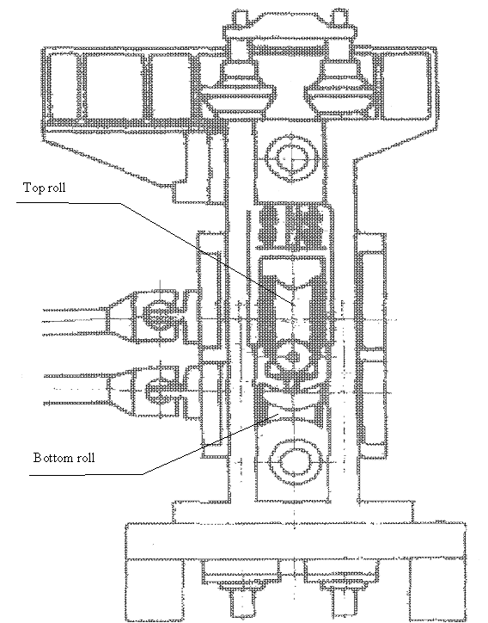
Fig. 1 Pilger mill

Pilger rolls are settled inside the pilger mill one above the other, as is shown in Fig. 1. Schematic diagram of one pilger roll is shown in Fig. 2 and the photo of its typical variant is shown in Fig. 3. Pilger mills are heavy objects (several tonnes) and to manipulate with them is extremely difficult. Diagnostic system minimizing number of manipulation is a great improvement for rebuilding process.

Fig. 2 Drawing of the pilger roll

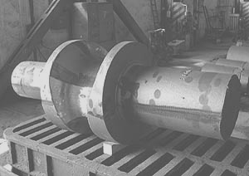
Fig. 3 Typical variant of the pilger roll

Rebuilding is a serious intervention into the geometry of the pilger mill. To assure smooth restart of the technology and quality of the production, it is necessary to put the accent on the quality of the rolls’ placement. Basic problem with the rolls’ placement is shown in Fig. 4.
Fig. 4 A drop between feeder’s and calibre’s axis

There is a difference $σ$($σ=h_{\text{Feeder}}−h_{\text{Calibre}}$) between axis of the raw tube feeder and calibre’s axis, while the axis of the top roll is parallel to the axis of the bottom roll. This difference increases stress between tube and pilger rolls, which decreases lifetime of the rolls and quality of the produced rolled seamless steel pipes. Another problem with the parallelity of the rolls is shown in Fig. 5.
Fig. 5 - Different angles between rolls

Bottom roll is in the correct height; therefore axis of the feeder and axis of the calibre are in the same level. Top roll is parallel with the ground, while bottom roll is inclined $α_{\text{bottom}}$degree. In generally, both of roles can be inclined by a different angle. Important is to assure the angle is smaller than allowed value (e.g. 0.5 degree). Higher inclination angle between the planes of the rolls causes undesirable stress during rolling and it brings problems with the geometry of the rolled seamless steel pipes. Special example of the parallelity problem is shown in Fig. 6.

Fig. 6 Different angles between rolls and ground

Bottom roll is in the correct height; therefore axis of the feeder and axis of the calibre are in the same level. Plain of both rolls are parallel ($α_{\text{bottom}}=α_{\text{top}}=α$), while their plain and the ground plain are inclined α degree. If the angle is higher than allowed value then undesirable stress can occur during rolling which decreases lifetime of the rolls and pilger mill.
Before the pilger mill is started it is necessary to ensure:

$\begin{aligned}α=α_{\text{bottom}}=α_{\text{top}}=0° \\ \left|σ\right|=0, \\ \text{where} \\ σ=h_{\text{Feeder}}−h_{\text{Calibre}}\end{aligned}$(1)

- Measuring device
The device, measuring above mentioned parameters, and monitoring system, evaluating measured values, have been developed in DASFOS v.o.s. Schematic diagram of the system is shown in Fig. 7.

Fig. 7 Monitoring system

The heart of the system is a Box Level device (BL); BL consists of a magnetic lock, an inclinometer, laser distance meter and a push button. Magnetic lock enables to fix the BL at the shaft of the top or bottom pilger roll at the position showed in Fig. 8.

Fig. 8 Position of the PL at the shaft

Inclinometer is connected via optically isolated RS232 with the Measuring Computer (MC). It provides angel of inclination in the vertical and horizontal plain. Laser distance meter provides to the MC an analogue value of the distance between shaft of the roll and the ground (in fact, MC measures distance between position of the laser device inside LB and the ground, however real distance is simply sum of this distance and a constant value). Once the BL is fixed at its position, user can press push button and monitoring systems scans several times angel of inclinations in the horizontal plain and vertical plain and the distance. As a result of the measurement the values of the angle washers, they must operators put under the left or right shaft of the measured roll, are displayed on the display.
Between MC and the Visualisation Computer (VC) is a private segment of the Ethernet network. This segment ensures real-time information exchange between embedded PCs with the aim to get information from the superior database, where data with physical dimensions of the rolls are stored, to process measured data and to display results on the display and on the screen of the VC.

4 Algorithm of the measurement
Pilger mill is heavy technology with many sources of disturbance. Measuring algorithm must be robust and eliminate any discrepancy during measurement. Flow chart of such algorithm, evaluating measurement form the bottom roll, is shown if Figure XX. Algorithm for top roll is very similar except the fact that the height of the roll’s axis is not measured here.
Start of the measurement represents situation when user fix LB at the shaft of the bottom roll. At this moment real-time information exchange between MC and VC is started. VC scans data from rolls’ database via public Ethernet segment for the actual pair of the rolls inside the pilger mill. Then the information about physical parameters of the rolls are proceed to the MC. MC set number of the executed measurement to 0 (measurement = 0) and periodically check horizontal inclination $I_{h}$of the LB. This value is on the one hand transferred via RS485 into the display and on the other hand via Ethernet into the VC. As soon as the$\left|I_{h}\right|<0\text{.}5°$, the user can press push button to start measurement. The reason for this condition will be discussed later.
Once the user press the button, the MC scans several times values for horizontal inclination$I_{h}$, vertical inclination $I_{v}$and the height$h$. If variation of the arbitrary measured set for each parameter is greater than MAX value, then MC must repeat measurement. It prevents inputs data from disturbance. When the sets are measured correctly then the values of the angle washers are calculated and the results are transferred into the display and VC. Then number of measurements is increased by 1 and it is tested if the previous measurement is the “same” as current. If not, then number of identical measurement is decreased by 1 and system is returned back and waits for another measurement. As soon as three last measurements at the same roll (bottom or top) are identical, the user can disrupt rebuilding process; the pilger mill is prepared to work. The measurements are usually alternating – one measurement at the bottom roll, one at the top, one at the bottom etc.

Fig. 9 Flowchart of the measuring algorithm

Results of the measurement are visible at display mounted near pilger mill (it alternately shows thickness of the left and right angel washer to ensure parameters in equation 1). Parameters are also accessible via private segment of the Ethernet network at the VC – example of the visualization screen is showed in Fig. 10, and via public segment of the Ethernet network at any computer in Internet (with installed monitoring system software).

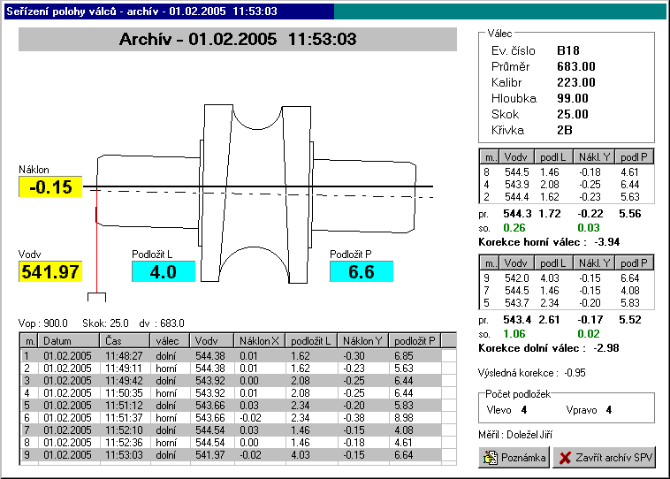
Fig. 10 Screenshot of the VC

5 Calculation of the washers
There are two angle washers (see Fig. 2) and their thickness (Wr, W_{l}) is calculated by a formula 2.

$\begin{aligned}μ=K−h_{\text{Feeder}}+(H+S)/2 \\ W_{r}= \\ \end{aligned}$ (2)
where:

$K$ is the median of the measured set of the roll’s shaft heights (see Fig. 2),
$h_{\text{Feeder}}$ is the height of the feeder of the material (see Fig. 4),
$H$ is the diameter of the roll (see Fig. 2),
$S$ is the drop between rolls (see Fig. 4),
$α$ is the median of the measured set of the roll’s vertical inclination $I_{v}$,
$L$ is distance between washers (see Fig. 2).

To ensure correct evaluation of the calculation, it is necessary to keep horizontal inclination of the LB in desired interval $±0\text{.}5°$; this fact is illustrated in Fig. 11.

Fig. 11 Horizontal error of the measurement

If the $\left|I_{h}\right|<0\text{.}5°$then ration between measured height of the shaft K’ and real height K is 1:1.00004, which is 1:1 with maximal absolute error of the measurement 0.04 mm.

6 Design of the communication protocol
Embedded monitoring system includes several communication chains from lower layers of the ISO/OSI model (RS232, RS485) to higher levels (TCP/IP). To ensure smooth information exchange in the whole system the formal method for description of the communication has been applied.
Authors’ previous experiences with formal methods in the communication protocols [4, 5] lead to utilize a formal description tool for developing of the communication skeleton, to verify the communication system and to implement the model in an executable form. As a formal description tool the temporal logics were used and as verification tool UPPAAL.
UPPAAL is an integrated tool environment for modelling, simulation and verification of real time systems, developed jointly by BRICS at Aalborg University and the Department of Computer systems at Uppsala University [6]. It is the appropriate tool for system that can be modelled as a collection of non-deterministic processes with finite control structure and real valued clocks, communicating through channels or shared variables.
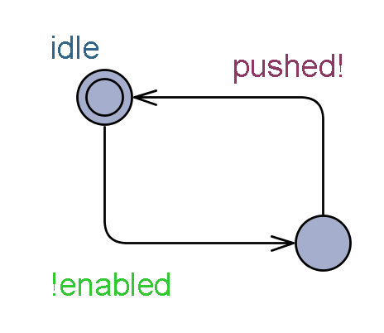
Fig. 12 Timed automaton of the user

Timed automaton of the user is shown in Fig. 12. The chart of the user represents pushing of the button on the LB. Chart has one stable state called idle and one alert state. If the push button on the LB is enabled, then guard condition !enabled is activated and automaton leaves idle state and activates synchronization signal pushed!.

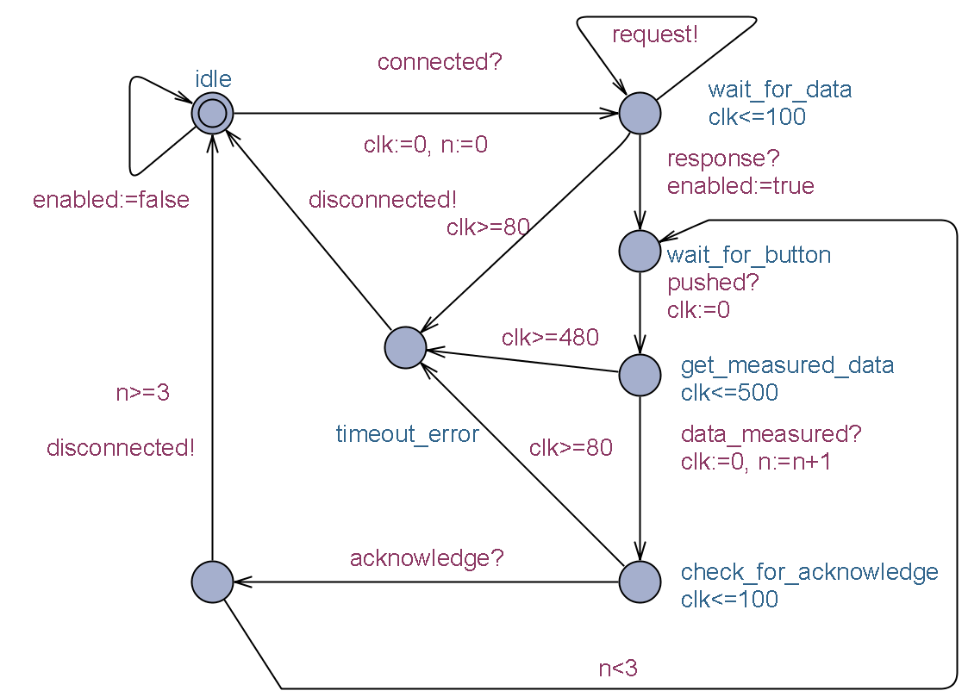
Fig. 13 Timed automaton of the VC

Timed automaton of the algorithm in the MC is shown in Fig. 13. Initial state of this automaton is idle state where MC waits for the second communication partner – VC. When synchronization signal connected? is arrived (from timed automaton of the VC), then MC sends synchronization request! to alert VC for data about adjusted rolls. It also set number of measurements to zero and resets watch dog time (n:=0, clock:=0) and moves into the state wait_for_data. As soon as response? synchronization signal is activated, then guard enabled is permitted and user can press push button on the LB. However, if the synchronization signal does not occur in the time interval <0; 80> then automaton enters the state timeout_error and disconnected! synchronization channel informs VC that MC has closed session. If user presses push button then synchronization signal pushed? moves automaton into the state get_measured_data where it stays until synchronization signal data_measureed?. If the signal does not occur in the time interval <0; 480> then above mentioned process of cancelling the session is started. If all process data are received then MC sends them to the VC and waits in the state check_for_acknowledge. If acknowledge from VC arrives, then guard condition n<3 moves automaton back into the state wait_for_button and guard n>=3 returns automaton back into the idle state and disconnected! synchronization signal is activated to inform VC about closing the session.

7 Conclusion
Timed automatons for the MC (as well as for VC) have been implemented under WIN32 platform and until present time authors have no report about bugs or dead-locks in the system. Process of verification of entire timed automaton model, as well as description of the timed automaton of the VC, are out of scope of this paper. In case of any questions do not hesitate to contact any of the authors.

Acknowledgements:
The paper presents research and development that is supported by Ministry of Education, Youth and Sports of Czech Republic by research intents MSM0021630503 and Grant Agency of the Czech Republic (GA 102/03/1097 and GA 102/05/0663). The research was also supported by FEEC, Brno University of Technology.

References:
[1] W.L. Dobrucki, R.Gregorczyk, A. Wiatoniowski and S. T. Zawada, Investigation of dynamic phenomena in the drive of a pilger mill for the hot rolling of tubes, Journal of Mechanical Working Technology, Volume 10, Issue 1, June 1984, pp. 3-27.
[2] M. C. Duffy, The evolution of the metal-working rolling-mill in the 19th century, Journal of Mechanical Working Technology, Volume 3, Issues 3-4, January 1980, pp. 341-355.
[3] J. Osika and W. Libura, Mathematical model of tube cold rolling in pilger mill, Journal of Materials Processing Technology, Volume 34, Issues 1-4, September 1992, pp. 325-332 .
[4] E. Hintze, and P. Kučera, Simulation of RFieldbus Networks, 5th IFAC International Conference on Fieldbus Systems and their Applications, Aveiro, 2003.
[5] P. Kučera, Formal Methods in Fieldbus Specification, Advanced Control Theory and Applications. Technical Univeristy Sofia, 2003.
[6] K. G. Larsen, P. Pettersson, and W. Yi, UPPAAL in a Nutshell, In Interantional Journal on Software Tools for Technology Transfer 1(1-2), Springer Verlag, 1998.

