DESIGN OF A CURRENT CONTROL SYNCHRONIZED CHAOTIC COLPITTS OSCILLATOR SYSTEM

O. TSAKIRIDIS¹, E. ZERVAS² ,M. KOUTSIOUMPOS³ and J. STONHAM⁴
^{1,3,4}Dept. of Computer and Electronics, Brunel University, Uxbridge, Middx UB8 3PH, United Kingdom.
²Dept. of Electronics, TEI of Athens, Athens, Egaleo 12210, Athens, Greece.

Abstract: - In this paper, a method to modulate and synchronize the chaos carrier in chaotic Colpitts oscillators is presented. A integrated Current control Synchronized Chaos Colpitts Oscillators (CSCCO) modulation system can produce infinite chaotic patterns in a wide operational condition, is showing end to end. This is very useful in real implementation of chaotic communications schemes and especially for coherent Chaos Shift Key (CSK) modulations. The main reason for that is twofold, first the simplicity of the proposed circuit, and second the electronic control of the emitter current affecting the dynamic behavior of CSCCO and also provides the CSCCO with very short settling time from one operational point to another. Finally, experiments performed up to 1 MHz, demonstrate the effectiveness and the regime of chaotic synchronization of CSCCO scheme.

Key-words: Chaos, Colpitts Oscillator, Chaos Synchronization, Gain Control Chaos Shift Key.

- Introduction

Chaos in the Colpitts oscillator, first reported in [1], has recently attracted a lot of interest due to its applications in encryption and modulation methods applied to communication systems. The main premise in these studies is that broad-band signals generated by simple deterministic systems with chaotic dynamics can replace pseudo-random carrier signals widely used in spread spectrum communication systems. The simplicity of chaos generators and the rich structure of chaotic signals are the most attractive features of deterministic chaos that have caused a significant interest in possible utilization of chaos communication.
In a chaos shift key communication system, M digital symbols are represented by chaotic signals generated from M dynamic systems or from one system with M different parameter values [2], [3]. In the binary case i.e., M=2, the transmitted signal essentially switches between two chaotic signals which are generated from two dynamic systems, or from one dynamic system having a parameter switched between two values, according to the digital symbol to be represented. Detection can take either a coherent form or a no coherent form.
In coherent detection, the receiver is required to reproduce the same chaotic signals sent by the transmitter, often through a “chaos synchronization” process which is

This work and its dissemination efforts co-funded by 75% from E.E. and 25% from the Greek Government under the framework of the Education and Initial Vocational Training Program – Archimedes.

unfortunately not easily implemented with sufficient robustness [4]. Once reproduced, the digital symbols can be recovered by standard correlation detection [5]. In no coherent detection of CSK, however, the receiver does not have to reproduce the chaotic signals. Rather, it makes use of some distinguishable property of chaotic signals to determine the identity of the digital symbol being transmitted. The most common exploited distinguishable property has been the bit energy [6].
In this paper we propose an integrated Current control Synchronized Chaos Colpitts Oscillators (CSCCO) modulation system which can produce infinite chaotic patterns in a wide operational condition. The electronic control of the oscillator is a very efficient means of generating a large number of chaotic signals in a short settling time. The outline of this paper is as follows. Section 2 describes the circuit design, experimental results are presented in Section 3. Finally Section 4 concludes the paper.

2. Circuit Design

The single ended Colpitts oscillator is shown in Fig. 1. The Colpitts oscillator is a combination of a transistor amplifier consisting of a single bipolar junction transistor (BJT), and an LC circuit used to feedback the output signal as it is depicted in Fig. 1. The fundamental oscillation frequency is given by:
$f=\frac{1}{2π\sqrt{L_{1}\frac{C_{1}C_{2}}{C_{1}+C_{2}}}}$ (1)

The Colpitts oscillator exhibits a complex dynamic behavior. The Lyapunov exponent for this dynamic system is positive, an indication of the chaotic behavior of the Colpitts oscillator.

Figure 1. Circuit Layout of the Single Ended Chaos Colpitts Oscillator.

The proposed CSCCO is shown in Fig.2. The fundamental frequency of the proposed CSCCO can be calculated by equation (1). The system in Fig. 2. is described by the following set of equations for the master oscillator:

${C_{1}}/2\frac{{\text{dV}}_{\text{BE}}}{\text{dt}}=I_{L1}−I_{C1}+I_{E1}(V_{\text{CE}},Q_{1})−I_{1}$
$C_{3}\frac{{\text{dV}}_{\text{CE}}}{\text{dt}}=I_{L1}−I_{C1}$$L_{1}\frac{{\text{dI}}_{L1}}{\text{dt}}=V_{3}−R_{1}I_{L1}−V_{\text{CE}}−V_{\text{BE}}−{\text{VQ}}_{4\text{on}}$ (2)

The collector current Ic1 is proportional to the emitter current:
$I_{c1}={αI}_{e1}$ (3)

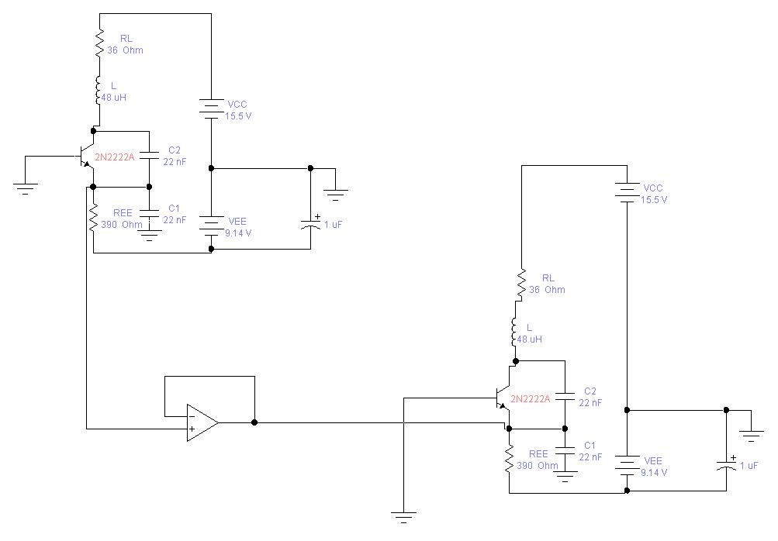
Figure 2. Circuit Layout of Current control Synchronized Chaos Colpitts Oscillators (CSCCO).

The non-linear current-voltage characteristic of the emitter-base junction can be approximated by a piecewise linear function as follows:
$I_{E1}(V_{\text{BE}})=\begin{aligned}\left\{\frac{−V_{\text{BE}1}−V_{\text{th}}}{r},V_{\text{BE}1}<−V_{\text{th}} | \right.\end{aligned}$ (4)

With r being the small signal ON resistance of the emitter base junction, and Vth the break point voltage (approximately 0.7 Volt).

The (Fig. 2) circuit is comprised of a master and a slave oscillator. The connection of these two oscillators is accomplished by the use of a coupling capacitor (1μF) and an operational amplifier (LF411) in buffer configuration.
Each oscillator consists of a single bipolar transistor (Q) which is biased in its active region by the use of V1, R1, and V2. The feedback network consists of L1, C1, and C2. By varying the current source Io the value of g is proportionally affected, thus changing the dynamic behavior of the CSCCO. By examining the bifurcation diagram (Fig. 3) of CSCCO we can achieve such a current value of Io, so the operational point (Point1) (g,Q) can be altered in another chaotic point (Point 2).

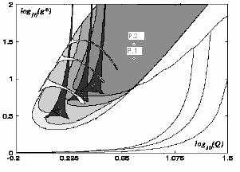

Figure 3. Bifurcation Diagram of the Master Oscillator of CSCCO.

In order to achieve synchronization, it is desirable for both of the oscillators to be as much as possible identical. The high cost in top quality material selection is a basic factor, however the construction of two identical circuits is impossible due to the tolerance of the components at first, and also due to the distribution of capacitance across the circuit. Apart from the top quality components a lot of attention to detail in the construction phase has been paid to keep interference and inter-modulation to the minimum. In order to achieve the required synchronization, both of the oscillator’s circuits (master/slave) are fed with the exact operational voltage and great accuracy in stepping. For this purpose a power supply has been design with symmetrical voltage (+12V / -12V) for the supply of the operational amplifier. And (-1,2V up to -22V, +1,2 up to +22V) for the transistor biasing. Furthermore for the utmost accuracy in biasing 10 turns potentiometers have been used. Table 1 and Fig. 4 are followed.

Circuit Elements | V1 | Io | R1 | L1 | C1/C2
Elements’  Values | 12  V | 22 mA | 36  Ω | 48 μH | 2 nF
Table 1. Circuit Parameters Values used in Simulation and in Experiments

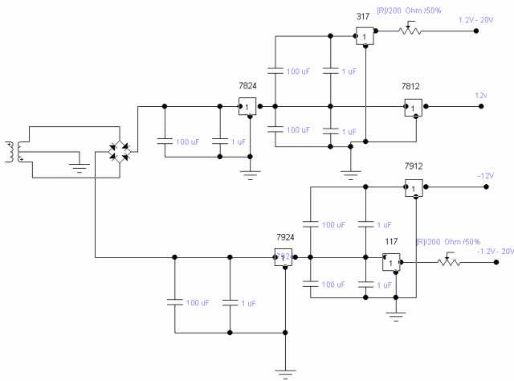

Figure 4. Symmetric Power Supply

3. Experimental Results

For the conduct of measurements the synchronization circuit of Fig. 2 has been realized, and this was performed with great due to the sensitivity of R.F. circuits in interference and inter-modulation. In Fig. 5 X-Y diagram is depicted, X-axis being Vbe voltage and Y-axis being voltage Vbc of one of the two oscillators (master) as it is oscillating chaotically with no coupling (isolated). We can observe the attractors that full every part in the figure and the cyclic orientation. In Fig. 6, the emitter waveform is presented (possible coupling point). We see the abundance of harmonic oscillations and their density, that tads to the required randomness – non periodicity.
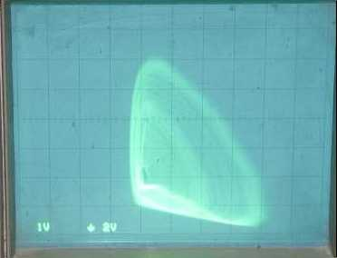

Figure 5. X-Y Diagram of Chaos Oscillator with no Coupling. X-axis Represents Vbe, Y-axis Represents Vbc.

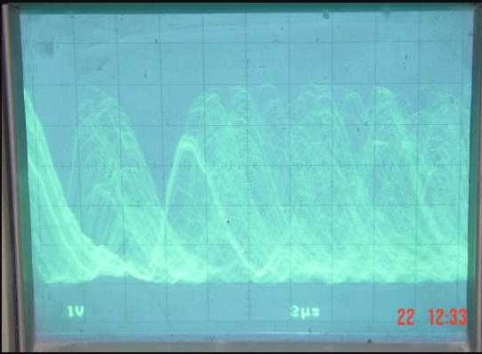
Figure 6. Emitter Voltage of Chaos Oscillator without Coupling.

In Fig. 7 and 8 both of the oscillators are chaotically oscillating, while being in synchronization and emitters are coupled with the interposition of voltage buffer LF411. In Fig. 7, Vbe waveform of one of the two oscillators (master) is depicted. We notice the non-periodicity of the signal as well as the plenitude of harmonic oscillations that is composed off. In Fig. 8 we have the corresponding X-Y diagram of the master oscillator and we can observe the attractors great density. In Fig. 9 the oscillator’s synchronization straight line is presented as X-axis corresponds to voltage Vbe of the master oscillator, and Y-axis corresponds to voltage Vbe of the slave oscillator. The synchronizations is almost perfect..

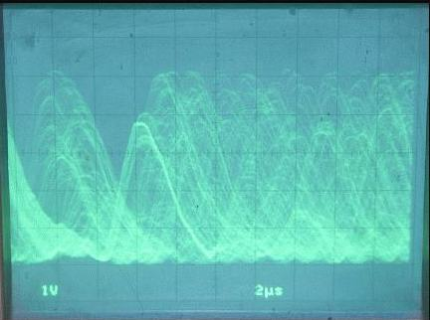

Figure 7. Emitter Voltage of Chaos Oscillator with Coupling.

3.1 Spectrum Experimental Measurements.
For the spectrum measurement the following procedure has been implemented. Initially a copper-wired coil was constructed 75mm in diameter, 1mm in individual wire thickness, and spiral density (N/L) 7/1cm the coil was connected to the spectrum analyzer and then placed very close and in parallel with the core of the master oscillator coil
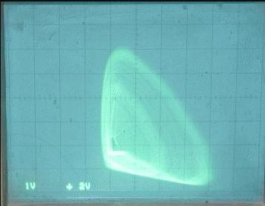

Figure 8. X-Y Diagram of Chaos Oscillator with Coupling. X-axis Represents Vbe, Y-axis Represents Vbc.

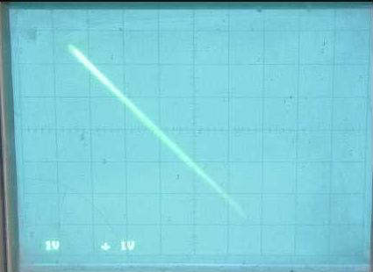

Figure 9. X-Y Diagram (Vbe master-Vbe slave) of Chaotic Oscillators in Synchronization.

With this kind of connection we manage to protect the expensive H.P. spectrum analyzer, and also we do not intervene in the circuit with the analyzer’s capacity. Following that, for the depiction of the spectrum sampling was performed by the analyzer by using Lab View program and then presentation at Origin 7.0.
In Fig. 10 depicts the spectrum of one of the two oscillators before coupling. We notice the slope of 20 dB/250KHz that remains almost perfectly constant after 300 KHz. At nearly 0.3MHz the primary (main) oscillation frequency is located, since maximum power is available at that frequency. The noise level of -80 dB that is shown in Fig. 10 should also evaluate. In Fig. 11 the oscillator spectrum in synchronization and chaotic oscillation is represented. We can observe that this spectrum is very similar to the spectrum of the non-coupled oscillator, so much as the slope, as well as the density of the spectrum. We notice two peaks at 0.75 MHz and 1.5 MHz these peaks are due to the intermodulation of the operational amplifier (O.P.) as they appear even when oscillators are not both fed, but only the O.P. This is confirmed from the Fig. 12 where analyzer’s noise is at -80dB (Fig. 13) and O.P. intermodulation noise at -60 dB.

Figure 10. Spectrum of Chaos Oscillator (Master) with no Coupling.

Figure 11. Spectrum of Chaos Oscillator (Master) with Coupling.

3.2 Regions of Chaotic Behavior in Coupled Oscillators.

During the spectrum measurement procedure it is observed that more that one bias regions that provide chaotic behavior exist, for a given coupled and synchronized oscillator. (example 15,5V -7,78V and 15,5V -8,10V). That can also be proved from the spectrum list in Appendix A and for each one the bias voltage is recordered. We note that even for fraction of a volt we can foll from chaotic to harmonic behavior. This observation proofs the demand for most accuracy on oscillators voltage supply.
Figure 12. Operational Amplifier Noise

Figure 13. Spectrum Analyzer Noise.

4. Conclusions

An integrated Current control Synchronized Chaos Colpitts Oscillators (CSCCO) has been designed to be capable of producing large numbers of chaotic signals in synchronization. Another advantage of the presented circuit design is the relative ease of its actual construction and also its potential use in a wide variety of applications in chaotic communication schemes, as the main functional element of chaotic oscillator. The electronic control of the chaotic carrier in CSCCO system, greatly facilitates the use of chaotic frequency modulation methods.
The are more that one bias regions for which the given oscillating system present chaotic behaviour. After many tests, it has be come obvious that is difficult for the central oscillation frequency of a given circuit, to rise above 300 KHz and simultanely to achieve synchronization. The sensitivity of chaotic systems is proven, based upon the component and bias values.

5. References

[1] M. P. Kennedy, “Chaos in the Colpitts oscillator”, IEEE Trans. Circuits and Systems, vol. 41, pp. 771–774, Nov. 1994.
[2] H. Depieu, M. P. Kennedy and M. Hasler, “Chaos shift Keying: Modulation and demodulation of a chaotic carrier using self-syncronizing Chua’s circuit”, IEEE Trans. Circuits and Systems II, vol. 40, pp. 634–216, Oct. 1993.
[3] H. Yu and H. Leung, “A comparative study of different chaos based spread spectrum communication systems”, in Proc. IEEE Int. Symp. Circ. Syst., Sydney, Australia, May 2001, pp. III-213-216.
[4] C. C. Chen and K. Yao, “Stochastic-calculus-based numerical evaluation and performance analysis of chaotic communication systems”, IEEE Trans. Circuits and Systems I, vol. 47, pp. 1663–1672, Dec. 2000.
[5] M. Sushchik, L. S. Tsimring and A. R. Volkovskii, “Performance analysis of correlation-based communication schemes utilizing chaos”, IEEE Trans. Circuits and Systems I, vol. 47, pp. 1684–1691, Dec. 2000.
[6] G. Kolumban, M. P. Kennedy, and L. O. Chua, “The role of synchronization in digital communication using chaos-Part I: Fundamentals of digital communications”, IEEE Trans. Circuits and Systems I, vol. 44, pp. 927–936, Oct. 1997.

_

Appendix A

