An application of a self learning neural network for revealing the presence of anomalies of a gear system

VINCENZO NIOLA
Department of Mechanical Engineering for Energetics
University of Naples “Federico II”
Via Claudio, 21 - 80125 Napoli
ITALY
http://niola.dime.unina.it

GIUSEPPE QUAREMBA
University of Naples “Federico II”
Via S. Pansini, 5 – 80131 Napoli
ITALY

Abstract: - A Self Learning Neural Network was designed with the scope of denoising and detecting the anomalies (i.e., spikes) on the signals obtained by a simulation of a system gear. In order to check the ability of the network to detect and to put in evidence the anomalies, random white noise was added to the original signal. The spikes were generated by simulating the fatigue crack of one tooth during the rotation of a gear system. Finally, the results of the network were compared to the ones obtained by decomposing orthogonally the signals by means the wavelet transform, of which the ability of investigating on such anomalies is well known.

Key-words: - Fuzzy logic, neural network, signal processing, wavelet analysis, diagnostics

1 Introduction
The requirement of gear systems with elevated mechanical characteristics and high performance with the aim both of increasing the degree of reliability and the optimization of the operating costs, has evidenced the importance of employ always new and more sophisticated instruments which can concur to the improvement of operating conditions of the industries [1].
In order to preview and to face these challenges, several test bed, numerical simulations and mathematical models have been proposed in the last years. They are the basis for the development of new methodologies useful both for understanding the phenomena which represents the main limit of the transmissions and for developing new and more reliable predictive test of diagnostics.
The present work, taking many articles [2],[3] as a starting point should be part of such a field of study for predictive diagnostics. In fact, it proposes to find the modifications in torsional vibrations due to the presence of a fatigue crack by applying, to a gear system model, the numerical simulation in conjunction with a neural network. The results were compared with the ones obtained by applying to the signals the wavelet transform.
Starting from the kinematical study of the gear a mathematical model was developed in order to simulate the dynamical behaviour. Then the neural network designed will be shortly described.

2 Mathematical Background

2.1 Discrete Wavelet Transform
Mother wavelets are special functions, whose first h moments are zero [4]. Note that, if ψ is a wavelet whose all moments are zero, also the function ψ_{ik} is a wavelet, where

$ψ_{\text{jk}}(x)=2^{{−j}/2}ψ(2^{j}x−k)$ . (1)

Wavelets, like sinusoidal functions in Fourier analysis, are used for representing signals. In fact, consider a wavelet ψ and a function φ (father wavelet) such that {{}, {ψ_{jk}}, k Z, j = 0, , 2,…} is a complete orthonormal system [5],[6]. By Parseval theorem, for every signal s L²(R), it follows that

$s(t)=\sum_{k}{a_{j_{0}k}ϕ_{j_{0}k}(t)+\sum_{j=j_{0}}^{j_{1}}{\sum_{k}{d_{\text{jk}}ψ_{\text{jk}}(t)}}}$ (2)

In particular, the decomposition of a signal s(t) by the Discrete Wavelet Transform (DWT) is represented by the detail function coefficients d_{jk} = <s, ψ_{ik}> and by approximating scaling coefficients $a_{j_{0}k}\text{=<}s,ϕ_{j_{0}k}$. Observe that d_{jk} can be regarded, for any j, as a function of k. Consequently, it is constant if the signal s(t) is a smooth function, having considered that a wavelet has zero moments.
Lemma 5.4 in [7] implies the recursive relations

$a_{\text{jk}}=\sum_{m∈Z}{h_{m−2k}a_{j+1,m}}$ and $d_{\text{jk}}=\sum_{m∈Z}{λ_{m−2k}d_{j+1,m}},$

where λ = (–1)^{k+1}h_{1-k}; { h_{k}, k Z} are real-valued coefficients such that only a finite number is not zero and they satisfy the relations

$$\begin{matrix}\sum_{k∈Z}{h_{k+2m}\overline{h_{k}}}=δ_{0m} \\ \\ \frac{1}{\sqrt{2}}\sum_{k∈Z}{h_{k}}=1\text{.}\end{matrix}$$

2.2 The Gear System Simulation
Starting from the equation of motion (see below) a model for the simulation was developed. The fig.1 shows a schematic representation of the mechanical system. The equivalent scheme used for the simulation analysis is depicted in fig.2a

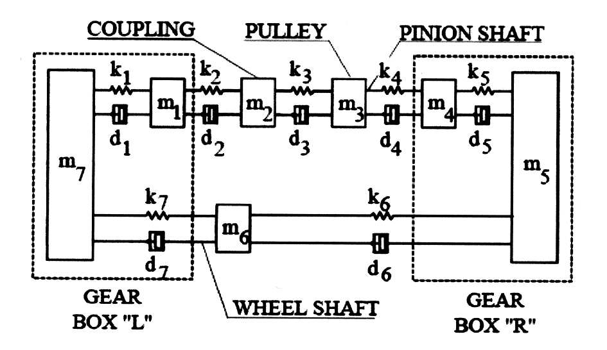
Fig. 1 Mechanical Model

Note that the generic equation motion of the i-th mass is as follows:

$m_{i}{\overset{¨}{x}}_{i}+d_{i}({\overset{˙}{x}}_{i}−{\overset{˙}{x}}_{i−1})+k_{i}(x_{i}−x_{i−1})+d_{i+1}({\overset{˙}{x}}_{i}−{\overset{˙}{x}}_{i+1})+k_{i+1}(x_{i}−x_{i+1})=0$ (3)

with clear meaning of symbols.
The simulation model was used for generating the data to be analyzed both in the case of a new gear and in the case of cracked gear. Since the cracked tooth alters the gearing stiffness, it represents an important input parameter for the model. In order to define the gearing stiffness it is necessary to specify the conduct arc, the pitch (defined by a cinematic analysis) and the meshing speed depending from both the rotation speed of wheel and the number of its teeth.
As in [2] several tests were performed with different rotation speed. For the values of input parameters of simulation model as the masses , the lumped parameters , the damping coefficients , etc., see [2].
It is important to note that, in accordance with the simulation model, the oscillation of system, due to the periodicity meshing stiffness, is activated if the all starting conditions, of integrator blocks of the model, are chosen not identically null. For this reason, a transient phenomena will be showed by the output variables. The wavelet analysis, of course, was applied by ignoring the transient part of the output signal.

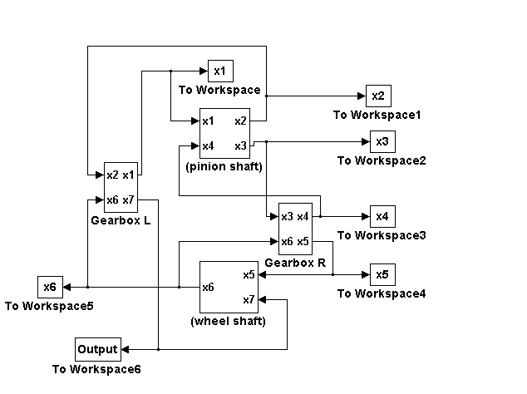
Fig. 2a A schematic simulation model

An example of calculation of x₇ output, in accordance with general equation (3) performed by the simulation model is showed in fig.2b.

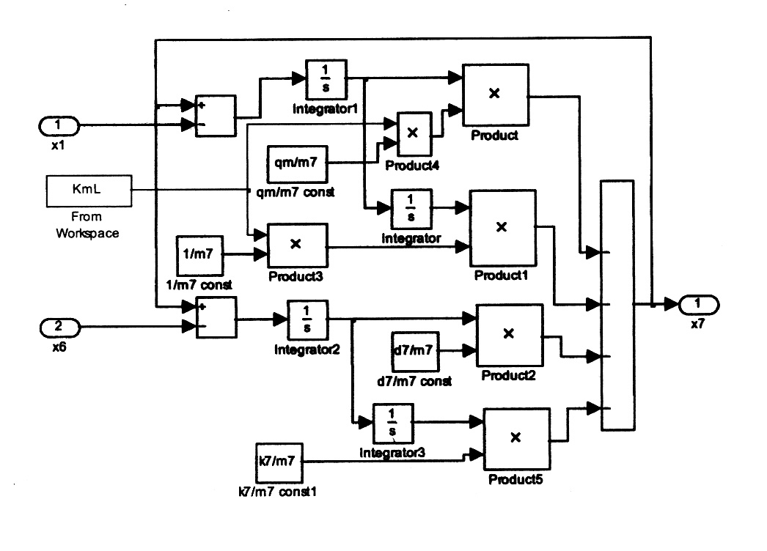
Fig 2b Block diagram for the calculation of x₇ according to the motion equation (3) for i=7

2.3 A brief description of Neural Network
As reported in [8] a Self Learning Neural Network (SLNN) was developed in order to operate both a denoising and an enhancement of features showed by the signals.
In particular, the effect of a fatigue crack of a gear system was reproduced by a simulation as illustrated in the previous paragraph.
For the SLNN it is important to note that it was based on three layers (named input, hidden and output) where the i-th node contains the value showed by the signals at i-th instant. Note that the nodes of two consecutive layers are linked by a weighted vector, while the nodes belonging to the same layer are not connected.
Each node was activated both in accordance with the inputs received from the total of nodes belonging to the preceding layer and from the activation function of the same node.
The total of input to the i-th node for each layer is:

$I_{i}=\sum_{j}{w_{\text{ij}}o_{j}}$ (4)
where $o_{j}$ is the output of the j-th node of the preceding layer and $w_{\text{ij}}$ is the weighted link between the i-th node of a layer and the j-th node of preceding layer.
The output of the i-th node is:

$o_{i}=f(I_{i})$ (5)

where $f(⋅)$is the activation function expressed as:

$f(⋅)=\frac{1}{\sqrt{2π}}e^{\frac{\bar{X}−x}{5\text{πσ}}}$ (6)
where $\bar{X}$ and $σ$were the mean and the standard deviation respectively of the values of the nodes selected by the neighbourhood system. We used an array composed of five nodes [9], [10] and [11].
The input layer takes as input the signal generated by the noised simulation program, as described in the previous paragraph, and each neuron of the layer uses (6) as transfer function.
The output of the 1st layer (but this is valid for all the three layers composing the neural network) was passed to the 2nd layer using the (4).
When the net is analyzing the i-th point we took as neighbourhood the points preceding i and the two points following i. This passage was done for each layer.
The output of the 3rd layer was then compared with the target signal (see next paragraph) obtaining the error signal which was passed to the 1st layer in order to recalculate the weights wij.
It is to underline that the weights, at the first epoch, were set equal to 1. This was done for initializing the neural network.
The formula implemented to recalculate the weights was chosen in order to minimize the error between the signal analyzed by net and the signal to which the net tries to fit the input signal:

(7)

named square variation index.
At the end of each iteration the output signal, obtained from the 3rd layer, was plotted in order to appreciate the improvement performed by the neural application.
Calculations were made using MATLAB 6.5, The MathWorks, Inc, Natick, Mass, Simulation Toolbox Version 2.1.2.

3 Results
In order to check the effectiveness of the proposed method, computer simulation has been done on a simulated gear system. The output signal obtained from the simulation was analyzed both by the SLNN and the wavelet transform; a typical signal extracted by the proposed simulation with the presence of three spikes due to the fatigue crack of a tooth, is shown in fig.3.
Fig. 3 Simulated output signal
To realize a more effective and reliable analysis of these kind of signals a random white noise was added to the original ones obtaining the signal depicted in fig.4.
Fig. 4 Simulated output signal with random white noise added

It is impossible to distinguish any dynamics or features showed by the original signal.
A signal as showed in fig.4, was used as input to the Neural Network. A more detailed description of the working steps are reported below.
The first step was the feeding of the input layers by the signal of fig.4. This signal was passed through all the three levels forming the net. The first iteration was named “net initializing”: all the weights of the links are equals to 1. The result of the first iteration is reported in fig.5.
Fig. 5 Result for the nosy signal after the 1st iteration

The output was compared with a “target signal” (i.e., the expected signal of fig.6) obtained by a normal gear system) to which the net tries to fit the input signal. In fig.7 is shown the “error signal” due to the difference of the waves of fig.5 and fig.6.
Fig. 6 Target signal
Fig. 7 Error signal

The last signal shown is used by the net to adjust the weights of the links for the second iteration . The weights of the links modified as explained before followed a square error minimization index.
The net converged after five iterations producing the results depicted in fig.8.
Fig. 8 Result obtained after the 5th iteration

If we process the signal depicted in fig.4, by wavelet transform it is not so easy to distinguish the presence of spikes and their features (see fig.9). By applying the SLNN, as pre-processing tool, the extraction of the three anomalies, from the starting noised signal of fig.8, can be easily performed by wavelet transform [12], see fig.10.
Fig 9 Results for the 6-level wavelet decomposition
Fig 10 Wavelet analysis of the SLNN output signal

4 Conclusions
A well designed SLNN should contribute to determine the presence of anomalous signals, due to the modifications in torsional vibration of a system gear due to a problem of the fatigue crack of one tooth, when they are also of small entities.
Moreover, the present work constitutes the basis for a next experience based on the improvement of a test bed, in order to compare the results of the present work with the ones provided by a real model by applying the same methodology showed in this paper.
The importance to prevent such anomalies (i.e., fatigue crack) is fundamental for the regularity of functioning and yield of a gear system. The methodology should be implemented on that machinery, working, usually, in extreme conditions of lubricating (e.g., high temperature, high speed, instantaneous speed changing, high power transmission, and so on). However the proposed methodology may be extended to fields were are involved important torsional and vibrational problems (e.g., navigation, automotive, etc.)
Normally, the signals are affected by noise, so it is fundamental to perform a soft denoising process without the application of any filter. In fact, their application could eliminate the presence of spikes (usually showing high frequency and small amplitudes) which reveal the potential mechanical fault of gear. For that reason, in this work, a SLNN was designed in order to realize a reliable real time signal processing method, without the application of any digital filter for the denoising.
The comparison with the response performed by means the application of WT is significative. In particular, it proves both the reliability of SLNN for such an application and the potential classification of signals, in conjunction with the wavelet analysis used for the extraction of their features.

Acknowledgements
We are grateful to doct. Gennaro Nasti for the computing support.

References:
[1] Niola V., Quaremba G., Oliviero R., The location of anomalies spikes on a working rotor: a theoretical – experimental test, International Journal of Applied Mechanics and Engineering, Vol.9, No.3, 2004, pp. 547 – 556.

[2] Dalpiaz G., Rivola A., Rubini R., Dynamic modelling of gear systems for condition monitoring and diagnostics, Congress on Technical Diagnostics – Gdansk, Poland – 1996 , pp. 185 – 192.

[3] Dalpiaz G., Rivola A., Rubini R.. A kineto-elastodynamic model of a gear testing machine. MTM’97. pp 549-53.

[4] Daubechies I., Ten Lectures on Wavelets, SIAM, 1992.

[5] Antoniadis A., Oppenheim G., Lecture Notes in Statistics – Wavelet and Statistics, Springer, 1995.

[6] Härdle W., et al, Lecture Notes in Statistics – Wavelets, Approximation, and Statistical Applications, Springer, 1998.

[7] Härdle W., Kerkyacharian G., Picard D., Tsybakov A., Wavelets, Approximations, and Statistical Applications, Springer, Berlin, 1998.

[8] Niola V., Quaremba G., A Self Learning Neural Network specialized for the analysis of mechanical systems, IX WSEAS Int. Conf. on Computers. Special Session: Mechanical Systems: Theory and Application, Vouliagmeni – Athens, Greece – July, 14-16, 2005. In Progress.

[9] Zadeh L.A., Fuzzy sets, Information and Control, Vol.8, No.338, 1965.

[10] Chiu S., Fuzzy model identification based on cluster estimation, Journal of Intelligent and Fuzzy Systems, Vol.3, 1994.

[11] Krishnapuram R., Frigui H., Nasraoui O., Fuzzy and possibilistic shell clustering algorithms and their application to boundary detection and surface approximation – Part I, IEEE Transactions on Fuzzy Systems, Vol.3, No.1, Feb 1995.

[12] Anthony T., Computational Signal Processing with Wavelets, Birkhäuser, Boston, 1998.

