Car Simulation and Virtual Environments for Investigation of Driver Behavior

PETR BOUCHNER, MICHAL HAJNÝ, STANISLAV NOVOTNÝ, ROMAN PIEKNÍK, JAN SOJKA
Department of Control Engineering and Telematics
Joint Laboratory of System Reliability
Czech Technical University, Prague
Faculty of Transportation Sciences
Konviktská 20, 110 00 Prague
CZECH REPUBLIC
http://www.lss.fd.cvut.cz

Abstract: - The operator is required to be constantly vigilant and even more attentive when operating the device. The paper introduces a cooperation of a car simulator realized in virtual reality (VR) environments and measurements of “human driver behavior” focused mainly on aspects of HMI and drivers’ attention decrease. In the first part a conception and a development of our VR car simulation devices is described. During the development of car simulators many problems need to be solved. One of these problems is represented by a simplification and a partial automation of a scenery creation. The first part is dedicated to algorithms used in our tools, which help to automate the creation of virtual scenes. The next part analyses in more details tools themselves and the rest of this section deals with demonstration of scenes, which were modeled using these tools. For simpler and faster generation of virtual sceneries it is suitable to store the models within a hierarchical database 3D object. Our database includes model objects from which subsequently forms surroundings for road virtual scenes. In the article it is described how to specify 3D model properties - their fundamental characteristic and consequent differentiation into specific categories. Sound perception cues are one of the most important ones besides the visual cues in the car simulation. The audio section of this article deals with simulating a sound of a car engine as a most significant audio stimulant for the driver. It shows basics of cross fading system which renders the car audio from multiple looped samples. First part contains analysis of car engine sound; the second describes how to synthesize it on the computer. A validation measurements and consequent results are shown at the end of this section. The final paragraphs shows examples of experiments developed for measurements of driver’s fatigue and other aspects of driver’s behavior.

Key-Words: - Driving simulation, Driving safety, EEG, Attention decrease, Driving in virtual environments

1 Introduction
The Joint Laboratory of System Reliability has been working on the research in the field of HMI and drivers’ behavior for many years. Several studies dealing with the human operator’s vigilance and/or attention decrease have been done in our laboratory. Beside those general tasks concerning the HMI we are focused on the tasks of the interaction between human drivers and motor vehicles (car drivers, rail engine drivers and so on).

2 Simulation devices for measurements
The following picture shows a basic setup and interconnections between all the particular components. It describes main connections between the functional blocks.

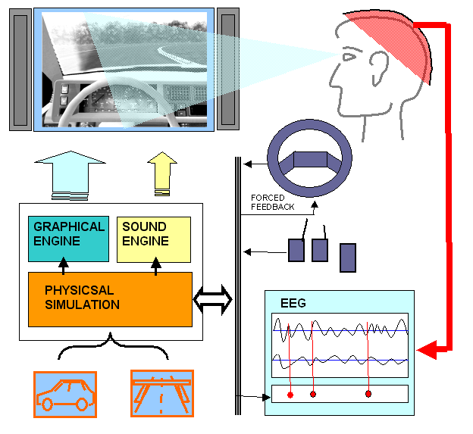
Fig. 1: The scheme of the basic setup of VR simulator

During the time spent on the development of the simulation devices to fit our needs and requirements best, we set up three different devices. The very first arrangement of our simulation device used a common PC steering wheel with two pedals with a sequential gear shifter (or automatic shifting was applied). Now we use a special three pedal system (including a possibility of involvement of the clutch if required) and an H-pattern gear shifter. Although this setup has been replaced with a real part of car cockpit we came back to it when incorporating Head Mounted Display. A proband equipped with HMD has now a freedom of view, which off course requires the cockpit to be completely 3D modeled. A sensor connected to his head scans the proband’s head turns (in 3 DOF). Second arrangement represents an intermediate step between the totally virtual conception and a usage of a real car body (see next paragraph). It gathers advantages of both of these approaches. On the other hand it leaks for example a perception of depth which is easily possible to do with 3D glasses.

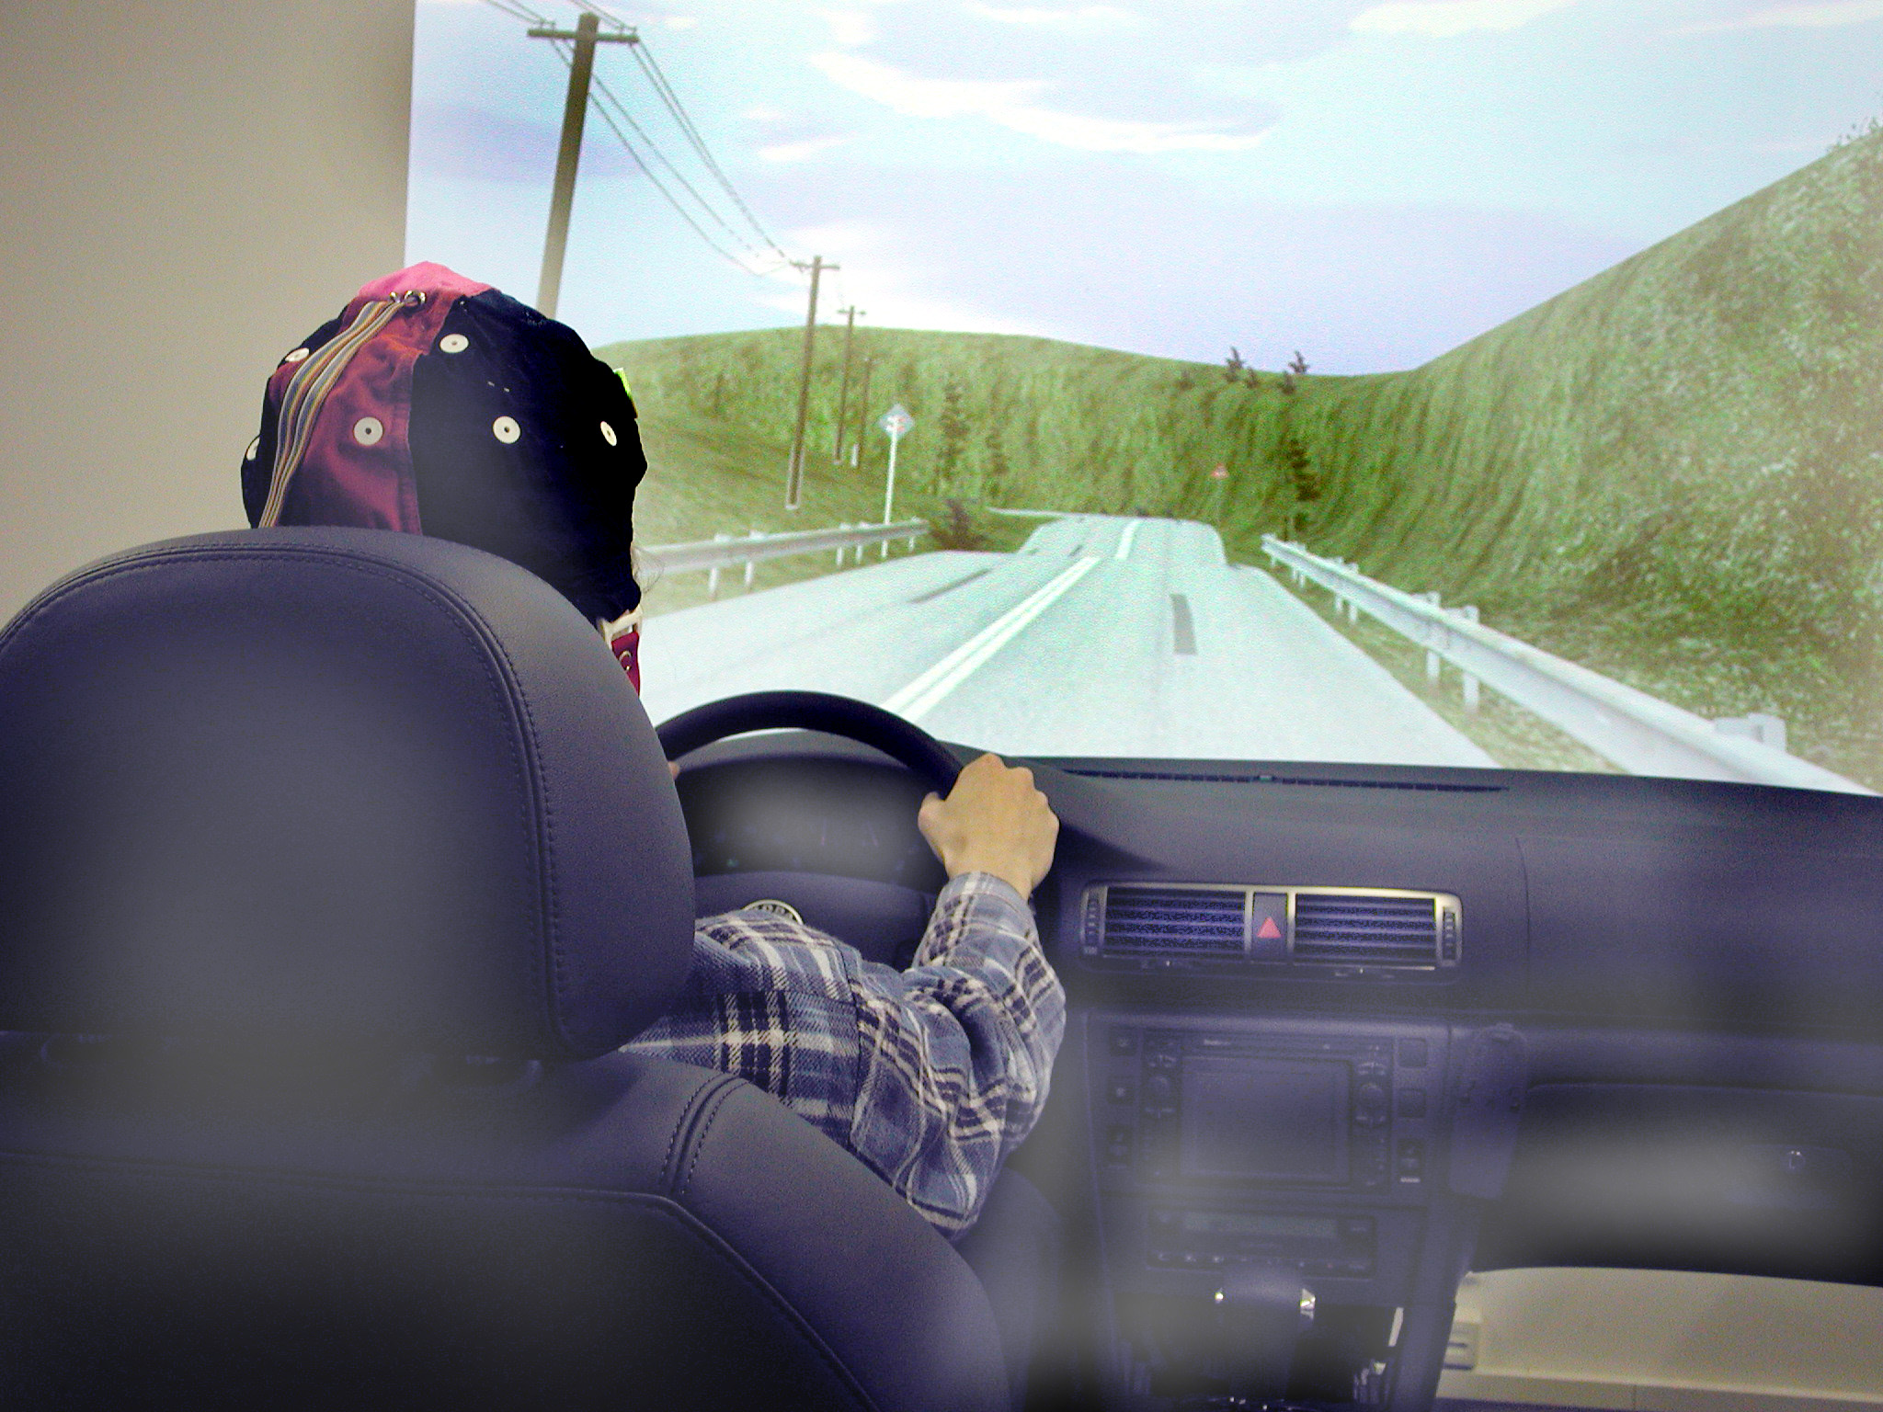
Fig. 2: A proband driving on light simulator

The “compact” simulator is closest to the reality (concerning ergonomics) because it uses a complete real car body. The tested person sits in a real cockpit and the virtual scenery is projected on the screen wall in front of the car hood. Results from measurements using such a device should not be loaded by an error caused by the difference between simulator and real car cockpit.

3 Tools for automated scenery creation
During the development of car simulators many problems need to be solved. One of these problems is represented by a simplification and a partial automation of a scenery creation. Quality simulator demands simulated background to be as real as possible. To guarantee its authenticity, real background can be gotten from Geographic Information Systems (GIS). Instruments constructed for particular automation creating scenes, are used like plugins for freeware modeling program. This program then models all the scenes.[10], [11]. This conception is very useful for obtain expansion or improves implementation.
The base of created scene is modeling of the real terrain using level lines (contour lines) triangulation. Coordinates of contour lines are obtained from the map lists of “the main base of the geographic data” (ZABAGED) [12], specifically from the altimeter. These map lists can be got from the topographical surveyor office.
Export of the co-ordinates to the text file can be done in the Bentley Microstation program. In text file, each line represents coordinates of the one contour-line point. Points have standard sequence of coordinates X, Y, Z, and these are isolated by comma. Being sorted by the X-coordinate, duplicity of the points appears and sometimes connection of the lines is lost. Because of this text file have to be arranged.
After this procedure there we have adjusted coordinates, which are basal data for the modeling program improved with the noted special instrument. This tool or instrument is based on using Delaunay triangulation to shape the terrain.

- exporting coordinates points to text the file
- deleting duplicity points
- importing data to the surface modeling instrument
- triangulation using Delaunay algorithm
- texture mapping

Next step of the automatic scene creating is building of the road models, and then placed on modeled surface. The main task of noted tool is to create a model of the road according to the derived real data, and also to get altitudinal coordinate from its position above the surface. Made model is then placed to the surface accurately. The impression is very real owing to an accurate calculation of the altitudinal coordinates of the road.
Input data are also gotten from the “main base of the geographic data”, this time from its planimetral (not altitudinal) part. This export is accomplished into the text file. Each point of the road is now represented by one line of the file. This text file is then adjusted by deleting duplicity lines, and arranged according to real objects. In view of considering the fact that the data from the Geographical information systems are not usually fitting for creating of a driving simulator scenes, was prepared enhanced tool. This modificated tool allows deriving input data according to user defined curve.
In the end of whole process, the objects are put to the prepared surface by means of the noted plug-in tool. It loads objects from the database and putted to the surface. Putted objects are for example buildings, lay-out items, and also the natural or geological formations. In the case of natural formations the random axis rotation is applied. Also random mild tilt is used for realistic impression.
Input data for creating road models are corrected text files symbolising co-ordinates of the road points, which are obtained exporting from map lists or from user defined database. Other input data can be the text files with prepared categories of communications (ČSN 73 6110) [14]. In real conditions not only standard communications occurs, but also communications hardly subsumable to any sort. Therefore in this plugin choice import text file, where are users defined road parameters.
For each point from imported file is recounted high co-ordinate, for new road to be created tightly settled on surface of terrain. This part of algorithm consist of a few steps and is repeated for every point of middle line road.
After setting all high co-ordinates is processing modeling of the road along the middle line. (Fig. 3)
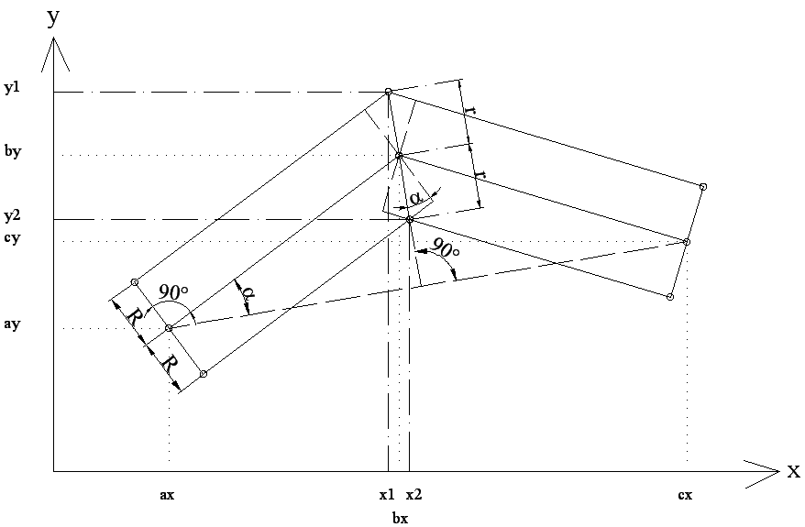
Fig. 3: Road modeling

For each sequence three points of middle line $A\left[\text{ax},\text{ay}\right] , B\left[\text{bx},\text{by}\right] , C\left[\text{cx},\text{cy}\right]$ is set direction vector $\vec{v}=\left(v_{1},v_{2}\right)=\left(\text{cx}−\text{ax},\text{cy}−\text{ay}\right)$ and then normal vector $\vec{n}=\left(n_{1},n_{2}\right)=\left(−v_{2},v_{1}\right)=\left(\text{ay}−\text{cy},\text{cx}−\text{ax}\right)$ then for points $X_{1}\left[x_{1},y_{1}\right]$ a $X_{2}\left[x_{2},y_{2}\right]$
$x_{1}=b_{x}+\frac{{\text{Rn}}_{1}}{\left|\vec{n}\right|\text{cos}α}=b_{x}+\frac{{\text{rn}}_{1}}{\left|\vec{n}\right|}$
$y_{1}=b_{y}+\frac{{\text{Rn}}_{2}}{\left|\vec{n}\right|\text{cos}α}=b_{y}+\frac{{\text{rn}}_{2}}{\left|\vec{n}\right|}$ (1)
$x_{2}=b_{x}−\frac{{\text{Rn}}_{1}}{\left|\vec{n}\right|\text{cos}α}=b_{x}−\frac{{\text{rn}}_{1}}{\left|\vec{n}\right|}$
$y_{2}=b_{y}−\frac{{\text{Rn}}_{2}}{\left|\vec{n}\right|\text{cos}α}=b_{y}−\frac{{\text{rn}}_{2}}{\left|\vec{n}\right|}$, where ; (2)
$r=\frac{R}{\text{cos}α}$ and (3)
R representative implemented parameters of road in depend on chosen category communication.
On count of previous step arise for each point of middle line in depend on chosen communication category, which is need connect by triangles and modeling road surface. By the end is to every triangle allocate U, V textures co-ordinates.

- export co-ordinates points to the text file
- deleting duplicity points
- points set upping
- import data
- choosing category of communication
- for all imported points do
- finding object, above the point is
- calculation of high co-ordinates of point
- calculation of co-ordintes of associated points on communication categories
- triangulation of all points
- allocate U,V co-ordinates to the faces

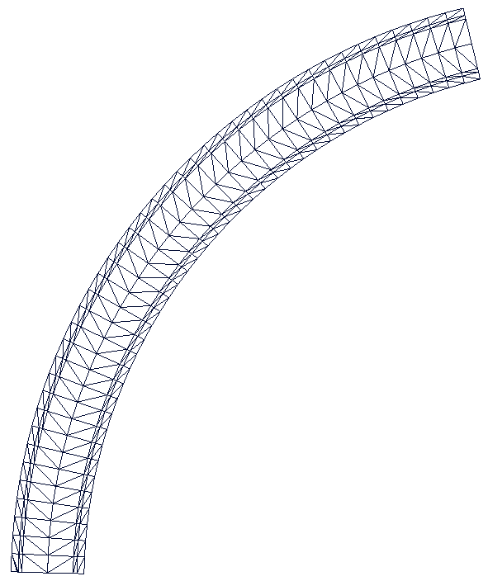
Fig. 4: Triangulation of the curved road

From the previous pictures it is possible to see redundant triangles in cross-section of the road surface. For the first look they could be considered as a visual improvement of the polygonal look of our roads. In fact this feature gives us a cheep and straightforward possibility to react on surface changes. Fig. 5 depicts what other modules can benefit from the surface information that is usually used only for the computation of kinetic equations.
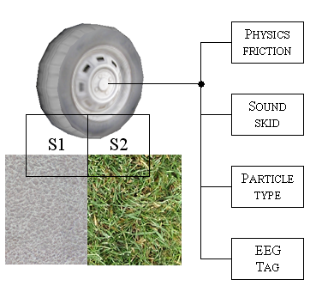
Fig. 5: Surface type flag is passed via the wheel position into several parts of the engine

From basic algebra it is easy to derive on which triangle the wheel stays (drives). Since the material (texture mapped on the triangle) defines look of the surface it is easy to come to constrain with it also other surface properties. The most important for us is the position, from which it is easy to decide if the driver keeps his/her lane and consequently to classify a fault rate of his/her driving. Such a classification is a marker of driver’s actual ability of correct driving. This classifier is then correlated with other physiological and mainly biological outputs arising from the driver [2]. Fig. 6 shows a basic set of positions of a car on the road. Form our experiences from the measurements we decided to do a smoother evaluation of deviation in left lane. It says how many wheels are out. Besides this simple measure it is possible to do a classification from a car trajectory but it requires much deeper investigation in driver’s driving style measures.
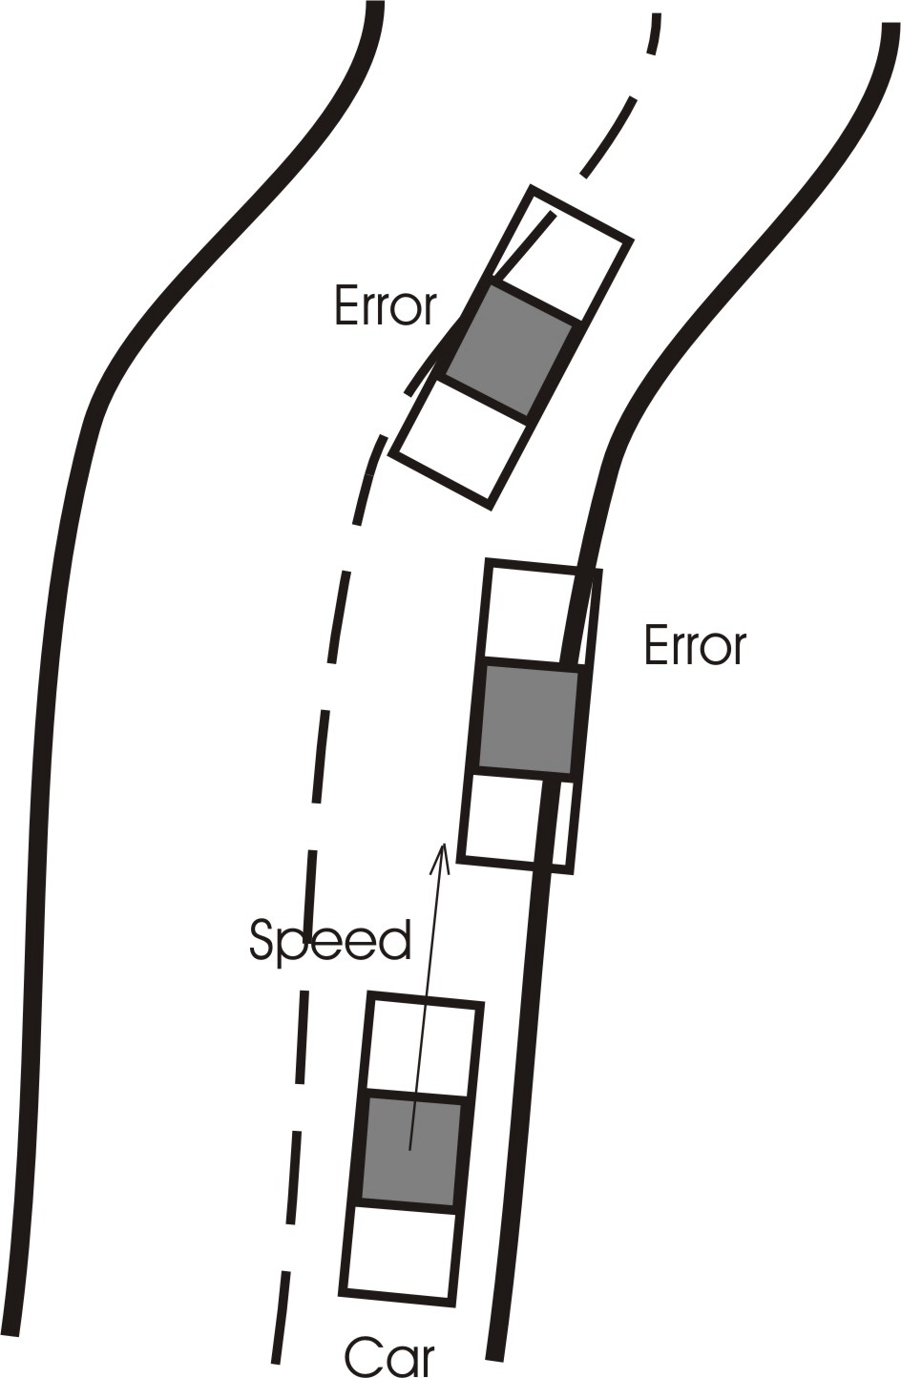
Fig. 6: Error classification for the ‘deviation form the track’ experiment

4 Databases of 3D on of objects
For easier and faster creating virtual scenes was composed a 3D object database. In this database are in placed generated 3D models, which serves especially like partial elements for creating new object road scenes. Each generated object contains definite count of polygons (triangles). Is it important, to have all defined objects in highest possible quality and low count of polygons. There are a lot of 3D models existing, which are visually very exactly simulated, but these are useless for real-time graphic, because contains too high count polygons. And when the graphic accelerator is overloaded by calculating complicated scenes, the frame rate of the simulation falls. It has no reason to place models farther from observer, where are too far, to see them well.[6]
The chosen part of virtual scene is semi complicated and 300 m long. The main part is the road here, in placed to the middle of scene. The road is divided into three parts. Light left curve with radius 3000 m (Fig. 7 middle), straight part and right curve with radius 150 m.
In built-up part (Fig. 8) is placed five buildings with different detail level. In the right part of scene are used three types of trees, in the near of road are more complicated broadleaf tree, far from road are placed lower quality cone trees and most far are the most simple trees (so called billboard, Fig 13).
Object | Type | Faces | Figure
Road | straight | 8 | Fig. 7
Road | curve (R=3000 m) | 64 | Fig. 7
Road | curve (R=150 m) | 336 | Fig. 7
architecture | building 1 | 423
architecture | building 2 | 343 | Fig. 8
architecture | building 3 | 36 | Fig. 9
architecture | building 4 | 519
architecture | building with fence | 1722 | Fig. 10
Forest | broadleaf trees (11) | 39732 | Fig. 11
Forest | cone trees (92) | 24288 | Fig. 12
Forest | forest on two faces | 2 | Fig. 13
Bench | wood | 198
road sign | alert | 102
Landscape |  | 322
Sum |  | 68095 | Fig. 14
Table 1: Number of faces in the objects
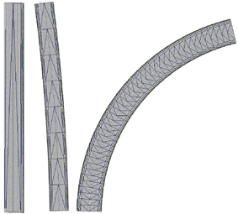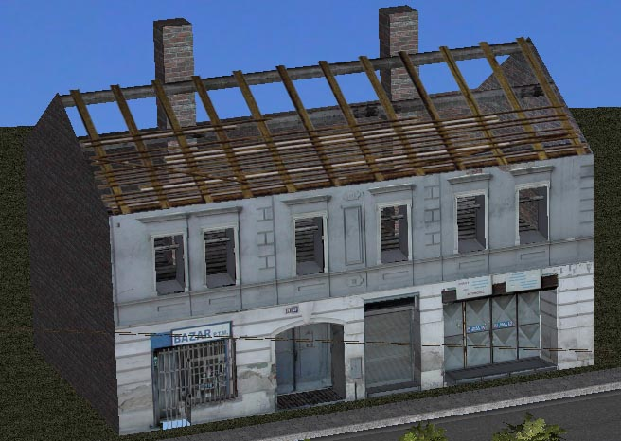
Fig. 7: Three type of road Fig. 8: Building 2

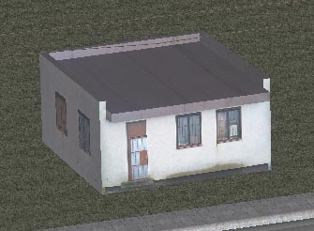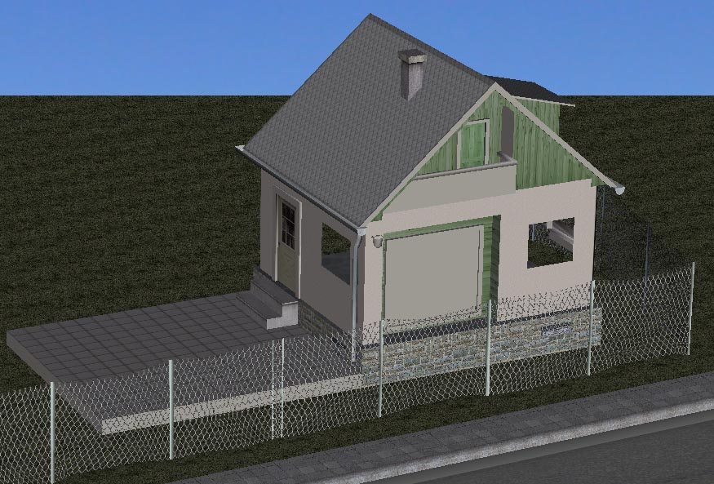
Fig. 9: Building 3 Fig. 10: Building with fence

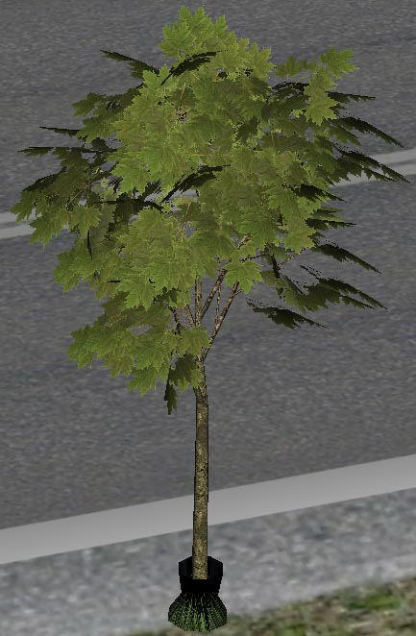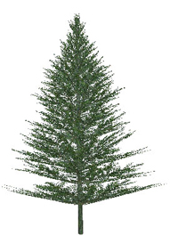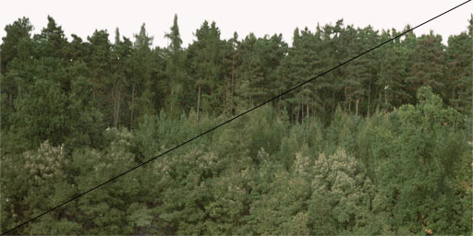
Fig. 11: Leafy Fig. 12: Conifer Fig. 13: Wood

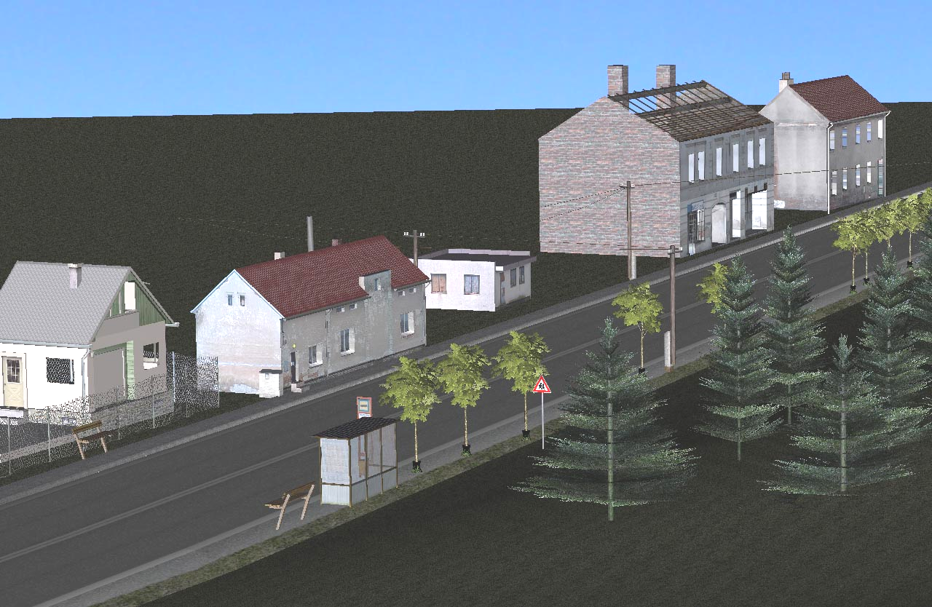
Fig. 14: Final view from particular scenery

For easier and faster orientation by searching type of models, are object hierarchical sorted to seven categories:

1) Architecture
2) Road object
3) Flora
4) Vehicles
5) Figure
6) Landscape a) Real
b) Fictive
7) Others

Architecture
In this category there are all building fragments relating to the roads. These models serve to multifarious scene, which provides more realistic view of scene (for example family houses, bridges, garages, walls etc.).
Road objects
To the road objects belong all models in direct neighborhood of the road, and has influence on traffic flow, both traffic safety and traffic information, and street lights, road barriers, billboards...
Flora
Flora does mean package of plants, trees, bushes. There are lots of complicated kinds in the real, such that these models demanding lots of polygons.
Vehicles
We can use these models for simulation and studies of passing by cars in different situations and different camera looks.
Figure
Collection of different figures (man, women, children, dogs etc.).
Landscape
To this category belong real landscape, created from real geographic information systems and landscape unreal, created without any real data.
Others
This category contains models which are not possible to be sorted to previous categories (phone box, post box, bench, table, chair etc.).
Database contains about 300 generated objects created mostly in program Zanoza modeler. Each model has a table of attributes containing detail information. This table is in XML format, for more complex use. According to this attributes everyone can simply find main information about chosen object and decide, whether to use it or not.

Table of attributes:
Example:
ID: 0001
File: dum02_fin.z3d
Category: Architecture
Object: building
Type: family house
Name_file: dum1
Description: house with grass and fence
Size: 29 kB
Faces: 1139
Extent (X,Y,Z)m: 24 x 7.1 x 27
Txt_resolution: 1024x1024x24b
Txt_file: dum02.tga
Txt_size: 3145 kB
Picture:dum.jpg
3D: ZM1.07
5 Audio system
Sound Analysis:
The car engine sound is one of the most important audio perception for the driver driving a car.
While driving real car, the engine is not usually the strongest source of the sound. But it is important for the driver to feel how fast the car drives and how fast the engine rotates. Besides the audio and visual sense there are the haptic perceptions which cause the feeling of speed. The rumble of driving a car is carried from the steering wheel to the driver’s hands, and also to the whole body by way of the seat. This is also very important but hard to simulate. In the driving simulator is convenient to simulate much more clear, strong and sharp sound than is present in the real car, especially if it is not possible to simulate haptic perceptions. The audio perceptions partially take over a task of haptic ones, which is very beneficial.
The engine itself produce sound field in the whole acoustic band. It also generates very loud subsonic tremble.
Car cab damps the sound of the engine as much as possible. It filters out higher frequencies more efficiently than the lower and subsonic. Sounds of very low frequencies are carried to the chassis, so the sound level in a subsonic band is higher in a cab than outside the car.
The sound pressure level slightly rises with rpm of the engine and with speed of the car.
The engine sound itself is very complicated and can be generated only on basis of recordings of the real car.
It is necessary to record the car engine in a high quality. The most suitable for this recording are small condenser microphones with low sensitivity, because the sound pressure levels around the car engine can be very high, there is the high risk of overload.

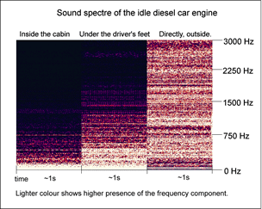
15: Sound specture of the idle diesel car engine

Fig. 16: Sound spectra of the idle diesel car engine

Synthesis:
Principle:
Because we cannot record the car sound in every situation we have to render it in real time in simulator. Probably the best way to render this sound in real time is to use multiple loops cross fading system. It uses multiple samples of recorded real car engine. Each sample is recorded on specific state (like actual rotates per minute (rpm) and load).
The simulator has a physical model, which sends actual state (rpm and load) to the audio system. The audio system qualifies the sample with the nearest state as the most suitable. The sample is slightly adapted to the exact state and played. This sequence is repeated round and attributes of the sound are updated multiple times per second.

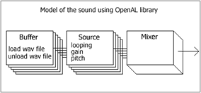
Fig. 17: Model of the sound using OpenAL library

The simplest simulation can be done using single sample played (looped) and real-time adapted to the actual conditions. But this system has high fidelity only in very small adjustments of rpm. When the actual ones differentiate from the recorded, we hear the sound distorted because the adjusted sound does not respond to reality. And of course load of the engine is not covered at all.
If there are more samples used, we have to define when each sample should play. It is necessary to define area where two or more samples play together. Where first sample smoothly rolls off and second swells. This transitional band cannot be too narrow or too wide. Too narrow transition causes us to hear ugly alteration of the sound color while rotates changes. On the other side, too wide transitional band causes degradation of the sound. The reason is that the multiple samples are played concurrently which is not soft for the listener.
The basic idea of pitching the sample with actual rpm is to use oversampling method. Shifted sample is then played with original sample rate. This method is used for emending sound with the speed. The aliasing phenomenon has to be take care of.

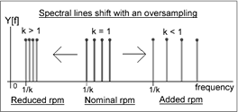
Fig. 18: Spectral lines shift with an oversampling

Taking note of engine load is more complicated. One of the ways is to record more samples and to use cross fading between them according to an actual state.
Actual speed of the car can be simulated by raising additional noise on background or by gradually added looped sample with noise. Suitable signals are brown noise, noise recorded in a driven car or other.

System can be realized with help of many libraries as Ms DirectX, OpenAL…

Measurement:
A small measurement was held to increase subjective quality of the simulated sound. Presuppositions were: cross fading looped system as a method of simulation and the five samples of car sound. The engine load wasn’t take into consideration.
The meaning of the measurement was to find optimal widths of the transitional bands between samples. Recordings were done with a diesel engine car. A sequence of rpm-values recorded on a real car was used.
Conclusion was that the widths should have risen with a rotation of the engine.
Subjective tests on six people really indicated that the most fitting widths of the transitional bands were proportional to rpm of the engine. For the engine idle (circa 800rpm) was optimal roll off about 12dB/100rpm, for rotates 2400rpm it is about 4dB/100rpm. But these values are very sensitive on particular car recordings and on the shape of the roll off curves.
Probands was also listening record of a real car beside the simulated sound. Simulated sound was described as of good quality, but as biggest imperfection was alleged the absence of taking engine load into consideration.

6 Conclusion
The physical simulation coupled with high quality VR environments has its indispensable role in the training of operators of expensive and complex technical devices. When we enhance the setup of such a system by measurements of driver’s biological signals analysis and observation of his/her performance on the road, we get a very powerful tool to investigate in drivers’ behavior. The high quality driving simulators with abilities of fast and easy adaptation on different requirements of the experiments opens wide field of possibilities in the research in the field of a car HMI and upcoming more and more demanding ITS technologies.

References:

[1] Bouchner P., Driver’s Micro-sleeps Detection Using Virtual Simulation, AIKED 2004, Salzburg
[2] Novák M., Faber J., Votruba Z., Přenosil V., Tichý T., Svoboda P., Tatarinov V., Reliability of Human Subject – Artificial System interactions, Acta Polytechnica, Volume 42, 2003.
[3] Charles F. P. George, Driving simulators in clinical practice, Sleep Medicine Reviews, Vol.7, No.4, 2003
[4] Akenine-Moller T., Haines E., Real-time rendering (2nd edition). A K Peters Ltd; July 2002.
[5] Novotný S., Automatic modeling road network in 3D virtual scene, Diploma Thesis, Faculty of Transportation Sciences, CTU, Prague, 2004
[6] Piekník R., Modeling 3D objects and create database for road virtual scene, Diploma Thesis, Faculty of Transportation Sciences, CTU, Prague, 2004
[7] Martin, G. Glen, B. Mus, M., Mus. Ph. D., Introduction to sound recording, [online], 2004,
< http://www.tonmeister.ca/main/textbook/>
[8] Creative labs developer relations, [online],
<http://developer.creative.com>
[9] Greg H., Capturing Engine Sounds, Gamasutra, 2002, [online], <http://www.gamasutra.com/
/features/20021030/hill_pfv.htm>
[10] Zmodeler2 homepage, [online], URL:<http://www.zmodeler2.com>
[11] PeDrO₂, [online],
URL:<http://pedro2.spytech.cz>
[12] Czech Office for Surveying, Mapping and Cadastre (COSMC), [online],
URL:<http://www.cuzk.cz>
[13] Bentley systems, Inc., [online], URL:<http://www.bentley.com>
[14] Road and Motorway Directorate of the Czech Republic, [online],
URL:<http://www.rsd.cz>

