Feature Extraction Based on the Structural Analysis of EEG Signals

VÁCLAV MATOUŠEK and PAVEL MAUTNER
Department of Computer Science and Engineering
University of West Bohemia in Pilsen
Univerzitní 8, CZ – 30614 PLZEŇ
CZECH REPUBLIC
http://www.kiv.zcu.cz

Abstract: - This contribution describes a novel method of the analysis of time series describing the EEG signals based on the structural analysis of signal wave forms. Two approaches to the structural analysis and consequential extraction of features will be presented – one approach based on the structural distortion of predefined signal shapes and the second one based on special linearization technique. Both approaches resolve into sequences of independent multidimensional feature vectors reliably describing the EEG signal curves in exactly given signal segments.

Key-Words: - EEG signals, structural analysis, shape transformation, linearization, feature extraction, classification

1 Introduction
Electroencephalograms (EEG) are complex signals that represent the activity of the brain. The difficulty in EEG analysis is that each recorded signal measures a mixture of several contributions: the electrical activity due to (several) phenomena in the brain itself, but also so-called artifacts, i.e. external contributions like the heart beats and eye blinking. Therefore, modern computerized methods of comparison and classification of EEG signals require a development of efficient techniques of feature extraction from sampled signals. There are many ways how to analyse and describe the recorded signals. One approach to remove the artifacts and to process the measured signals in order to separate the brain activity contributions is an Independent Component Analysis method [1]. Another approach is based on the structural analysis of signal wave forms. Two approaches to the structural analysis and consequential extraction of features will be presented here – one approach based on the structural distortion of predefined signal shapes and the second one based on special linearization technique. Both approaches resolve into sequences of independent multidimensional feature vectors reliably describing the EEG signal curves in exactly given signal segments. Especially, the second approach seems to be relatively simple and efficient; low complexity and high reliability belongs to the main features of it.

2 Feature Extraction
Having acquired and possibly transmitted EEG signals, we must prepare them for matching with other like measures. In general, a signal processing subsystem has to be divided into three tasks: feature extraction, quality control, and pattern matching.
Our first goal is to deconvolve the true signals from the presentation and sensor characteristics of the pen also coming from the electronic data collection subsystem, in the presence of noise and signal losses imposed by the transmission process. Our second, related goal is to preserve from the signals those qualities which are distinctive and repeatable, and to discard those which are not or are redundant. There are as many wonderfully creative mathematical approaches to feature extraction as there are scientists and engineers in the area of signal processing. You can understand why such algorithms are always considered proprietary. But, a lot of methods known in general are unusable for the feature extraction from EEG signals due to very special features of these signals. Then, a special feature extraction method must be developed to reach an adequate signal shape recognition rate. It is based on the combination of structural recognition methods (use of predefined signal shape primitives) and computation of numeric features of signals used additionally for pattern classification.
In general, feature extraction is a form of non-reversible compression, meaning that the original signal wave forms cannot be reconstructed from the extracted features. After feature extraction, or even before or during, we want to check to see if the signal received from the data collection subsystem is of good quality. If the features "don't make sense" or are insufficient in some way, we can conclude quickly that the received signal was defective and request a new sample from the data collection subsystem while the user stays still at the disposal. The development of this "quality control" process greatly improves the performance of our signal processing system, but its description is beyond the scope of this work.
The feature "sample" (sequence of feature vectors describing single frames of each EEG signal), now of very small size compared to the original signal, will be sent to the pattern matching process for comparison with one or more previously collected and stored signal frame patterns. The term "enrollment" refers to the placing of that feature "sample" into the pattern database in time of the collection of signal waveform patterns (system training phase). Once in the database and associated with an identity by external information (provided by the enrollee or others), the feature sample is referred to as the "template" for the individual to which it refers. The purpose of the pattern matching process is to compare a presented feature sample to a stored template, and to send to the decision subsystem a quantitative measure of the comparison. In this application, the pattern matching process is based on the computation of a minimal distance criterion with the special defined distance (see the fourth paragraph). For simplification, we assume closely matching patterns to have small "distances" between them.

3 Mathematical Background of the Method

First approach:
An incoming signal is at first segmented into so-called "peaks", i.e. into segments bounded by zero points (s(t) = 0). Each peak isolated by a zero crossing detector is classified into one class out of a predefined class set (the classes are discussed later). The given class is represented by a peak shape template (PST) which is in fact an etalon and classification is based on "peak-to-PST" distance evaluation [3]. The distance defined by a Euclidian metric is not as distinctive as needed for this task. A lucid and fast method can be used instead: For each peak few simple features are extracted:
a) number and positions of local maxima and minima,
b) positions of global extremes,
c) symmetry characteristics, and
d) value with physical meaning of gravity centre.
The PST classes are designed in the way that a peak can be classified according to few if-then rules operating over the features and their mutual combinations.
The method core transforms an incoming EEG signal into a sequence of triplets {PST, Amplitude, Duration}, where PST is the corresponding PST index, Amplitude is height of the peak, and Duration is length of the peak in samples.
Assessment of Amplitude value is not fully straightforward. The peak maximum is not suitable to be taken as an Amplitude value, because the maximum can be influenced by channel distortion, or an electrical problem in the signal path. The maximum of the incoming signal is often an isolated sample or Dirac-like impulse caused by e.g. sensor or pen plug, A/D board, etc. In order to avoid problems resulting from this, the following formula is used to compute the Amplitude value A, A = 0.5 * (s(n) + max s(n)), where s(n), n = 0, 1, …, N – 1 is the signal segment corresponding to the N-sample long analyzed peak.
Structural primitives for developed method, i.e. peak etalons, were defined after thorough scanning of 65 digitized files containing EEG data. The goal was to figure out how many different "peak shapes" they include. After gaussian convolutive filtering which smoothed the temporal course of the signal, it was observed that all the peaks could be approximated by 8 basic peak shape templates (PST) which thus represent the restricted set of structural primitives. The small number of PSTs is reasoned: It is not necessary to record superimposed sine waves which are more complex than
y(t) = C₀ sin(t) + C₁ sin(3t) + C₂ sin(5t),
where C_{n} ∈ <0 , 1>, because the parts of the signal obtained from sensors are aperodic and we reconstruct only small pieces (frames) of the "windowed" signal. As a result of this analysis, 8 basic peak shape templates (PST) were proposed and designed. Two of them (0 and 7) have a special meaning and are not analytically defined, analytical functions used to sample the PSTs No. 1 – 6 either for distance-based signal transformation or for signal reconstruction are listed in the following Table 1, their graphical representation is shown in Fig. 1.
The two etalons missing from Fig. 1 are PST 0, which represents the signal peaks with amplitude that is lower than a given threshold – simply said "no signal", and PST 7 representing those peaks which are not long enough to be reliably classified into any of the 1 – 6 PST classes (because in case where the peak is some 10 samples long, resampled PSTs are identical and it is impossible to decide which one could "fit" the analyzed peak best).
Each signal segment is processed separately and the following characteristic features are extracted from each segment:
a) kind of the peak shape template (assigned structural element),
b) its amplitude, and
c) its periodicity.
Numeric features are evaluated on basis of the structural description of signal segments: the assigned structural elements are transformed (distorted) with the aim to adapt the peak shape to the analyzed signal wave form. The coefficients of the shape transformation compose the description of the signal – one feature vector representing the adapted wave shape is assigned to each analyzed signal segment.
The wave shape of each signal segment is compared with all above defined basic functions (see Table 1) and the basic function with a minimum of Euclidean distance is chosen as the best representing waveform:
$f_{j}= \underset{∀k}{\text{min}}\sum_{i}{{\left[x_{i}−f_{k}\left(t_{i}\right)\right]}^{2}}, j,k∈ 1\text{.}\text{.} N, t_{i}=\frac{T_{k}}{N}⋅i$,

where N is the number of basic functions,
T_{k} is the period of the k-th basic function f_{k.}.

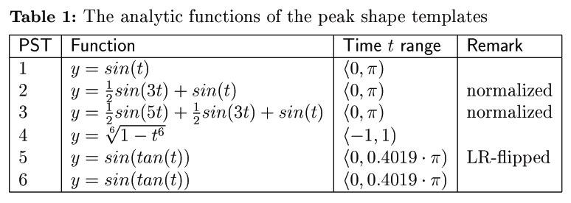
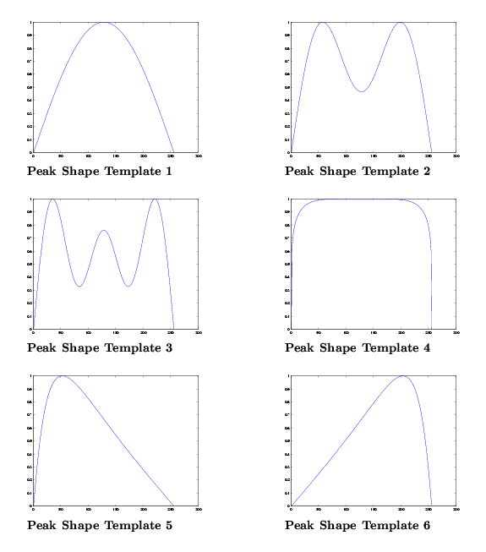
Fig. 1: Peak shape templates No. 1 – 6

Finally, the coefficients of the chosen basic function are determined for the best approximation of the segment wave and they represent the amplitude, periodicity, and translation. The coefficients of the function approximation are evaluated using a Newton iterative method, initial values of the coefficients are dependent on the choice of the basic function and they gain values 0.0, 0.5, 1.0, or 1.4, respectively. Feature vector representing the signal segment includes the number of the chosen wave, initial and computed values of the basic function coefficients, standard deviation and the variance of the approximated signal. Feature description of the analyzed (classified) character consists of the sequence of feature vectors.

Second approach:
This approach to recognition of EEG signal segments requires a decomposition of an incoming signal to constant number of signal segments, windowed by rectangular window with 50 % overlapping (see Fig. 2). Each signal segment is processed separately and is approximately replaced by a short line in each signal segment and subsegments of the concrete one as well (see Fig. 3); feature vector representing the signal segment includes then the linearization coefficients (initial and computed values of the signal wave form deviations etc.), standard deviation and the variance of the replaced signal form.

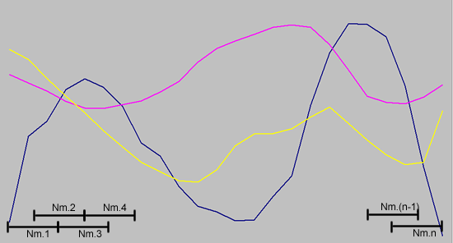

Fig. 2: Signal segmentation (windowing)

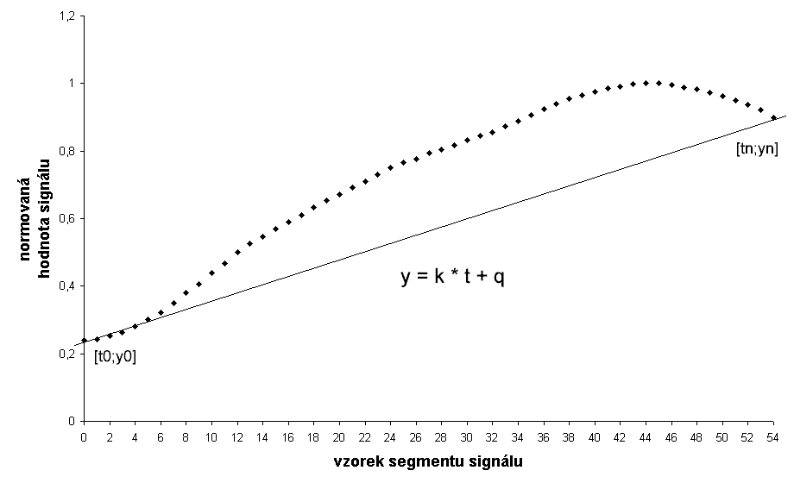Fig. 3: Linearization of one signal segment

Feature description of the analyzed (classified) part of the EEG signal then consists of the sequence of n-dimensional feature vectors.

4 Method Application
Functional features of the developed hybrid extraction method were verified on the classification of EEG signal segments recorded by 11 test-persons (probands). Each common signal segment was described by the sequence (of fixed length) of feature vectors.
An application of both approaches (alternatives of the developed method) requires:
- definition, evtl. derivation of PSTs, and determination of initial values of basic function coefficients, or definition of linearized signal segments respectively;
- generation of signal wave form patterns and storage of them in the pattern library during a training phase; this process requires the use of 5 – 10 equal or similar signal wave shapes;
- evaluation of acquired patterns by the user (labelling);
- semantic sorting of the pattern library corresponding to the user’s pattern evaluation.
The classification of unknown (classified) common signal segments is provided using a minimum distance criterion, based on an evaluation of the Euclidean distance (see above). But, there are two different levels of the distance evaluation – direct comparison of signal feature vectors at the first level and the computation of a composite distance (the weighted sum of the “first level” distances) at the second evaluation level.

5 Experimental Results
The goal of accomplished experiments was to validate the functional features and performance of the proposed method and to evaluate the algorithmic complexity of the method. Both approaches described above were tested and evaluated on a special prepared test data set.
The definition of peak shape templates (for the first approach) or the determination of signal segmentation (the length of common signal segments and the window dimension) required a detailed analysis of a sufficient set of recorded signals. To provide this step, files containing about 2 hours of EEG recordings were acquired at the special laboratory. With help of these data files the peak shape templates were derived and defined as a starting set of templates and functions for the first experiments. The Tab. 2 lists the frequencies of particular PST occurrences (percentage) in the pilot EEG signals scanned during the analysis phase.
The results were approximately the same for all the pilot EEG signal files. This might be accepted as a proof that the preliminary considerations were correct. The signals include approximately 20 % of "no signal" and about 30 % of peaks which were classified into PST 7 group – these are all the mishappened frames lying at the very border of Nyquist frequency and therefore being sampled as the isolated oscillating samples or peaks with nearly no rise and fall, few (2–5) samples long.

Table 2: Frequencies of particular PST occurrences
PST | Description | Freq [%]
0 | no signal | 18.47
1 | Sine | 6.24
2 | composed sine | 11.85
3 | composed sine | 10.62
4 | “table peak” | 1.93
5 | left-to-right slope | 10.21
6 | right-to-left slope | 9.86
7 | “short peak” (noise) | 30.82

Table 3: Results of classifier testings
Classifier | Minimum Distance | k-NN for k = 1 | k-NN for k = 2 | k-NN for k = 3
Recognition Rate | 80.1 % | 77.8 % | 78.6 % | 78.2 %

The results presented in Tab. 3 can be evaluated as a bit unsatisfying; the first approach shows moreover relatively high complexity and it requires a comprehensive training; therefore it was replaced by the second one in all further experiments.

The second approach being mainly used for detection (recognition) of predefined (known) signal wave shapes stored into the signal wave shape library was tested on the same data files containing the recorded EEG signals. Approximately 40 % of data were used for classifier training (creation of the signal pattern library), the rest as the test data to verify the features of the method. Feature vectors were created by linearization of 200 ms, 100 ms, and 50 ms long signal segments and consist of 32 items (real values). The part of results obtained using of data files of seven test persons are shown in following Tab. 4:

Table 4: Results of classifier testings achieved using the linearization technique
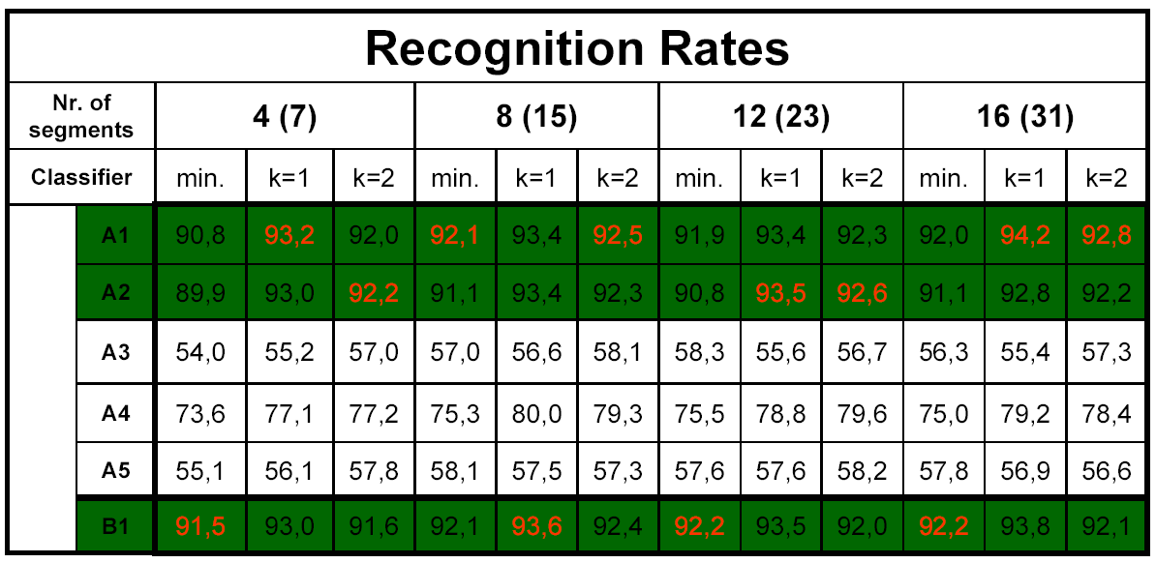

6 Conclusion
The application of both above described hybrid approaches to the feature extraction from EEG signals seems to be a forward-looking technique with which the high recognition rates can be achieved. Two different alternatives of the hybrid feature extraction method were tested; the second approach (based on the linearization technique) shows better recognition rates than the first one.

Better recognition rates were reached for recognition of “standard” signal wave forms, shapes of which are well known and the classifier was trained by sufficient set of training data.
The application of both above described hybrid approaches to the feature extraction from EEG signals seems to be a forward-looking technique with which the high recognition rates are achieved. Better recognition rates of signal part recognition were reached using the second approach, with significantly lower computational complexity at the same time. From this viewpoint, the results achieved by the second approach seem to be rather promising and auspicious.

7 Acknowledgement
The research was supported by a grant of the Ministry of Education of the Czech Republic No. ME 701 “Creation of Neuroinformatic Databases and Data Mining from them”.

References:
[1] UCL Machine Learning Group, Independent Component Analysis. http://www.dice.ucl.ac.be/mlg
[2] Novak, M., Faber, J. Votruba, Z., Problems of reliability in interactions between human subject and artificial system. NNW Publishing, Prague, 2004
[3] Ekstein K., Time Domain Structural Analysis of Speech Signals. PhD. Thesis, University of West Bohemia in Pilsen, 2002

