Fuzzy and expert system for detection and evaluation of micro-sleep

Ing. Bc. Tomáš Tichý, Ph.D.; Prof. MUDr. Josef Faber, DrSc.
Czech Technical University in Prague, Faculty of Transportation Sciences
Department of Control and Telematics,
Joint Laboratory of System Reliability
Konviktska 20, Prague 1, Czech Republic

Abstract: - The goal of this paper is to desigen a system for the detection and evaluation of the decrease of drivers´attention. The paper refers to possible reasons and risks of a phenomenon called micro-sleep. It also describes the measurement methodology. The paper apprise of a new way of detection and evaluation of micro-sleep. The methods of fuzzy system and knowledge system is used. The state of the proband is assessed by classification modules F-COMS and C-COMS which were designed specifically for these systems. The paper also describes the individual frequencies of an EEG spectrum including their mutual dependencies in particular states and individual contributions in a detailed way. The conception of the proposed system for detection and evaluation of the decrease of attention ensues from the uniqueness of an individual, and the inaccuracy of measurement on humans, as well as from the universality of a system construction, capable of detecting not only the inattention of a driver, but also his/her maximum concentration or pathological changes.
Key words: - EEG, fuzzy system, knowledge system, micro-sleep.

1 Introduction
Problems of reliable interaction between artificial systems and human beings has not been solved satisfactorily. Implementation of new technologies with elements of intelligence decreases the probability of defects and increases the service life of such devices, but at the same time it is more demanding with respect to the reliability of human operators.
Operators who work with a complex and efficient artificial systems such as transport systems (aircraft, train expresses, trucks, ships), extensive power station systems, security and defensive systems and others, have to make fast and correct decisions maintaining maximum focus and concentration on a specific task. These complex demanding tasks are connected with many other internal and external factors such as length of working hours, mental and physical state, extreme climatic conditions, quality of working environment, but also monotonous scenes the operator is observing.
The present focus of our research is on the recognition of the decrease in attention and thereby the decrease of reaction on the created stimulation. The observation of an almost constant scene or view and the personal indisposition of an operator may result in a significant decrease of his attention which might lead to a micro-sleep (momentary drowsiness). This state of a human brain is very dangerous and may lead to huge material and financial damages, and, even worse, to losses of human lives.
To be able to detect the decrease in the operator’s attention while interacting with systems, we have to monitor the most significant parameters, which would unambiguously identify the decrease of attention, and the possible accession of micro-sleep. The most significant parameters are: the electric activity of brain; frequency of breath; heart beat frequency; eyes movement (or lid movement if needed) and others.
The attention of a human operator fluctuates constantly. These changes can be, in the course of the operator’s activity, quite considerable. Very often it is the monotony and fatigue that leads to the decrease of attention and micro-sleep.
A micro-sleep is a short-period decrease of attention, which results from a short-period of the first phase of a synchronous sleep.
Our workstation specializes in measuring electrical brain activity. Electronic brain activity rises by synchronization of a large population of neuron cortex near the thalami-cortical oscillation. The brain activity is scanned by electrodes placed on the skull surface, and the potentials are transcribed in time the EEG curve.
The EEG recording measured on the skull of human operator has very little energy and so electric potential is in the order of only tens of μV. Therefore, electrodes are used incased in plastics, and the transmission from the skull surface to the electrode is enhanced by conductible gel (which decreases impedance), or we use tin or Ag/AgCl electrodes, which also use conductible gel as a means of transport.
The resulting EEG records are processed with the aid of the Fast Fourier Transformation (FFT), the single spectra being derived from these records. The fundamental brain frequencies are: delta (0,5 - 3,5 Hz), theta (4 - 7 Hz), alpha (8 - 13 Hz) and beta (14 - 30 Hz).
By comparing the spectra of different states of the human brain (vigilance, mental activity – reading, counting, drowsing, sleep) the characteristic distribution and representation of the single frequency for an actual state can be dermined.

2 Measuring
As noted above, the attention of human operators, constantly changes over the time. In order to determine a subjective limit of the operator’s attention decrease, the changes of his reaction times are measured.
To ascertain the beginning of a micro-sleep we measure the reaction time which is the length of the time of the sound or optical stimulus. Based on the research of these times we ascertain the intensity of a micro-sleep till the onset of the first phase of the synchronic sleep. This measurement is done by an external timing module that is connected with two computers precisely transfering the reactions of a human operator directly into the EEG curve on the second computer, see figure 1.

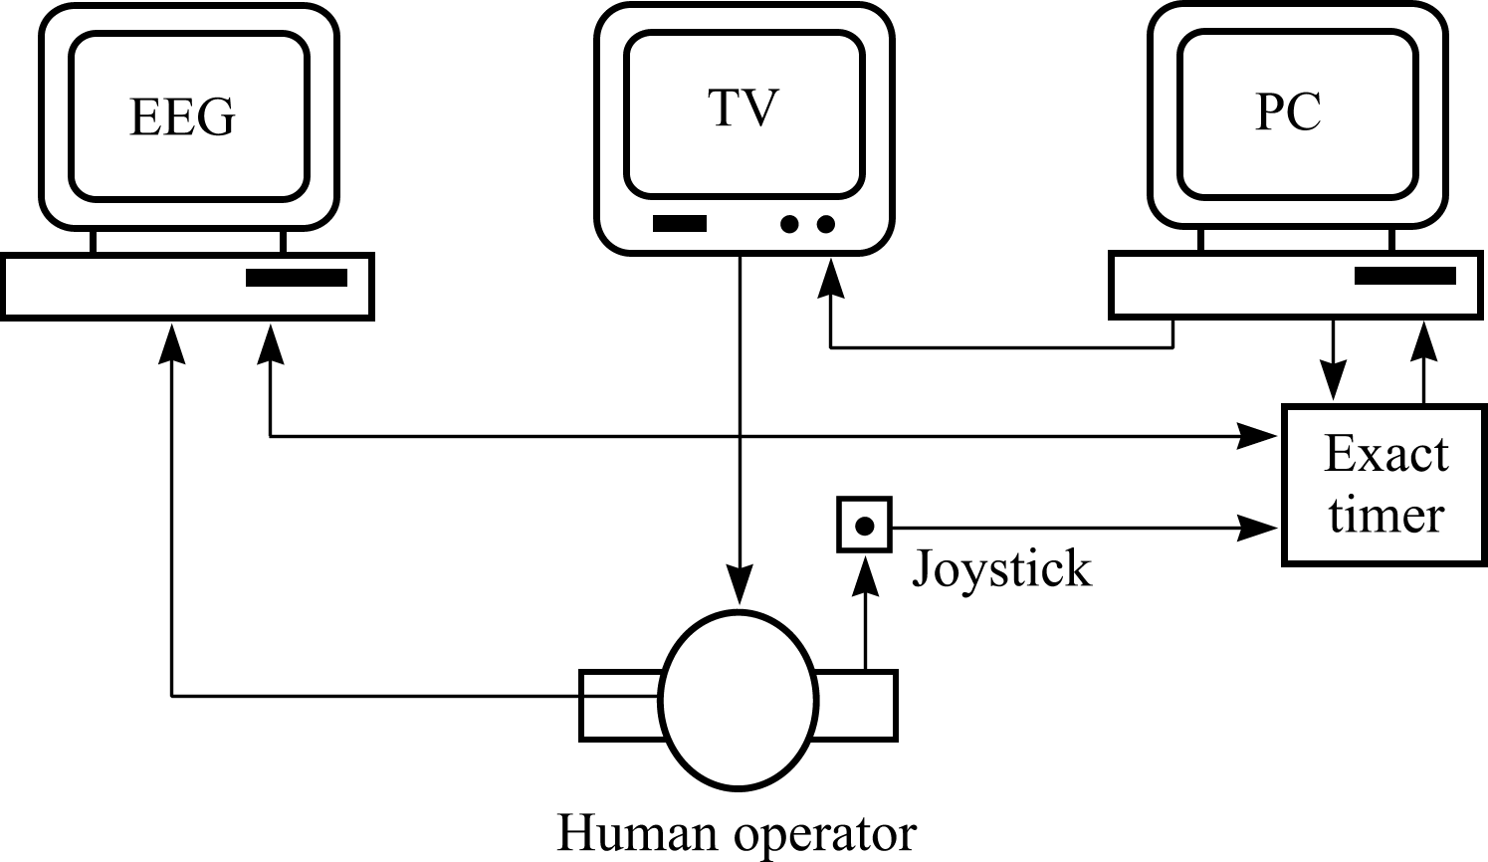
Figure 1. Diagram of EEG recording with reaction times

To simulate the conditions of a human operator in traffic, a video is showing the tested person a TV screen with a similar view he can see during his long hours of duty. At the same time we force the operator to react to several visual or sound cues.

3 Methods of working
After recording the EEG with reaction times to an accuracy of milliseconds, we process this information with FFT and obtain a spectral curve.
For the first processing of measuring data we used spectrum analysis for individual states of measuring a human (close eyes – CE, open eyes – OE, calculation – Cal., test of Reven – Rav., vigilance – Vig., relaxation – Rex. and sleep – Sp.) with the help of software from the company ALIEN technik ltd. [18]. We processed measuring of four basic states:
- Vigilance
- Thinking
- Relaxation
- Sleep
The software was created in MATLAB 6.0, which filters the measuring data with the help of Butterworth filter from 1 Hz to 20 Hz, and the Welch method spectrum analysis was made for the selection of a 3 second segment of EEG record for a competent selected electrode [11]. We created processing of EEG curve for 16 chosen tested persons.

3.1. Basic frequency of EEG spektra
The measuring curve was processed with the help of the spectral analysis devided in to four basic frequencies. We can discriminate the individule states for measuring a human if we know the basic frequencies. They are the following:
- Delta – δ – (1 – 3,5 Hz)
- Theta – ϑ – (4 – 7,5 Hz)
- Alpha – α – (8 – 13,5 Hz)
- Beta – β – (14 – 20 Hz)
These frequencies were processed for seven possible states of the measured person (CE, OE, Cal., Rav., Vig., Rex. and Sp.). From these results, approximate division to three basic groups in dependence on reaction time [14] can be determined. In addition, the process of thinking has to be taken into account, which significantly intervene with the changes of the individual frequencies in the EEG measuring.
We can devide the states of the proband in to four basic states:
Vigilance – the reaction time being in the interval <180 - 400 ms>. The measuring person is not concentrated on any subject. The decisive brain activity is delta frequency, and at the same time alpha frequency appears, which is more perceptible at closed eyes. Theta and beta frequencies are not distinct. From the seven states of the measured proband, OE and Vig. (which is a state with the eyes closed), can be included into the state of vigilance. In this paper we are going to use the term „Vigilance“, by which the state with open eyes (OE) is meant.
Thinking – the reaction time has been mesured, but the number of the reaction time is likely to be over 400 ms in dependence on the concentration and the solution of the task. The decisive brain activity is delta frequency, which is considerably higher than at vigilance and at sleep. Theta frequenc increases. Alpha and beta frequency are not distinct either. The state of thinking is very similar to the first stadium of the sleep, but the delta frequency is more distinct. From the seven states of the measured proband, Cal. and above all, Rav. (with open eyes), can be included into the state of thinking. In this paper we are going to use the term „Thinkinig“, by which the state during the Raven test (Rav.) is meant.
Relaxation – the reaction time being in the interval <400 - 800 ms>. The measured person is in the state of relaxation and without concentration on the certain task. Decisive brain activity is alpha frequency, which is a dominant frequency. Delta and theta frequencies increase only a little, and beta frequency is not distinct. From the seven states of the measured proband, Rex.. and CE (which is as like as relaxation), can be included into the state of relaxation. In this paper we are going to use the term „Relaxation“, by which the state during the relaxation (Rex.) is meant.
Sleep – the reaction time being in the interval <800 - 1200 ms>. The measured person reacts on an outside stimulus, but can come over to the first stage of a synchronous sleep or it already is in the first stage of a synchronous sleep. Delta frequency has a distinctly higher value than at vigilance, but this value is lower than at thinking. Alpha frequency starts to fall and is lower than at relaxation. Theta frequency starts getting higher, but beta frequency is not distinct. From the seven states of the measured proband, Sp., can be included into the state of sleep. In this paper we are going to use the term „Sleep“, by which the state during the sleep (Sp.) is meant.
The examples of the frequency spectra for the individual states are showen in the figure 2.

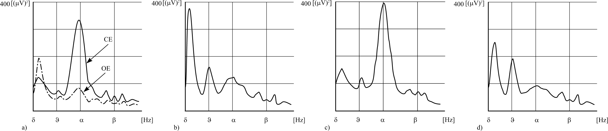
Figure 2: a) Spectrum of EEG for state of Vigilance (CE and OE).
b) Spectrum of EEG for state of Thinking (Rav.).
c) Spectrum of EEG for state of Relaxation (Rex.).
d) Spectrum of EEG for state of Sleep (Sp.).

This devision into four groups is subjective, has, however, its evident value. Every human is an individual, whose EEG curve is specific, as well as the distribution of parameters describing the basic states. The reaction time is a secondary value for verification and testing of the measured human and the orientation in the EEG graph.

3.2. Expanded frequency of EEG spektra
For a detailed evaluation frequency of the spectra with regard to the seven selected states, basic frequencies were separated into smaller intervals. These intervals were able to describe the individual states of the proband or factor of each frequency could be defined, which had an influence on the state of the proband. We devided the frequencies of the sixteen graphs into the slow (index 1) and the quick ones (index 2):
- Delta frequency – delta1 – δ1 – (1 – 2 Hz),
– delta2 – δ2 – (2,5 – 3,5 Hz),
- Theta frequency – theta1 – ϑ1 – (4 – 5,5 Hz),
– theta2 – ϑ2 – (6 – 7,5 Hz),
- Alpha frequency–alpha1 – α1 – (8 – 10 Hz),
– alpha2 – α2 – (10,5 – 13,5 Hz),
- Beta frequency – beta – β – (14 – 20 Hz).

The beta frequency was not separated, because is not distinct and contains artefacts. Beta frequency was thought for full the description and the process spectrum in the particular states.
Statistic description was made and the findigs were the same as in the basic frequency EEG spectrum, e.i., the diffuseness data file for the individual and separated frequencies were about 100%. It is very difficult to provide general rules for measuring a human being, so we had to approach each proband individually.
From the above mentioned description it can be stated that the individual components can be compared at slow and quick frequencies for four basic states of measuring a human.
Vigilance – Decisive frequency for delta frequency is the slow frequency δ1, for theta frequency it is the slow frequency ϑ1, too. Τhe decisive frequency for the alpha frequency is the quick frequency α2.
Thinking – Decisive frequency for delta frequency is the slow frequency δ1, for theta frequency it is the slow frequency ϑ1, too. Τhe decisive frequency for the alpha frequency is the quick frequency α2.
Relaxation – Decisive frequency for delta frequency is the slow frequency δ1, for theta frequency it is the slow frequency ϑ1, too. Τhe decisive frequency for the alpha frequency is the quick frequency α2.
Sleep – Decisive frequency for delta frequency is the quick frequency δ2, for theta frequency it is the slow frequency ϑ1, too. Τhe decisive frequency for the alpha frequency is the quick frequency α2.
Both the individual slow and quick frequencies of the basic activities were determined by the number of appearances of the particular activities of the probands. The describtions of the slow and quick frequencies are rather individual, but it is possible to use them for detailed or as help descriptions at individual states of measuring a human.
3.3. Relation of brain frequency
We can compare the individual frequencies in a human, as it is shown in the figure 3.1, which describes the individual states of the proband.
We provide four coefficients of proportions of EEG activity and only one coefficient with beta frequency. The beta frequency has a small value, contains artefacts, and is not suited for confrontion with the alpha and delta frequencies. Basic coefficients of proportion of the EEG activity are:
- Coefficient of proportion alpha/delta – k_{α/δ}
- Coefficient of proportion alpha /theta – k_{α/ϑ}
- Coefficient of proportion delta/theta – k_{δ/ϑ}
- Coefficient of proportion beta/theta – k_{β/ϑ}

Individual coefficients of proportions of the EEG activity are applied for both, the slow (index 1) and quick frequencies (index 2). We can describe the states of a human, if we know the value of the individual coefficients, which are different from number 1 or are parts of specific interval I_{k} = <k_{min,} k_{max}>.
The individual states of a human in dependency of coefficients are:
Vigilance – Value of coefficients k_{α/δ} < 1; k1_{α/δ} < 1 and k2_{α/δ} < 1.
Value of coefficients k_{α/ϑ} > 1; k1_{α/ϑ} > 1 and k2_{α/ϑ} > 1.
Value of coefficients k_{δ/ϑ} > 1; k1_{δ/ϑ} > 1 and k2_{δ/ϑ} > 1.
Value of coefficients k_{β/ϑ} > 1; k1_{β/ϑ} > 1 and k2_{β/ϑ} > 1.
In individuals, the coefficients k_{α/ϑ} and k_{β/ϑ} , may be different from the value 1.
Thinking – Value of coefficients k_{α/δ} < 1; k1_{α/δ} < 1 and k2_{α/δ} < 1.
Value of coefficients k_{α/ϑ} < 1; k1_{α/ϑ} < 1 and k2_{α/ϑ} > 1.
Value of coefficients k_{δ/ϑ} > 1; k1_{δ/ϑ} > 1 and k2_{δ/ϑ} < 1.
Value of coefficients k_{β/ϑ} < 1; k1_{β/ϑ} < 1 and k2_{β/ϑ} < 1.
In individuals, the coefficients k_{α/ϑ} and k_{β/ϑ} , may be different from the value 1. The value of the coefficient k_{α/δ} at thinking is lower than the value at vigilance, and the coefficient k_{δ/ϑ} at thinking is lower than at vigilance, too.
Relaxation – Value of coefficients k_{α/δ} > 1; k1_{α/δ} > 1 and k2_{α/δ} > 1.
Value of coefficients k_{α/ϑ} > 1; k1_{α/ϑ} > 1 and k2_{α/ϑ} > 1.
Value of coefficients k_{δ/ϑ} > 1; k1_{δ/ϑ} > 1 and k2_{δ/ϑ} > 1.
Value of coefficients k_{β/ϑ} < 1; k1_{β/ϑ} < 1 and k2_{β/ϑ} < 1.
In individuals, the coefficients k_{δ/ϑ} and k_{β/ϑ} , may be different from the value 1. The value of the coefficient k_{δ/ϑ} the relaxation is lower than the value at vigilance and thinking.
Sleep – Value of coefficients k_{α/δ} < 1; k1_{α/δ} < 1 and k2_{α/δ} < 1.
Value of coefficients k_{α/ϑ} < 1; k1_{α/ϑ} < 1 and k2_{α/ϑ} > 1.
Value of coefficients k_{δ/ϑ} > 1; k1_{δ/ϑ} < 1 and k2_{δ/ϑ} > 1.
Value of coefficients k_{β/ϑ} < 1; k1_{β/ϑ} < 1 and k2_{β/ϑ} < 1.
In individuals, the coefficients k_{δ/ϑ} and k_{β/ϑ} , may be different from the value 1. The value of the coefficients k_{α/δ} and k_{α/ϑ} the sleep are higher than the value at thinking, but lower than the value at vigilance.
The value of the individual coefficients and the coefficients of the slow and quick frequencies are very individual. The states of a proband can be described by these coefficients. We can create decision levels with regard to the size of ratio and reciprocal confrontation. We can take the coefficient k_{β/ϑ} for refinement, but without larger signification. The values of individual ratios can be given exactly or in the definite interval I_{k} = <k_{min,} k_{max}>.

4 Results
This chapter describes a project of system for the detection and evaluation of the decrease of attention in the measured probands. Simplification block diagram of the measuring equipment is illustrated in figure 3, which is able to evaluate the states of the measured proband. The system is composed of these basic sections:
- Preprocessing of signal – the EEG signal of the proband is scanned, and is preprocessed before being sent to next level of the processing of the signal.
- Transfer of signal – a suitable transfer medium, which can transfer the measuring signal from a human to the place of processing.
- Processing of EEG signal – EEG signal is processed by the means of spectral analysis to the individual frequency bands.
- Evaluation – evaluation and confrontion of the individual frequency bands; classification by the competent states of a proband.
- Output – warning of the danger or the onset of micro-sleep or the decrease of attention.

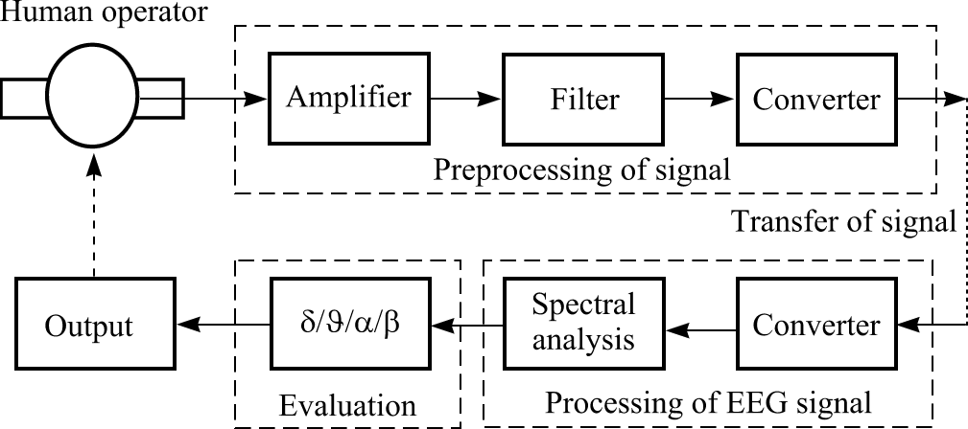

Figure 3: Block diagram of measuring equipment.
This paper describes generally the equipment for detection of the decrease in attention with the emphasis on the evaluation block, which is able to analyze the EEG spectrum and make decision about the enlistment of states of the proband.

4.1. Evaluation systém
After the processing of the EEG signal it is necessary to evaluate the signal and to decide which state of a proband is available, and to prepare the signal for output. The system for detection of the individual states of a human and the dangerous decrease of attention or a micro-sleep is designed in this paper. A block diagram can be seen in the figure 4.
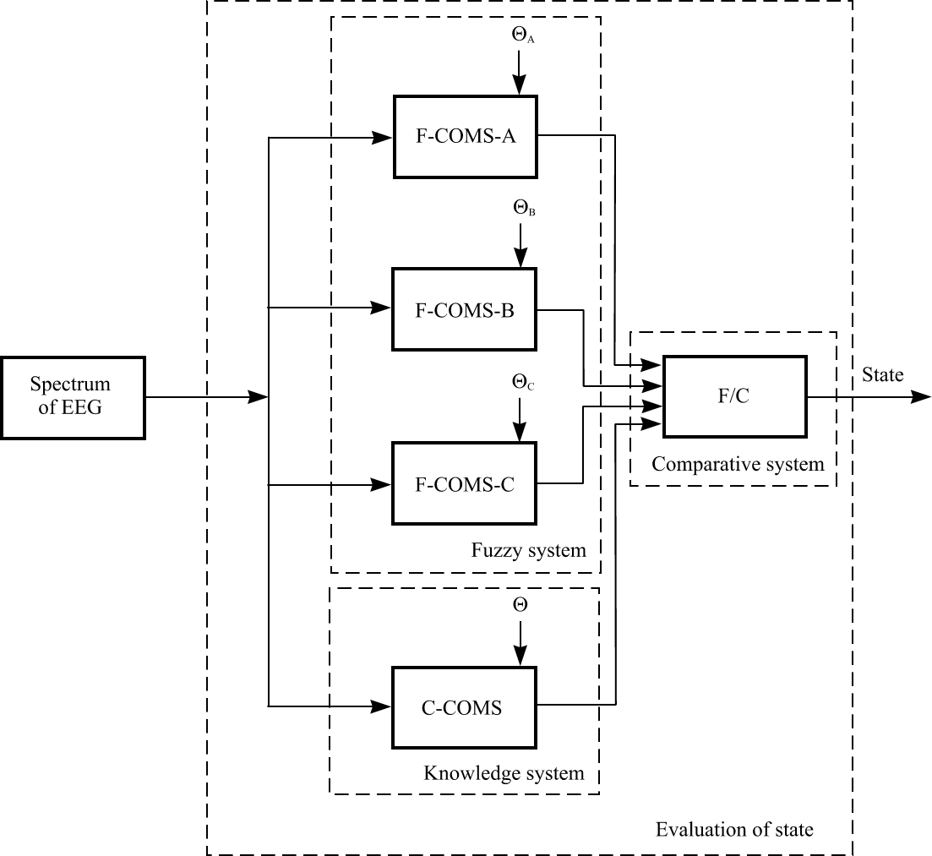

Figure 4: Block diagram of evaluation system.

The evaluation system of the state of a proband is composed of three bacis subsystems:
- Fuzzy system
- Knowledge system
- Comparative system
It is possible to determine the state of a proband comparing the individual states from comparative system and the individual weights „Θ“. This system was simulated in SW MATLAB 6.0.

4.1.1. Fuzzy system
A fuzzy system consists of individual blocks of fuzzy classificatory. We used three classificatory, which are evaluated individual weights.
F-COMS-A – basic frequencies are sent as an input of the fuzzy classificatory module, and four basic states of a proband are interpreted at the output. Individual rules of allocation are provided separately. The weight Θ_{A} is set for this fuzzy classificatory at the highest value from all the three fuzzy classificatory. The reason is the application of the basic frequencies of the EEG spectrum. The output will be provided by the state A and the first setting will be the weight of 0,5.
F-COMS-B – the slow frequencies of basic EEG spectrum frequencies are sent to enter the fuzzy classificatory module, and after the exit, the four basic states of the proband are interpreted. Individual rules of allocation are provided separately. The weight Θ_{B} is set for this fuzzy classificatory at a lower value than the value of the fuzzy classificatory A. The output will be provided by the state B and the first setting will be the weight of 0,3.
F-COMS-C – the quick frequencies of basic EEG spectrum frequencies are sent to enter the fuzzy classificatory module, and after the exit, the four basic states of the proband are interpreted. Individual rules of allocation are provided separately. The weight Θ_{C} is set for this fuzzy classificatory at a lower value than the value of the fuzzy classificatory A. The output will be provided by the state C and the first setting will be the weight of 0,2.
These three fuzzy classificatories are based on the language descriptions of the individual states, the brain activity and the slow and quick frequencies. The weights can be balanced in advance, according to the significance of the particular classificatory, which are the results of the first measurings of a proband.

4.1.2. Knowledge systém
Comparing the three fuzzy classificatory may not always be sufficient, because the rules implying all the combinations also include complex rules to determine the state of the proband. Therefore a simple knowledge system was added into the evaluation system, which is used for comparing the coefficients of the proportion of the individual frequencies. This knowledge system should support the solution of complicated problems of the evaluation of the proband´s states. It is very difficult to provide an exact algorithm for the state determination, because the states of a proband change in time, for example, the differentiation of the state of sleep and the state of thinking is not easy.
The knowledge system with output value H has a competent weight Θ with the first setting at the value of 0,75. The weight of the knowledge system can more or less prefer the knowledge system to the prejudice of the individual fuzzy systems. Of course, the weight of knowledge system can be modified in favour of a fuzzy system in dependency on quality of our setting.
4.1.3 Comparative system
The evaluation system compares the particular fuzzy systems respectively and compares the fuzzy systems with knowledge system. At the same time the system of evaluation takes the weighting of setting of a particular system into account. An evaluation system can be created using two basic techniques. First, we use comparative logic for individual states of a proband. Second, we can use a certain aggregation function, which will set a resulting state.
In the paper, a simple aggregation function is described, which was simulated in SW MATLAB 6.0; it uses weight average of the particular systems.
Formula for calculation of the state of the proband:
$$V_{S}=\frac{H(Θ+ϕ)+A(Θ_{A}+ϕ_{A})+B(Θ_{B}+ϕ)+C(Θ_{C}+ϕ_{C})}{4}$$
This calculation specifies the state of measuring a human. Coefficients of weight are included in the calculation and are modified on the basics of the number of individual states, which are saved in the memory. The time of comparing the modifed coefficients of weights φ, φ_{A}, φ_{B} a φ_{C} is given by the number of individual states. Particular systems can modify the coefficients of weights differently. Weights and coefficients of weights are in interval <0, 1>.
The coefficients of weights can be modified similarly to the entire weight setting of the systems, dependent on measuring and processing of the proband and his setting evaluation block. Setting coefficients of weights are separate in each block of a fuzzy or knowledge classificatory in dependency of the number of states. The numbers of states should be ensured by the on-line measuring of the proband´s decrease of attention.

4.2 Assessment of Evaluation system
In order to be able to assess the quality and reliability of the designed classificatory, a training and testing set is to be available to measure the individual states of a proband. We introduced seven states of a human for this purpose, which we reduced to four basic states of a proband (vigilance, thinking, relaxation and sleep). We chose sixteen graphs for different measurings of a proband. The graphs were conditioned by providing all the seven basic states, reaction times and no artifacts. We chose a suitable electrode, too. We found parallelism for sixteen graphs, but in detailled description the individual states were found different.
Therefore a graph containing a major quantity of suitable segments for the states of a proband was chosen, and we set coefficients, weights and rules for competent states of the proband. The system correctly evaluated the individual states approximately at 85% of success. We have to consider that the states of the proband, such as the calculation and vigilance with closed eyes, can be taken as relaxation (the dominant is frequency alpha). If individual rules are set correctly the coefficients and weights are to possible to reached with reliability over 90%.
Compared with a particular fuzzy classificatory, the highest reliability is F-COS-A, which can be evaluated with a reliability over 75%, fuzzy classificatory F-COMS-B over 70% and fuzzy classificatory F-COMS-C below 70%. The reliability is dependent on the setting of a universe fuzzy set, it means, for a better reliability the number of the data for a setting and the number of measurings are very important.
Comparing with the knowledge system, its reliability is about 80%. For this setting we need more data, too. The reliability of the knowledge system is higher than the fuzzy classificatory.
System of the evaluation enables the change of weight in dependency of the states of thinking, relaxation and sleep. The change of coefficients of the particular weights is very important, above all, the state of relaxation, because the state of relaxation precedes the state of sleep.
We can say indirectly, that the transition from relaxation to the first stadium of sleep can be regarded as the decrease of attention or a micro-sleep.
This classificatory able to recognize the individual states of measuring a human, using a fuzzy and knowledge system, and to detect a dangerous decrease of attention.

5 Conclusion
For the detection of the decrease in attention we used the measuring method of the electrical brain activity (electroencephalograph – EEG). We chose sixteen graphs with seven states of a human being. The states were compared reciprocally for all individual probands. The research proved that it was practically impossible to determine uniform rules or mathematical dependency. We can generally describe the states of a human, but the processes of the frequency spectra are highly individual. We divided the basic frequencies into slow and quick frequencies of the spectra, with no frequency beta (the frequency beta contains artifacts). Both the slow and quick frequencies are individual. We defined particular coefficients of the proportions for basic, slow and quick frequencies for the individual probands.
We proposed a system of evaluation of the decrease in attention on the basis of language descriptions and calculations the coefficients of proportions. We simulated the evaluation system in MATLAB 6.0, the system of evaluation being a subsystem for detection and evaluation system of the decrease in human attention.

References
[1] Amundsen A. H., Sagberg F.: Hours of service regulations and the risk of fatigue- and sleep-related road accidents. T∅I Report, Oslo, 659/2003.
[2] Bittner R., Smrčka P., Pavelka M., Vysoký P. a Poušek L.: ECG, EEG and EOG based fatigue indicators. Presented at Intelligent systems in patient care, Vienna, 2001, 01110801.
[3] Brühning E, Haas I., Mäder H., Pfafferott I., Poepple-Dacker M.: telephone use while driving and traffic safety. 9th International confernce – Road safety in Europe, Bergish Gladbach/Cologne,Germany 1999.
[4] Faber J.: Electroencephalography. Prague, UK, 1992.
[5] Faber J.: Electroencephalography and psychophysiology. DVL Prague, 2000.
[6] Gevins A. S., Rémond A.: Methods of analysis of brain electrical and magnetic signals. Handbook of electorencephalography and clinical neurophysiology. Amsterdam-New York-Oxford, Elsevier, 1987.
[7] Malaviya A.: On-line Handwriting recognition with a fuzzy feature descriotion language. Disertation work, TU-Berlin 1996.
[8] Novák M. a collective: Artificial neuron network, theory and application. Prague, C. H. Beck, 1998.
[9] Novovičová J.: Probability and mathematics statistic. CTU, Praha, 1999.
[10] Pokorný M.: Artificial intelligence in simulation and control. BEN, Praha, 1996.
[11] Rosa A.C. Allen Lima J.: Fuzzy Classifikation of Microstructural Dynamics of Human Sleep. IEEE-SMC 1996, pp 1108-1113.
[12] Svoboda P.: Methods of analyses of EEG activity. Dissertation. CTU, Prague, 2001.
[13] Štikar J., Hoskovec J., Štikarová J.: Psychology in traffic. UK, Prague, 2003.
[14] Tichý T., Bureš Z.: The problem of detection of micro-sleep on human operator. University of Central Florida, Orlando, Florida, USA, 2001.
[15] Tichý T.: Identification of system for detection of micro-sleep with fuzzy methodology. Development No. LSS 98/2001, Prague, 2000.
[16] Tichý T.: Selection of significant parameters of drivers` attention decrease. Dissertation. CTU, Prague, 2000.
[17] Tichý T.: System for detection and evaluation of micro-sleep. Disertation work, Prague, 2003.
[18] Wierwille, W.W., Ellsworth, L.A., Wreggit, S.S., Fairbanks, R.J., Kirn, C.L.: Research on Vehicle-Based Driver Status/Performance Monitoring; Development, Validation, and Refinement of Algorithms For Detection of Driver Drowsiness. U.S. Department of Transportation, National Highway Traffic Safety Administratlon. DOT HS 808 247, Final Report (1994).
[19] ALIEN technik ltd.: User manual for apparatus of EEG 2/32. Hronov, CZ, 2003.

