Registration and Evaluation system of the physiological data

PRENOSIL, Vaclav, BURES, Zbynek
Department of Automated system and Informatics
University of Defence
Kounicova 65, 612 00 Brno
Czech Republic

Abstract: - The unsatisfactory reliability of nearly all-artificial systems in use by man through out history represents one of the main problems of mankind. The main reason for this unfavorable situation can be seen in increasing requirements on an operator’s ability. The goal of this article is to suggest the system of detection and evaluation of decrease of a driver’s attention. It describes a modular system, which can record and evaluate physiological data in real time. The modular system is based on the digital signal processor (DSP) ADSP2191 utilizing a field programming gate array (FPGA) Xilinx.

Key-Words: - System of evaluation physiological data, Digital Signal Processor, Programming Gate array

1 Introduction
The unsatisfactory reliability of nearly all-artificial systems in use by man through out history represents one of the main problems of mankind. This is caused not so much by the low reliability and short lifetime of artificial systems themselves, but very often is due to various errors by human operators who deal with such systems. Naturally, the losses caused by artificial system operation faults are proportional to their power, significance and value. In the case of many modern transportation systems (planes, fast trains, large ships, trucks), large power plants, important financial systems, security and defense systems, and also important medical care systems, the losses caused by their malfunction could be extreme high or also of catastrophic character.
Therefore, besides the continuing interest in diminishing the probability of technical failures in any artificial system as much as possible (with respect to economically acceptable expenses), considerable interest has also been shown in recent years in the reliability of system operator activity. Many statistics demonstrate that the amount of human error represents a still larger proportion of all the expenses, which are required for the compensation of artificial system malfunctions.
The requirements on a human operator of an artificial system can be concentrated in the following main categories:
a) requirements on attention level and continuity,
b) requirements on the speed of operator reaction,
c) requirements on the correctness of operator decisions.
Within all three above-mentioned categories of the reliability of human operator - technical system interaction a correlation naturally exists. A straightforward correlation exists between attention level and speed of reaction. Operators functioning at a high level of attention usually also possess very fast reactions. On the other hand cases can appear, when fast, almost impulsive reaction may not be accompanied by very high level of the operator’s concentration and attention. Some people can react fast also when their attention is shared by very different objects (they have very fast reflexes).
In addition, a high level of attention in the majority of cases leads to a very high probability of correct decisions and vice versa - if somebody is not concentrating enough, there is a rather low probability that his/her decision will be correct.
On the other hand, in the case of very fast reactions accompanied by a very low level of a human operator’s attention, the probability of an incorrect decision can increase significantly. This is typical for a so-called surprise reaction, from which a transition to a panic reaction can sometimes be observed.
The main reason for this unfavorable situation can be seen in increasing requirements on an operator’s ability, his/her level of continuous and long-time attention, the speed of his/her reactions and monotonous scenes or view which operator must watch.
A drop in the attention level of a particular human operator can be caused by various external or internal reasons; some of them have a general character; the intensity of others depends significantly on the operator’s individuality. Among the general conditions causing the decrease in attention are:
- extreme length of a particular operator’s service without breaks,
- operator’s physical and mental exhaustion,
- monotonous scene which the operator has to observe for a long time,
- extreme temperature in which the operator has to serve (too high or too low),
- extreme humidity in which the operator has to serve (too high or too low),
- extreme air pressure,
- air smell, dust density etc.
Matters leading the operator to concentrate on problems other than his/her main service can likewise cause attention to drop. All these circumstances in combination with a monotonous character of the operator’s service, the scenes that are observed by him/her and his/her possible personal indisposition could lead to a micro-sleep. Before starting the discussion of the problems of micro-sleep, we shall try to define this curious state of the human organism. Micro-sleep is such a state of the human organism, in which the mental vigilance and attention of the human operator controlling some artificial system decreases for a maximum acceptable value below a certain limit.
The problem of the possibility for improvement of the reliability of interaction between a human operator and some technical system solved formerly my colleges. The main methodical tool considered here for the purpose of detection and prediction of an operator’s micro-sleep is the analysis of EEG signals resulting from thalamo-cortical oscillations, which can be detected in the human operator’s head. If the results of such an analysis are presented back to the particular operator in a suitable way, they can have positive influence the level of his/her attention. A possible recommendable set of significant parameters (markers) of EEG character, suitable for micro-sleep detection is proposed, its practical application discussed and preliminarily experimentally verified.
The goal of this article is to suggest the system of detection and evaluation of decrease of a driver’s attention (record system). It describes a modular system, which can record and evaluate physiological data in real time. The modular system is based on the digital signal processor (DSP) ADSP2191 utilizing a field programming gate array (FPGA) Xilinx. A system of communication between modules and program’s layers architecture are described in detail. We want to use different types of signals (EEG, ECG, eye movement, temperature, pressure, etc.) for evaluation. This is the reason why it was necessary to create a new format and data structure for recorder and destination computer (used for data storage and data mining). When the system finishes evaluation it sends the result to the signaling equipment. The signal equipment must wake-up a proband and log this event. There was suggested a system of transfer of the proband’s actual state too.

2 Problem Formulation
The record system of detection and evaluation of decrease of a driver’s attention architecture is showed on figure No. 1. The main idea is make possible to on-line evaluation of micro-sleeping markers firstly and immediate warning of operator - driver secondly. In this time is not known useful computing executions therefore the architecture of the record system is extensible. The module showed on figure No. 1 presents basic module of the record system in this sense.
Figure No. 1: Architecture of the on line record system
Data are saved in memory Compact Flash type. External analog-digital converters are connect to control microcomputer by FPGA structure XILINX type. Interface USG enables external communication and immediate warning. In role of control mikrocomputer is used digital signal processor Analog Devices ADSP2191. Its block diagram is on figure No. 2.
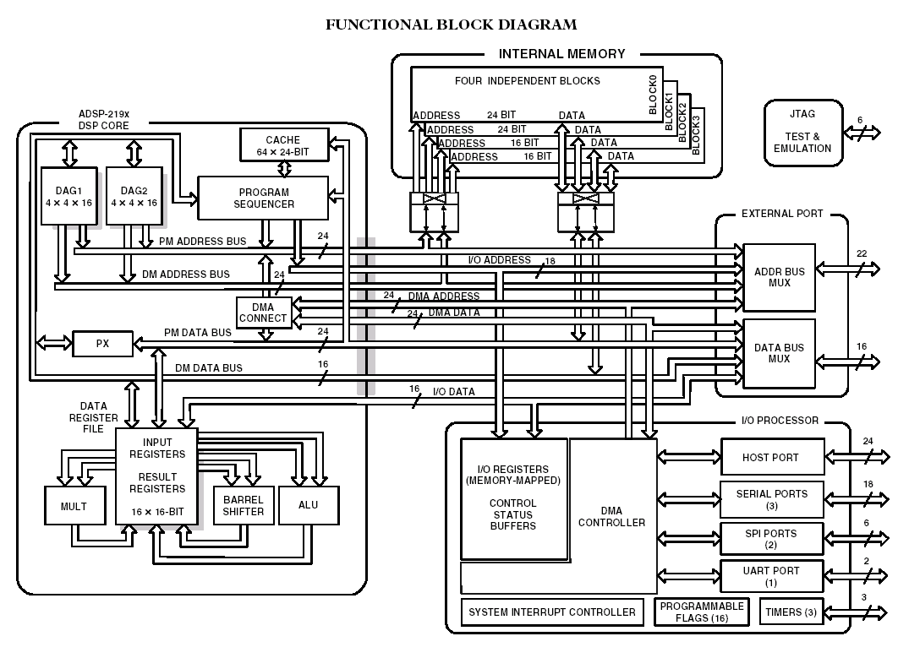
Figure No. 2: Architecture of the on line record system
The computing capacity of recording system can be increased by parallel interconnection of the basic module. Principe of the extension is showed on figure No. 3. Programming structures FPGA play here interface role as well.

Figure No. 3: Principe of the extension computing capacity.

2.1 Software of the Record System
The software of the record system is designed as a layer structure. The layers of the software are expressed by diagram on figure No. 4

Upper layers | 1 | On line computing algoritmus
 | 0 | Computing algoritmus
Lover layers | 4 | Communication layer
 | 3 | FFT calculation or similar
 | 2 | Saving raw data
 | 1 | Filtering of the data
 | 0 | Control of the converters  and interface communication

2.2 Data structure
There is used XML format of the physiological data in three branches:
1. elements of measurements parameters (see figure No. 4)
2. elements of measurement device parameters (see figure No. 5)
3. elements of physiological data (see figure No. 6).

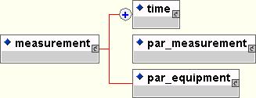
Figure No. 4: Structure of measure elements.

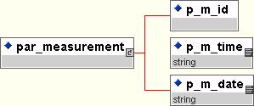
Figure No. 5: Structure of device parametrs.

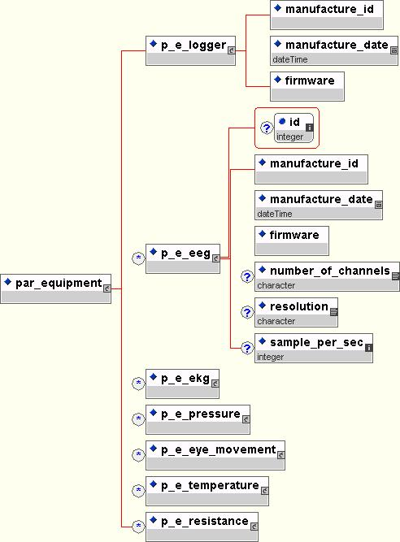
Figure No. 6: Structure of physiological data.

2.3 Experiment and realization
The record and evaluation system was built in University defense laboratory.
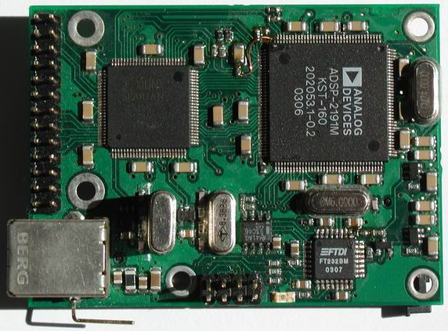
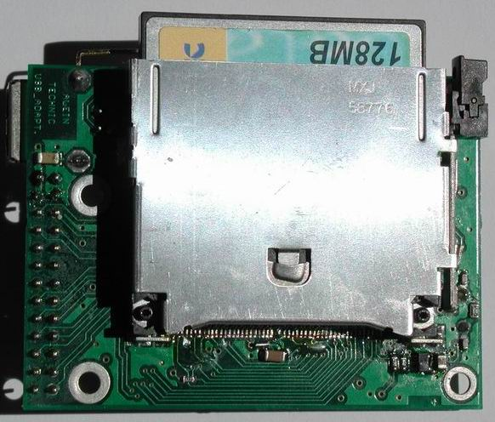
Figure No. 7: Experimental realisation
References:
- Douglas J. Smith: HDL Chip Design, Doone Pubns; March 1998.
- Analog Devices, Inc.: ADSP-2100 Family User’s Manual, Canada, 1995.
- Valuch J. M: Neurotechnologie, mozek a souvislosti (3. vydání), Galaxy, 1998.
- Jiří Jan: Číslicová filtrace, analýza a restaurace signálů, VUT Brno, 1997.
- Richard J. Higgins: Digital Signal Processing in VLSI, USA Norwood, 1990.
- Analog Devices, ADSP-2191M: DSP Microcomputer Data Sheet (Rev. A, 7/02), 2002, [online].
URL: http://www.analog.com/UploadedFiles/Data_Sheets/360699349136344294185456ADSP_2191M_a.pdf
- Analog Devices, ADSP-2191M: Documentation Errata, 2002, [online].
URL: http://www.analog.com/processors/epErrataDisplay/0,2796,,00.html?ContentID=32612&SectionWeblawId=432
- Analog Devices, ADSP-219x DSP Instruction Set Reference (Rev 1.0), October 2000, [online].
URL: http://www.analog.com/processors/epManualsDisplay/0,2795,,00.html?SectionWeblawId=432&ContentID=33024&Language=English
- Analog Devices, ADSP-219x/2191 DSP Hardware Reference (Rev 1.1), August 2003), [online]

