A Novel approach for tuning Power System Stabilizer (SMIB system) using Genetic Local Search technique

J.SATHEESHKUMAR JEGADEESAN Dr.A.EBENEZER JEYAKUMAR
Department of Electrical Engineering Department of Electrical Engineering
Government College of Technology Government College of Technology
Coimbatore, INDIA Coimbatore, INDIA

Abstract: - The genetic local search technique (GLS) hybridizes the genetic algorithm (GA) and the local search (such as hill climbing) in order to eliminate the disadvantages in GA. The parameters of the PSS (gain, phase lead time constant) are tuned by considering the single machine connected to infinite bus system (SMIB). Here PSS are used for damping low frequency local mode of oscillations. Eigen value analysis shows that the proposed GLSPSS based PSS have better performance compared with conventional and the Genetic algorithm based PSS (GAPSS). Integral of time multiplied absolute value of error (ITAE) is taken as the performance index of the selected system. Genetic and Evolutionary algorithm (GEA) toolbox is used along with MATLAB/SIMULINK for simulation.

Key-words: - Genetic local search, power system oscillations, power system stabilizer, genetic algorithms, SMIB, K-constants

1. Introduction
Power systems experience low-frequency oscillations due to disturbances. These low frequency oscillations are related to the small signal stability of a power system. The phenomenon of stability of synchronous machine under small perturbations is explored by examining the case of a single machine connected to an infinite bus system (SMIB). The analysis of SMIB [4] gives physical insight into the problem of low frequency oscillations. These low frequency oscillations are classified into local mode, inter area mode and torsional mode of oscillations. The SMIB system is predominant in local mode low frequency oscillations. These oscillations may sustain and grow to cause system separation if no adequate damping is available. In recent years, modern control theory have been applied to power system stabilizer (PSS) design problems. These include optimal control, adaptive control, variable structure control, and intelligent control.
Despite the potential of modern control techniques with different structures, power system utilities still prefer the conventional lead-lag PSS structure. The reasons behind that might be the ease of on-line tuning and the lack of assurance of the stability related to some adaptive or variable structure techniques.
Unlike other optimization techniques, Genetic Algorithm (GA) works with a population of strings that represent different potential solutions therefore, GA has implicit parallelism that enables it to search the problem space globally and the optima can be located more quickly when applied to complex optimization problem. Unfortunately, recent research has identified some deficiencies in GA performance. This degradation in efficiency is apparent in applications with highly epistatic objective functions, i.e. where parameters being optimized are highly correlated. In addition, the premature convergence of GA represents a major problem.
In this proposed genetic local search (GLS) [7] approach, GA is hybridized with a local search algorithm to enhance its capability of exploring the search space and overcome the premature convergence. The design problem with mild constraints and an eigenvalue-based objective function.
The GLS algorithm is employed to solve this optimization problem and search for the optimal settings of PSS parameters. The proposed design approach has been applied to SMIB system. Eigen value analysis and simulation results have been carried out to assess the effectiveness and robustness of the proposed GLSPSS to damp out the electromechanical modes of oscillations and enhance the dynamic stability of power systems.

2. System investigated
A single machine-infinite bus (SMIB) system is considered for the present investigations. A machine connected to a large system through a transmission line may be reduced to a SMIB system, by using Thevenin’s equivalent of the transmission network external to the machine. Because of the relative size of the system to which the machine is supplying power, the dynamics associated with machine will cause virtually no change in the voltage and frequency of the Thevenin’s voltage (infinite bus voltage). The Thevenin equivalent impedance shall henceforth be referred to as equivalent impedance (i.e. Re+jXe).
The synchronous machine is described as the fourth order model. The two-axis synchronous machine representation with a field circuit in the direct axis but with out damper windings is considered for the analysis. The equations describing the steady state operation of a synchronous generator connected to an infinite bus through an external reactance can be linearized about any particular operating point as follows(eq:1-4):
${ΔT}_{m}−ΔP=M\frac{d^{2}Δδ}{{\text{dt}}^{2}}$ (1)
$ΔP=K_{1}Δδ+K_{2}{ΔE}_{q}^{'}$ (2)
${ΔE}_{q}^{'}$=$\frac{K_{3}}{1+{\text{sT}}_{d0}^{'}K_{3}}{ΔE}_{\text{fd}}−\frac{K_{3}K_{4}}{1+{\text{sT}}_{d0}^{'}K_{3}}Δδ$ (3)
${ΔV}_{t}=K_{5}Δδ+K_{6}{ΔE}_{q}^{'}$ (4)
The K-constants are given in appendix.
The system data are as follows [8]:
Machine (p.u):
$x_{d}$ = 0.973 $x_{d}^{'}$ = 0.19
$x_{q}$ = 0.55 $T_{d0}^{'}$ = 7.765 s (5)
D = 0.0 H = 4.63
Transmission line (p.u):
r_{e} = 0.0 x_{e} = 0.997 (6)
Exciter :
K_{A} = 50.00 T_{A}= 0.05 s (7)
Operating point :
$V_{t0}$= 1.0 P₀ = 0.9 (8)
Q₀ = 0.1 δ₀ = 65 ⁰
The interaction between the speed and voltage control equations of the machine is expressed in terms of six constants k₁-k₆. These constants with the exception of k₃, which is only a function of the ratio of impedance, are dependent upon the actual real and reactive power loading as well as the excitation levels in the machine.
Conventional PSS comprising cascade connected lead networks with generator angular speed deviation (Δω) as input signal has been considered. Fig.1 shows the linearized model of the single machine connected to large system (SMIB) around the operating point.

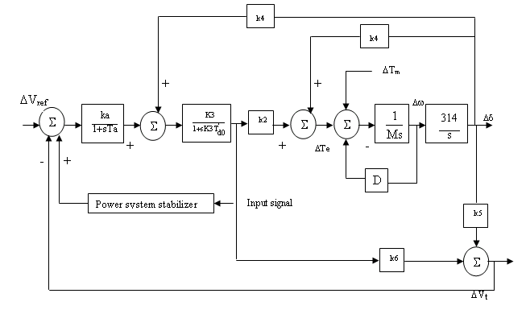
Fig.1 Linearized model of SMIB system

From the transfer function block diagram, the following state variables are chosen for single machine system. The linearized differential equations can be written in the form state space form as
$\overset{0}{X(t)}=A\text{.}x(t)+\text{BU}(t)$ (9)
Where
X(t) = [ Δδ Δω ΔE_{q}’ ΔE_{fd}]^{T} (10)
A=$\left[\begin{matrix}0 & \text{314} & 0 & 0 \\ −D/M & −K_{1}/M & −K_{2}/M & 0 \\ −K_{4} & 0 & −1/K_{3}T^{'_{\text{do}}} & −1/T^{'_{\text{do}}} \\ −\left(K_{A}/T_{A}\right)K_{5} & 0 & −\left(K_{A}/T_{A}\right)K_{6} & 1/T_{A}\end{matrix}\right]$
(11)
${\overset{\text{.}}{B=\left[\begin{matrix}0 & 0 & 0 & \frac{K_{A}}{T_{A}}\end{matrix}\right]}}^{T}$ (12)
System state matrix A is a function of the system parameters, which depend on operating conditions. Control matrix B depends on system parameters only. Control signal U is the PSS output. From the operating conditions and the corresponding parameters of the system considered, the system eigenvalues are obtained.

3. Transfer function model of PSS and design considerations
The exciter considered here is only having the gain of K_{A} and the time constant of T_{A}. The typical PSS consists of a washout function, a phase compensator (lead/lag functions),and a gain. It is well known that the performance of the PSS is mostly affected by the phase compensator and the gain. Therefore, these are the main focus of the tuning process. Two first order phase compensation blocks are considered. If the degree of compensation required is small, a single first-order block may be used. Generally slight under compensation is preferable so that the PSS does not contribute to the negative synchronizing torque component.
Wash out function (T_{w}) has the value of anywhere in the range of 1 to 20 seconds. The main considerations are that it should be long enough to pass stabilizing signals at the frequencies of interest relatively unchanged, but not so long that it leads to undesirable generator voltage excursions as a result of stabilizer action during system- islanding conditions. For local mode of oscillations in the range of 0.8 to 2 Hz, a wash out of 1.5 sec is satisfactory. From the view point of low-frequency interarea oscillations, a wash out time constant of 10 seconds or higher is desirable, since low- time constants result in significant phase lead at low frequencies.
The stabilizer gain K has an important effect on damping of rotor oscillations. The value of the gain is chosen by examining the effect for a wide range of values. The damping increases with an increase in stabilizer gain upto a certain point beyond which further increase in gain results in a decrease in damping. Ideally, the stabilizer gain should be set at a value corresponding to maximum damping. However the gain is often limited by other considerations. The transfer function model of the SMIB system with the PSS is given in Fig.2.
The transfer function of Power System Stabilizer is given by,
$H_{1}(s)=\text{K*}\frac{\text{10s}}{(1+\text{10s})}∗(\frac{1+{\text{sT}}_{1}}{1+0\text{.}\text{05}s})^{2} (\text{13})$

Where,
K—PSS gain
T_{w}—washout time constant
T₁-T₄---phase lead time constants
A low value of T₂=T₄=0.05 sec is chosen from the consideration of physical realization. T_{w}=10 sec is chosen in order to ensure that the phase shift and gain contributed by the wash out block for the range of oscillation frequencies normally encountered is negligible. The wash out time constant (T_{w}) is to prevent steady state voltage off sets as system frequency changes. Considering two identical cascade connected

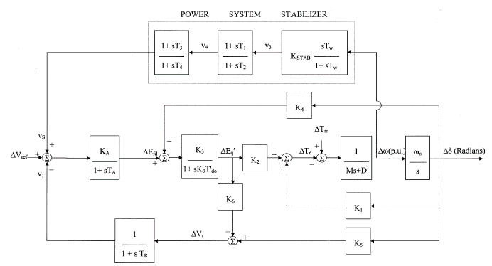

Fig.2 SMIB system with power system stabilizer

lead-lag networks for the PSS T₁=T₃ . Hence now the problem reduces to the tuning of gain (K) and T1 only.
The parameters of the PSS obtained for the damping ratio of 0.3. The oscillation frequency is generally about 0.8-2 Hz for the local mode of oscillations. In this SMIB system only local mode of oscillations are considered for the tuning of PSS. The local mode of oscillation occurs when a machine supplies power to a load center over long, weak transmission lines. Pole placement technique is used for the tuning of CPSS design [6].
3.1. Conventional PSS design
The eigenvalues of the above A matrix are obtained using Matlab. It is evident from the open loop eigenvalues, the system without PSS is unstable and therefore it is necessary to stabilize the system by shifting these eigenvalues to the LHP and far off from the imaginary axis. The location of the desired eigenvalues is calculated by choosing a damping factor ζ for the dominant root. The real part is -ζω_{n} and the imaginary part is
ω_{n} $\sqrt{1−ζ^{2}}$
Where
ω_{n} _{is} the undamped natural frequency of the corresponding root.
For the determination of PSS parameters a damping factor of ζ=0.3 is chosen (maximum damping). Corresponding to this damping factor the desired eigenvalues are obtained as.
λ₁= -ζω_{n}+ ω_{n} $\sqrt{1−ζ^{2}}$
λ₂= -ζω_{n}- ω_{n} $\sqrt{1−ζ^{2}}$
It is to be noted here that the some of the eigenvalues need not be shifted since they are placed for off in LHP. If any electromechanical modes of oscillations are present then PSS needs to be added to enhance the dynamic stability of the system. By using Decentralized modal control (DMC) algorithm the parameters of the conventional power system stabilizer are found.

3.2. Ga based design of PSS
Minimizing the following error criteria the controller generates the parameters of the gain and the phase lead time constant.
In this paper Integral of time multiplied absolute value of error (ITAE) [4] will be minimized through the application of a genetic algorithm, as will presently be elucidated. The GA works on a coding of the parameters (K, T) to be optimized rather than the parameters themselves. In this study Gray coding was used where each parameter was represented by 16 bits and a single individual or chromosome was generated by concatenating the coded parameter strings. In contrast to traditional stochastic search techniques the GA requires a population of initial approximations to the solution. Here 30 randomly selected individuals were used to initialize the algorithm. The GA then proceeds as follows:

3.2.1. Fitness determination
The first step of the GA procedure is to evaluate each of the chromosomes and subsequently grade them. Each individual was evaluated by decoding the string to obtain the Lead-lag compensator parameters which were then applied in a Simulink representation of the closed-loop system.
1. The five fittest individuals were automatically selected while the remainders were selected probabilistically, according to their fitness. This is an elitist strategy that ensures that the next generation's best will never degenerate and hence guarantees the asymptotic convergence of the GA.
2. Using the individuals selected above the next population is generated through a process of single-point cross-over and mutation. Mutation was applied with a very low probability of 0.001 per bit. Reproduction through the use of crossover and mutation ensures against total loss of any genes in the population by its ability to introduce any gene which may not have existed initially, or, may subsequently have been lost.
3. This sequence was repeated until the algorithm was deemed to have converged (50 iterations). As was indicated previously the simulation and evaluation of the GA tuned Lead-Lag compensator was achieved using the MATLAB/Simulink environment.

3.3. GLS algorithm
Step 1: set the generation counter k=0 and generate randomly n initial solutions, X₀ = {x_{i}, i=1……….n}. The i^{th} initial solution x_{i} can be written as x_{i} =[p₁ p₂…pj…p_{m}], where the j^{th} optimized parameter p_{j} is generated by randomly selecting a value with uniform probability over its search space [p_{i}^{min} ,p_{j}^{max}]. These initial solutions constitute the parent population at the initial generation x₀. Each individual of x₀ is evaluated using objective function J. set x=x₀;
Step 2: optimize locally each individual in x. replace each individual in x by its locally optimized version. Update the objective function values accordingly.
Step 3: search for the optimum value of the objective function, J_{min}. set the solution associated with J_{min} as the best solution, x_{best} with an objective function of J_{best}.
Step 4: check the stopping criteria. If one of them is satisfied then stop, else set k=k+1 and go to step 5.
Step 5: set the population counter i=0;
Step 6: draw randomly, with uniform probability, two solutions x₁ and x₂ from x. apply the genetic crossover and mutation operators obtaining x_{3;}
Step 7 : optimize locally the solution x₃ and
obtain x₃;
Step 8 : check if x₃ is better than the worst solution in x and different from all solutions in x then replace the worst solution in x by x₃ and the value of objective by that of x₃;
Step 9: if i=n go to step 3, else set i=i+1 and go back to step 6;
To demonstrate the effectiveness and robustness of the proposed GLSPSS over a wide range of loading conditions are verified.

4. Comparision of various design techniques
The linearized incremental state space model for a single machine system with its voltage regulator with four state variables has been developed. The single machine system without PSS is found unstable with roots in RHP. The system dynamic response without PSS is simulated using Simulink for 0.05 p.u disturbance in mechanical torque. MATLAB coding is used for conventional PSS, Genetic PSS, and Genetic local search (GLS) PSS design techniques. The final values of gain (K), and phase lead time constant (T) obtained from all the techniques are given to the simulink block. The dynamic response curves for the variables Δω, Δδ and ΔV_{t} are taken from the simulink. The system responses curves of the conventional PSS (CPSS), GA based PSS as well as GLS based PSS are compared.
Shaft speed deviation is taken as the input to the all the Power system stabilizers. So the PSS is also called as delta-omega PSS. The system dynamic response with PSS is simulated using these Simulink diagrams for 0.05 p.u step change in mechanical torque ΔT_{m}. The dynamic response curves for the variables change in speed deviation (Δω), change in rotor angle deviation (Δδ) and change in terminal voltage deviation (ΔV_{t}) of the single machine system with PSS are plotted for three different types of power system stabilizers (PSS) are shown in Figs. 3– 5. It is observed that the oscillations in the system output variables with PSS are well suppressed. The Table I shows various types of PSS and its parameters after tuned by conventional, genetic and genetic local search technique.

Table 1

PSS parameters of various pss for single machine system.

PSS type | PSS parameters
CONVENTIONAL LEAD-LAG PSS | K = 7.6921  T =0.2287
GA BASED PSS | K =26.5887  T=0.2186
GLS BASED PSS | K=35.1469  T=0.2078

4.1. Simulation results
- Performance of fixed-gain CPSS is better for particular operating conditions. It may not yield satisfactory results when there is a drastic change in the operating point.
- Dynamic response shows that the GA based PSS has optimum response and the response is smooth and it has less over shoot and settling as compared to conventional PSS.
- As compared to the conventional PSS & GA based PSS the proposed genetic local search (GLS) based design of PSS gives the optimum response and the response is smooth and it has reduced settling time.
- The time multiplied absolute value of the error (ITAE) performance index is considered. The simulation results show the proposed Genetic local search based PSS can work effectively and robustly over a wide range of loading conditions over the conventional and GA based design of PSS.
5. The response curves shows that GLS PSS has less over shoot and settling time as compared to the GA PSS and the traditional Lead-lag PSS.

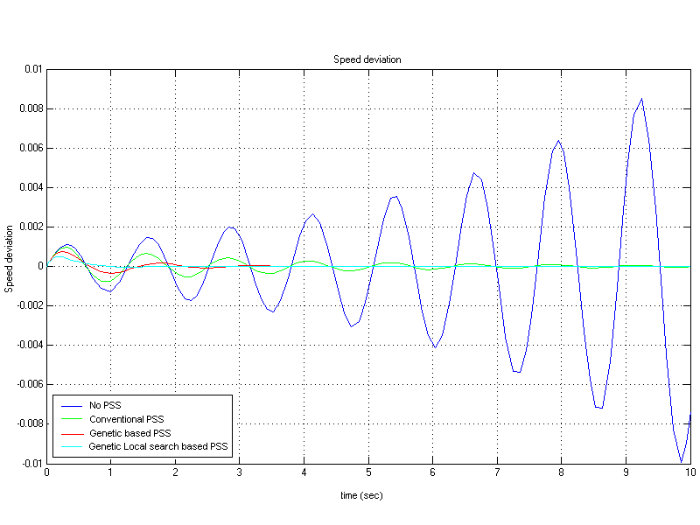
figure.3 Δω Vs time for normal load condition of the SMIB system

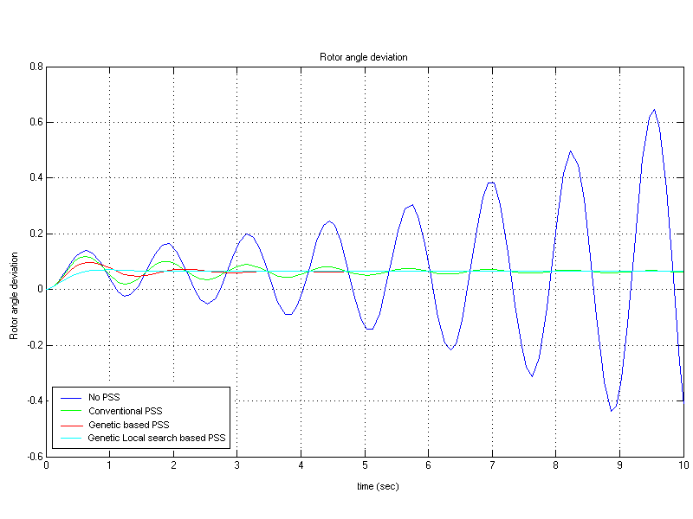
Fig.4 Δδ Vs time for normal load condition of the SMIB system

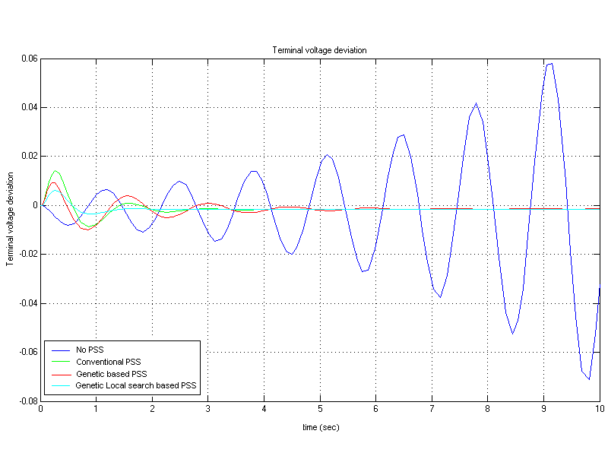
Fig .5 ΔVt Vs time for normal load condition of the SMIB system

Conclusion
In this study, a genetic local search algorithm is proposed to the PSS design problem. The proposed design approach hybridizes Genetic Algorithm with a local search to combine their different strengths and overcome their drawbacks (i.e.) GA explores the search space (spectrum of optimum location points either maxima or minima) before it gives data to the local search technique. Then local search technique is the best technique than GA to find the optima (either maxima or minima). The potential of the proposed design approach has been demonstrated by comparing the response curves of various power system stabilizer (PSS) design techniques.
Optimization results show that the proposed approach solution quality is independent of the initialization step. Eigen value analysis reveals the effectiveness and robustness of the proposed GLSPSS to damp out local mode of oscillations. In addition, the simulation results show that the proposed GLSPSS can work effectively and robustly over wide range of loading conditions and system configurations.

Appendix
Derivation of k-constants
All the variables with subscript 0 are values of variables evaluated at their pre-disturbance steady-state operating point from the known values of P₀ , Q₀ and V_{t0}.
$i_{q0}$ =$\frac{P_{0}V_{\text{to}}}{\sqrt{(P_{0}x_{q})^{2}+(V_{t0}^{2}}+Q_{0}x_{q})^{2}}$ (14)
$v_{d0}$ = $i_{q0}x_{q}$ (15)
$v_{\text{qo}}$ =$\sqrt{V_{t0}^{2}}−v_{t0}^{2}$ (16)
$i_{d0}$ =$\frac{Q_{0}+x_{q}i_{q0}^{2}}{v_{q0}}$ (17)
$E_{q0}$= $v_{q0}+i_{d0}x_{q}$ (18)
$E_{0}$ =$\sqrt{(v_{d0}+x_{e}i_{q0})^{2}+(v_{q0}−x_{e}}i_{d0})^{2}$ (19)
$δ_{0}$ = ${\text{tan}}^{−^{1}}\frac{(v_{d0}+x_{e}i_{q0})}{(v_{q0}−x_{e}i_{d0})}$ (20)
K₁ = $\frac{x_{q}−x_{d}^{'}}{x_{e}+x_{d}^{'}}i_{q0}E_{0}\text{sin}δ_{0}+\frac{E_{q0}E_{0}\text{cos}δ_{0}}{x_{e}+x_{q}}$
(21)
K₂ = $\frac{E_{0}\text{sin}δ_{0}}{x_{e}+x_{d}^{'}}$ (22)
K₃ = $\frac{x_{d}^{'}+x_{e}}{x_{d}+x_{e}}$ (23)
K₄ = $\frac{x_{q}−x_{d}^{'}}{x_{e}+x_{d}^{'}}E_{0}\text{sin}δ_{0}$ (24)
K₅=$\begin{aligned}\frac{x_{q}}{x_{e}+x_{{}_{q}}}\frac{v_{d0}}{V_{t0}}E_{0}\text{cos}δ_{0}−\frac{{\text{xd}}^{'}}{x_{e}+x_{d}^{'}}\frac{v_{q0}}{V_{t0}}E_{0}\text{sin}δ_{0} \\ \end{aligned}$
(25)
K₆ =$\frac{x_{e}}{x_{e}+x_{d}^{'}}\frac{v_{q0}}{V_{t0}}$ (26)
Nomenclature
All quantities are per unit on machine base.
D Damping Torque Coefficient
M Inertia constant
$ω$ Angular speed
$δ$ Rotor angle
I_{d}, I_{q} Direct and quadrature components of armature current
X_{d}, X_{q} Synchronous reactance in d and q axis
X_{d}’, X_{q}’ Direct axis and Quadrature axis transient reactance
E_{FD} Equivalent excitation voltage
K_{A} Exciter gain
T_{A} xciter time constant
T_{m},T_{e} Mechanical and Electrical torque
T_{do}’ Field open circuit time constant.
V_{d},V_{q} Direct and quadrature components of terminal voltage
K1 Change in T_{e} for a change in $δ$ with constant flux linkages in the d axis
K2 Change in T_{e} for a change in d axis flux linkages with constant $δ$
K3 Impedance factor
K4 Demagnetising effect of a change in rotor angle
K5 Change in V_{t} with change in rotor angle for constant E_{q}’
K6 Change in V_{t} with change in E_{q}’ constant rotor angle

References
[1] Hu Guo-qiang, Xu Dong-jie and He Ren-mu, “Genetic algorithm based design of power system stabilizers”, IEEE International conference on electric utility deregulation, restructuring and power technologies”, pp. 167-171, Apr.2004.
[2] Joe H.Chow, George E.Boukarim and Alexander Murdoch, “Power system stabilizers as undergraduate control design projects”, IEEE trans. on power systems, vol 19, pp.144-151, Feb.2004.
[3] Mehran Rashidi, Farzan Rashidi and Hamid Monavar, “Tuning of power system stabilizers via genetic algorithm for stabilization of power systems”, IEEE
0-7803-7952-7/03/$17.00,pp.4649-654,2003.
[4] Y.L.Abdel-Magid and M.M.Dawoud, “Tuning of power system stabilizers using genetic algorithms”, Electic Power Systems Research,Vol. 39, pp. 137-143, Jul.1996.
[5] M.Klein, G.J.Rogers, S.Moorty, P.Kundur, “Analytical investigation of factors influencing power system stabilizers performance”, IEEE trans. On energy conversions, vol.7, No.3, pp. 382-390, Sep.1992.
[6] Yao-nan, Qing-hua Li , “Pole placement power system stabilizers design of an unstable nine- machine system”, IEEE transactions on power systems, Vol 5, No.2,pp.353-358,1990.
[7] Tadahiko Murata, Hisao Ishibuchi and Mitsuo Gen, “Neighbourhood structures for Genetic local search algorithms” 2nd International conference on knowledge-Based intelligent electronic systems, IEEE, 0-7803-4316-6/98/$10.00, pp.259-263, 1998.
[8] Ghadir Radman and Youssef smaili, “Performance evaluation of PID power system stabilizer for synchronous generator”, IEEE, 88CH2571-8/88/0000-0597$1.00, pp.597-601, pp.597-601, 1988.

