Introduction
Design and Analysis of Packet Synchronizer in
Dual-Mode DSSS/OFDM Wireless Systems

JIN-HWA GUO, JUI-YUAN YU, and TERNG-YIN HSU
Department of Computer Science and Information Engineering
National Chiao-Tung University
No.1001, Daxue Rd., Hsinchu City 300,
TAIWAN (R.O.C.)
Abstract: - In this paper, a packet detection algorithm for the coexistence of dual DSSS/OFDM system; and an algorithm for OFDM symbol timing estimation are proposed. Using only one pair of ADCs with dynamic sampling, the preamble based packet synchronizer can successfully detect both DSSS/OFDM systems while achieving low-power consumption. From simulation results, the false alarm rate can be less than 10⁻³ under SNR = 1.2 dB and SNR = 3.2 dB with respect to DSSS and OFDM wireless systems.

Index Terms: - OFDM, DSSS, dynamic sampling, packet detection, symbol timing estimation
Direct Sequence Spreading Spectrum (DSSS) and Orthogonal Frequency Division Multiplexing (OFDM) are widely used in modern wireless communications systems [1-4]. There are more and more practical systems and standards integrating these two modulation schemes into one operating platform and is able to decode the signal when either of them is transmitted. Different modulation systems, however, occupy different bandwidth conventionally, and two sampling rate have to be used to detect and synchronize the received signals. Conventionally, there are more than two sets of ADCs for I channel and Q channel existing in some receiver designs [5], some of the others, however, use much higher clock rate is used for ADC sampling.

To reduce the sampling rate, a dynamic ADC sampling methodology can be applied [7]. It has the advantage that the sampling frequency and phase from ADPLL/ADDLL can be controlled by the baseband processor and thus approach the optimum symbol timing. However, this methodology only deals with the systems of single modulation presented until now.

Here, we propose a dynamic synchronization algorithm suitable for the coexistence of DSSS and OFDM that is able to detect which one is coming under two possible packet types. Since the sampling frequency and phase can be adjusted accordingly, no extra hardware is necessary to detect the transmitted signal. It means that only one set of ADCs, I and Q branches; is used. During the packet or format recognition, of course, automatic gain control (AGC) is applied to get the optimum ADC swing level. Then, the symbol boundary decision is made. Finally the data error due to the sample clock mismatch between transmitter (TX) and receiver (RX) are fixed in the baseband processor.

This paper is organized as follows. First, the system model is described in section 2. Next, packet detection is presented in section 3. Then the symbol timing is discussed in section 4. Finally is the simulation results and conclusion.

System Model
In the proposed system, it needs to decode the data of OFDM and DSSS format when either of them is transmitted. We assume that the OFDM SYNC field consists of ten short preambles, and a guard interval followed by two long preambles. On the other hand, there is a series of scrambled positive and negative ones in DSSS preamble, which are spread over the Barker sequence b(t)={＋－＋＋－＋＋＋－－－}, and the format is depicted in Fig. 1. To achieve the robust synchronization, an universal receiver architecture is shown in Fig 2. As the signal is down converted, the analog waveform is sampled by one pair of ADCs for I and Q channels whereas two pairs of ADCs in conventional design. The sampling clock is controlled by ADPLL and ADDLL. In the baseband, there are two match filter (MF) for the detection of OFDM and DSSS. The control unit switches the MUX according to the MFs’ result, and change the clock rate of the ADPLL/DLL to a proper value. At the same time, AGC adjusts the power level in the front end to keep the system performance.

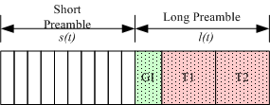
(a)
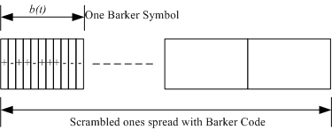
(b)
Fig. 1: (a) an example of OFDM preamble (b) an example of DSSS preamble

Fig 2: The universal architecture of the proposed packet synchronizer

Packet Detection

Dynamic Sampling
With the method of dynamic sampling, the generated clock can be handled by the Control Unit. The initial clock rate is set at the higher one between OFDM and DSSS. When a specific type of preamble is declared, the frequency of ADPLL is then moved to two times of its symbol rate for timing acquisition. After that, the sampling rate is down to one time of the original symbol rate. Thus, we can achieve the packet detection by only one set of ADCs and dynamically control the sampling frequency for low power purposes. In the beginning of synchronization, the received signal type is unknown, so it has three possible cases: OFDM preamble, DSSS preamble, and others. In subsection 3.2 and 3.3, we are going to define the condition by which the declaration of coming for OFDM or DSSS can be made.

Detection of OFDM Preamble
OFDM preamble is a Pseudo Noise (PN) sequence in frequency domain, auto-correlation normalized by its power is widely adopted in OFDM packet detection [6-7]. The OFDM short training symbol s(t) is used for the packet detecting. The auto-correlation function c(t) is defined by

(1)

where * denotes complex conjugate and L_{a} is the length of each OFDM short preamble. It is the correlation of the present short preamble with the delayed one. The received energy p(t) for the short preamble can be written as

$p(t)=\sum_{k=0}^{L_{a}−1}{{\left|r(t+k)\right|}^{2}}$ (2)

The resulting timing metric Λ_{OFDM}(t) is defined by

(3)

If the timing metric Λ_{OFDM}(t) exceeds a pre-defined threshold Γ, we declare the presence of OFDM packet. The decision of the threshold value will be discussed later.

Detection of DSSS Preamble
The DSSS preamble is scrambled ones spread with an 11-chip Barker sequence. The packet detection of DSSS is to correlate the received signal with a pre-known spreading sequence. If it is correctly matched, the correlation power will be greater than the others, and we may call it a ‘Peak’. The cross correlation d(t) is defined by

$d(t)={\left|\sum_{k=0}^{L_{B}−1}{r(t+k)⋅b(k)}\right|}^{2}$ (4)

where b(k) is the 11-chip Barker code and L_{b} is the length of Barker code.

Unfortunately, there are usually mismatch between the initial OFDM sampling rate and chip-rate of DSSS preamble, and thus exists a timing shift The shifted samples r’(t) can be derived as follow

(5)

where ⊕ denotes convolution operation, TI is sampling interval, and ΔPn is the clock offset. The peak varies from time to time even if the first chip is correctly aligned.

Due to the mismatch of sample rate, two characteristic are examined to ensure a DSSS packet is coming. First, the interval of two adjacent peaks remains a constant period. Second, the peak values should be greater than others in one period, and we can compare peak value with several “valley” values. Thus, the resulting timing metric Λ_{DSSS}(t) is defined by

(6)

where T_{S} is the period of peak occurrence, T_{C} is the chip period of spreading code, and [ts, te] is the index window of summation. The criterion for the declaration of DSSS is to see if Λ_{DSSS}(t) is positive. How to choose the length and location of index window [ts ,te] will be discussed later. Here we summarize the criterion for declaration of OFDM and DSSS as

and (7)

Performance of Packet Detector
To evaluate the performance of packet detection in several cases, reference designs [1-2] are taken as the simulation platform. Thus the symbol rate and chip rate of OFDM and DSSS are 20 MHz and 11 MHz, respectively. The probability of packet loss and false alarm are to be analyzed.

In the first case, assume OFDM packets are transmitted, the distribution of timing metric Λ_{OFDM}(t) is depicted in Fig. 3. It shows the timing metrics in different packet types transmitted, i.e. OFDM preamble, DSSS preamble, or none of them. In order to detect OFDM signals, the optimal threshold Γ is set at the intersection of OFDM and Noise curves. It can be seen that Γ is equal to 0.5 as illustrated in Fig. 3.

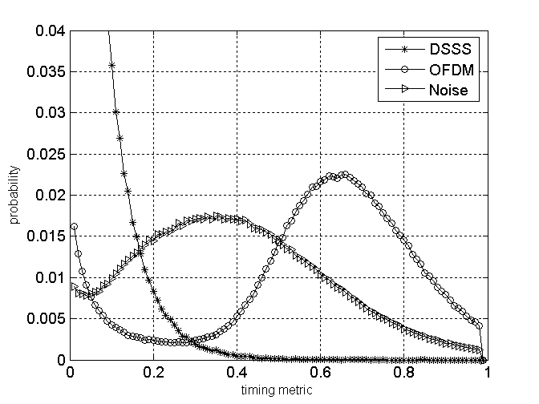
Fig. 3 Distribution of timing metric Λ_{OFDM}(t) @ SNR = 6 dB

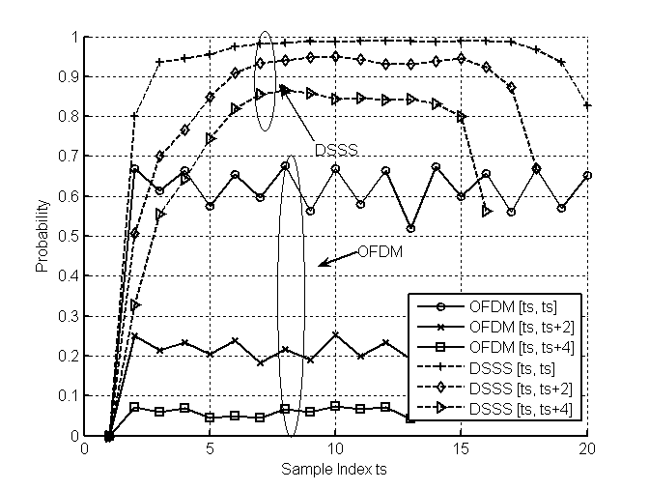
Fig. 4 Probability of timing metrics Λ_{DSSS}(t) @ SNR = 3 dB

In the second case, assume DSSS packets are transmitted. The probability under the condition Λ_{DSSS}(t)>0, which is the criterion to detect DSSS, is discussed by means of window length and location. We denote the window length by η, and the end index te can be defined by te = ts + η. As η increases, since the peak value is compared with more valley values, the probability of Λ_{DSSS}(t)>0 are decreasing. In the presence of multi-path, the peak will spread out and inference those correlations close to it. As a result, the probability of Λ_{DSSS}(t)>0 are also decreasing if we choose window location to be near the peak location.

The probability of detecting DSSS in transmitted different packet types is illustrated in Fig. 4. The start index ts are represented by x-axis and the window length η are illustrated in different curves. As η increasing, those curves in OFDM group are decreasing faster than those in DSSS group.

If we analyze Fig. 3, it is possible to know that Λ_{OFDM}(t) exceeds threshold whereas the received signals are only noise. In this situation, false alarm is occurred. In order to reduce false alarm, it is necessary to examine the times by which the timing metrics Λ_{OFMD}(t) exceeds specific threshold Γ. Hence the final criterions used for OFDM and DSSS detection are defined in the similar way by

(8)
(9)

where sign(.) denote the operation of signum which return 1 if the element is positive, 0 if the element is negative. The criterion holds if timing metrics exceeds specific threshold consecutively a certain times. We summarize packet detection algorithm in FSM depicted in Fig. 5.

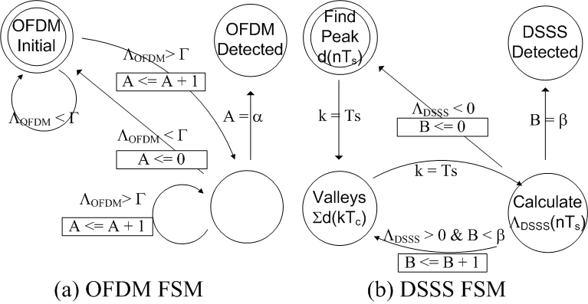
Fig. 5 the FSM of Packet Detection

Estimation of OFDM Symbol Timing
After OFDM preamble has been detected, we need to decide the symbol timing. The task of symbol timing is to find the FFT window boundary. The miss-aligned FFT window will not only decay the original signal but also induce the inter carry interference (ICI) and inter symbol interference (ISI) [8]. Accordingly, we want the estimated symbol timing as close to the last sample in guard interval (GI) as possible. The estimation of symbol timing τ can be obtained by observing the cross-correlation ξ(t) and finding its maximum within a defined range

and (10)

where LT denotes the ideal long training sequence, L_{L} is the length of LT, and [τs, τe] define the search window.

The start of window search τs can be estimated by monitoring the timing metric c(t) in (1). If it is below the threshold consecutively, we can assume it is at the end of short preamble and initiate the window search. Furthermore, since auto correlation is not robust to noise, τs is an approximately position that may be moved earlier or later than the real end of short preamble.

Conventionally, the end of search window τe is defined by a fixed length ε, say τe =τs +ε. If ε is too small, the range [τs, τe] may not contain the true symbol timing, whereas a large ε will result in more buffers to store the received long preamble, which is used to estimate channel impulse response. In contrast of fixed search window, we propose a dynamic search window algorithm by observing whether the maximum is greater than its successors consecutively. For this purpose, a variable ξ_{max} and a counter λ(t) are defined by

(11)
(12)

The symbol timing τ is determined immediately as the counter λ(t) exceeds a pre-defined number p. In accordance with the proposed algorithm, the ξ_{max} (τ) is the local maximum over the window [τs, τe] and the window length is at least p. In our reference system, the desired symbol timing is between sample index 177 and 192, and the estimated index in different p has the distribution as illustrated in Fig. 5. The distributions of estimated indexes are centralized by increasing p.

Simulation Result
To evaluate the performance of proposed packet detection and symbol timing estimation, a reference design based on dual modulation OFDM and DSSS [1][2] is considered. The simulation environment is under Rayleigh fading channel with RMS 50ns and CFO 50 p.p.m. The results are obtained by applying 10000 simulation runs with different SNR. The overall synchronizer performance is shown in Fig. 6. In transmitted OFDM packets, the packet loss rate is less than 10⁻³ under SNR 2.4 dB whereas the packet false alarm rate is less than 10⁻³ under SNR 3.2 dB. The symbol timing algorithm is compared by search window length, the proposed algorithm is based on dynamic window length, as shown in equations (11) and (12) with p=58 whereas the reference one is fixed window length with ε=128. The SNR loss is about 0.7 dB at the target line, however the proposed algorithm works better under low-SNR conditions.

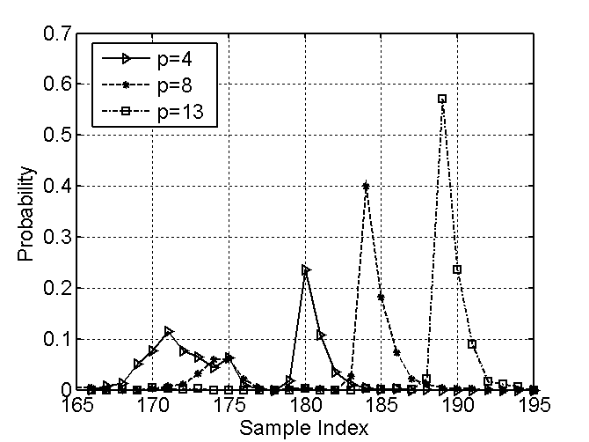
Fig. 5 The distribution of symbol timing @ SNR = 6 dB

Fig. 6 The overall synchronizer performance

Conclusion
The proposed packet synchronizer can be successful to handle both OFDM and DSSS packets in dual-mode (OFDM/DSSS) systems with only one set of ADCs and dynamically controlling the sampling frequency. By this way, we can achieve the low-power approach in the wireless baseband processor, whereas keep the overall performance met standard requirements.

References:
- Supplement to standard for LAN/MAN part 11: Wireless MAC and PHY specifications: High-speed physical layer in the 5GHz band, IEEE 802.11a, 1999.
- Supplement to standard for LAN/MAN part 11: Wireless MAC and PHY specifications: Higher-Speed Physical Layer Extension in the 2.4GHz Band, IEEE 802.11b, 1999.
- Multi-band OFDM Physical Layer Proposal for IEEE 802.15 Task Group 3a, IEEE P802.15-03/268r3, 2003.
- DS-UWB Physical Layer Submission to 802.15 Task Group 3a, IEEE P802.15-04/0137r3, 2004.
- Nakajima, N.; Kohno, R.; Kubota, S., ”Research and developments of software-defined radio technologies in Japan”, Communications Magazine, IEEE, Vol. 39, Issue: 8, Aug. 2001
- Timothy M. Schmidl and Donald C. Cox, “Robust Frequency and Timing Synchronization for OFDM”, IEEE Transactions on Communications, Vol. 45, NO. 12, Dec 1997
- Alan J.Coulson, “Maximum Likelihood Synchronization for OFDM, Using a Pilot Symbol: Algorithms”, IEEE Journal on Selected Areas in Communications, Vol. 19, NO. 12, Dec 2001
- Speth, M., Gunnar Fock, D., Meyr, H., “Optimum Receiver Design for Wireless Broad-Band Systems Using OFDM-Part I”, IEEE Transactions on Communications, Vol. 47, NO. 11, Nov 1999.

