A Tiny Microprocessor Floating Point Implementation of a General Regression Neural Network
JESÚS LÁZARO, JAGOBA ARIAS, JOSÉ L. MARTÍN, ARMANDO ASTARLOA, UNAI BIDARTE
Department of Electronics and Telecommunications
University of the Basque Country
Alda. Urquijo s/n. 48013 Bilbao, Vizcaya
SPAIN

Abstract: - Nowadays, neural networks play a key role in many electronic applications. Software implementations are the most used ones because they require a great amount of resources. With the increasing power and capabilities of current FPGAs it is obvious that they can be translated into hardware to increase their speed and usefulness. This paper presents a hardware implementation of a particular neural network, the General Regression Neural Network (GRNN) using floating point arithmetics. This network is mainly used for function approximation. This paper also presents how to translate a GRNN from Matlab to the hardware implementation.
Key-Words: - GRNN, Picoblaze, floating-point, Matlab

1 Introduction
Since their introduction, General Regression Neural Networks have been of great interest. Applications range from control [1], prediction [2][3], modelling [4][5], fault diagnosis [6], etc. This paper presents a way of translating this kind of neural network into hardware directly from Matlab [7]. The circuit proposed in this paper makes use of the internal particularities of a Xilinx device to efficiently implement some of the particularities of a neural network. It also used a tiny microprocessor to substitute complex state machines that appear when using floating point arithmetics.

This paper is organized as follows: section 2 describes the fundamentals of General Regression Neural Networks and their internal structure. In section 3, we describe the hardware implementation discussing the particularities of being implemented in a Xilinx device as well as the Matlab/hardware translation procedure. Section 4 deals with the hardware resources used to finish with conclusions in section 5.

2 General Regression Neural Networks
2.1 Introduction
General Regression Neural Networks (developed by Specht [8]) need no iterative training, what makes them very attractive. They are able to approximate any arbitrary continuous function extracting the required data from the training data. They are consistent, in other words, the estimation error approaches zero if the training set size becomes large enough.

General Regression Neural Networks (GRNN) are based on the nonlinear regression theory. The regression of a dependent variable y on an independent variable x estimates the most probable value for y, given x and a training set. The training set consists of pairs of matches (x,y). The regression method will estimate the value of the output that minimizes the mean-squared-error.

GRNN is based upon the following formula:
$$E\left[x|y\right]=\frac{\int{\text{yf}(x,y)\text{dy}}}{\int{f(x,y)\text{dy}}}$$ | (1)

where y is the output of the estimator, x is the estimator input vector, E[y|x] is the expected output value, given the input vector x and f(x,y) is the joint probability density function (pdf) of x and y.

GRNN is a way of estimating f(x,y) using only a training set. The pdf is derived from the data with no a priori knowledge about its form, making the system perfectly general provided the underlying density is continuous and that the first partial derivatives of the function evaluated at any x are small [9].

Specht shows the function value is estimated optimally as follows:
$$y_{j}=\frac{\sum{h_{i}w_{\text{ij}}}}{\sum{h_{i}}}$$ | (2)

where w_{ij} represent the desired output of the input training vector x_{i} and output j. $h_{i}=e^{\frac{−D_{j}^{2}}{2⋅σ^{2}}}$ is the output of a radial basis function (see figures 1 and 2). $D_{i}^{2}$ is the squared distance between the input vector (x) and the training vector i (u_{i}). σ is a constant controlling the size of the receptive region.

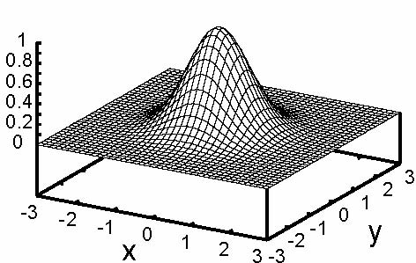
Fig 1 Three-dimensional radial basis function
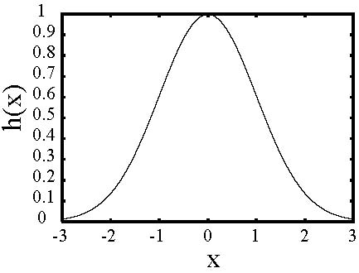
Fig 2 Two-dimensional radial basis function
2.1 Structure
The internal structure of a GRNN neural network is depicted in figure3.

The first step is to calculate the distance from the input vector of length R to each of the Q training vectors of length R. There is a large number of functions that can be used to measure distance. Among others, the most used are the Euclidean distance ($D_{i}^{2}$) and the city block norm ($D_{i}^{1}$):
$$D_{i}^{2}=\sum_{k}{\sqrt{x_{k}^{2}−μ_{k}^{2}}}$$ | (3)

$$D_{i}^{1}=\sum_{k}{\left|x_{k}−μ_{k}\right|}$$ | (4)

In a second step, each Q distance is multiplied by the corresponding b factor. This b₁ factor corresponds to the different variances that each vector in the training set may have (see figure 2 for a two-dimensional example). The result of this product is transformed by a radial basis function, in this case:

$$a=e^{−n^{2}}$$ | (5)

The nprod block multiplies each of the outputs of the radial basis function (a₁) by each of the desired targets normalized by the sum of elements of a₁.

$$n^{2}=\frac{\sum{a_{1,q}{\text{LW}}_{q}}}{\sum{a_{1,q}}}$$ | (6)

At the end of the GRNN we find a pure linear layer.

3 Hardware Implementation
3.1 Introduction
The circuit that is obtained from the structure described in figure 3 is of high complexity and resource consuming. The first step in the hardware implementation of a GRNN is to impose limits to the algorithm implementation. Among others, the key points are the data bus widths as well as the input, training set and target data widths. In our case, all the input data are represented in a fixed point format while the targets of the training set and the output of the system are represented in floating-point notation.

Other point that leads to a simpler circuit is the b₁ variable. It may take any value, both integer and decimal, and may change from vector to vector in the training set. One simplification that has been used in this implementation is the decision of using a constant b₁ equal to one. Any other two's power multiplication could easily be introduced. The introduction of an arbitrary b₁ value would require a new multiplier and would lead to a wider data bus.

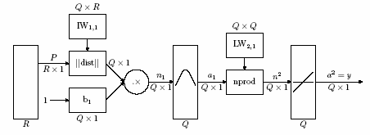
Fig 3 Structure of a General Regression Neural Network

3.2 Structure
The module is subdivided into four main blocks:
- grnn: This block (see figure 4) is in charge of receiving the input data to the neural network from any existing previous blocks. It compares the input with all the training set vectors, obtains the distance between both of them and passes the value to the radial base function. In other words, it performs all the steps in a general regression neural network except from the product with the targets of the training vectors and the normalization. In the selected implementation scheme, the b parameter has been chosen equal to 1 to reduce the computational cost. It must be noted than any power of two factor can easily be chosen without any additional computational cost. The distance that has been chosen is the euclidean distance since the radial basis function has a square factor, in this way; the square factor and the square root of the distance are cancelled. To perform the different functions, this block is further subdivided into the next main elements:
- iw: This block is a distributed memory where all the values of the training vectors are stored. This block can be done in different ways depending on the applications. If the number of training vectors is very big, it could be synthesized using block rams or the dynamic shift registers inside the LUT of a Xilinx device.
- subtracter: This block is in charge of finding the difference between the input vector and each of the different training sets.
- square: This block is in charge of applying the square factor to the output of the subtracter. Due to the reduced number of possible values of the subtraction ([-4,4] and integers), it is done using a distributed LUT.
- ACCUMULATOR: The function of this block is to add each difference of each training vector. It is also in charge of controlling a possible overflow of the accumulator. It is not necessary to accumulate beyond the point where the radial basis function will give a zero results. In other words, the accumulator is the exponent of the radial functions, once the exponent is greater than a certain value, the result will be zero for the given precision. In our case, the radbas block determines the chosen precision.
- RADBAS: This block is in charge of performing the negative exponential (see equation 5). This block has been synthesized in a block ram used as LUT. A RAMB16_S36 has been used in the implementation. In such a memory a 512 by 24 bit LUT can be synthesized. The 24 bits have been distributed in the following way: 16 bits for the mantissa and 8 bits for the exponent. The number is represented in the following way:

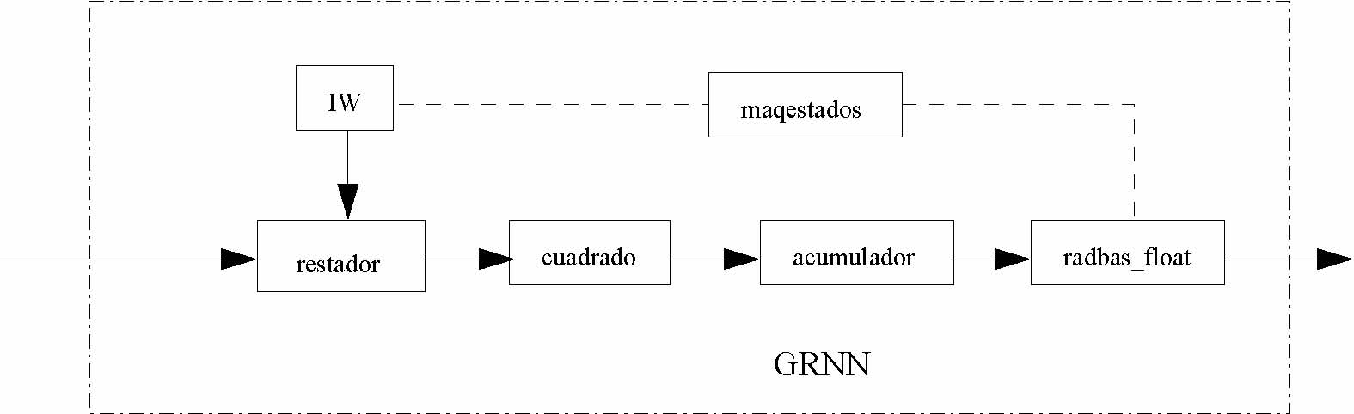Fig 4 Structure of the gran block

$$N=1\text{.}\left[M_{\text{15}}M_{\text{14}}⋯M_{1}M_{0}\right]⋅2^{3−\left[E_{7}E_{6}⋯E_{1}E_{0}\right]}$$ | (7)
So the biggest allowed number is 1.599987792968750e+001 and the smallest 1.381786968815111e-076. The precision spans more towards zero since the negative exponential quickly makes the results near zero.
- fsm: This block is in charge of controlling successive reads from the memory where the test vectors are saved (iw), controlling the reads from the inputs and generate the signals to activate the following stages.
- flotante_grnn: This block (see figure 5) is in charge of multiplying the output of the radial function and the targets of the training vectors. It is also in charge of performing the floating-point additions of the product and the output of the radial function to perform the normalization. This block is built up of the following main elements:
- mult_float: This block is in charge of making the product between the output of the radial function and the target corresponding to the vector in the training set that is being processed. The block is done using a hardware multiplier of the VirtexII and successive Xilinx devices, an adder and a control circuit in charge of normalizing the result.
- kcpsm3: This block is in charge of doing the floating-point accumulations. The main element is a kcpsm microprocessor [10][11] (also known as PicoBlaze). The main characteristics are the small size and the perfect adaptation to the internal structure of the Xilinx devices. Its main usefulness is the substitution of complex state machines as the ones in charge of performing floating-point additions.
- divisor_float: This element is in charge of dividing the accumulated values of the product between the radial basis outputs and the targets and the accumulated value of the radial basis output. It has three main elements: a fixed-point divisor for the mantissas, a subtracter for the exponents and a control element for the normalization of the result.
3.3 Control
The control of the whole system is mainly divided into two different parts. On one hand we can find the finite-state machine (FSM) that controls the inputs and the reads from the training vectors memory. This FSM is in charge of synchronizing the data that comes from the exterior and the training vectors. On the other hand, we have the program that controls the tiny microprocessor. The program resides in a block ram of the device and is in charge of performing the floating-point additions and controls the registers where the results are stored.
It must be noted that the microprocessor control is done in such a way that the processing of the next training set vector can begin before the accumulation of the previous one has been finished. In this way, the efficiency is increased.

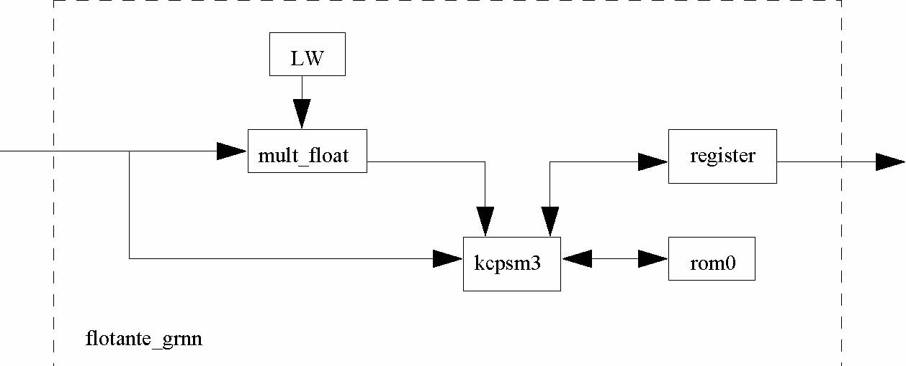
Fig 5 Structure of the flotante_gran block

3.4 Hardware considerations
The implementation of the GRNN has been focused to be fitted in Xilinx devices as has previously been commented. Due to this election, several points of the structure have been determined. The output width of the exponential and the target vector has been adopted to efficiently use the internal 18-bit hardware multiplier of the Xilinx Virtex family [13]. The mantissa of the floating point values could vary, but the 18x18 embedded signed multiplier suggests bus widths inferior to 17, being the closest power of two width 16.

Another point is the radbas block. The radial function exponential has been implemented using a LUT. A distributed LUT could be used but a block ram implementation has been chosen to improve the area performance. It must be noted that a single Virtex II block ram can store the whole LUT, substantially reducing the cost of the exponential.

Another point to care about is the floating-point divider. In the implementation, an integer divides is used. In this point we have a pair of option:
- The LogicCore of the divider generates a pipelined divider [14]. We must only accomplish one division for every input vector. The pipeline could only be used if the time to process the whole input vector is less than the time to finish de division. The pipelined divider's data width is 17 bit so the dividing time is 17 clock cycles.
- A simple sequential integer divided can be used. In this case the dividing time is the same (17 clock cycles) but we cannot introduce new dividing data until the prior division is finished.
Quite often the pre-division processing takes longer than 17 clock cycles (9 word vectors and 2 training vectors is enough). In these cases, the sequential divisor can be used instead of the pipelined divider. In this way, the total area used decreases dramatically. In our implementation, a sequential divided has been used.

3.5 Net generating procedure
One thing that has not been discussed so far is the translation of the neural network (done in Matlab) to the hardware implementation. It must be noted that the only differences between different nets are the data stored in the training vector memories (LW and IW) and the corresponding bus widths. This is accomplished using a Matlab program that translates the net object to a VHDL file where all the data is stored. Extensive use of generics helps in maintaining the procedure simple.

4 Hardware results
The circuit described in this paper has been implemented using a Spartan3 xc3s1500 in a general purpose evaluation board (). In this scenario, the neural network uses the following resources:

MULT18X18s | 1 out of 32 | 3%
RAMB16s | 2 out of 32 | 6%
Slices | 283 out of 13312 | 2%
SLICEMs | 34 out of 6656 | 1%
BUFGMUXs | 1 out of 8 | 12%

The implementation size varies with the training set size, in this case, 6 vectors composed of 64 elements have been used as set. The implementation runs at 80 MHz and for the example above, it requires 927 clock cycles to obtain the result.
5 Conclusions
In this paper a hardware approach in neural network implementation is presented. The methodology proposed is able to translate a neural network designed and tested in Matlab to a VHDL design. This hardware implementation of a neural network is able to attain high speeds, boosting its possibilities.

The use of tiny microprocessors simplifies the and adds flexibility to the most complex parts of the systems, allowing an efficient implementations of the floating-point adding units.

The hardware of this implementation is focused on Xilinx architecture and makes use of the embedded multipliers and Block RAMs to efficiently synthesize the General Regression Neural Network. This point decreases its generality, although it can be easily changed to become general at performance and area cost.

References:
[1] Mohamed A. Mahmoud and Abdullatif E. Ben-Nakhi, Architecture and Performance of Neural Networks for Efficient A/C Control in Buildings, Energy Conversion and Management, Vol. 44, 2003, pp. 3207-3226.
[2] Byungwhan Kim and Kunho Kim, Prediction of profile surface roughness in CHF3/CF4 plasma using neural network, Applied Surface Science, Vol. 222 (1), pp. 17-22.
[3] Linxi Zhang, Jing Li, Zhouting Jiang and Agen Xia, Folding rate prediction based on neural network model, Polymer, Vol. 44 (5), 2003, pp. 1751-1756.
[4] Byungwhan Kim, Sungmo Kim and Kunho Kim, Modelling of plasma etching using a generalized regression neural network, Vacuum, Vol. 71 (4), 2003, pp. 497-503.
[5] Michael Obach, Rudiger Wagner, Heinrich Werner and Hans-Heinrich Schmidt, Modelling population dynamics of aquatic insects with artificial neural networks. Ecological Modelling, Vol. 146 (1-3), 2001, pp. 207-217.
[6] Won-Yong Lee, John M. House and Nam-Ho Kyong, Subsystem level fault diagnosis of a building's air-handling unit using general regression neural networks, Applied Energy, Vol. 77 (2), pp. 153-170.
[7] The Mathworks, Matlab®, http://www.mathworks.com/.
[8] D. F. Specht. A General Regression Neural Network, IEEE Transactions on Neural Networks, Vol. 2, 1991, pp. 568–576.
[9] D. F. Specht. Generation of Polynomial Discriminant Functions for Pattern Recognition. IEEE Transactions on Electronic Computers, Vol. 16, 1967, pp. 308-319.
[10] K. Chapman, KCPSM Constant(k) Coded Programmable State machina, Xilinx Application Notes, Xilinx, 2000.
[11] K. Chapman, PicoBlaze 8-Bit Microcontroller for Virtex-E and Spartan-II/IIE Devices, Xilinx Application Notes, Xilinx, 2003.
[12] Xilinx, Virtex-II Complete Data Sheet (All four modules), 2003, http://direct.xilinx.com/bvdocs/publications/ds031.pdf
[13] Logicore, Pipelined Divider, http://www.xilinx.com/ipcenter/catalog/logicore/docs/pipediv_dsp.pdf

