The Implementation of the MAC (Monitor, Alarm and Control) System for Digital Terrestrial Broadcasting

TAE KYOON KIM, O HYUNG KWON
Electronics and Telecommunications Research Institute
161 Kajong Dong, Yusong Gu, Taejeon, KOREA 305-350
tkkim@etri.re.kr http://www.etri.re.kr

Abstract: - This paper, presents the design and implementation of the master/slave MAC (Monitor Alarm and Control) subsystem for digital terrestrial broadcasting systems. The master MAC (MMAC) subsystem controls and monitors the status of transmitter equipment on the path and gathers alarms from it by the operator in order that the system can transmit signals reliably. The slave MAC (SMAC) subsystem controls and monitors the status of RF equipment, including the modulator and HPA (High Power Amplifier), and gathers alarms. The advantages of the MAC subsystem are remote control, real time processing, and a center-concentrated.

Key-Words: - MAC, DTV, monitor, alarm, control, remote, center-concentrated

1 Introduction
The development of digital compression technology and high speed digital transmission technology has made possible the implementation of digital broadcasting systems. In designing these technologies, current and potential functionality and performance must be considered. The DTV broadcasting system consists of five subsystems: the encoder, remultiplexer, PSIP (Program & System Information Protocol), modulator and HPA. The program provider transmits programs to the encoder inputs from the transmission equipment via a transmission link. Each component of the input signals is coded and multiplexed by the encoder and multiplexer, respectively. The multiplexed output bit stream is distributed to receivers by a transmission link. The block diagram of the digital transmission system is shown in Fig. 1.
Fig. 1 Block diagram of digital broadcasting system
SMAC controls and monitors the RF transmission equipment, including the modulator, upconverter and HPA. The MMAC controls and monitors the baseband equipment including the video encoder, audio encoder, multiplexer, PSIP and remultiplexer. The MMAC also controls and monitors the SMAC and gathers alarms from it.

2 MAC System
The functions of the MAC are shown in Fig. 2. The transmission equipments is monitored and controlled from the MAC. The functions of the MAC are reporting equipment status, maintaining and downloading configuration information, diagnostics (on initialization, operator initiated, and fault isolation on alarm), and logging all changes and actions.

Fig.2 Functions of the MAC subsystem

2.1 Requirements
The MAC consists of eight task functions: start-up, shutdown, transmission link, communication, control, monitor, UI (User Interface) and error handling.

2.1.1 start-up
- From the cold-start condition, the start-up time is less than ten minutes.
- Display each item of equipment as not communicating until communication is established with each one.
- Determine the most recent valid non-volatile equipment configuration information available.
- Set the configuration of the equipment.

2.1.2 shut down
- If shutdown request is received from the operator, the system asks the operator to confirm the shutdown.
- The OS shutdown is reported to the operator.

2.1.3 transmission link
- Log equipment state changes and commands issued by the operator.
- Have three levels of operator permission.
- Have a configurable audio alarm.

2.1.4 communication
- Be able to communicate with external devices requiring Ethernet links.
- Communicate with other external devices requiring RS232 interface links.
- Consider equipment devices not to be communicating if a response to a poll message has not been received within a period of less than five seconds.

2.1.5 control
- configure or change the state of the equipment according to the operator’s commands
- initialize equipment upon power-up or reset of the equipment
- control transmission equipments

2.1.6 monitor
- perform periodic diagnostic polling of equipment
- consider each equipment devices as being in one of three modes: major, minor, and no alarm
- update its internal database of monitored values for equipment devices upon detecting a change of status in a device

2.1.7 User Interface
- update the graphical status display within 5 seconds of detecting a change of state in the equipment
- use a color graphical representation for an item of equipment in the alarm mode

2.1.8 error handling
- where recovery is not possible, the MAC logs all errors with sufficient detail to enable further debugging, and then shuts down the MAC application gracefully

2.2 Design & Implementation

2.2.1 MAC H/W
The MAC H/W configuration is shown in Fig. 3. The MAC subsystem consists of the MMAC and SMAC. The MMAC communicates with the baseband equipment through the Ethernet to control and monitor the status of the video encoder, audio encoder, multiplexer, remultiplexer, and PSIP server. The MMAC communicates with the SMAC of the RF equipment via modem to control and monitor the status of the modulator, upconverter and HPA (High Power Amplifier).

Fig. 3. MAC H/W configuration

The MMAC host computer performs the MAC program to get the alarm and status of the equipment and control the equipment’s parameters.

2.2.2 Interface
The MAC consists of three panels: the main panel, summary/status panel and control panel. Fig. 4 shows the main panel of the MMAC. The main panel logs in and logs out the privileged jobs and obtains an overview of the status of the equipment in the transmission link. The main panel accesses the control monitor panels for the equipment, and reads the log of the MAC events that have taken place. The main panel is divided into three parts-the menu bar, transmission link, and equipment.
The menu bar is located on the top of the main panel and contains the system menu, communication menu, shutdown menu, and circumstance menu. The transmission link contains an icon, that is arranged in a way that it shows the path of the incoming and outgoing signals. It is shaded for different states. The equipment shaded in green means that it has no alarms and is operating normally. The equipment shaded in red means that it has a major alarm and is no longer operational.

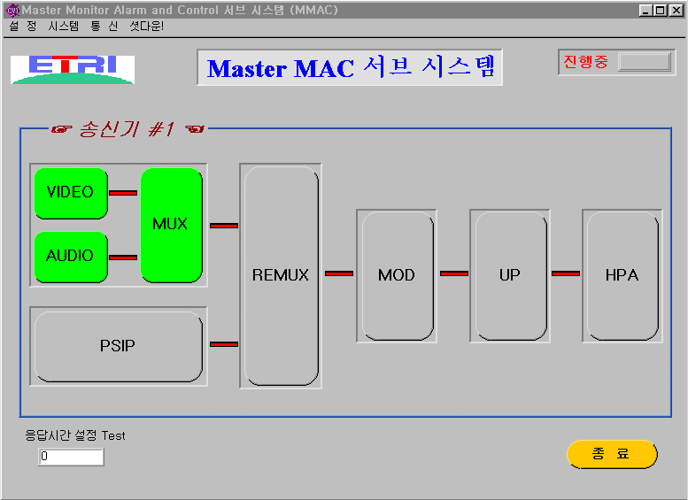
Fig. 4. The MMAC Main Panel

Fig. 5 shows the summary and status panel of the MAC. The status panel for equipment is opened by clicking on the icon in the main panel. Each parameter in the equipment is associated with an attribute. These attributes are divided into two main groups, namely the status attributes and the control attributes. The status attributes are associated with parameters which need to be monitored but cannot be controlled by the operator. The status attribute mainly consists of the attribute title, the known value, and the unit.
The control attributes are associated with parameters that can be changed by the operator. It allows the operator to edit the value of the parameter. It is divided into four parts-the attribute title, the parameter selection body, the known value, and the unit. In some of the control attributes, the parameter may not have a unit and the unit part is omitted. Three types of control attributes are described below according to their parameter selection body.

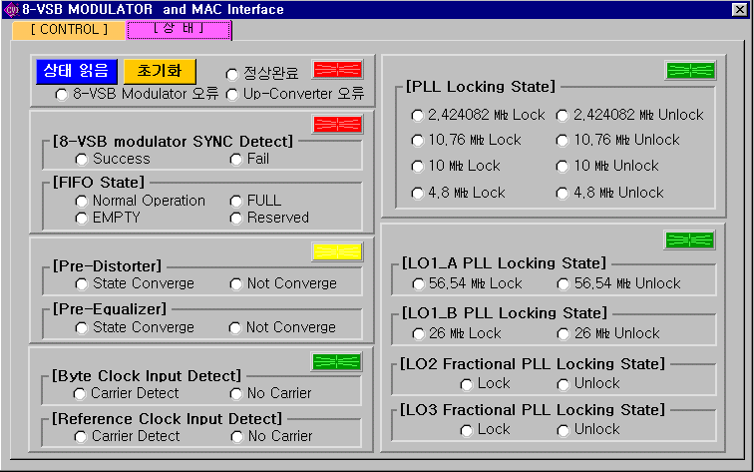
Fig. 5. The Summary and Status Panel

Fig. 6 shows the control panel of the MAC. The control attributes are associated with a parameter that can be changed by the operator. The control portion of an attribute is operable only at the appropriate security level.

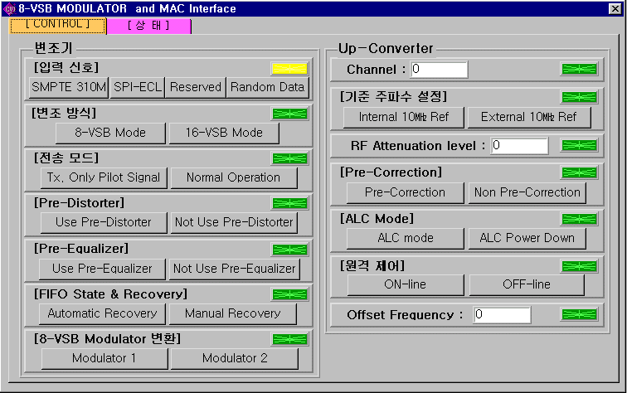
Fig. 6. The Control Panel

2.2.3 MAC S/W
The MAC component is the only component of the MAC subsystem. The MAC component’s primary purpose is to provide configuration control and monitoring of equipment. The MAC sends messages to the equipment devices to control their configuration. The equipment devices send messages to the MAC component to inform the MAC of their current status and configuration. The operator uses a mouse and keyboard to instruct the MAC component how to configure the equipment devices. The MAC component uses a graphical display to inform the operator of the current status and configuration of the equipment devices. Fig. 7 shows the function flowchart of the MMAC. Fig. 8 shows the flowchart of the alarm control.

Fig. 7. The flowchart of MAC function

Fig. 8 The flowchart of MAC alarm control

The MAC software uses object oriented module decomposition. The object oriented decomposition tries to separate modules into self-contained objects or groups of related objects. In this type of breakdown each object controls its own functionality. It encapsulates the data related to itself and only allows changes to this data through its own functions. The MAC is especially suited to an object oriented approach because of the many easily identifiable objects and the asynchronous event driven nature of a window application. Each object can specify which events it is interested in and process these events according to its own specific needs. Using an object oriented approach with the MAC is very flexible. Most objects can be individually coded and tested. Integration of objects into the overall framework is easy and allocation of work resources is flexible due to easy reassignment of modules. Fig. 9 shows digital broadcasting system.

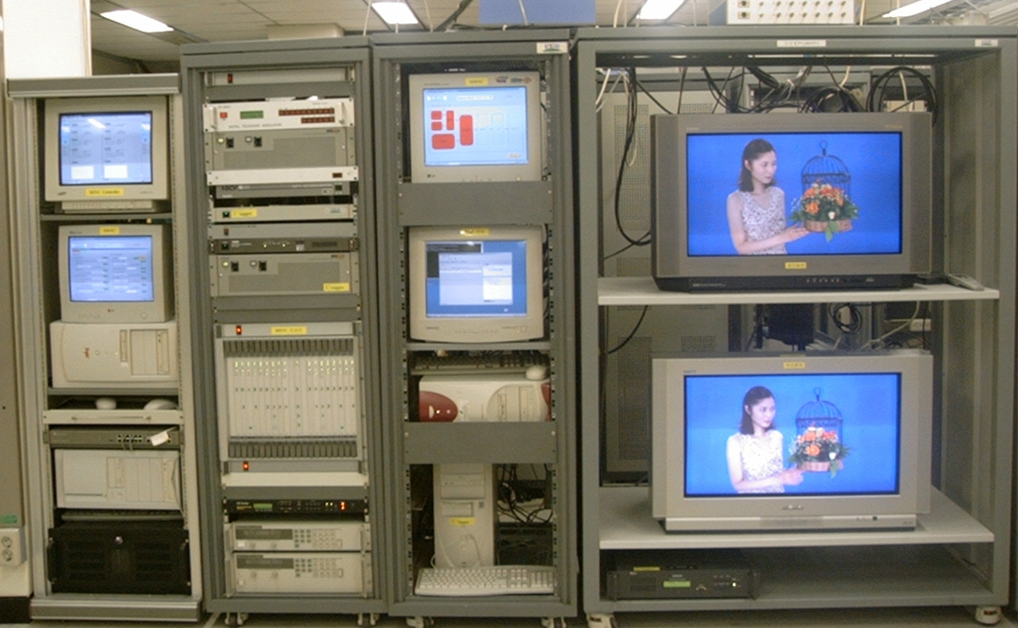Fig. 9. Digital Broadcasting System

3 Conclusion
This paper has presented an implementation of the MAC subsystem for a digital broadcasting system. Digital broadcasting systems have been operating since 2001. Their operation shows superior quality over analog broadcasting systems, and they support HD (High Definition). The MAC controls and monitors the status of the transmission equipment and gathers alarms from it. The MAC design is a PC-based system and the advantages of this system are that it is center-concentrated, processed in real time, remote controlled and decomposed into object-oriented modules.

References:
[1] P. Dambacher, Digital broadcasting, P. London: Institution of Electrical Engineers, 1996
[2] R. Blair, Digital Techniques in Broadcasting Transmission, Focal Press, 2002
[3] T.K.Kim et al’s, The Implementation of TS MAC (Transmitter Station Monitor, Alarm and Control) System for Digital DBS System, IEEE Trans. on Broadcasting, Vol. 44, No. 1, March 1998, pp.94-99.

