JEDPI: An Environment for Running Java Distributed Programs in the Internet
Laurentino Duodecimo R. Fernandes *, ** and Celso Massaki Hirata **
* UBM – Centro Universitário de Barra Mansa
Rua Vereador Pinto de Carvalho, 267 – Barra Mansa – RJ – Brazil
CEP 27330-550
** Instituto Tecnologico de Aeronautica
S.J.Campos - SP - Brazil
CEP 12.228-900
e-mails: duo@comp.ita.br, hirata@comp.ita.br

Abstract
A distributed program can be described as a group of autonomous computers interconnected and communicating only through message-passing. Although the Internet is the most ubiquitous platform, it is being used mostly for client-server applications. It is believed that a new breed of applications, based on distributed programs, will be needed in a near future. Nowadays, however, there exists little support of tools, environments, and platforms to easily, build, test, and implement distributed programs. This work presents an environment to run, test, and debug distributed programs in the Internet. Such an environment consists of an application running in the Internet, which manages distributed program or processes. Processes are written using a Java API which acts as a layer to hide from the users most of the language complexity. The environment is intended to be used for teaching the construction of distributed programs. It can also be used for building small distributed applications.

Keywords: Internet development environment, Java distributed programming

- Introduction

Nowadays, the Internet is the most ubiquitous platform for computer applications. It uses mostly the TCP/IP protocol. The Internet allows to run applications in a corporate network, as applications for intranets, as well as, global applications, for instance, e-commerce applications. However most of the applications are client-server based. In a client-server application, the client requests some service to the server, and the server processes the request by returning or updating some information. The communication is performed mostly by asynchronous sending of messages. In a client-server application, clients are not directly dependent on each other. They do not exchange messages among themselves.

On the other hand, distributed programs consist of pieces of software, usually called processes, running on different hosts and they aim to meet a processing goal by exchanging message. The processes exchange messages in order to implement synchronization and communication. Synchronization involves the coordination of actions, with respect to time, of two or more processes. Synchronization is used, for instance, to discipline the access of processes to a shared resource. Communication is the exchange of information between processes. In order to provide synchronization and communication, distributed applications generally use high-level languages or platforms. Examples of such languages and platforms include AdaTM (Ada is a trademark of the US Government [USA, 1980]), C++, Java [SUN], Darwin/Regis [MAGEE, J., DULAY, N. and KRAMER 1993 and 1994], and CORBA [OMG]. They provide inter-process communication using constructs based on the following primitives: receive, asynchronous send, synchronous send, request-reply, and remote procedure call (RPC). The basic primitive receive can be extended to conditional receive, time out on receive, selective receive, and guarded receive. For the semantics of these primitives refer to [SLOMAN & KRAMER, 1987]. Since the communication is subject to delay and failure, processes themselves can fail. For instance in a remote procedure call, if the called process fails, then the calling process fails too. So, some sort of mechanism to deal with exceptions is wished.

The task of developing distributed programs is not easy. Using an architectural view as in Darwin/Regis, the first step requires the identification of the components, description of the components in terms of interface and sub-component. Composite components are formed by sub-components whereas primitive components hold their process behaviors. Components interact with other components through their interfaces. The second step consists of codification of the primitive components. The codification involves the use of the communication primitives. Afterwards, the components are compiled into a target code. The executable code then is distributed into the hosts, so that they can be started. There can be more than one component in a single host. Typically, the components exchange messages using the communication network and known protocols.

The tasks of testing and debugging distributed programs are acknowledged to be very difficult. The execution threads of processes may vary between two runs even if the corresponding program use the same input data. This happens because the delay in the communication network is not always deterministic. So it is not always easy to reproduce the same conditions that led to bug. Testing and debugging distributed programs usually involves running the programs under artificial situation of failure. The failures include failure of host, message loss, long communication delay, message overtaking, and network partitioning. Forcing these situations requires a reasonable effort and knowledge of operation of the hosts and the communication network. Additionally to forcing failure situation, we want to control the process execution. Ideally, we want to pause processes, check and change their states, and resume their execution.

Most of the approaches to develop distributed programs such as Darwin/Regis, Java, CORBA, and Haskell do provide the primitives for the inter-process communication and even some mechanism to deal with exceptions. However they lack an environment to run, test and debug distributed programs.

This work presents an environment to run, test and debug distributed programs in the Internet for Java programs. It is required that the programs be written using a specific Java API, which embodies most of the managerial functions to control the program execution. The environment consists of management processes running in the hosts of the Internet network. The management processes manages user processes written in a Java API, which acts as an abstraction layer hiding from the users most of the management complexities. The environment is useful to learn, construct, and test, and debug distributed programs.

The article is divided into six sections. The next section, we present the requirements and the architecture of the environment. In section three, we show how to use the environment through a simple example. Section four discusses how the environment is implemented. In section five, we discuss our experience with implementations of classical algorithms in distributed programming. Finally, in the last section, conclusions and final comments are presented.

2 Requirements and architecture

We assume that the environment is to develop Java distributed programs in the Internet. With respect to software development, we are not concerned with the design tasks such as identifying the components, their interfaces, their behavior and so on. We take these for granted. We start from the codification task. For the design of the environment, we envision a situation in which a user wants to implement a distributed program, composed of user processes, on a set of hosts connected through the Internet. A user can choose to run the program either in different machines or in a single machine. In a stand alone machine, the machine hosts all the user processes. So such an environment must provide:

- Easy initialization of the management processes in the hosts.
- A graphical user interface (GUI), allowing intuitive and easy operation.
- Through the GUI, the user can configure the host connections.
- Through the GUI, the user can distribute the processes into the hosts.
- The user codes the processes using a Java API. The API is to reduce the skill and effort necessary to construct the manageable distributed programming code.
- The user can visualize the process run.
- The user can pause and resume processes. After pausing a process, he must be able to view and/or change its state.

In order to meet these requirements, we propose a distributed environment with the master/slave component architecture. The components hosts and manages the user processes. The master component is capable of configuring and distributing user processes. The master component has a special GUI to interact with the user. Through the interface, the user can configure the user process connections for communication, distribute the user processes into the hosts (send the user process to a specific slave component), and control (start, pause, resume, stop) its own user process. On the other hand each slave component manages only its own user process. The slave component receives the user process sent by the master and starts it. It has a more restricted GUI since the configuration and distribution are made by the master only.

3. Using the environment

For the user, both master and slave components present themselves as windows. Each component is responsible for receiving a process and starting it. Each component has an interface to control the process execution. The interface has windows for:
• showing an animation of the interactions of the process that is running.
• providing a chat.
• helping the user on how JEDPI works and how one can use it.
The master component has additional interfaces to configure the connections as well as to distribute the user processes.

In order to explain how JEDPI works, we make use of a classical example of distributed programming: the consumer-producer problem. The producer creates and sends messages to the consumer. The consumer process receives the messages and destroy them. An illustrative description of both processes is in Figure 1.
process producer
loop
create message
send message to consumer
end-loop
end-producer process

process consumer
loop
receive message from producer
destroy message
end-loop
end-consumer process

Figure 1: Algorithmic description of the consumer-producer problem

We describe the use of JEPDI using a sequence of steps. The steps can be grouped in three main phases, namely initialization of the environment, configuration and distribution of the distributed application, and execution and control. For our example, suppose we have two hosts in the same domain: hirata and duo.

In the first phase, the master component is started in some host using a port number as argument. Using our example through DOS prompt, we have:
[hirata] C:\> java master 1234

A master GUI is presented to the user. Slave components can then be started in different hosts by providing the port number and the hostname of the master. For our example, we have:
[duo] C:\> java slave 1234 1234@hirata

When a slave is started it passes its identification to the master component. The master acknowledges the slaves and makes them available for configuration through the user interface. After all the slaves are ready, the user proceeds with phase two, configuration and distribution.

Using the master graphical interface, the user can configure the connections between components (hosts). In our example, we have to connect from hirata to duo only. When the configuration is ready, it is sent to the components. In Figure 2, an interface of the configuration is shown.

After the configuration, the user then can code the program. In our example, two classes are coded: Producer and Consumer using the JEDPI API. The codes of both classes using the API is illustrated in Figure 3. The codes are compiled into Java classes, which are stored in a class directory. After compilation, the classes are retrieved from the directory and distributed into the hosts. In our example, Producer class is sent to hirata and Consumer is sent to duo.

After the classes are received, the corresponding objects are instantiated and have their executions started. The executions can be visualized in their GUI. Using the GUI, both processes can be paused and resumed. It is also possible to check and update their state. So the user can control the user process until he terminates the execution. The user can terminate execution either individually, for each component, or globally, through the master component. After terminating a program, all the components are reset, and the user can start another distributed application.
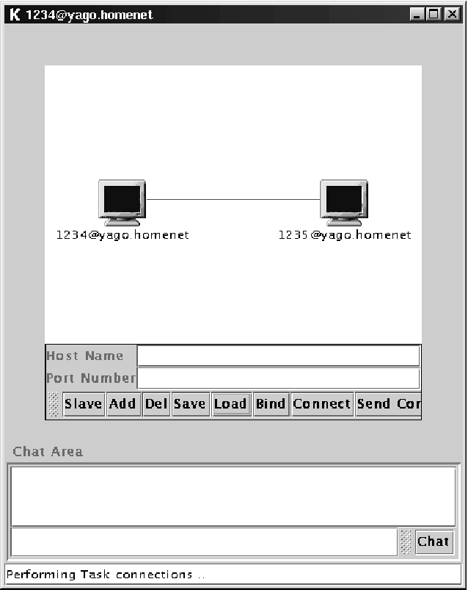

Figure 2: Configuration of two components for consumer-producer problem.

package jedpi.tasks;
import jedpi.*; //import packages
public class Producer extends TaskAdapter implements Serializable
{
private int produced;

public Producer(Jedpi Jedpi, String name)
{
super(Jedpi, name);
}

void initTask()
{
this.setTitle("Producer v-1.0");
this.produced=0;
this.autoShowState=false;
}

void taskLoop()
{
this.broadcast();
this.produced++;
this.setShowState("Produced : " + this.produced);
}
}

package jedpi.tasks;
import jedpi.*; //import packages

public class Consummer extends TaskAdapter implements Serializable
{
private int consumed;

public Consummer(Jedpi Jedpi, String name)
{
super(Jedpi, name);
}

void initTask()
{
this.setTitle("Consummer v-1.0");
this.consumed=0;
this.autoShowState=false;
}

void taskLoop()
{
if(this.hasMessage())
{
this.readMessage();
this.consumed++;
this.setShowState("Consumed : " + this.consumed);
}
}
}

Figure 3: Code of the consumer-problem using the JEDPI API
4. Implementation of the JEDPI

JEDPI management components communicate through sockets, since the TCP/IP is the most used protocol in the Internet. It is important to note that the communication of the user process is allowed to have all sorts of inter-process communication such as asynchronous send. The JEDPI components use client and server sockets in order to only manage the user process communication. A server socket listens to a port, waiting for a request from a client socket. The client socket requests a connection through a IP-port pair. As each component has a port, IP and name, we can use the "port@name" string to identify the component. Name uniqueness holds regardless of the fact that JEDPI components run in the same or in different machines.

The basic communication mechanism of distributed programs is message-passing. Through messages, processes are capable of synchronizing and communicating so that the processing goal can be achieved. Messages are exchanged through the use of inter-process communication primitives. So, JEDPI has to provide a communication layer for the user processes and also has to manage the communication. In order to manage the communication, JEDPI messages must have additional information for management. Our solution is wrap user message using JEDPI message. JEDPI message is a triplet formed by the fields: site, clock and user message. Site is an integer representing the order of the component in an alphabetically ordered component list. The field clock is an integer representing the value of a site’s logical clock [LAMPORT, 78]. User message is the message exchanged by the user processes. We use the class Message to refer to the JEDPI message. The class has basic methods such as: obtain its contents as a single string in the form "site:clock:info", obtain a single content field, make copy of Message object, and so on.

In order to be manageable by JEDPI, user processes must inherit from TaskAdapter class and implement the interface TaskInterface. The TaskAdapter class is a Java abstract class while TaskInterface is an interface. By complying to this, the user process inherits all the methods needed to read messages from other sites, send messages to one specific site and broadcast messages to all connected sites, among others. During the process coding, the user is required to implement only two methods: one for initializing the task, informing the identification of the process, and other with the body of the task, i.e. process behavior. These methods are called by the parent class (TaskAdapter). The initialization method is called just once. The body of the process is called repeatedly, each time a event is processed. In the body, the user describe both process behavior and process management. Process behavior is described in terms of control statements and inter-communication statements, and process management tasks are described in terms, for instance, of animation of the process execution, insertion of breakpoints to pause the process run for further examination and logging.

In order to implement the GUI, the Java language offers a set of useful features in its library classes. For visual graphical user interface, the AWT and Swing classes library, are used. The Java language has classes to deal with communication, among those ServerSocket and Socket classes for connected communications under IP protocol. Multithread programming is possible with the use of Thread classes, thus allowing a concurrent execution by creating many threads as necessary. This allows the implementation of asynchronous send and receive. Java allows to load and transfer classes among component instances. To perform the transfer we make use of the ClassLoader class, InputStream and OutputStream classes and its subclasses.

- Experience with JEDPI

We have used JEDPI to implement many classical algorithms of distributed programming. For instance, we implemented the Ricart-Agrawala algorithm [SINGHAL & SHIVARATRI, 1994] for mutual exclusion. Figure 4 shows the configuration, and Figure 5 shows the execution.

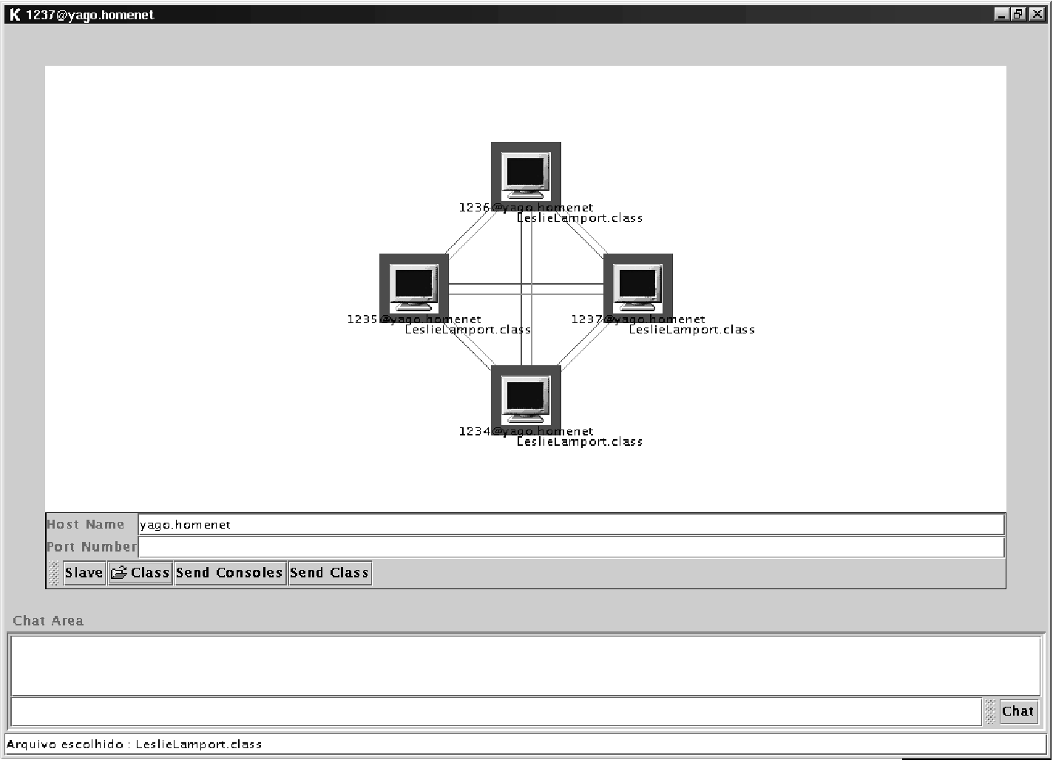

Figure 4: A JEDPI master state component showing the communication configuration.

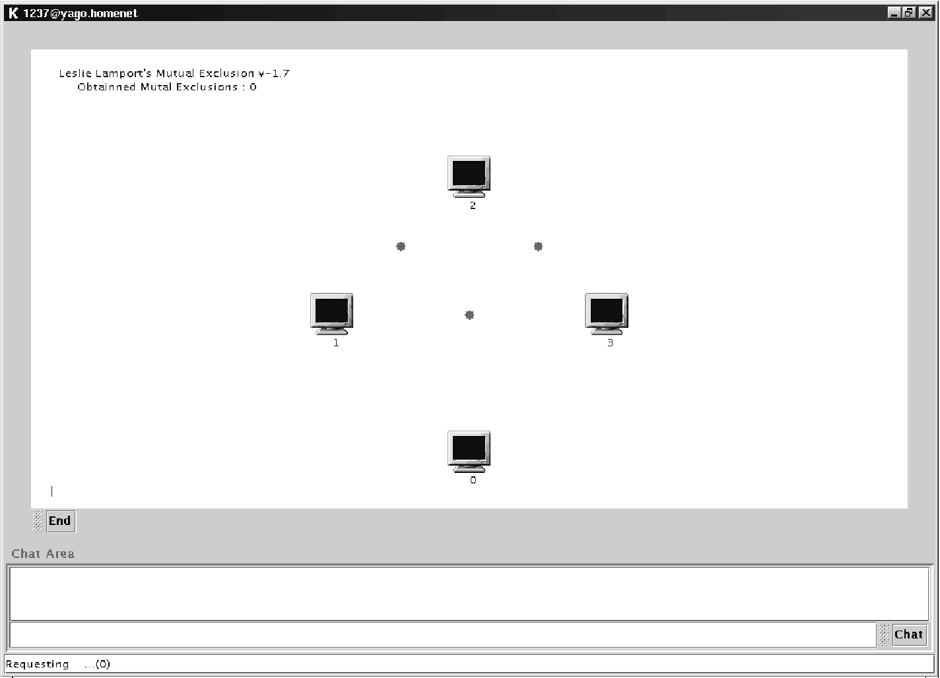

Figure 5: One of the JEDPI state component executing its process.

Other algorithms [SINGHAL & SHIVARATRI, 1994] implemented using JEDPI include Misra’s Ping Pong and Leslie Lamport’s mutual exclusion. The above algorithms have been used to teach distributed programming in our undergraduate and graduate courses in our department.

Our experience with the above implementations shows that JEDPI is easy to install, configure and use. Its API for describing, though simple, is powerful and reliable.
- Conclusions and comments

We proposed and implemented an environment to run distributed programs. The JEDPI environment allows to run, test and debug distributed programs in the Internet for Java programs. The restriction is that the programs are written using a specific Java API, which embodies most of the managerial functions to control the program execution.

Based on our experience with various implementations, we claim that the environment is simple to use and meet all the design requirements stated in section two. However, the work is not complete yet. We plan to implement the control of the communication between the user processes. In a future release, JEDPI will allow to force failure situation. For instance, JEDPI will allow message loss, message overtaking, user controlled delay of the message component, and network partitioning.

References

SLOMAN., M. & KRAMER, J. Distributed Systems and Computer Networks. Prentice-Hall, 1987.
LAMPORT, L. Time, Clocks, and the Ordering of Events in a Distributed System. Comm. of the ACM, Vol. 21, No.7, July 1978, pp. 558-565.
SUN MICROSYSTEMS. About the Java Technology. Available in: <http://java.sun.com/docs/books/tutorial/getStarted/intro/definition.html>. Accessed on July 20, 2001.
OBJECT MANAGEMENT GROUP. CORBA basics. Available in: <http://www.omg.org/gettingstarted/corbafaq.htm#TotallyNew>. Accessed on Jun 29, 2001.
Singhal, M.; Shivaratri, N. G. Advanced concepts in operating systems. McGraw-Hill, 1994. 522 p.
USA Department of Defense, Reference Manual for the Ada Programming Language, Proposed Standard Document, July 1980.
MAGEE, J., DULAY, N. and KRAMER, J., Regis: A constructive development environment for distributed programs, Distributed Systems Engineering Journal, Vol. 1, No. 5., Sept 1994, 304-312.
MAGEE, J., DULAY, N. and KRAMER, J., Darwin/MP: An Environment for Parallel and Distributed Programming, Hawaii International Conference on System Sciences HICSS-26, Jan 1993.

