Development of Policy Management Tool
in Policy Based Network Security System.

Geonlyang-Kim, Jongsoo-Jang.
Electronics and Telecommunications Research Institute
161 Gajeong-Dong Youseong-Gu Daejeon city
KOREA
glkim@etri.re.kr, jsjang@etri.re.kr

Abstract
This paper introduces Policy Management Tool which was implemented based on Policy Information Model in policy based network security system that was made by using policy sever. Policy based network security system consists of policy server managing and sending policies to keep a specific domain from attackers and policy clients detecting and responding intrusion by using policies that policy server sends. Policies exchanged between policy server and policy client are saved in database in the form of directory through LDAP by using Policy Management Tool based on NSPIM. NSPIM is policy information model founded upon PCIM of IETF and PCIMe and expanded. Policy Management Tool based on NSPIM provides not only policy management function, but also editing function using reusable object, function generating object name and blocking rule automatically, and other convenient functions for user. Policy Management Tool provides the function generating policies and checking integrity and consistency of those. So, It generates right policies meeting the schema of Policy Repository.

Key-Words: - Policy Management Tool, Policy Core Information Model, Network Security

1 Introduction

As users of Internet have increased and large networks have constructed actively, the intrusions of network based system increase suddenly. So network security is needed very much. In recent years, the method that blocks originally intrusion from outside such as DDOS(Distributed Denial of Service) attack is needed seriously. Policy Framework Working Group proposed policy framework for a policy based network security system as a solution for network security.[1]
We apply the policy framework to our network security system. The Policy based network security system consists of policy server providing policies and controlling policy clients and policy clients detecting intrusion and responding to it by using policies that policy server sends to secure specific domains. Policy repository that has policies is accessed by LDAP(Lightweight Directory Access Protocol) protocol, and policies are transferred to policy client as the form of PIB(Policy Information Base) by COPS(Common Open Policy Service) protocol. Policy Information Model is needed for defining the structure of PIB and MIB(Management Information Base), and the schema of LDAP Server (i.e. policy repository). Components of system can be presented, managed and shared efficiently through policy information model, and process several jobs by using policy information model.
There is the CIM(Common Information Model) of DMTF(The Distributed Management Task Force) as information model, and the PCIM(Policy Core Information Model) of IETF(The Internet Engineering Task Force) extended based CIM was standardized as RFC3060. This network security system defines NSPIM(Network Security Policy Information Model) by extending PCIM and PCIMe(Policy Core Information Model extensions) for presenting signature policies that are used for intrusion detection and response in several components of system, because policy information model for network security hasn’t standardized.
The policy information that used in network security system is defined as NSPIM, and PMT(Policy Management Tool) that designed based on NSPIM is needed for managing and controlling these policies. This paper describes the NSPIM presenting signature policies and the PMT managing policies that are used for network security in policy based network security system.
This paper is organized as follows. Section 2 describes the architecture of policy based network security system and interaction of modules in system. Section 3 describes the definition of NSPIM and the example, several functions of PMT, and the input course of policy using PMT.

2 The Architecture of Policy Based Network Security System.

In the policy based network security system introduced in this paper, a domain consists of one policy server and several policy clients, and when the domain is very wide, it is able to be extended as building another high-level policy server controlling several policy servers. In this paper, we describe a policy based network security system in one domain. The architecture of policy based network security system in a domain is as shown in fig. 1.

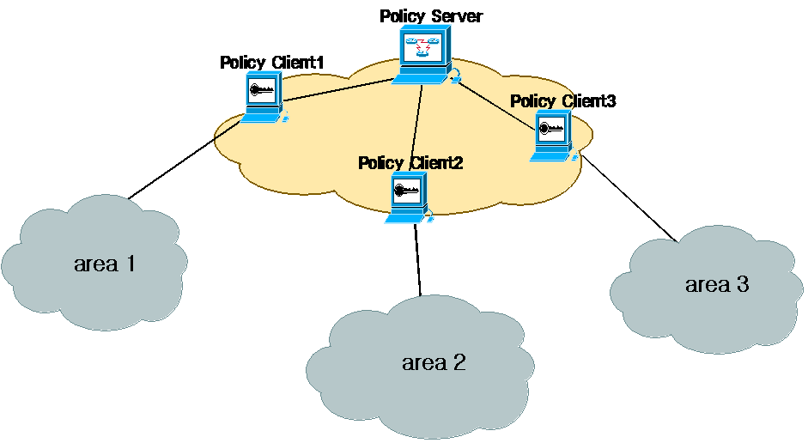
Fig. 1 Policy Based Network Security System for a domain.

Policy client analyzes packets accessing to inside network, detects intrusion, sends alert message to policy server, and transfer traffic data, alert data and log data that policy server uses for generating response policy. Policy client detects intrusions and response about it by using policy. On the other hand, policy server generates response policy about intrusion through synthetic analysis such as statistic analysis, anomaly analysis using traffic data and alert data that several policy clients transfer. Policies of policy repository are transferred from policy server to policy clients through secure tunnel using IPSec(Internet Protocol Security).[2]
The constitution of policy server and policy client is as shown in fig. 2. The PMT has functions to initiate and update Policy Repository, and to notify changed instances to the PDP(Policy Decision Point). The PMT transforms input data into LDIF(The LDAP Data Interchange Format), saves them in PR(Policy Repository) by using LDAP(Lightweight Directory Access Protocol) protocol, has a function to manage and control policies. The PDP determines policy, and transfers policies formed of MIB encoded ASN.1 from the Policy Repository to several policy clients by using COPS(Common Open Policy Service) Protocol, and has a function to transfer notification to viewer when problems take place during the execution based policies. The AM(Alert Manager) has functions to save alert data transferred from policy client into database and to transfer alert data to viewer. The HA(High-level Analyzer) has functions to detect the distributed attack by using the traffic data, alert data and the log data of several policy clients and to generate new response policies by analyzing correlation of the alert data of several policy clients.

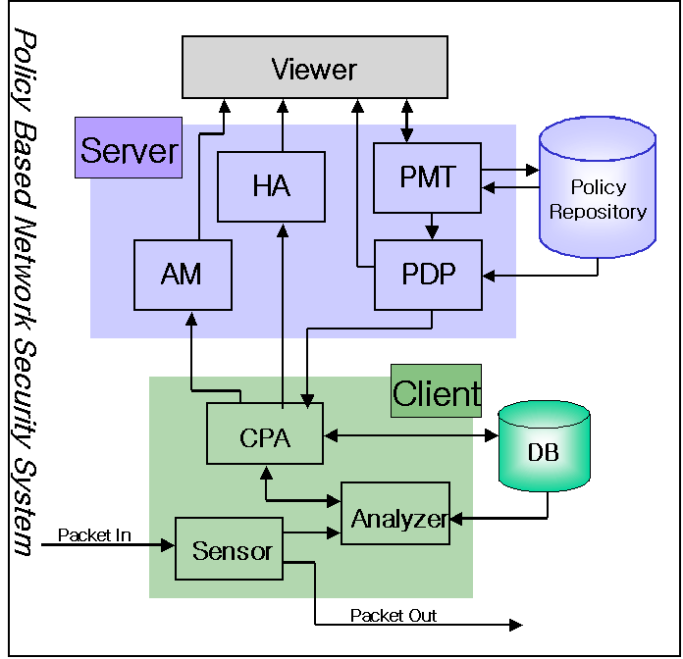
Fig. 2 The inside Architecture of System.

The Sensor has a function to collect the packet data,(e.g. capturing and filtering packet) for analyzing packets. The Analyzer has a function to detect the intrusions by comparing policies in the database with data collected from the sensor. The CPA(Cyber Patrol Agent) saves policies transferred from policy server into the database, and takes response action whether transferring alert message to policy server or blocking packets and so on.
In this way, the PMT is needed for managing and controlling policies efficiently, because data for communications among modules in policy based network security system are policies.

3 The Policy Management Tool Based on Network Security Policy Information Model.

In this section, PMT as module in policy server includes PMV(Policy Management Viewer), graphic user interface. We describe NSPIM extended based PCIM and PCIMe before illustrating the functions of PMT, because PMT designs based on NSPIM. We describe functions of PMT, the course inserting data to PR by using PMT.

3.1. Network Security Policy Information Model.

The information model structures the knowledge about users, applications, networks, and how they interact into multiple knowledge domains to enable different people to use it. [3]
PCIM presents the object-oriented information model for representing policy information currently under joint development in the IETF Policy Framework WG and as extensions to CIM(the Common Information Model) activity in DMTF(the Distributed Management Task Force). This model defines two hierarchies of object classes: structural classes representing policy information and control of policies, and association classes that indicate how instances of the structural classes are related to each other. The policy classes and associations defined in this model are sufficiently generic to allow them to represent policies related to anything. However, it is expected that their initial application in the IETF will be for representing policies related to QoS and to IPSec. Policy models for application-specific areas such as these may extend the Core Model in several ways. The fig. 3 represents inheritance hierarchies for the structural classes consisting of PCIM.[4][5][6][7] [8]

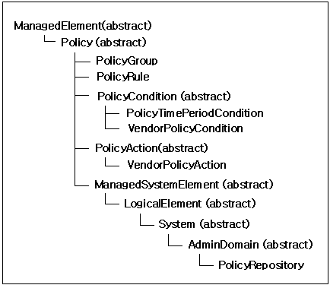
Fig. 3 Inheritance Hierarchy for the Core Policy Classes

NSPIM is information model for signature policies detecting intrusion and responding to it and extends PCIM. The inheritance hierarchy for structural classes consisting of NSPIM is shown in fig. 4.

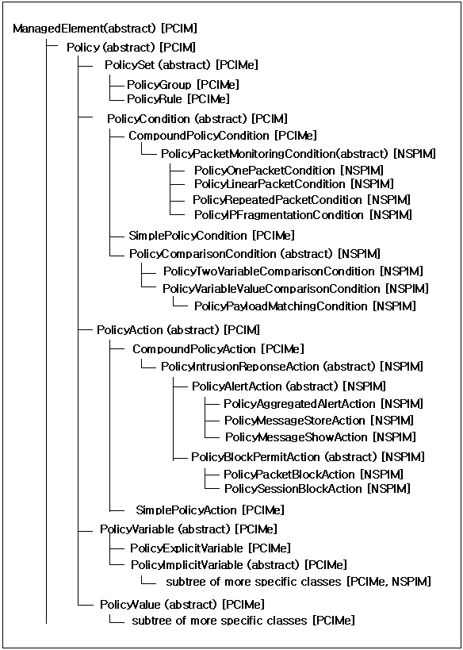
Fig. 4. Inheritance Hierarchy for Structural Classes of NSPIM

NSPIM uses core classes defined in PCIM such as “PolicyGroup”, “PolicyRule”. NSPIM defines structural abstract classes such as “PolicyPacketMonitoringCondition”, “PolicyComparisonCondition”, “PolicyIntrusionResponseAction” newly. The abstract “PolicyPacketMonitoringCondition” class is a condition for monitoring one or more packets, and can associate with several condition classes as child class, because it is inherited from the “CompoundPolicyCondition” class in PCIMe. It is to check the header and/or payload of packets. The “PolicyOnePacketCondition” class represents a condition for only one packet, and the “PolicyRepeatedPacketCondition” class represents a repeated condition for specific packets during specific period. The “PolicyLinearPacketCondition” class represents a condition for linear packets of specific number and the “PolicyIPFragmentationCondition” class represents a condition for packets that identify with a “identification” field and a “source address” field of header. The abstract “PolicyComparisonCondition” class represents a condition for comparison of two objects, and it includes a comparison condition for two variables and that for a variable and a value. The abstract “PolicyIntrusionResponseAction” class is a class defining response action for intrusion, and associates with alert and block action class as child class. In this way, the classes of PCIM and PCIMe are used for basic outline, but we extend very much for network security policies. [9]
We describe “Smurf” PolicyRule for examing the class definition of NSPIM. As shown in fig. 5, the rule named “Smurf” is associated with the “IcmpAnomaly” PolicyGroup. The “Smurf” rule is that the pattern identifier is “6001”, the priority of it is “2”, and the intrusion impact of it is “6”. It means if three packets during one second and twenty packets during two seconds meet the conditions that protocol field of packet header is ICMP, the destination IP address field of packet header is HomenetBroadcast, and the ICMP type field of packet header is 8, take actions storing alert message to database and showing it to alert viewer, that is “Attack try of Denial of Service using Smurf”.
When we design the “Smurf” PolicyRule, the model consists of the structural classes and association classes by using UML(Unified Model Language) is shown in fig. 6.
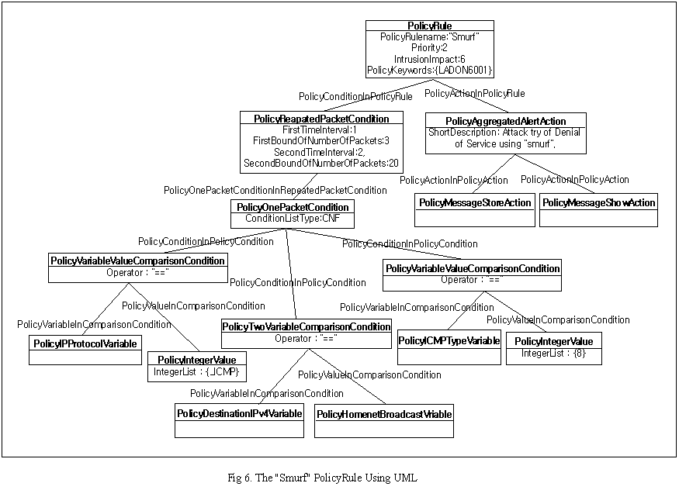

6001 Pattern [Smurf:IcmpAnomaly;2;6;MStore|MShow]
while(3:1 - 20:2) {
icmp any > _homenet_br (CTYPE:8) }
(MESSAGE: "Attack try of Denial of Service using Smurf")
Fig. 5. The “Smurf” PolicyRule

3.2 The Functions of Policy Management Tool

This section describes the functions of PMT including PMV.
The first, PMT searches, displays policies in policy repository. As shown in fig. 7, policies of policy repository can be nested at a group according to their characteristic, and the group is able to be nested at the upper group and be managed. The left view displays the objects consisting of policies as tree structure. The objects consisting of policies are not associated directly at one policy rule, and have hierarchy structure. As displaying this hierarchy structure, we are able to see the information of these objects at first sight. The right view displays the attributes of the objects that are selected at the left view and the information of subordinate objects that are associated with the object selected at the left view.
In this way, we may see all information of policies such as the attributes of objects at first sight. The PMT also provides a function that may search with the attributes such as name or keywords of object.

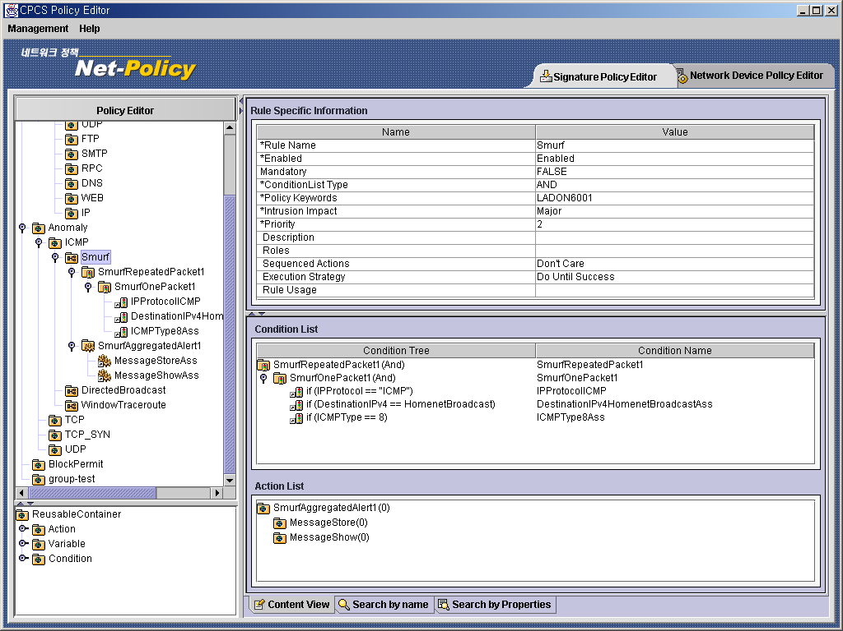
Fig. 7 The Policy Management Viewer.

The second, PMT provides convenience of editing by using reusable object. Policy objects can be partitioned into two groups: ones associated with a single policy rule, and ones that are reusable, in the sense that they may be associated with more than one policy rule. The objects in the first group are termed “rule-specific” and those in the second group are characterized as “reusable”. As shown in fig. 8, it makes a condition as selecting and adding reusable condition objects in the left view, and creating rule-specific condition objects as using the “create” button of bottom in the right view for condition with out reusable object. The condition instance using reusable objects in “Smurf” PolicyRule is that the protocol is ICMP, that the field of type in ICMP packet header is 8, and that the destination IP address is HomenetBroadcast. In this way, PMT provides several conveniences as using the concept of reusable object when editing policies.

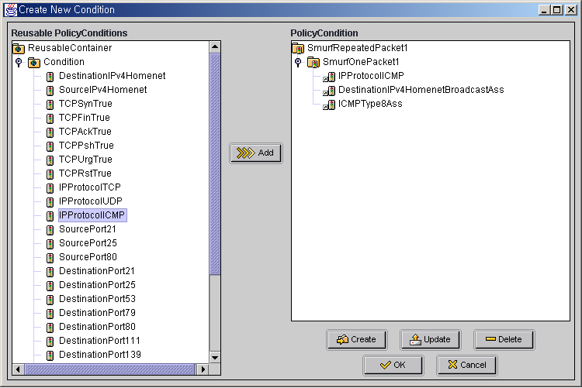
Fig. 8. View creating condition using reusable objects.

The third, PMT provides the function verifying the schema of policy and modifying policies of PR, and checking integrity and consistency of policy. The function checking integrity and consistency of policy means whether the value of data is right or not and what object can be created. For example, PMT checks that the value of source port is included within 1-65535 range. When protocol is UDP, PMT checks whether it generates only conditions for header fields of UDP packet. In this way, the PMT provides convenience when editing policies by using the concept of reusable object. Section 3.3 illustrates this process in greater detail.
The forth, when creating object, it provides a function generating object name. The function generating object name is excuted after selecting a object for creating it, and it is showed to user when the window including object name generated pops up. For example, a “IPSpoofing” rule consists of IPSpoofingOnePacket, SourceIPv4Homenet, DestinationIPv4Homenet, SourceMACDestinationMAC, IPSpoofingAggregatedAlert, MessageStore, MessageShow. The user can specify object name for generating object at random, but the function generating object name provides convenience because it reduces troublesome considering object name expressing the meaning of object well and typing it.
The fifth, it provides a function notifying changes of policies to PDP after changed policies are saved to policy repository. Administrator requests policy changes to PMT through PMV, and if policy of PR is changed, PMT notifies policy changes to PDP. PDP transfers this changed policies to policy clients, and policy clients can detect and respond intrusion with changed policies.
The sixth, it provides a function generating blocking rule automatically. In the main viewer, alert messages are transferred from policy clients, and if alert traffic is over threshold value, the IP address originating alert message is recorded in a black list as a bad user or a bad host. When administrator clicks the record representing a bad user or host in the black list for blocking, PMT creates objects consisting of a blocking rule, saves them to policy repository and records it in the blocking list. If the system is attacked from outside and is needed to block a specific IP address, PMT provides the rapid response for attack with the function generating a blocking rule automatically without time for editing it, and that is able to reduce damage.
The administrator should know the concept of NSPIM and input LDIF based on NSPIM for saving policies to PR. In case of existing MOF, he should exchange MOF to LDIF by using MOF compiler. But, those don’t need by using PMT based on NSPIM

3.3. Data Input Course Using Policy Management Tool.

In the case of creating object, when user specifies properties, it checks whether instances having same name and keyword exist and user specifies the value of the defined range. All packets have super condition objects such as “PolicyOnePacketCondition”, “PolicyRepeatedPacketCondition”, “PolicyLinearPacketCondition”, and “PolicyIPFragmentationCondition”. And objects such as “PolicyRepeatedPacketCondition”, “PolicyLinearPacketCondition”, “PolicyIPFragmentationCondition” are able to associate with one or more “PolicyOnePacketCondition” object. PMT help administrator generate objects rightly by providing interface based on NSPIM.
In the case of updating object, the procedure is the difference between rule-specific object and reusable object. When rule-specific object is updated, the PMT checks whether objects having same name and keyword exist and the values specified by user belong to the defined range. On the other hand, when reusable object is updated in case that objects referring it exist, the procedure that checks whether the references were updated is added.
In the case of deleting object, the procedure is the difference between rule-specific object and reusable object, too. If there are subordinate objects of rule-specific object, the PMT checks deleting subordinate objects, and If there are no subordinate objects of it, the PMT checks intention for deletion once more. The reusable objects have no subordinate objects because each object is saved at reusable container. So, when user deletes reusable objects, reusable objects referred by other objects can’t be deleted. And the procedure that the PMT checks intention for deletion once more in case of those not referred by other objects only exists.
After this edition, objects are saved at PR(Policy Repository). Policy Repository is the structure of directory. A directory is an information repository for data about objects such as users, applications, files, and other resources. By using standard directory access protocols, such as LDAP, different types of clients can access the data in a directory. An entry is the basic unit of information stored in a directory. Entries contain a series of attributes that contain information about the object. Each attribute contains a type and one or more values. Entries are organized hierarchically in a treelike structure called a DIT(Directory Information Tree). Each entry has a unique identifier called a DN(distinguished name), by which the entry is organized in the DIT. Entries are named according to their position in the DIT.
The left view of fig. 9 is window specifying the attributes of “Smurf” policy rule. When administrator specifies them by using the Policy Management Tool, they are stored into Policy Repository as LDIF format through LDAP protocol. The data stored into Policy Repository by using the Policy Management Tool are showed at the right view of fig. 9.[10]

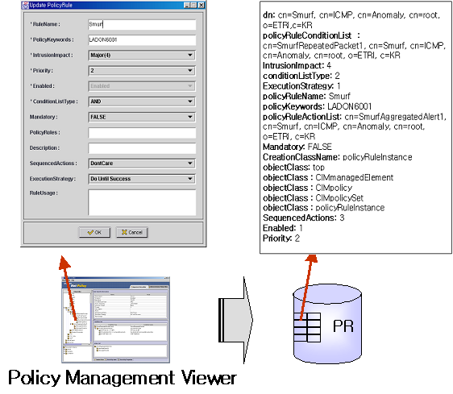
Fig. 9. The Data Stored to PR by Policy Management Tool

4 Conclusion

This paper introduced Policy Management Tool based on Network Security Policy Information Model in the policy based network security system for intrusion detection and response. The Policy Management Tool provides many functions, display and change policies, check integrity and consistency of policies, notify update information to Policy Decision Point, generate blocking policies automatically, edit by using reusable objects. The Policy Management Tool serves several conveniences by providing these functions. And the instances are saved to Policy Repository in the form of directory though LDAP Protocol by the Policy Management Tool based Network Security Policy Information Model.
In the Future, our works include extending Network Security Policy Information Model for policies of variant policy clients, and researching hierarchical policy information model for signature policies detecting and responding intrusion, configuration policies, and management policies managing this policies.

References:
[1] http://www.ietf.org/html.charters/policy-charter
.html
[2] Jinoh Kim, Kiyoung Kim, Jongsoo Jang, “Policy-Based Intrusion Detection and Automated Response Mechanism”, The 16th International Conference on Information Networking, Session 2B-4.1 ~ 10, 2002.
[3] Steven Judd, John Strassner, "Directory Enabled Networks - Information Model and Base Schema”, Draft v3.0c5, September, 28, 1998.
[4] J. Strassner, E. Ellesson, B. Moore, and A. Westerinen, "Policy Core Information Model -- Version 1 Specification", RFC 3060, February 2001.
[5] B. Moore, L. Rafalow, Y. Ramberg, Y. Snir, J. Strassner, A. Westerinen, R. Chadha, M. Brunner, and R. Cohen, "Policy Core Information Model Extensions", work in progress, <draft-ietf-policy-pcim-ext-01>, April 2001.
[6] Distributed Management Task Force, Inc., “Common Information Model (CIM) Specification, version 2.2, June 1999.
[7] Snir Y., Ramberg Y., Strassner J., Cohen R.: Policy Framework QoS Information Model, work in progress, <craft-ietf-policy-qos-info-model-03.txt>, April 2001.
[8] Jason J., Rafalow L, Vyncke E. : IPsec Configuration Policy Model, work in progress, <draft-ietf-ipsp-config-policy-model-02.txt>, March 2001.
[9] Sook-Yeon Kim, Myung-Eun Kim, Ki Young Kim, Jongsoo Jang, “Information Model for Policy-Based Network Security Management”, The 16th International Conference on Information Networking, Session 8B-4.1 ~ 11, 2002.
[10] J. Strassner, A. Westerinen, E. Ellesson, B. Moore, R. Moats, "Policy Core LDAP Schema", work in progress, <draft-ietf-policy-core-schema-11.txt>, May 2001.
[11] G. Good, “The LDAP Data Interchange Format (LDIF) – Technical Specification”, RFC 2849, June 2000.
[12] A. Westerinen, J. Schnizlein, J. Strassner, M. Scherling, B. Quinn, S. Herzog, A. Huynh, M. Carlson, J. Perry, S. Waldbusser, “Terminology for Policy-Based Management”, November 2001

