Intelligent Neural System for Safety Control

R.A.KOSINSKI ^{a, b}

ª Central Institue for Labor Protection, Czerniakowska 17, 00-701 Warsaw, Poland

^{b} Faculty of Physics, Warsaw Technical University, Koszykowa 75, 00-662 Warsaw
rokos@ciop.pl

Abstract: - Safety system for recognition of danger situations at automatized work stands (e.g. with stationary robots) is presented. The system consists of a vision part based on the TV camera connected with a frame grabber which observes the neighbourhood of the robot and a set of cellular neural networks which analyses the sequence of images transmitting from the camera. The neural system is able to work in a real time and react intelligently on the objects appearing near the robot. If the situation is danger the system stops the robot, thus preventing the collision.

Key-Words: - safety control, cellular neural networks, intelligent systems

1 Introduction
Pattern recognition is one of the most important applications of artificial neural networks. Special role in this application play cellular neural networks (CNNs), which enable to recognize and extract from the presented picture earlier defined elements like edges, object of specified shape, or with a specified velocity etc [1,2]. These properties of CNNs may be applied in different systems for advanced pattern recognition, in particular in the systems for safety control .
Safety control systems may be used for an intelligent analysis of automatized work stands with robots. During the work of a robot its arm may collide with the objects of different kind (e.g. workers supervising a technological process), which suddenly have appeared in the neighbourhood of the robot. Such a collision may result in an injury of the worker or in the damage of the robot arm. Safety system installed at the work stand may analyse the current situations in the neighbourhood of the robot and, if there is a dangerous situation, it can stop the robot, thus preventing a collision. On the other hand, random stops of the robot (e.g. due to appearance of the small objects) cause interruption in the technological process of the robot and are connected with a significant loses. The system presented here consists of the vision part based on TV camera coupled with a frame grabber and a neural system based on hybrid system of CNNs realized in the PC computer.

2 The safety system
The architecture of the system in shown in Fig.1. TV camera observes the safety field (SF) of the radius R surrounding working area (WF) of the robot arm of the radius r_{o}. Additional sources of light enable to reach the proper illumination of SF, in particular remove random shadows. The series of TV images are sent to the frame grabber which perform initial processing of the pictures. Next the neural system compare and analyses the pictures. When the situation in SF is recognized as a danger one the signal stopping the robot is sent. As results from the above description the safety system have to work in a real time i.e. the total time t_{s} of the following processes: transmission of pictures from TV camera to the frame grabber and its initial processing, comparison and analysis in CNNs system and stopping the robot arm, have to be smaller than the time t_{ob} . In the time t_{ob} the object appearing in the SF reaches the WF field. The frequency of the renewal of images in a standard TV-camera (which we used in order to reduce the costs of the system) and the inertia of the robot arm cause that only the time of processing of pictures by the neural system t_{n} can be effectively reduced in order to have t_{s} < t_{ob} . Proper time t_{n} was achieved with CNNs .

3 The neural system
In the CNN neurons form the square network and the location of each neuron is given by two indices i,j. Such a shape correspond to the CCD matrix, which is light sensitive element of TV digital camera. Thus, dark/white pixel of TV image can be represented by a firing/resting neuron (when a proper threshold value is taken into account in an image processing). The most fundamental property of the CNNs is that the topology of synaptic connections of each neuron in the network (despite the neurons lying on the edges of the network) are the same forming a cloning template of the range r, where r equals the order of neighbours connected with each neuron. Thus, the state of each neuron x_{i,j}(t) is defined by matrix [A], which describe the influence of output signals of neighbouring neurons (feedback matrix); matrix [B], which describe the influence of the input signals of neighbouring neurons (control matrix) and the external polarization I [3]. The dimensions of matrix [A] and [B] equals (2r+1) x (2r+1), and the output state of the neuron y_{i,j}(t)= f[x_{i,j}(t)] is given by activation function of the neuron f.
In our safety system the situation in SF is classified as a danger one if: 1) the object which has appeared in SF is large enough i.e. its greatest dimension D, as seen by the camera, is grater than a specific dimension D₀ ; 2) The velocity v of this object is v_{min} < v < v_{max} . Thus maximal dimension and the velocity of the object appearing in SF have to be extracted and computed from the sequence of TV images sending from the frame grabber to the neural system. The neural system consists of a parallely connected CNNs, each having 512 x512 neurons, which correspond to the number and locations of pixels in the input TV image.

4 Detection of a new object
The first CNN checks if any new object has appeared in the SF field. Initial states of neurons correspond to the grey level of the pixels of an initial image transmitted from the camera. (Fig.2a). When the new image is transmitted from the camera (Fig.2b) its grey level defines new input values of neurons. The output values of the neurons corresponding to the picture of the object which has appeared in SF (Fig.2b) , are set to a maximal value on the basis of a certain, experimentally found, threshold value. The values of other neurons are set to zero (Fig.2.c). Following templates with r = 1 are used to perform thresholding operation

$$\left[A\right]=\begin{matrix}0 & 0 & 0 \\ 0 & 0 & 0 \\ 0 & 0 & 0\end{matrix}$$

$\left[B\right]=\begin{matrix}0 & 0 & 0 \\ 0 & −1 & 0 \\ 0 & 0 & 0\end{matrix}$ $I=0$

Next the noise in the image of new object is removed using template [4]
$$\left[A\right]=\begin{matrix}0 & 0 & 0 \\ 0 & 0 & 0 \\ 0 & 0 & 0\end{matrix}$$

$\left[B\right]=\begin{matrix}0\text{.}1 & 0\text{.}1 & 0\text{.}1 \\ 0\text{.}1 & 0\text{.}5 & 0\text{.}1 \\ 0\text{.}1 & 0\text{.}1 & 0\text{.}1\end{matrix}$ $I=0$
and the edges of the image are smoothed with the template
$\left[A\right]=\begin{matrix}0 & 0 & 0 \\ 0 & 2 & 0 \\ 0 & 0 & 0\end{matrix}$$I=−1\text{.}5$

$\left[B\right]=\begin{matrix}−0\text{.}\text{25} & −0\text{.}\text{25} & −0\text{.}\text{25} \\ −0\text{.}\text{25} & 2 & −0\text{.}\text{25} \\ −0\text{.}\text{25} & −0\text{.}\text{25} & −0\text{.}\text{25}\end{matrix}$
The result of this process is shown in Fig.2.d.

5 The extraction process
The next CNNs, connected parallely with the first network, calculates the maximal size of the object D, which is compared with the parameter D_{o} . When D is greater than D_{o} the situation is classified as a danger one. Because the real size of the object and the size D of its image observed by the camera is a function of the distance between the object and the camera (and depends on the hight of the object), this relations are be taken into account in classification of the present situation in SF.
In our calculations the maximal dimension of the object D is computed as the diagonal d of the rectangle which is circumscribed on the object (Fig.3)

.

$$d=\sqrt{x^{2}+y^{2}}$$
The velocity of the object is computed on the basis of two subsequent positions of the object dist(t) and dist(t+1), relatively to the robot’s arm rotation centre C. As results from Fig.4, the velocity v of the the object is defined by the

$$v=\frac{\text{dist}(t+1)−\text{dist}(t)}{Δt}$$

6 Experiments
The system of CNNs is programmed in C language, which enable to perform the analysis in a real time. Interface of the system enable to chose the parameters proper for the type of the robot, technological process, or for other application. User can chose radii R and r of the fields SF and WF, dimension D₀ and velocity range [v_{min}, v_{max}]. Also the arbitrary fields (CF) which are excluded from the CNNs analysis can be defined by the user. The system also register the data on the danger situation which have occurred earlier.
Experiments were performed using chosen industrial robot IRP 10, with the maximal range of arm equals 110 cm. The system was based on PC computer with two Pentium 600 MHz processors. In the vision part of the system Pulnix TV digital camera, giving 25 images per second was used.
Time t_{s} which was achieved in our experiments were smaller than 40 ms and were independent on object’s position and its movement direction. The sensitivity of the system describes Tab.1 where minimal velocities and minimal dimensions of the object for different values of radius R of SF are shown.

Tab.1.
R [m] | v_{min}[m/sec] | D_{o}[cm]
1.5 | 0.14 | 0.6
2.5 | 0.25 | 1.0
5.0 | 0.5 | 2.0

In the Tab.2. the dependence between velocity v of moving object and the distance L which it travels in the time interval between the object has been noticed to the moments of system’s reaction, is shown.

Tab.2.
v [m/sec] | L [cm]
0.83 | 6.8
1.66 | 13.6
3.33 | 7.4

On the basis of the performed experiments it can be stated that the safety system based on the CNNs is fast enough to work in real time and is able to prevent the danger situations which appear in the work of robot. Possibility of choosing of a number of parameters of the system cause that it is applicable to different types of robots, technological processes and also for other purposes connected with the intelligent analysis of the field observed by TV camera.

References:
[1]L.O.Chua, CNN – a Paradigm for Complexity, World Sci., Singapore, 1998
[2]C.M.Bishop, Neural Networks for Pattern Recognition, Clarendon Press, Oxford, 1995
[3]L.O.Chua and L.Young, IEEE Trans. CAS 10, 1257 (1988)
[4]R.C.Gonzales, Digital Image Processing, Addison Wesley, Reading, MA, 1992

Figures

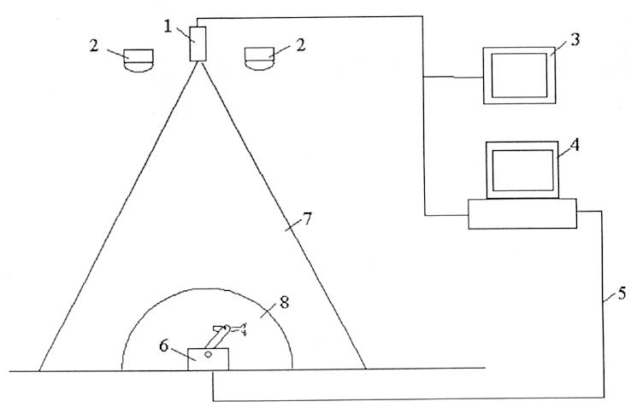
Fig.1.Architecture of the system. 1 – TV camera, 2 - sources of light, 3- display, 4 - link between the computer and the robot, 6 - The robot, 7 - area observed by TV camera (SF), 8 – working area (WF)

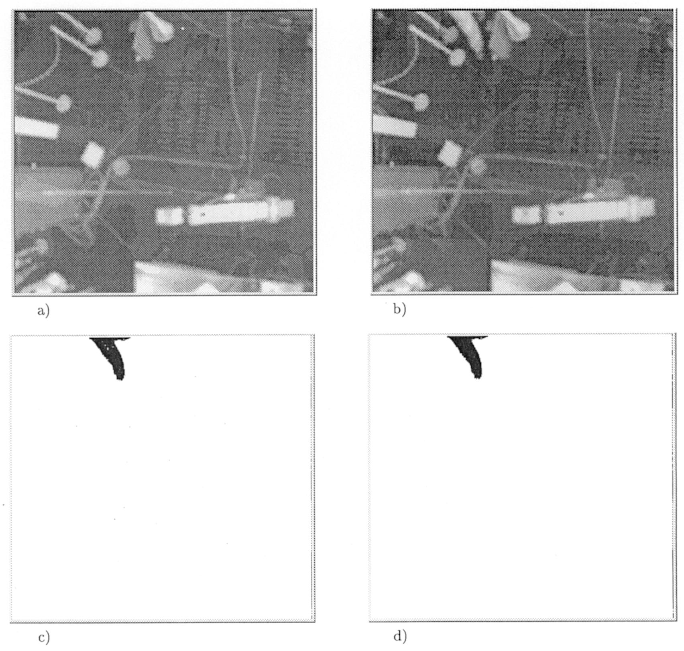

Fig. 2. Stages of image preprocessing.

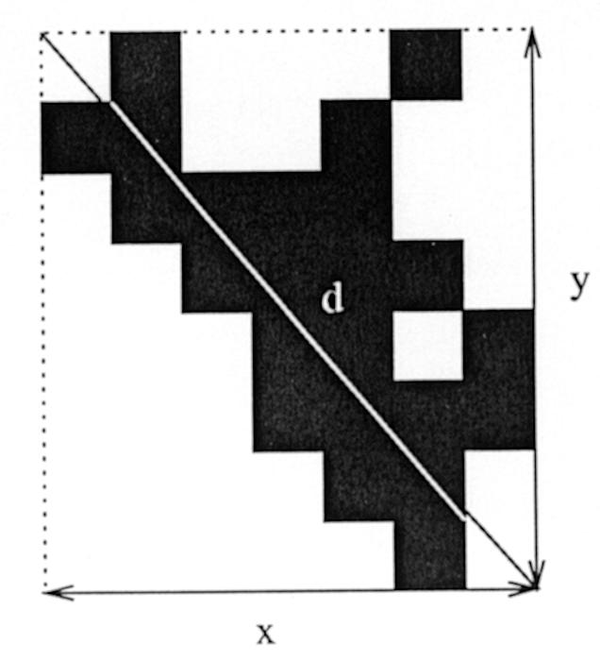 | 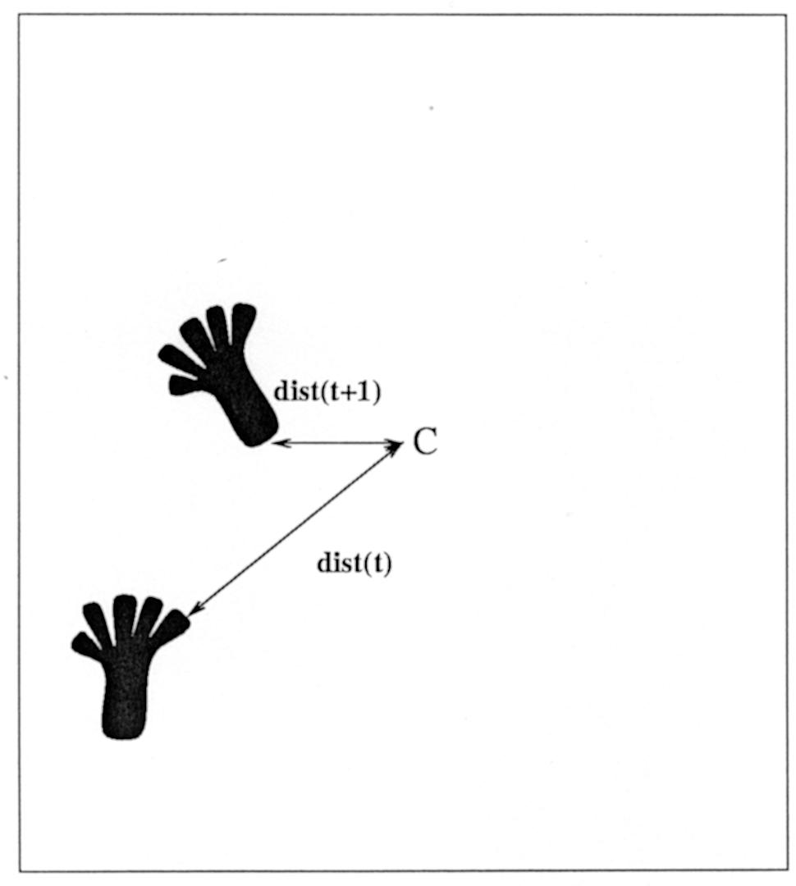

Fig. 3. Calculation of maximal dimension of the object.
Fig. 4. Calculation of the velocity of the object.

