A Simple Regulators Optimization Method For A Thyristorized
Controlled Induction Motor Drive System

Angelo J. J. Rezek; Carlos A. G. Pereira; Valberto F. da Silva; José Antônio Cortez;
José M. E. Vicente

DET-DON/IEE/UNIFEI
CEP: 37500-903 - Itajubá, MG - Brazil
Tel.: +55-35-36291180 - FAX: +55-35-3629-1380
e-mail: rezek@iee.efei.br

Abstract: The capacitor excited induction motor is fed by a natural commutated inverter. The control system has been implemented to modify the rectifier voltage. The inverter firing technique used has been the machine terminal voltage sensor, employing the dedicated integrated circuit TCA 780 (Icotron-Siemens). The reference pins (5) of the TCA’s 780 are supplied by the secondary voltages of two synchronizing transformers, connected to the electrical system and the machine terminals for the rectifier and inverter firing units, respectively. The pulses are generated by TCA’s 780 using the ramp method.
The control system has been implemented to modify the rectifier voltage. For this purpose there are the speed and current regulators designed according to the symmetric optimization criterion [2]. These regulators have been determined using a simple design procedure that will be presented in this paper.
A DC control level voltage V_{CC} (0→10[V]) connected to the pins 11 of the TCA’s 780 makes possible the modification of the firing angle (α), in a way that for a V_{CC} of 10[V] there is an α of 180º, and for a V_{CC} of 0[V], α equals 0º. An intermediary value of α can be obtained by modifying V_{CC}, so that the relationship between α and V_{CC} remains linear.
The DC control voltage of the rectifier (V_{CCR)}) is varying, but the control voltage of the inverter (V_{CCI}) remains always 0[V]. In this case a zero crossing machine terminal voltage has been used to fire the inverter. The synchronizing transformer used in this case has been a special transformer delta/zig-zag Δ/z-195⁰ [1], so the inverter firing angle is constant and equals 165º. The rectifier synchronizing transformer is delta zig-zag Δ/z-30º and the firing angle of this unit is varying.
The inner proportional integral (PI) regulator makes possible the limitation of the motor current and both PI speed and current regulators act when a load disturbance torque occurs or in a drop in the rectifier voltage.
The motor current and speed signals, have been registered in these cases, by using a storage oscilloscope, and the experimental results discussed. Presently digital PI and fuzzy regulators are being implemented to compare the results of the dynamic behavior of the controlled system.

Keywords: Optimization; Induction motor drives; Regulators

- Introduction
A simple regulator design procedure for an induction motor will be presented in this paper. The method is based upon the symmetric optimization criterion[2]. Experimental results using PI regulators designed according to this proposed method will be presented.
The main advantage of the regulators used for implementation is that we can adjust separately the gain (P) and the time constant (I) of the proposed regulator[2].

- Regulator Design Procedure
A. Electrical Machine Armature Equation
$$V_{\text{dR}}=R_{a}I_{a}+L_{a}\frac{{\text{dI}}_{a}}{\text{dt}}+V_{\text{dI}}$$
By using Laplace transform, yields:
$$V_{\text{dR}}\left(s\right)=R_{a}I_{a}\left(s\right)+{\text{SL}}_{a}I_{a}\left(s\right)+V_{\text{dI}}\left(s\right)$$
$$V_{\text{dR}}\left(s\right)−V_{\text{dI}}\left(s\right)=I_{a}\left(s\right)⋅\left[R_{a}+{\text{SL}}_{a}\right]$$
$I_{a}\left(s\right)=\frac{V_{\text{dR}}\left(s\right)−V_{\text{dI}}\left(s\right)}{R_{a}+{\text{SL}}_{a}}$ (1)
where:
$V_{\text{dR}}→$Rectifier DC output voltage
$V_{\text{dI}}→$Inverter DC output voltage
$L_{a}→$Total inductance (including DC link inductor and machine = L_{d} + 2L_{m})

$R_{a}→$Total resistance (including DC link inductor and machine = R_{d} + 2R_{m})
Defining,
$T_{a}=\frac{L_{a}}{R_{a}}$ (2)
where:
$T_{a}→$Armature time constant
$$I_{a}\left(s\right)=\frac{V_{\text{dR}}\left(s\right)−V_{\text{dI}}\left(s\right)}{1+{\text{ST}}_{a}}⋅\frac{1}{R_{a}}$$
$$\frac{I_{a}}{I_{N}}×I_{N}=\frac{V_{\text{dR}}\left(s\right)−V_{\text{dI}}\left(s\right)}{R_{a}}×\frac{V_{N}}{V_{N}}×\frac{1}{1+{\text{ST}}_{a}}$$
$$\frac{I_{a}}{I_{N}}=\frac{V_{\text{dR}}\left(s\right)−V_{\text{dI}}\left(s\right)}{V_{N}⋅R_{a}}×\frac{V_{N}}{I_{N}}×\frac{1}{1+{\text{ST}}_{a}}$$
$\frac{I_{a}}{I_{N}}=\frac{V_{\text{dR}}−V_{\text{dI}}}{V_{N}}×\frac{V_{N}}{R_{a}⋅I_{N}}×\frac{1}{1+{\text{ST}}_{a}}$ (3)
In “pu” values, we have:
$i_{a}=\frac{I_{a}}{I_{N}}$ (4)
$v_{\text{dR}}=\frac{V_{\text{dR}}}{V_{N}}=e$ (5)
$v_{\text{dI}}=\frac{V_{\text{dI}}}{V_{N}}=u$ (6)
$v_{i}=\frac{V_{N}}{R_{a}I_{N}}$ (7)
$i_{a}=(v_{\text{dR}}−v_{\text{dI}})⋅\frac{v_{i}}{1+{\text{ST}}_{a}}$ (8)
where:
$V_{N}→$Rated $V_{\text{dR}}$
$I_{N}→$Rated $I_{a}$
$I_{a}→$DC link current
By replacing,
$V_{\text{dR}}=E$ (9)
$V_{N}=E_{N}$ (10)
$E=1\text{.}\text{35}⋅U_{2}⋅\text{cos}α$ (11)
$\frac{d_{E}}{dα}=−1\text{.}\text{35}⋅U_{2}⋅\text{sen}α$ (12)
where:
$U_{2}→$Rectifier AC supply voltage (phase-phase) (V)
$α→$Rectifier firing angle
$\frac{d\left(EE_{N}\right)}{d\left(αΠ\right)}=−1\text{.}\text{35}×\frac{U_{2}}{E_{N}}×Π×\text{sen}α$ (13)
In “pu”values, yields:
$\frac{d\left(e\right)}{d\left(α_{u}\right)}=−1\text{.}\text{35}×\frac{\text{230}}{\text{308}}×Π×\text{sen}α$ (14)
where:
$α_{u}→$“pu” firing angle
Defining $V_{S}→$Static converter gain, we have:
$V_{S1}={\left|\frac{\text{de}}{{dα}_{u}}\right|}_{α={\text{90}}^{o}}=3\text{.}\text{17}$ (15)
(maximum gain)
$V_{S2}={\left|\frac{\text{de}}{{dα}_{u}}\right|}_{α={\text{22}}^{o}}=1\text{.}\text{18}$ (rated) (16)
(minimum gain)
Medium static converter gain:
$V_{S}=2\text{.}\text{17}$ (17)
Also: $v_{i}=\frac{E_{N}}{R_{a}I_{N}}=\frac{\text{308}}{4\text{.}\text{04}×7}=\text{10}\text{.}\text{89}$ (18)
The total gain,
$V_{\text{Sia}}=v_{s}⋅v_{i}$ (19)
$$V_{\text{Sia}}=2\text{.}\text{17}×\text{10}\text{.}\text{89}=\text{23}\text{.}\text{72}$$
$V_{\text{Sia}}=\text{23}\text{.}\text{72}$ (20)
Small time constants:
$T_{\text{SS}}→$Firing circuit time constant $=2\text{.}5[\text{ms}]$
$T_{\text{gi}}→$Current transducer filter time constant $=1\text{.}5[\text{ms}]$
$$σ=T_{\text{SS}}+T_{\text{gi}}$$
$σ=4\left[\text{ms}\right]$ (21)

B. Current Regulator Design
The relationship $\frac{T_{a}}{4σ}=\frac{\text{87}}{4×4}=5\text{.}\text{44}$>$1$
According to the table 6.4 of [2].
The current regulator gain is :
$V_{\text{Ri}}=\frac{T_{a}}{2V_{\text{Sia}}σ}=\frac{\text{87}}{2×\text{23}\text{.}\text{72}×4}=0\text{.}\text{46}$ (22)
The current regulator time constant:
$$T_{i}=4σ⋅\frac{T_{a}}{T_{a}+3σ}=4⋅4⋅\frac{\text{87}}{\text{87}+3×4}$$
$T_{i}=\text{14}\text{.}\text{06}\left[\text{ms}\right]$ (23)
The reference value filter is given by:
$T_{\text{gS}2}=4σ\left(1−e^{−\left(\frac{T_{a}}{4σ}−1\right)}\right)$ $T_{\text{gS}2}=4×4\left(1−e^{−\left(\frac{\text{87}}{\text{16}}−1\right)}\right)$
$T_{\text{gS}2}=\text{15}\text{.}\text{81}\left[\text{ms}\right]$ (24)

PI Current Regulator
Gain: $V_{\text{Ri}}=0\text{.}\text{46}$
Time constant: $T_{i}=\text{14}\text{.}\text{06}\left[\text{ms}\right]$
Reference value filter: $T_{\text{gS}2}=\text{15}\text{.}\text{81}\left[\text{ms}\right]$
Transducer filter $T_{\text{gi}}=1\text{.}5\left[\text{ms}\right]$
C. Speed Regulator Design
According to [2], the equivalent time constant of the current closed loop is given by:
$T_{e}=2σ+\frac{1}{2}×T_{\text{gS}2}=\text{15}\text{.}9\left[\text{ms}\right]$ (25)
Also the speed transducer filter $\left(T_{\text{gN}}\right)$is equal
$T_{\text{gn}}=\text{100}\left[\text{ms}\right]$ (adopted) (26)
The small time constants of the speed regulator loop
$σ'=T_{e}+T_{\text{gn}}=\text{116}\left[\text{ms}\right]$ (27)
The acceleration machine time constant [2]
$T_{H}=\frac{2Π}{\text{60}}\frac{{\text{JN}}_{0}}{M_{N}}$ (28)
where:
$J→$machine inertial moment $\left[\text{Kg}\text{.}m^{2}\right]$
$M_{N}→$rated torque $\left[N\text{.}m\right]$
$N_{0}→$no load speed $\left[\text{rpm}\right]$
we obtain $T_{H}=1\text{.}\text{41}\left[s\right]$ (29)
The relationship,
$\frac{T_{H}}{4σ'}=3\text{.}\text{04}$>1
According to table 6.3 [2].
Speed regulator gain:
$V_{\text{RN}}=\frac{T_{H}}{2σ^{'}}=6\text{.}1$ (30)
Speed regulator time constant :
$T_{n}=4σ^{'}=\text{464}\left[\text{ms}\right]$ (31)
Reference value filter:
$T_{\text{gS}1}=T_{n}=\text{464}\left[\text{ms}\right]$ (32)

PI Speed regulator
Gain: $V_{\text{RN}}=6\text{.}1$
Time constant: $T_{N}=\text{464}\left[\text{ms}\right]$
Reference value filter: $T_{\text{gS}1}=\text{464}\left[\text{ms}\right]$
Transducer filter $T_{\text{gn}}=\text{100}\left[\text{ms}\right]$

- Experimental Results
Figure 1 shows the implemented system. Figure 2 shows the used regulators and filters. Figure 3 shows the speed and current when a load disturbance torque occurs, showing the speed regulation. Figure 4 shows the current and Vcc control voltage when positive and negative disturbance load torque takes place. Figure 5 shows the rectifier and inverter voltage for rated conditions (speed, current, voltage). Figure 6 shows the capacitor and the inverter current (AC side), for rated conditions. Figure 7 shows the induction motor current (approximately sinusoidal). Figure 8 shows the complete drive blocks diagram. Figure 9 shows the current regulation loop. Figure 10 shows the speed regulation loop.
The induction machine starting process used has been the start-up with auxiliary machine (DC machine connected in the same shaft of the motor. This machine in the starting process works as a motor) . After the start-up the DC machine works as a DC generator, supplying a resistive bank, acting as a load for the motor (Fig. 2).

Motor and system ratings:
- Voltage: 220 [V] J: 0.1 [Kg.m²]
- Current: 8.8 [A] L_{d}: 331.57 [mH]
- Poles: 4 Rd: 0.6 [Ω]
- Power: 2.25 [KW] Lm: 11.48 [mH]
- Speed: 1700 [RPM] Rm: 1.72 [Ω]
- M_{N}: 12.67 [N.m] C: 70 [μF]

- Conclusion
A simple control circuit has been implemented in laboratory. The adjustment of the regulators has been made according to the symmetric optimization criterion [2]. The regulators design procedure for a controlled induction motor is very simple and efficient and some obtained experimental results have been presented.
The closed loop control system tested has presented good accuracy and dynamics.

- Aknowledgment
The authors would like to thank FAPEMIG Proc. TEC 2917/98 for the economical support to the development of this research work.
- References

[1] Abreu, J.P.G.; Rezek, A.J.J.; Coan, R.J.P. “Phase Shift Transformer 0→360⁰ by Using Tap’s with Constant Voltage (in Portuguese), Proceedings VI CBA, Vol.II, pg. 670-674, Belo Horizonte(MG), 1986.

[2] F. Fröhr & F. Orttenburger “Introduccion al Control Electronico” Siemens, Marcombo S/A, Barcelona, 1986.

[3] Rezek, A. J. J.; Rodrigues, M. S.; Miranda, V. A.M.; Oliveira, V.A.; Cassula, A.M.; Costa Jr.,R.A .Torres, A. Z.. ”Design and Simulation of a Controlled DC Drive” (in portuguese), Proceedings of 2nd International Seminar on Electrical Machines and Controlled Drives - II SIMEAR, Abinne Tec 91, EPUSP, São Paulo, SP-Brasil, vol. 3, pp. 141-160, May, 1991.

[4] Quinderé, K. E. B.;Rezek, A. J. J. ;Abreu, J. P. G.; Silva, V.F.; Cortez, J. A.; Vicente, J. M. E.; Almeida, A.T. L. “A simple regulators optimization method for a thyristorized controlled synchronous motor drive system”, Anais Cobep99, Volume 1, pp.82-87, Fóz do Iguaçú, PR, Brasil, 1999.

Fig. 1 – Implemented system

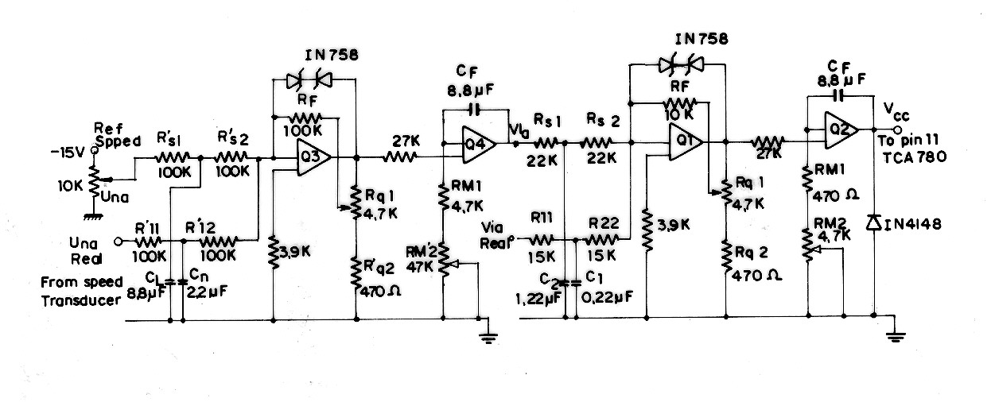
Fig. 2 – Used filters and regulators

Fig. 3 - Speed and current when a negative and a positive load disturbance torque occurs:
Vertical Scales => Current - upper curve : 1DIV = 7[A] - Speed - lower curve: 1DIV = 600[RPM]

Fig. 4 - Current and V_{CC} voltage when negative and positive load torque disturbance occurs.
Vertical Scales => Current - upper curve: 1DIV = 3.5[A] - Vcc Voltage - lower curve : 1DIV = 0.2[V].

Fig. 5 - Rectifier and inverter voltage for rating conditions.

Vertical Scales => Rectifier Voltage - upper curve: 1DIV = 50[V]
Inverter Voltage - lower curve: 1DIV = 50[V].

Fig. 6 - Capacitor and inverter currents for rating conditions.

Vertical Scales => Capacitor Current - upper curve: 1DIV = 20[A]
Inverter Current (AC side) - lower curve: 1DIV = 20[A].

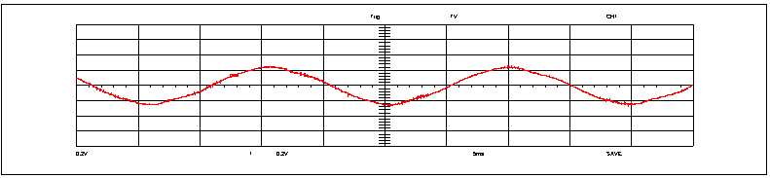
Fig. 7 - Rated induction motor current.
Vertical Scales => Motor Current: 1DIV = 10[A].

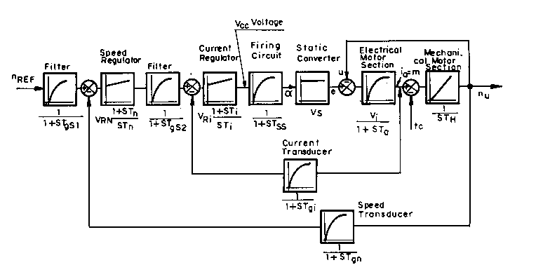
Fig. 8 - Complete drive block diagram.

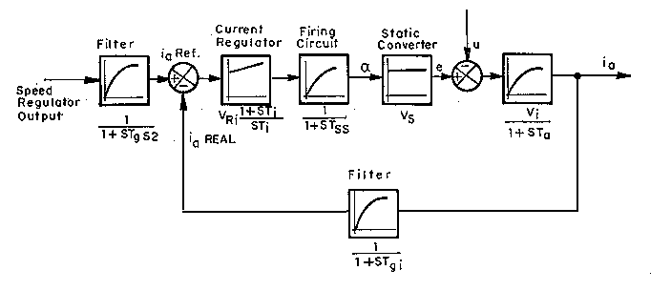
Fig. 9 - Current regulation loop.

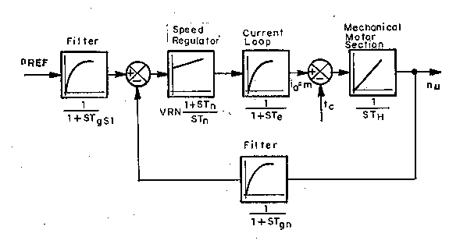

Fig. 10 - Speed regulation loop.

