An Investigation of TCSC and Load Dynamics Influence on Power System Inter-Area Mode Oscillations

ADRIANA F. DOMINGUES VIVALDO F. DA COSTA LUIZ C. P. DA SILVA

Departamento de Sistemas e Controle de Energia

Universidade Estadual de Campinas
Cidade Universitária Zeferino Vaz
C. P. 6101 - CEP 13081-970
Campinas SP
BRAZIL
adrianaf@dsce.fee.unicamp.br vivaldo@dsce.fee.unicamp.br lui@dsce.fee.unicamp.br
http://www.dsce.fee.unicamp.br

Abstract: - Thyristor Controlled Series Capacitor (TCSC) is a prominent FACTS (Flexible AC Transmission Systems) device that can rapidly modulate the reactance of a transmission line, resulting in improvement of system performance. In this paper, simulations studies of a simple two-area power system model were conducted to investigate the damping effects of the TCSC and load dynamics on inter-area mode oscillations. The study is based on investigation of the eigenvalues of the linearized power system model in the framework of dynamic bifurcation theory.

Key-Words: - Stability, Inter-Area Oscillations, TCSC, Dynamic Load Model, Bifurcations, Eigenvalues.

1 Introduction
A problem of much interest in the power industry is the mitigation of low frequency oscillations, which often arise between coherent areas within a power network. These oscillations are called inter-area modes and their occurrences are due to the dynamics of inter-area power transfer. Typical oscillation frequencies of inter-area modes range from 0.1 to 0.8 Hz. Inter-area modes often exhibit poor damping when the aggregate power transfer over a corridor is high relative to the transmission strength. When undamped inter-area power oscillations emerge, their amplitude can increase over several minutes and loss of synchronism may appear in such cases and partial or complete collapse of the power system may follow [1].
The most common control measures in use today to increase transmission capability for systems limited by oscillatory instability employ power system stabilizers (PSSs). The basic function of a power system stabilizer is to extend stability limits by modulating generator excitation to provide damping to the oscillations of a synchronous machine. However, with increasing transmission line loading over long distances, the use of conventional power system stabilizers may not be effective in damping inter-area modes under certain circumstances [2]. In such cases, other effective solution such as the use of recently developed power electronic devices in the transmission system, such as the TCSC, is being considered [3]. This FACTS device has been proved to have additional benefits for increasing system damping, other than its primary function, i.e. power flow control. A current example of a TCSC used to damp inter-area oscillations is found in Brazil. Two TCSCs located at each end of the Brazilian North-South interconnection make it possible to damp out the inter-area oscillation mode, reducing the risk of instability. It is worth pointing out that these TCSCs are the first ones in the world till now used to damp out power oscillations of two interconnected electrical systems [4], [5].
Many researchers have investigated inter-area mode oscillations. A representative sample of these are [6], [7]. Nevertheless, FACTS devices such as TCSC were not considered in these studies. An investigation of TCSC influence on damping of power system inter-area oscillations is presented in [8]. However, the damping effects of the TCSC were analyzed by using a reduced order model of the generators as well as by considering only static load characteristics. In this paper, the contributions of the TCSC to the enhancement of power system inter-area modes oscillation damping are investigated by considering a detailed two-axis generator model with a static excitation system and dynamic load modeling.
This paper is organized as follows: Section 2 briefly describes the small-signal analysis tools used in this study as well as gives a general description of the system used for analysis. Section 3 presents the simulation results and discussion. Conclusions are made in Section 4.

2 Power System Model and Small-Signal Stability Analysis
The power system electromechanical stability problem can be represented by a set of differential and algebraic equations, as follows,

$x=f\left(x,y,μ\right)$ (1)
$0=g\left(x,y,μ\right)$ (2)

where x is a vector of dynamic state variables, y is a vector of algebraic variables, and μ is a parameter, which can be varied slowly, such as nodal powers. Differential equations represent the dynamics of generators, regulators and loads, while algebraic equations represent the network, static loads and connections between network and dynamic devices in the system.
For small-signal stability analysis, we assume the system parameter variation is slow enough so that the model can be linearized around some equilibrium point as,
$Δ\overset{}{x}=AΔx$ (3)

where
$A=J_{1}−J_{2}J_{4}^{−1}J_{3}$ (4)

is the system state matrix, provided detJ₄ ≠ 0. J₁, J₂, J₃ and J₄ are Jacobian matrices of f and g related to dynamic state and algebraic variables, respectively.
The bifurcation theory can be used to predict how the system becomes unstable as parameters vary. In this approach stability analysis is performed by computing the eigenvalues of the system state matrix as certain parameters are allowed to vary slowly and continuously. The loss of local stability of an operating point is associated with an eigenvalue transition from one complex half-plane to the other. This instability may be due to a real mode instability (null eigenvalue) or a complex mode instability (one pair of pure imaginary eigenvalues). In the framework of dynamic bifurcation theory, these two modes correspond, respectively, to the saddle-node and Hopf bifurcations of the differential-algebraic model of power system [9]. In this paper, this approach is used for the analysis of the inter-area mode of a two-area system.

2.1 A Two Area System
In this work, the behavior of the inter-area mode of a symmetric two-area test power system taken from [1] is analyzed considering different situations such as the inclusion of a TCSC on the intertie and dynamic load modeling.
Fig. 1 shows the original system composed by four generating units, with a TCSC connected in series with the line between load buses 5 and 6. This system displays three electromechanical modes of oscillation; two inter-plant modes, one in each area, and one inter-area mode, in which the generating units in one area swing coherently and against the generating units located in the other area. Traditional indices such as participation factors are used in conjunction with mode shapes to identify and classify the oscillatory modes in this test system [1].

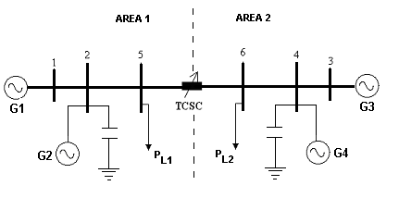
Fig. 1 – Two-Area System with TCSC

The two-axis model of the synchronous machine is used for each of the generators of the power system in Fig. 1. All four generators units have a first order exciter. The generator data are given in Appendix. The effects of special controls such as power system stabilizers are ignored.
The TCSC model used in the current study is shown in Fig. 2 [10]. The TCSC data are given in Appendix.

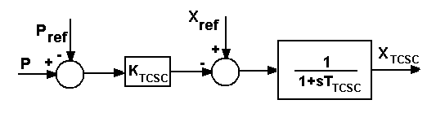
Fig. 2 – TCSC Model

An aggregate dynamic load model proposed in [11] is used to represent the loads in Fig. 1. This model comprises a set of differential-algebraic equations as follows:

$\overset{}{x_{p}}=\frac{1}{T_{p}}[P_{s}(V)−P] , P=x_{p}P_{t}(V)$ (5)
$\overset{}{x_{q}}=\frac{1}{T_{q}}[Q_{s}(V)−Q] , Q=x_{q}Q_{t}(V)$ (6)

where x_{p} e x_{q} are state variables, P and Q are the active and reactive load demand, {P_{s}(V),Q_{s}(V)} and {P_{t}(V),Q_{t}(V)} are steady state and transient load/voltage characteristics, respectively, and T_{p} and T_{q} are time constants which characterizes the response of the loads. The functions P_{s}(V) and P_{t}(V) can be defined as

$P_{s}\left(V\right)=P_{o}{\left(\frac{V}{V_{o}}\right)}^{n_{\text{ps}}}$ (7)
$P_{t}\left(V\right)={\left(\frac{V}{V_{o}}\right)}^{n_{\text{pt}}}$ (8)

where V_{o} and P_{o} are nominal voltage of the bus and the corresponding active power of the load, respectively, and n_{ps} and n_{pt} are steady-state and transient voltage exponents. Reactive-power functions are defined in a similar manner. In this work, the steady state and transient load/voltage characteristics are represented as constant power (n_{ps} = 0) and constant impedance (n_{pt} = 2), respectively. Two values of the time constants are used in the simulations: T_{p} = T_{q} = 0.05 s (fast response load) and T_{p} = T_{q} = 30 s (slow response load).

3 Simulations Results
In all the simulations, it is considered a loading factor λ that expresses the information of power delivering in pu from area 1 to area 2. It starts from λ=1.0 (base case) and is incremented to show the behavior of the system stability under heavier loading conditions. The base case is an operating point considered in [1]. Each of the four generators is generating about 700 MW. Area 1 has a local load P_{L1} = 970 MW, while area 2 has a load P_{L2} = 1770 MW. Under these conditions area 1 is exporting 400 MW to area 2.

3.1 Effects of TCSC
Fig. 2 and 3 show the critical eigenvalues loci of state matrix, which is associated to the inter-area mode, as the loading of the system increases, respectively, for the cases without and with TCSC. In these cases, the static constant power load model is used to represent the two loads P_{L1} and P_{L2}.
Table 1 shows that at initial point (λ=1.0), the original system shows a negative damping ratio, while by adding a TCSC it becomes positive.

Table 1 – Damping Ratio of Inter-Area Mode (%) with and without TCSC (λ=1.0)

System | Damping  Ratio (%)
Original System (without TCSC) | -1.71
System with TCSC | +1.97

As it can be seen in Fig. 2, originally, the inter-area mode is unstable for all values of loading. Fig. 3 shows that by adding the TCSC, the inter-area mode becomes stable and the damping increases. Nevertheless, it should be noted that a saddle-node bifurcation related to inter-area mode appears in a higher loading condition (λ=1.55).

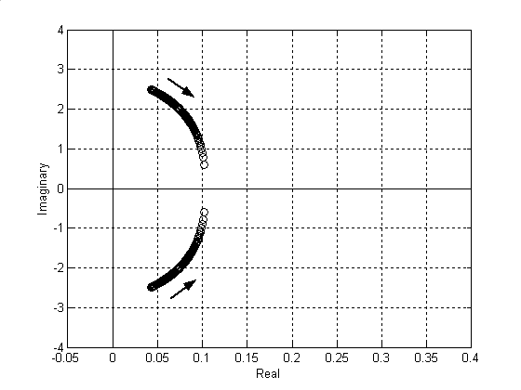
Fig. 2 – Critical Eigenvalues Loci of the Original System

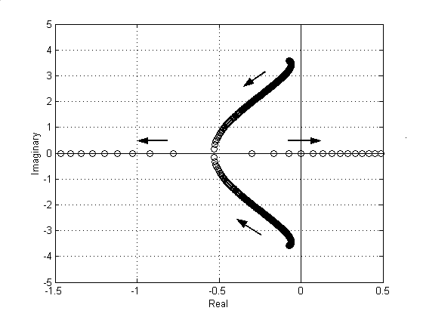
Fig. 3 – Critical Eigenvalues Loci of the System with TCSC
3.2 Effects of Dynamical Load Location
Table 2 shows, at initial point (λ=1.0), the damping ratio of inter-area mode of the original two-area system (without TCSC) for different load conditions. It is clear to see that, if the area that is sending power to another has a dynamic load, the damping of inter-area oscillations gets worse. On the other hand, if the area that is receiving power from another has a dynamic load, the damping of inter-area mode is benefited. To illustrate it and establish a comparison, Figures 4 and 5 give the trajectory of the critical eigenvalues related to inter-area mode considering fast response load, at buses 5 and 6, respectively. When the dynamic load is at bus 5, it is worse to the inter-area damping, while at bus 6 the damping is improved. In this case, as it should be noted in Fig. 5, a Hopf bifurcation occurs (λ=1.06).

Table 2 – Damping ratio of inter-area mode (%) for different load locations (λ=1.0)

Bus | Load | Damping  Ratio (%)
5 and 6 | Static | -1.71
5 | Dynamic (slow) | -5.74
 | Dynamic (fast) | -2.93
6 | Dynamic (slow) | +2.12
 | Dynamic (fast) | +0.32

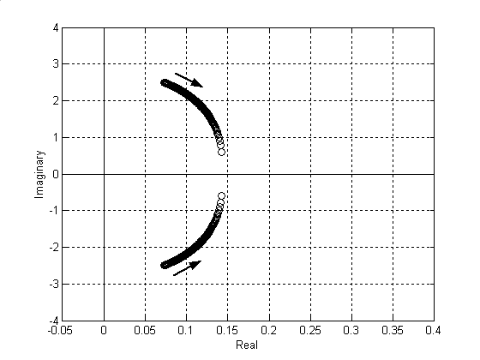
Fig. 4 – Critical Eigenvalues Loci of the System with Dynamical Load at Bus 5 (fast)

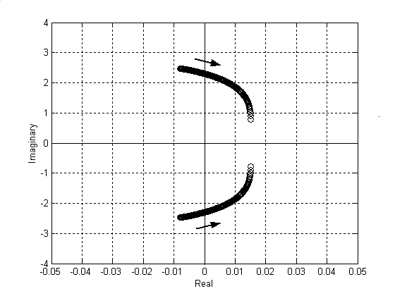
Fig. 5 – Critical Eigenvalues Loci of the System with Dynamical Load at Bus 6 (fast)

Figures 6 and 7 show the critical eigenvalues loci for slow response load on buses 5 and 6, respectively. As it can be seen in these Figures, the inter area damping becomes positive only for dynamic load located at bus 6. As shown in Fig. 7, the damping effects of slow response load at receiving end are an increasing function of intertie loading. It can also be seen that there is a real eingenvalue that dislocates towards the right semi-plan, which is associated to load variables x_{p} and x_{q} (indicated by participating factor). This indicates a possible occurrence of voltage collapse for higher loading levels.

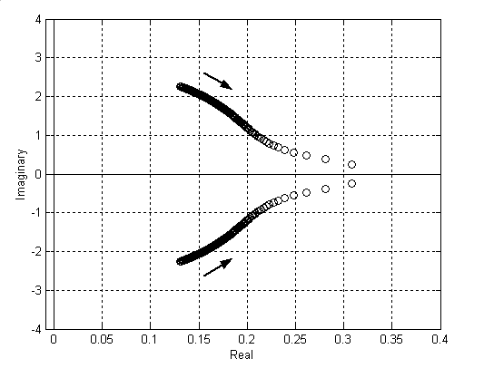
Fig. 6 – Critical Eigenvalues Loci of the System with Dynamical Load at Bus 5 (slow)

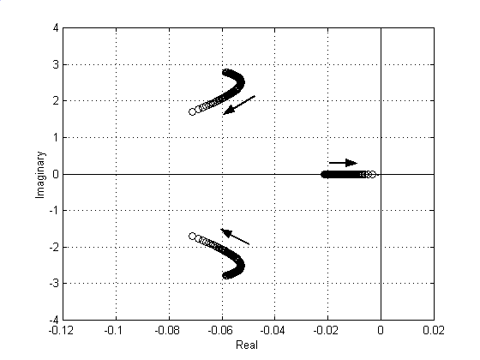
Fig. 7 – Critical Eigenvalues Loci of the System with Dynamical Load at Bus 6 (slow)

3.3 TCSC and Dynamical Load
When the TCSC is included on the intertie of the two-area test system used in this paper, the qualitative behavior of the inter-area mode is not modified with the inclusion of dynamic load model on buses 5 and 6 as it can be seen in Figures 8 and 9 for slow response loads. However, in these cases, a saddle-node bifurcation related to inter-area mode appears in a higher loading condition (λ=1.55), the same of the static load case shown in Fig. 3. By comparing Figures 8 and 9, it can be noted that with the inclusion of dynamic load model on bus 5 the critical eigenvalues are located closer of the imaginary axis in the base case (λ=1.0). This is also illustrated in Table 3, which shows the damping ratio for this initial loading point. Fig. 10 shows the trajectory of the critical eigenvalues for dynamic load models at buses 5 and 6 considering fast response loads. As expected, this case differs slightly from that shown in Fig. 3 (static load model) since the steady state load/voltage characteristic used for the dynamic load/model is constant power.
It is worth pointing out that for slow response load, as shown in Fig. 8, the occurrence of the saddle-node bifurcation is related to inter-area mode and not to the load variables as in the case without the TCSC shown in Fig. 7.

Table 3 – Damping Ratio of Inter-Area Mode (%) with TCSC (λ=1.0)

Bus | Load | Damping  Ratio (%)
6 | Dynamic (slow) | +3.95
5 and 6 | Dynamic (slow) | +2.19
5 and 6 | Dynamic (fast) | +2.51

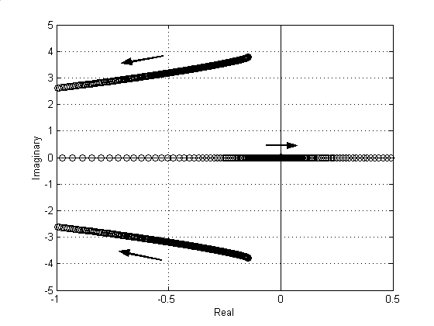
Fig. 8 – Critical Eigenvalues Loci of the System with TCSC and Dynamical Load at bus 6 (slow)

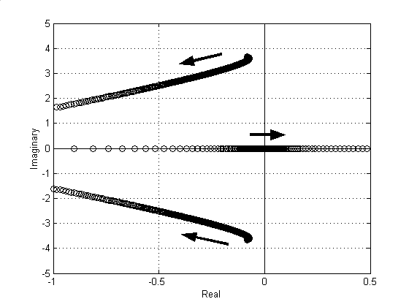
Fig. 9 – Critical Eigenvalues Loci of the System with TCSC and Dynamical Loads at buses 5 and 6 (slow)

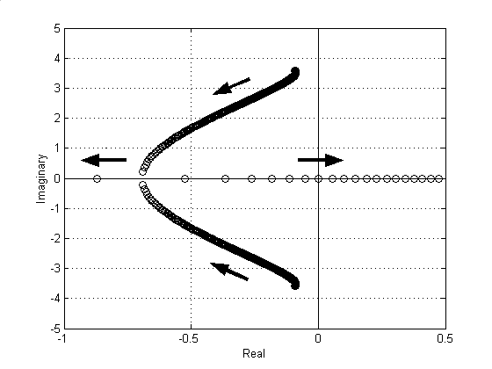
Fig. 10 – Critical Eigenvalues Loci of the System with TCSC and Dynamical Loads at buses 5 and 6 (fast)

4 Conclusions
This paper has examined the effects of Thyristor Controlled Series Capacitor and aggregate dynamic load models on damping of inter-area mode oscillations of a two-area system. The studies were conducted using eigenvalues analysis and bifurcation theory. It was shown that load dynamics have a great impact on the damping of the inter-area mode oscillations. Slow and fast load response speeds were considered. With the inclusion of the TCSC on the intertie, regardless of the load model used (static or dynamic), the simulations results presented show that oscillatory instability, that is to say, Hopf bifurcation, does not occurs, since the damping effect of TCSC is an increasing function of the tie line loading. Therefore, only saddle-node bifurcation related to the inter-area mode, which is associated with the loss of synchronizing torque between the two areas, can occurs. In all cases, the studies revealed that this bifurcation occurs for the same value of bifurcation parameter.
Though studies were conducted on the simple power system to gain insight into the damping effects of TCSC and load dynamics on damping of inter-area mode oscillations, the observations are quite general and may form useful basis for the analysis of more complex and large systems.

Appendix:

Generator Data:
D=0; x_{d}=1.8 pu; x’_{d}=0.3 pu; x_{q}=1.7 pu;
x’_{q}=0.55 pu; R_{a}=0.0025 pu;
H=6.5 s; T’_{d0}=8.0 s; T’_{q0}=0.4 s

AVR Data:
K_{e}=200; T_{e}=0.01s

TCSC Data:
K_{TCSC}=0.9; T_{TCSC}=0.015 s

References:
[1] P. Kundur, Power System Stability and Control, McGraw-Hill, 1994.
[2] X. Yang, A. Feliachi, Stabilization of Inter-Area Oscillations Modes Through Excitation Systems, IEEE Transactions on Power Systems, Vol. 9, No. 1, 1994, pp. 494-502.
[3] N. Yang, Q. Liu, J. D. McCalley, TCSC Controller Design for Damping Interarea Oscillations, IEEE Transactions on Power Systems, Vol. 13, No. 4, 1998, pp. 1304-1310.
[4] C. Gama, R. Leoni, J. B. Gribel, R. Fraga, M. J. Eiras, W. Ping, A. Ricardo, J. Cavalcanti, R. Tenório, Brazilian North-South Interconnection – Application of Thyristor Controlled Series Compensation (TCSC) to Damp Inter-Area Oscillation Mode, Cigré 37 Session, 1998.
[5] G. S. Luz, L. R. C. de Moura, C. R. Zani, S. M. Filho, N. J. P. de Macedo, S. S. Wanderley, TCSC at Serra da Mesa Substation [Brazilian North-South Interconnection]: Control System Improvement and Behavior Assessment, VIII Symposium of Specialists in Electric Operational and Expansion Planning, 2002, pp. 1-6.
[6] M. Klein, G. J. Rogers, P. Kundur, A Fundamental Study of Inter Area Oscillations in Power Systems, IEEE Transactions on Power Systems, Vol. 6, No. 3, 1991, pp. 914-921.
[7] M. Klein, G. J. Rogers, S. Moorty, P. Kundur, Analytical Investigation of Factors Influencing Power System Stabilizers Performance, IEEE Transactions on Power Systems, Vol. 7, No. 3, 1992, pp. 382-390.
[8] M. Noroozian, G. Andersson, Damping of Power System Oscillations by Use of Controllable Components, IEEE Transactions on Power Delivery, Vol. 9, No. 4, 1994, pp. 2046-2054.
[9] H. G. Kwatny, R. F. Fischl, C. O. Nwankpa, Local Bifurcations in Power Systems: Theory, Computation and Application, Proceedings of the IEEE, Vol. 83, No. 11, pp. 1456-1481.
[10] E. Salgado, W. W. Ping, L. A. Piloto, A. Bianco, L. M. S. Thomé, C. H. C. Guimarães, C. A. Gama, A. N. Vasconcelos, A. R. M. Tenório, L. S. Costa, Controlled Series Compensation: Digital Program Modeling and Possible Applications to the Brazilian System, V Symposium of Specialists in Electric Operational and Expansion Planning, 1996, pp. 659-665.
[11] W. Xu, Y. Mansour, Voltage Stability Analysis Using Generic Dynamic Load Models, IEEE Transactions on Power Systems, Vol. 9, No. 1, pp. 479-493.

Acknowledgements:

The authors would like to thank FAPESP, Brazilian research agency, for the financial support.

