A Visual Tool to Distribution Network Reconfiguration

MARCELO ESCOBAR DE OLIVEIRA, LUIS F. OCHOA, ANTONIO PADILHA, JOSÉ ROBERTO SANCHES MANTOVANI
Departamento de Engenharia Elétrica
Universidade Estadual Paulista – Câmpus de Ilha Solteira
Caixa Postal 31 CEP: 15385-000 - Ilha Solteira - SP
BRAZIL
padilha@dee.feis.unesp.br

Abstract: - Power distribution network reconfiguration is performed with open/close operations of sectionalizing switches, maintaining the feeder’s radial topology, aimed to losses minimization and load balancing. A distribution networks simulator with a friendly graphic interface and reconfiguration functions, developed in Visual Basic language, is presented. The simulator shows quick response, based on load flow and losses calculation, with the best configurations for each load situation, obtained by an algorithm previously developed using Fortran language. This approach is a great tool for training, education, but it is also useful for distribution networks planning and operation. The user can easily see the network configuration with different values of voltage drop and power losses for each situation.

Key-Words: - Reconfiguration, distribution network, power losses, load flow, education

1 Introduction
Power distribution networks are mostly radially configured, aimed to make easier inherent protection factors, i.e.: coordination and short circuit currents attenuation, looking for equipments costs reduction. In general, these networks present possibilities for topology modification using sectionalizing switches located in strategic points. The topology changing, maintaining the radial configuration, is aimed to reduce the feeders’ active losses, improve the consumer’s voltage profile, increase reliability indices and eliminate and/or isolate faults restoring or supplying the power. Thus, these sectionalizing switches are used for both objectives: protection (faults isolation) and reconfiguration (configuration management).
The reconfiguration problem is solved using computational simulation. Fortran language is widely known in Electrical Engineering, due to its great calculation potential. However, this kind of programming make difficult the results visualization and analysis, besides it has no training utility. Almost no improvement has been made in the development of power distribution networks software for the reconfiguration problem analysis.
The present paper is aimed to improve it, developing a visual tool to distribution network simulation with reconfiguration functions, and a graphic interface based on Visual Basic language. It is important to indicate that a computational program for distribution networks reconfiguration was developed in Fortran language [1], without any visual function.
Therefore, with the use of a tool that make easier the objectives and data manipulation and understanding, there is going to take a big step into the improvements for distribution networks training, planning and operation. The visual facilities to record the network data and to show results are very helpful for engineers and students.

2 Network Reconfiguration Algorithm
A radial system presents low short circuit currents, simple protection equipments, low cost of operation and construction, but also presents low reliability. Thus, radial networks are constructed with sectionalizing switches at strategic points, aimed to help into the network protection and reconfiguration.
Generally speaking, we could say that the network reconfiguration problem consists on searching an optimal strategic of operation in a way to minimize feeders’ losses and propitiate a suitable load balancing in the three-phase system, considering protection reliability aspects and consumers’ power supply quality.
The exact solution for the reconfiguration problem involves the selection, within all possible configurations, of that which has the smallest loss. To find the exact solution is impossible, due to the exponential growing, dependent on the number and location of the system switches, of the number of generated feasible configurations. This is called combinatorial explosion.
Approximate heuristic algorithms have been suggested to solve the reconfiguration problem, resulting one good or almost optimal solution, therefore it is possible to find a set of configurations with the smallest loss values.
The distribution network reconfiguration problem has a heuristic algorithm to solve the reconfiguration problem, showing as the final result one configuration or a set of configurations that allow the network operation with minimal losses in the feeders.
Formulating the reconfiguration problem as a non-linear programming problem we obtain:

$\text{Min} P_{k}=\sum{R_{i}×I_{i}^{2}}$ (1)
s.a.
- radiality;
- voltage level constraints;
- reliability constraints;
- load balancing constraints;
- integer and real variables;
where
- k $∈$ K; K set of all the feasible radial configurations for the system;
- $P_{k}$; active losses in all k-configuration branches;
- BN; branch numbers of the k-configuration;
- $R_{i}$; ith branch resistance of the k-configuration;
- $I_{i}$; ith branch current of the k-configuration;

Using the constraints of Eq. (1), the criteria for the proposed methodology is based on the maximum voltage drop allowed in the feeders and on the definition of families and descendants to identify promissory configurations, considering the minimal system losses aspect and attending a set of constraints, such as: system radiality, acceptable voltage levels, reliability, etc.
Then was develop an algorithm which, starting from an initial radial configuration and a set of sectionalizing switches, are generated almost all possible radial configurations for the studied system. The quantity of possible configurations could have almost an infinite value. In this way, with the use of this radial configurations search algorithm is proposed a heuristic technique to diminish the set of configurations to be studied.
Due to the link between the voltage drop and the system losses, the cutting process of the configurations number is made based on the voltage drop value, i.e. if any configuration has certain voltage drop bigger than the scheduled limit, the future configurations originated by this one would be eliminated.
It was implemented an approximated load flow method to diminish the computation effort. It is similar to the method found in [2], where a constant power model is used and the currents are corrected as a function of the voltage mismatch.

3 The Visual Tool
This approach is aimed to allow the results verification of the network reconfiguration program, described before, making easier and better the data input and specially the output. Thus, the simulator improves the efficiency and the dynamic into the power distribution networks training, planning and operation.
Through this simulator the user will be able to input data into specific text boxes for each data of the network to be reconfigured, obtaining the diagrams of the initial configuration. As an option, the user is able to view the diagrams of the best five reconfigurations.
The simulator needs some network data as entries to obtain the configurations with the smallest losses. This data is inputted into the simulator through windows, and each entry made is saved into a file opened at the start up of the simulator, as shown in Fig. 1.

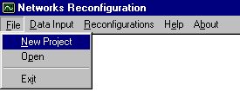
Fig. 1 Main Window

The simulator has three windows for the data input. In the first one (Fig. 2) are inputted the general network bus data.
After this process, the next window is used for the distribution lines data (Fig. 3), divided in opened switches and closed switches.
When the entries are finished the opened file will be complete for the data transference with the Fortran program.

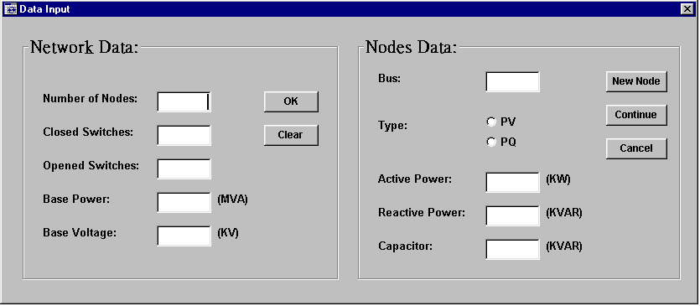
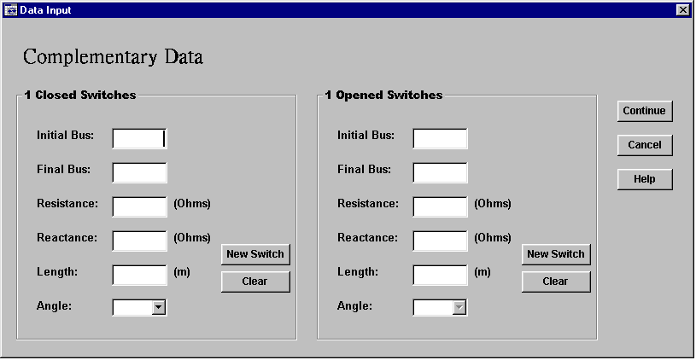
Fig. 2 Network Data Window
Fig. 3 Distribution Lines Data Window
To start the calculation of the network reconfigurations, the simulator ask the value of the minimum voltage limit through the window showed in Fig. 4.

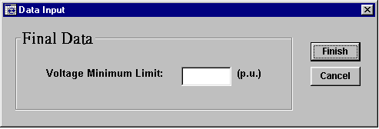
Fig. 4 Minimum Voltage Limit Window

When the calculation is finished, is presented a graphic window that shows the one-line network diagram of the initial configuration.
The user will be able to see also the one-line network diagram of the five best reconfigurations (with smallest losses) by choosing in the option menu.
This graphic window, where one-line network diagram is presented, showing dashed and colored lines. A dashed line represents an opened sectionalizing switch. Colored lines are voltage drop dependent. The range for each color is showed in the legend (Fig. 5). Besides, the user will be able to know what the voltage at each node is, just by clicking on it.

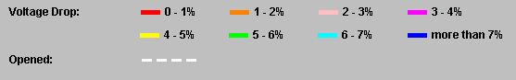
Fig. 5 Line Legend

To make easier this software for the user, the simulator provides help by describing the procedures using the software.

4 Results
Some tests known by the specialized literature were made aimed to analyze the simulator performance. Two tests are described as follow:

4.1 14-nodes System
This first system has 14 nodes, 3 sectionalizing switches, 23 kV and 100 MVA base voltage. Full data can be found in [3]. Table I shows the five options for the reconfiguration (with the smallest losses) proposed by the simulator. The minimum voltage limit adopted was 0.96 p.u.
Fig. 6 (a) shows the initial configuration CI and Fig. 6 (b) shows the smallest losses reconfiguration.

Table I. 14-nodes System Reconfiguration

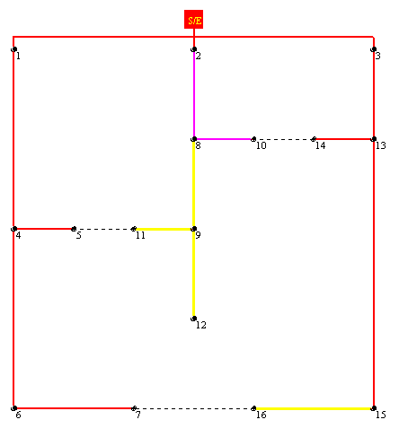
(a)
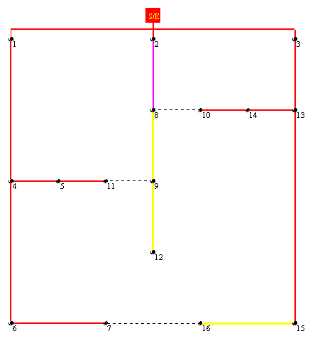
(b)
Fig. 6 (a) Initial Configuration, (b) Smallest Losses Configuration

4.2 32-nodes System
The second system has 32 nodes, 5 sectionalizing switches, 12.66 kV and 10 MVA base voltage. Full data can be found in [4]. Table II shows the five options for the reconfiguration (with the smallest losses) proposed by the simulator. The minimum voltage limit adopted was 0.92 p.u.
Fig. 7 (a) and (b) show the one-line diagrams for the initial configuration and the smallest losses configuration, respectively.

Table II. 32-nodes System Reconfiguration

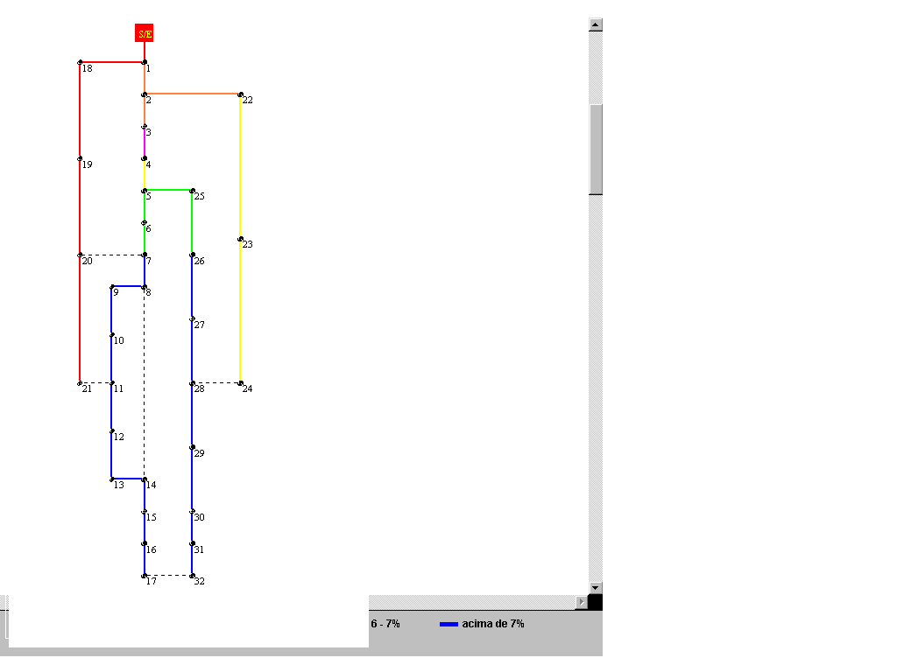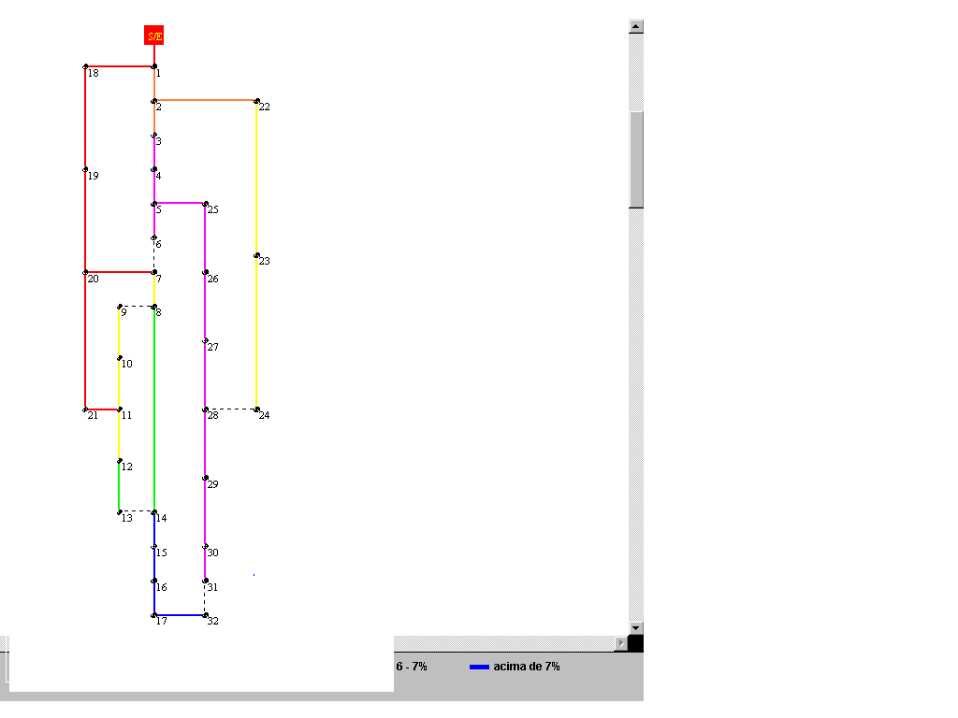
(a) (b)
Fig. 7 (a) Initial Configuration, (b) Smallest Losses Configuration

5 Discussion
In this paper, a visual tool was implemented using the Visual Basic language, because of it is very simple to use and is very efficient. The Fortran language used to implement the reconfiguration algorithm did not have the visual facilities.
To make an easy and efficient simulator, the Fortran program had been changed a little, making some modifications to improve the interaction between languages. It means, the output file was modified to obtain just the relevant data for the simulator development.
The computational program for reconfiguration developed before, gives as result a set of configurations with the smallest loss values. The values of the losses, depending on the analyzed system, are very close. Sometimes, there are no important alterations in the values of losses between configurations. Thus, it depends on the system operator to choose those that are more feasible into the operational aspects.
The Visual Basic interface search into the Fortran program results for the best five configurations based on the minimal loss criteria. The user will be able to choose any configuration to see it on the graphic window.
Using this analysis, the obtained losses are considered acceptable, as stated in [1].

6 Conclusion
In this paper, a visual tool to power distribution network reconfiguration, efficient and robust to solve the radial distribution network, had been presented and discussed.
To make this first version of the software even more useful, there is the possibility to create a graphic data entry, where the user could draw the network to be analyzed.
A visual tool, like that, can be very helpful for operational and planning engineer and for students and training staff of distribution companies.

7 Acknowledgements
The first author would like to thank the CNPq (Conselho Nacional de Desenvolvimento Científico e Tecnológico) for its financial support.

References:
[1] J. R S. Mantovani; F. Casari; R. A. Romero, Reconfiguração de Sistemas de Distribuição Radiais Utilizando o Critério de Queda de Tensão, SBA Controle & Automação, Vol.11, No.3, 2000, pp. 150-159.
[2] M. E. Baran; F. F. Wu, Network Reconfiguration in Distribution Systems for Loss Reduction and Load Balancing, IEEE Trans. On Power Delivery, Vol.4, No.2, 1989.
[3] S. Cinvalar; J. J. Grainger; H. Yin; S. S. H. Lee, Distribution feeder reconfiguration for loss reduction, IEEE Trans. On Power Delivery, Vol.3, No.3, 1988, pp. 1217-1223.
[4] S. K. Goswani; S. K. Basu, A new algorithm for the reconfiguration of distribution feeders for loss minimization, IEEE Trans. On Power Delivery, Vol.7, No.3, 1992, pp. 1484-1491.
[5] M. Morrison, Java 2 – Para leigos passo a passo, Ciência Moderna, 2000.
[6] E. Petroutsos, Dominando o Visual Basic 6 – “A Bíblia”, Makron Books, 1999.

