Effect of Temperature Dependent Thermal Properties of Working Fluid on ε-NTU and LMTD Methods in Countercurrent Flow Heat Exchanger

H.SHOKOUHMAND*,M.NIKOO**
Mech. Eng. Group
University of Tehran
Iran
*Prof. of Mech. Eng
**M.S. Student of Mech. Eng

Abstract: - The overall heat transfer coefficient changes along the heat exchanger becouse of temperature dependent thermal properties of fluids, such as specific heat,viscosity,density and …. In this paper, the effect of change in physical properties of both fluids on overall heat transfer coefficient (U) in counterflow heat exchangers is cosidered. A numerical model of a counterflow heat exchanger in which these effects are explicitly considered is presented. This model is applied to two examples under different operating conditions with different ranges of properties. Five various methods are compared to determine mean value of U. It is shown that the effect of variation overall heat transfer coefficient on ε-NTU chart is considerable specially if the range of variation heat transfer coefficient of fluid is wide.

Key-Words: - Heat exchanger, Overall Heat transfer coefficient, Fluid Property, NTU, Efficiency

1 Introduction
In many applications and designs, it is common to assume that the physical properties of fluids are constant and so the overall heat transfer coefficient alonge the heat exchanger is considered constant. It is calculated at the mean temperature of inlet and outlet. So the performance of the tubular heat exchanger in rating problems, or heat transfer surface area requirement in sizing problems, with no properties variations can be achieved using the ε-NTU relations which reported in many textbooks. Furthermore, the use of LMTD is only an approximation in practic. This is nearly true for gases and nonviscous liquids. But there may be a great variation with viscous liquids particularly if viscosity changes considerably throughout the exchanger. Heat transfer coefficient is dependent upon a number of thermal resistances in series, and in particular on heat transfer coefficients on both fluid sides. In a viscous liquid exchanger a fivefold to tenfold variation in the heat transfer coefficient is possible. Furthermore, the large absolute temperature changes in the heat exchanger produce correspondingly large variations in properties of the fluid that can affect performance.
Effect of nonuniform overall heat transfer coefficient has been investigated many times since 1933. Colburn (1933) has undertaken the solution of problems with varying value of U by assuming the variation of U to be linear with temperature [1].

Colburn showed that the true product of (U.∆T) for use in general equation is as follow:
$\overset{\text{.}}{Q}=U_{\text{true}}\text{.}A\text{.}{ΔT}_{\text{lm}}$ (1)

$U_{\text{true}}\text{.}\text{LMTD}=\frac{U_{x=l}{ΔT}_{x=0}−U_{x=0}{ΔT}_{x=l}}{\text{ln}\frac{U_{x=l}{ΔT}_{x=0}}{U_{x=0}{ΔT}_{x=l}}}$ (2)
Hausen (1983), Roetzel (1969) and Peter (1970) proposed methods for calculating average overall heat transfer coefficient at two or three points in the heat exchanger. A step by step method to determine mean value of U for an exchanger presented by Roetzel and Spang[2].When 1/U and ∆T various linearly with Q, Butterworth[3] has shown that :

$\begin{aligned}\frac{1}{U_{\text{true}}}=\frac{1}{U_{x=0}}[\frac{{ΔT}_{\text{lm}}−{ΔT}_{x=l}}{{ΔT}_{x=0}−{ΔT}_{x=l}}]+ \\ \frac{1}{U_{x=l}}[\frac{{ΔT}_{x=0}−{ΔT}_{\text{lm}}}{{ΔT}_{x=0}−{ΔT}_{x=l}}]\end{aligned}$ (3)

The variation in U_{local} could be nonlinear dependent upon the type of the fluid. The effect of varying U_{local} can be taken into account by evaluating U_{local} at a few points in the exchanger and subsequently integrating U_{local} values by Simpson or Gauss method(Shah, 1993).
The main objective of this paper is to use a numerical method that allows to be applied variation of heat capacity and heat transfer coefficient with temperature in design. The following analysis qualifies the way to determine the variation of individual heat transfer coefficient with temperature in a pure countercurrent heat exchanger.
This paper consists of two main sections: in the first section, the method, a numerical model and two examples are presented. In the next section, some various methods are compared and the numerical results are presented.

2 Analysis
Before presenting the numerical model, it is better to specify the implicit idealizations as follows:
- The heat exchenger operates under steady state conditions.
- The velocity and temperature at the entrance of the heat exchanger on each fluid side are uniform.
- The fluid flow rate is uniformly distributed through the exchanger on each fluid side.
- The temperature of each fluid is uniform over every cross section in counter flow exchanger.
- The heat transfer area is distributed on each fluid side.
- Longitiudinal heat conduction in the fluid and in the wall are negligible.
- Heat losses to surrounding are negligible.
- There are no thermal energy sources and phase change in the exchanger.
- The surfaces area of the inner tube at both sides are equal.(the thickness of inner tube is negligible)
- The exchanger is clean and no fouling factor is considered.

2.1 Heat transfer coefficient calculation
Heat transfer coefficient (h) in turbulent liquid flow (Re>10000) is calculated from this equation[4]:

$h=\text{.}\text{0204}(K/{d_{e}})\text{.}{\text{Pr}}^{\text{.}\text{415}}{\text{Re}}^{\text{.}\text{805}}\text{.}(η/{η_{s}})^{\text{.}\text{18}}$ (3)

In transition flow(2000<Re<10000),haet transfer coefficient is calculated as follow[4]:

$\begin{aligned}h=0\text{.}1(K/{d_{e}})\text{.}({\text{Re}}^{2/3}−\text{125})\text{.}{\text{Pr}}^{\text{.}\text{495}}(1+\frac{\text{de}}{L})^{2/3} \\ \text{.}\text{EXP}\left\{−0\text{.}\text{0225}\text{.}(\text{lnPr})^{2}\right\}\text{.}(η/{η_{s}})^{\text{.}\text{14}}\end{aligned}$ (4)

To determine the effect of temperature variation on overall heat transfer coefficient, h and C_{p} have been calculated in every point between inlet and outlet temperature of fluids.
2.2 Numerical model
In this section the governing finite difference equations are derived. Fig.1. illustrate the model with linearly distributed grid.The unknowns are the metal,hot fluid and cold fluid temperature at each node.Ofcourse if the inlet and outlet temperature of one fluid is known ∆A_{i} is unknown. Here L is length of the heat exchanger, and n is the total number of heat exchanger elements.
Fig.2. illustrates the control volume consisting of the hot fluid in the ith section.Assuming steady state operation, there are three energy flows that must be accounted for : the enthalpy flow into and out of the node,the heat transfer from the fluid to the metal seperating the fluids. An energy balance on the hot fluid can be written for this C.V.:

$\begin{aligned}\frac{C_{h}\left(T_{h,i}\right)+C_{h}\left(T_{h,i−1}\right)}{2}T_{h,i−1}=\frac{C_{h}\left(T_{h,i}\right)+C_{h}\left(T_{h,i−1}\right)}{2}T_{\text{ih},} \\ +\frac{h_{h}\left(T_{h,i}\right)+h_{h}\left(T_{h,i−1}\right)}{2}{ΔA}_{i}\left(\frac{T_{h,i}+T_{h,i−1}}{2}−T_{m,i}\right)\end{aligned}$ (5)
i=1...n

where ∆A_{i} is the surface area per control volume, C_{h} is the capacity rate of the hot fluid and h_{h} is the heat transfer coefficient in the side of the hot fluid. The quantities of C_{h} and h_{h} are assumed to be functions of the local hot fluid temperature. A similar set of equations can be written for the cold fluid in each interval, which is shown in Fig.3.:

$\begin{aligned}\frac{C_{c}\left(T_{c,i}\right)+C_{c}\left(T_{c,i−1}\right)}{2}T_{c,i}+\frac{h_{c}\left(T_{c,i}\right)+h_{c}\left(T_{c,i−1}\right)}{2}{ΔA}_{i} \\ \left(T_{m,i}−\frac{T_{c,i}+T_{c,i−1}}{2}\right)=\frac{C_{c}\left(T_{c,i}\right)+C_{c}\left(T_{c,i−1}\right)}{2}T_{c,i−1}\end{aligned}$ (6)
i=1...n

where C_{c} and h_{c} are heat capacity rate and heat transfer coefficient of cold fluid respectively.
Fig.4. illustrates the metal in ith interval. There are two energy flows that are accounted, heat transfer from hot fluid and to cold fluid. Energy balance can be written as follow:

$\begin{aligned}\frac{h_{c}\left(T_{c,i}\right)+h_{c}\left(T_{c,i−1}\right)}{2}{ΔA}_{i}\left(T_{m,i}−\frac{T_{c,i}+T_{c,i−1}}{2}\right) \\ \frac{h_{h}\left(T_{h,i}\right)+h_{h}\left(T_{h,i−1}\right)}{2}{ΔA}_{i}\left(\frac{T_{h,i}+T_{h,i−1}}{2}−T_{m,i}\right)\end{aligned}$ (7)
i=1...n

The hot and cold fluids enter the heat exchanger at specified inlet temperature providing two boundary conditions.
T_{h,i=0}=T_{h,in} (8)
T_{c,n}=T_{c,in} (9)

Eqs,(5)-(7) together with boundary conditions given by (8)-(9) constitute a set of 3n+2 equations in an equal number of unknown temperatures. The coefficients of the matrix may themselves depend on the temperature and therefore the system is nonlinear.
For rating problem, A_{i}=A/n and for sizing problem T_{h,i}=T_{h,in}-i.(T_{h,in} – T_{h,out}) /n.

The local heat transfer coefficient is defined as follow:
$\frac{1}{U_{i}}=\frac{1}{h_{h,i}}+\frac{1}{h_{c,i}}$ (10)
The local heat transfer rate can be written as :
$d\overset{\text{.}}{Q}=U\text{.}\text{dA}\text{.}ΔT$ (11)
${\overset{\text{.}}{Q}}_{i}=U_{i}{ΔA}_{i}\left(\frac{T_{h,i}+T_{h,i−1}}{2}−\frac{T_{c,i}+T_{c,i−1}}{2}\right)$ (12)

and the net heat transfer rate is given by :
$\overset{\text{.}}{Q}=\sum_{i=1}^{n}{{\overset{\text{.}}{Q}}_{i}}$ (13)

From equation (11), the mean overall heat transfer coefficient given by :
$U_{\text{true}}=\frac{1}{L}\int{U(x)}\text{dx}$ (14)
which can be calculated from numerical solution.

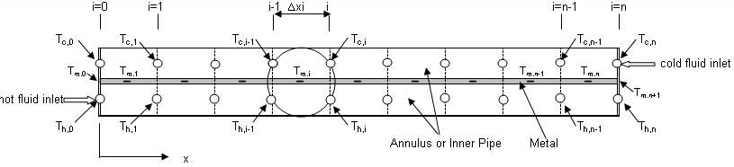
Fig.1.Model with linearly ditributed grid

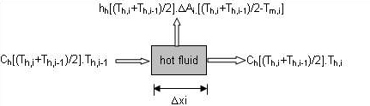
Fig.2.Control volume and energy flows for the hot fluid

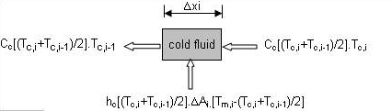

Fig.3.Control volume and energy flows for the cold fluid

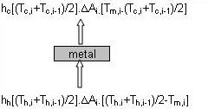

Fig.4.Control volume and energy flows for the metal

The maximum rate of heat transfer used to define the effectiveness is as follows:

${\overset{\text{.}}{Q}}_{\text{max}}=\text{min}\left(\int{C_{h}(T)\text{dT}},\int{C_{c}(T)\text{dT}}\right)$ (15)
The effectiveness of the heat exchanger is defined as the actual rate of the change in the anthalpy of the fluid to the maximum possible rate of heat transfer :
$ε=\frac{\overset{\text{.}}{Q}}{\overset{\text{.}}{Q_{\text{max}}}}$ (16)
The true product of (U.∆T) defined as [5]:
$(U\text{.}ΔT)_{\text{true}}=\frac{\overset{\text{.}}{Q}}{A}$ (17)
and the true number of heat transfer unit is given by:
${\text{NTU}}_{\text{true}}=\frac{1}{C_{\text{min}}}\int{\frac{d\overset{\text{.}}{Q}}{ΔT}=\frac{U_{\text{true}}A}{C_{\text{min}}}}$ (18)
The numerical technique presented in this section has been solved by EES[6].

2.3 Examples
In order to demonstrate the detailed analysis of the model, two specific examples in different arrangements and different ranges of termal properties, are presented in this section as rating problem. Table 1 and Table 2 describe these examples.
Table 1-Data in example 1.
Item | Unit | Tube side(hot) | Annulus(cold)
Fluid name | - | Ethylene | Water
Flow rate | Kg/s | 1.203 | 3.377
Inlet temp. | Cº | 100 | 20
Diameter | mm | 45 | 70
length | m | 30 | 30
Table 2-Data in example 2a.
Item | Unit | Tube side(cold) | Annulus(hot)
Fluid name | - | Water | Oil
Flow rate | Kg/s | 1.2 | 0.8
Inlet temp. | Cº | 30 | 100
Diameter | mm | 25 | 45
length | m | 24.876 | 24.876

For sizing problem, example 2b has been considered in Table 3.

Table 3-Data in example 2b.
Item | Unit | Tube side(cold) | Annulus(hot)
Fluid name | - | Water | Oil
Flow rate | Kg/s | 1.2 | 0.8
Inlet temp. | Cº | 30 | 100
Outlet temp. | Cº | - | 60
Diameter | mm | 25 | 45

Fig.5 to Fig.8 illustrate variations of individual heat transfer coefficient of fluids with temperature, which is presented in examples 1 and 2.

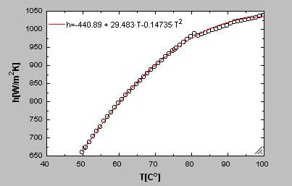  Fig.5. Heat transfer coefficient of ethylene vs T in example 1. | 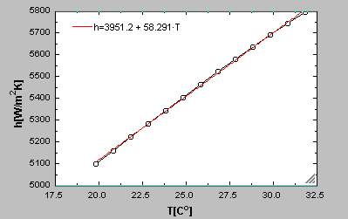  Fig.6. Heat transfer coefficient of water vs T in example 1.

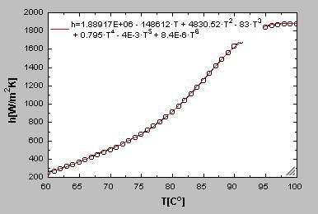  Fig.7. Heat transfer coefficient of oil vs T in example 2. | 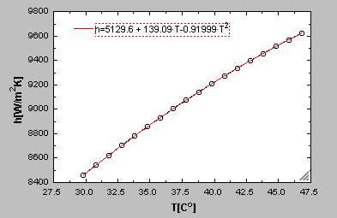  Fig.8. Heat transfer coefficient of water vs T in example 2.

3 Results and Discussion

3.1 Comparative analysis of various methods
In order to establish the error of averaging overall heat transfer coefficient five differrent methods are applied to two sets of input data. Also to evaluating the heat transfer area these five methods are applied to example 2b. To be able to perform the numerical integration, all data are fitted by polynomial curve fits. The methods used are as follows:
- Method summarized in this paper(Numerical solution).
- Colburn method [1] .
- The U value determined at the arithmetic mean of inlet and outlet temperature.
- Step by step, method presented by Roetzel [2].
- Butterworth method to evaluating mean value of overall heat transfer coefficient[3].
The final results of this part are presented in Table 4 to Table 6. Table 4 summarizes calculated efficiencies and errors introduced by various methods in example 1.In Table 5, these errors are indicated for example 2a and finally, in Table 6, the errors in heat transfer area requirement are presented.

Table 4-Compare of methods in example 1.

Table 5-Compare of methods in example 2a.
Method | U[W/m²K] | ε% | %(ε-ε_{exact})/ε_{exact}
Exact | 745 | 61 | 0
Colburn | 703 | 54.8 | -10.1
U at arithmatic temp. | 805.4 | 62.8 | +2.95
Roetzel | 753.8 | 58.75 | -3.7
Butterworth | 684.3 | 53.3 | -12.6
Method | U[W/m²K] | ε% | %(ε-ε_{exact})/ε_{exact}
Exact | 665 | 52 | 0
Colburn | 647.13 | 45.6 | -12.3
U at arithmatic temp. | 835.3 | 57.1 | +9.8
Roetzel | 583.7 | 41 | -21.1
Butterworth | 390 | 28 | -46
Table 6-Compare of methods in example 2b.
Methods | Exact | Colburn | Mean value | Roetzel | Butterworth
A[m²] | 3.017 | 2.522 | 1.953 | 2.8 | 4.174
%Error | 0 | -16.4 | -35 | -7 | +38
Error = (A-A_{exact})/ A_{exact}

The exact values are determined by using the integration method with 100 interval . In example 1, viscosity of hot fluid (controlling film) increases from 0.0025 at inlet to 0.007 at outlet. Prantel number also various from 22 to 66. therefore individual heat transfer coefficient of the hot fluid (ethylene) decreases from 1039 W/m²K at inlet to 661 W/m²K at outlet . Because the heat transfer coefficient of ethylene is lower than the water, the effect of variation heat transfer coefficient of ethylene is more than this effect in water.
In example 2a, viscosity of hot fluid(controlling film) increases from 0.0013 at inlet to 0.0073 at outlet. Prantel number various from 220 to 1040.Therefore individual heat transfer coefficient of oil decreases from 1886 W/m²K at inlet to 249 W/m²K at outlet.
According to the above compare, the errors in approximation methods, presented in example 2, are large, because of large variation in overall heat transfer coefficient throughout the exchanger. According to this discussion, if the variation of U along the heat exchanger is not large(example 1,U various from 880.9 to 585.4), the Roetzel method is recommended. But if there is a large variation in viscosity of controlling film and therefore a large variation in heat transfer coefficient(example 2, U various from 242.7 to 1572.3 ), the approximation methods should be avoided.
Based on the finding of example 2b it appears that non of the approximatiom methods should be considered, because the variation of U is nonlinear.The best approach is numerical solution to take into consideration the actual variation of termal peroperties.

3.2 Numerical results analysis
According to equation 10 variations of U against ∆T and L have been illustrated in Fig 9 and Fig 10, respectively.It is concluded that, both of these variation are nonlinearly. The numerical integration of U along the exchanger,as it is seen in Fig 10,is in agreement with the value of true overall heat transfer coefficient represented in equation 14.
$$U=\frac{1}{L}\int{U_{i}}{\text{dx}}_{i}={\text{22355}}/{\text{30}}=\text{745}\text{.}\text{16}$$
Fig.11, Fig.12 and Fig.13 illustrate the temperature profiles of water and ethylene along the heat exchanger, in constant properties and variable properties. One of the important result can be achieved from this figures is that, the temperatures in real condition is lower than that in constant properties assumption. The maximum difference occures nearly at the middle of the heat exchanger. Since this difference is lower in the entrance of water than the other points, the ethylene temperature at the end of the exchanger is larger in variable properties. This result is in agreement with the previous analysis on the efficiency of the exchanger. The graphical integration, presented in Fig.14, shows that heat transfer surface requirement in example 1 is nearly equal to the selected length, which confirm the solution.

$A=π\text{.}D\text{.}L=4\text{.}2$m²

Fig.15 and Fig.16 represent the variation of U against L and ∆T. In example 2a, because the variation of oil viscosity and therefore the variation of oil heat transfer coefficient, throughout the heat exchanger in example 2, are more than these variations in example 1,variation of U is more sensible in example 2 in compare with example 1. Fig.17 illustrates the temperature profiles in example 2. Effect of variation of overall heat transfer coefficient on temperature profiles in example 2, is not negligible and so the error is not negligible.
Fig.18 illustrates variation of heat transfer rate along the heat exchanger in example 2. It can be seen that the net heat transfer rate in example 2 variable properties condition is lower than that in constant properties assumption.
Effect of variable overall heat transfer coefficient on ε-NTU chart in a counterflow heat exchanger in example 1 and 2 has been shown in Fig.19 and Fig.20, respectively. NTU_{constant} is defined as follows:

${\text{NTU}}_{\text{cons}\text{tan}t}=\frac{U_{\text{cons}\text{tan}t}\text{.}A}{C_{\text{min}}}$ (19)

It can be shown that, for a specific NTU_{constant} , the efficiency of heat exchanger in variabe properties is lower than that in constant properties assumption, and this difference increases with increasing in NTU_{constant} or heat transfer area.

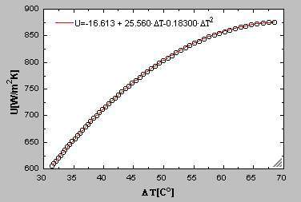
Fig.9. Overall heat transfer coefficient vs ∆T in example 1.

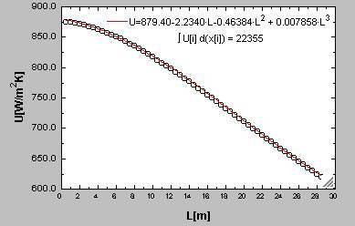
Fig.10. Overall heat transfer coefficient vs L in example 1.

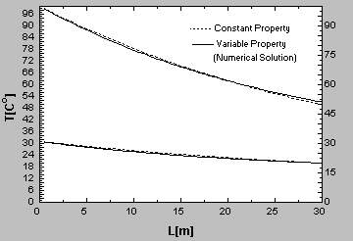
Fig.11. Temperature profiles in example 1.

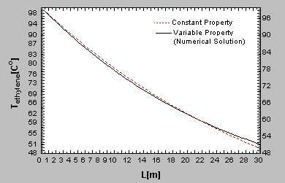
Fig.12. Variatin of ethylene temperature along the heat exchanger .
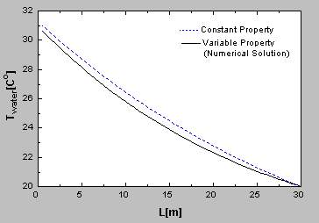
Fig.13. Variatin of water temperature along the heat exchanger in example 1
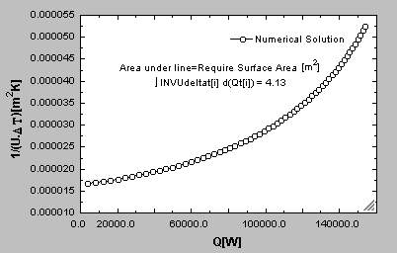
Fig.14. Variatin of (U.∆T)⁻¹ vs Q in example 1
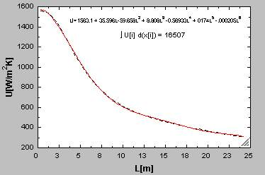
Fig.15. Overall heat transfer coefficient vs L in example 2a

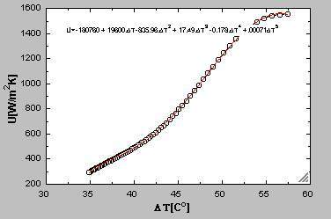
Fig.16. Overall heat transfer coefficient vs ∆T in example 2a.

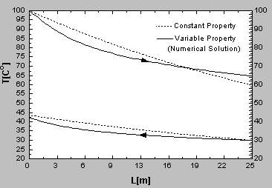
Fig.17. Temperature profiles in example 2a.

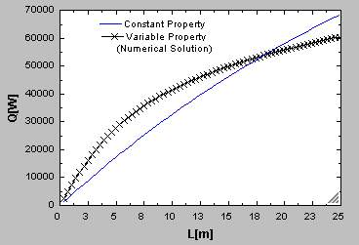
Fig.18. Variation of heat transfer rate along the exchanger in example 2a.
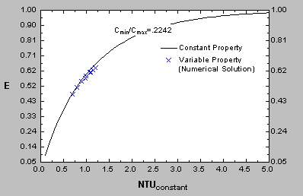
Fig.19. ε-NTU Chart for counter flow heat exchanger based on example 1

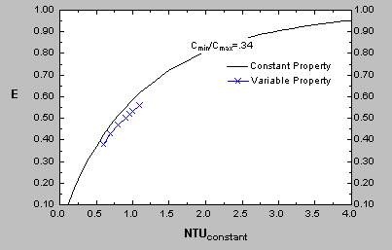
Fig.20. ε-NTU Chart for counter flow heat exchanger based on example 2a

Table7 represents the magnitute of ∆T_{true} and LMTD_{true} in example 1 and 2, where LMTD_{true} is obtained from true outlet temperature of fluid, that obtained from numerical model. As it can be seen, if LMTD calculated with true temperatures, true mean temperature difference is neary equal to true log mean temperature difference.

Table 7-compare of LMTD_{true} and ∆T_{true} in example1 and 2a.
Example | ∆T_{true} | LMTD_{true}
1 | 47.89 | 47.7
2 | 45 | 45.4

4 Conclusion
This paper presented a numerical model of a counter flow heat exchanger, in which properties variation with temperature are explicitly accounted. A numerical model was used to investigate the performance or heat transfer area. Five different methods of averaging U were compared, to determine how they rank in accuracy in predicting efficiency or heat transfer surface area requirement for two example. In the next section, it was concluded that changes of physical properties decrease heat transfer rate and termal efficiency of the heat exchanger. It was found that constant thermal properties assumption can cause a large errors in the rating and sizing problems.
Finally, the effect of variable thermal properties on ε-NTU chart and true temperature difference was achieved.

References:
[1] A.P.Colburn,Mean temperature difference and
heat transfer coefficient in liquid heat exchanger,Ind.Engng.Chem,Vol.25,pp.873-877 (1933).
[2] R.K.Shah,and D.P.Sekulic,Nonuniform overall heat transfer coefficients in conventional heat exchanger design theory-revisited, J.of Heat Transfer. Vol.120, pp.520-525 (1998).
[3] D.Butterworth,A calculation method for shell and tube heat exchangers in which the overall coefficient various along the length,Conference on Advances in Thermal and Mechanical Design of Shell-and-Tube Heat Exchangers,No.590, pp.56-71 (1973).
[4] E.A.D. Saunders, Heat exchangers selection,

design and construction,Copublished in the U.S. with John Wiley & Sons,Inc, Newyork (1988).
[5] Donald Q.Kern,Process heat transfer, Mc-GrawHill International Editions, Chemical Engineering Series (1965).
[6] Klein SA, Alvarado FL. EES-Engineering Equatin Software, Avalible: http://fchart.com
[7] W.Roetzel,Heat exchanger design with variable heat transfer coefficient for crossflow and mixed flow arrangement, Int.J.Heat Mass Transfer. Vol.17,pp.1037-1049 (1974).
[8] G.F.Nellis, A heat exchanger model that includes axial conduction,parasitic heat load and property variations, Cryogenics. Vol.43, pp.523-538 (2003).
[9] R.K.Shah, and A.C.Muller, Heat exchanger basic design methods in handbook of heat transfer, Second edition,Edited by W.M.Rohsenew, J.P.Hartnett, Chapter 18, Part 1,Mc-GrawHill, Newyork (1982).
[10] R.K.Shah, Heat exchanger basic design methods in low Reynolds number flow heat exchanger, by S.Kakac, R.K.Shah and A.E.Bergless, pp.22-72 (1983).
[11] S.Kakac,A.G.Bergles and E.O.Fernards,Two phase flow Heat Exchanger Thermal Hydraulic Fundumental, Kluwer,Academic Publisher (1988).
[12] F.P.Incropera,D.P.Dewitt, Introduction to heat transfer, Second Edition, Vol.2 (1990).
[13] G.F.Hewitt,G.L.Shives,T.R.Bott, Process heat transfer, First Edition,CRC Press,Newyork (1994).

