Bacteriophage Multiplication—Dependence on Host Physiology

ARIEH ZARITSKY¹, AVINOAM RABINOVITCH², MONICA EINAV¹ AND HILLA HADAS¹
Departments of Life Sciences¹ and Physics²
Ben-Gurion University of the Negev
POB 653, Be’er-Sheva, 84105
ISRAEL

Abstract: - Bacteriophage burst size is a function of three independent parameters (eclipse and latent periods, and rate of ripening during the rise period) that together are essential and sufficient to describe multiplication in the bacterial host. A general model [1] to describe the classical “one-step growth” experiment allowed their calculations from results obtained with T4 in Escherichia coli B/r under different growth conditions and manipulations [2]. The parameters were satisfactorily derived using a sophisticated least-squares program. It was found that all three parameters can be described by their dependence solely on the culture doubling time τ before infection [3]. Their functional dependence on τ thus derived was used to calculate burst size values, the latter agreeing well with the experimental results. The dependence of the parameters on growth conditions can be used to predict phage development under other experimental treatments.
Phage adsorption rate was positively correlated to cell size and directly proportional to total cellular surface area, indicating constant receptors density on cell envelopes irrespective of growth conditions [2]. The rates of synthesis and assembly of phage components seem to depend on the content of the protein-synthesizing system, and lysis time seems to depend on cellular dimensions.
The similarity to materials corrosion was invoked to develop a model for phage-infected bacterial lysis based on the statistics of extremes [4]. The importance of cell size, envelope thickness and lysosyme eclipse on the final probability distribution of lysis was considered. Experiments are suggested to test the model.

Key-Words: - Adsorption Phage Eclipse Latent Lysis Burst Rate Bacterial Growth Conditions Model

1. Introduction
Studies on growth and development of bacteriophage (bacterial virus, nicknamed phage) in the 1940s played a vital role in the history of molecular biology [5]. The classical one-step growth experiment [6] defined latent period, rise time and burst size, and the eclipse period was discovered by disrupting infected bacteria before their spontaneous lysis [7].
By the time bacterial physiology was established as a discipline [8], molecular biology had become so attractive that some unsolved questions in phage-host cell interactions have been ignored and never seriously looked at since. The vast amount of knowledge gained during the last 35 years on the biochemistry, genetics, and physiology of bacteria [9] enables a fresh look on these interactions, which may shed light on various cell properties [2].
In a typical one-step growth experiment [6], a culture of cells is mixed with phage suspension at a low multiplicity of infection (moi) to guarantee single infections. Samples are plated periodically on a lawn of sensitive bacteria, and the number of phages is calculated from the number of plaques formed after overnight incubation. This procedure has recently been used [2] to describe the development of T4 phage inside its host Escherichia coli under varying well-defined physiological states of the bacteria. The dependence of phage growth parameters on cell size, age, and shape, on rates of metabolism and chromosome replication, and on time of lysis was evaluated semi-quantitatively. To derive objective values of the parameters, they were defined rigorously, and the time dependence of the process was calculated and compared with the data [1], with due note taken of the statistical distributions of the parameters within the populations of both phages and bacteria.
Two additional parameters of the interaction between the phage and its host cell were studied, experimentally (rate of adsorption; [2]) and theoretically (time of lysis; [4]), with cell size and envelope features considerations. The former took advantage of the known changes in cell dimensions with growth rate, and the latter considered the unknown envelope thickness and lysosyme eclipse time.
2. The Model Systems

2.1 The one-step growth experiment
Since burst times of individual cells are normally distributed, the number of phages per bacterium (PPB) increases as erfc[(q - t)/Δ], where q is the burst time (latent period) and 2Δ is the width of the distribution. Times are measured from infection of a cell by a single phage. The eclipse period ν (; 15 min in the example of Fig. 1) is the average time after infection of appearance (inside the cell) of the first complete phage. From this time onwards, the PPB is assumed to increase linearly during the rise period with a constant rate α (8 per min in the example of Fig. 1a). The number of PPB (φ) stops increasing when the bacterium bursts, at the end of the latent period μ (30 min in Fig. 1b), reaching a final burst size of B = α(μ - ν) (120 in Fig. 1b). The PPB inside an infected cell before its burst (φ₁) and the number which emerges from lysed cells (φ₂) are shown in Figs. 1c and 1d, respectively. Evidently, φ₁ + φ₂ = φ. In the experiments [2], φ₂ is obtained by titrating phages in the suspension [6] while φ is obtained independently after lysing the cells artificially [7]. For a population, where ν and μ vary in both infecting phage and infected bacterium, the actual, smoother curves are displayed in Fig. 1, e-g. Both ν and μ are assumed to have Gaussian distributions around their averages with coefficients of variation σ/ν and β/μ (of 20%, or 3 and 6 min, respectively, in the example of Fig. 1).

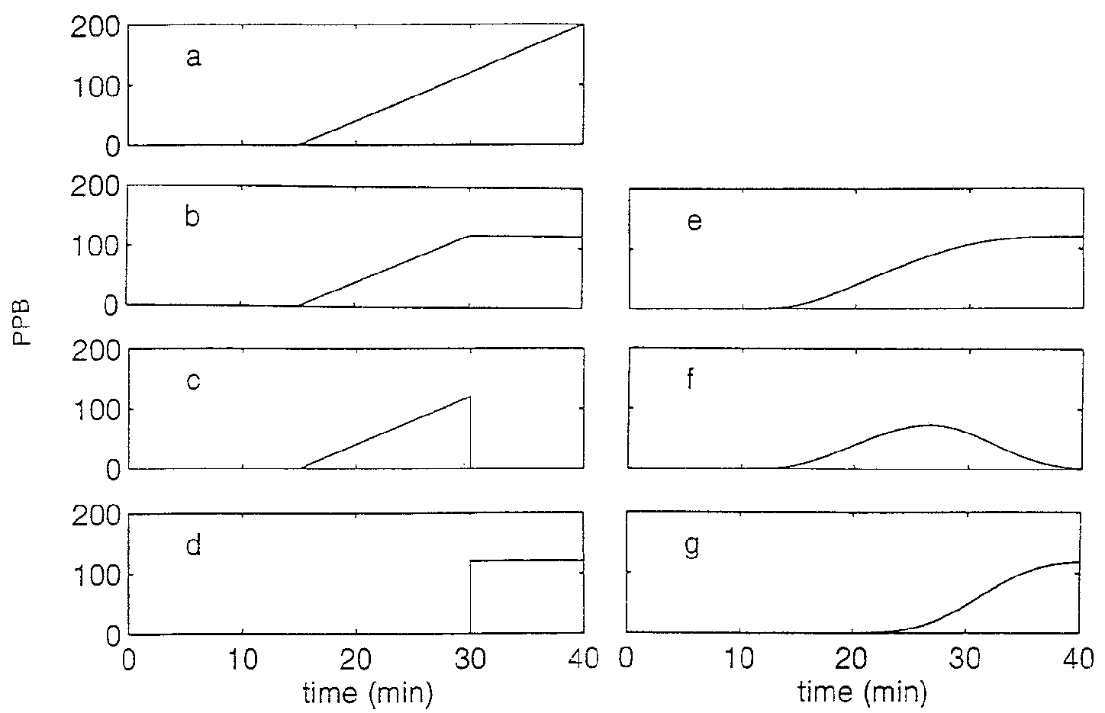

Fig. 1. A schematic representation of the number of phages per bacterium (PPB), with parameters as given in the text, if bacteria do not burst (a), total in lysed and nonlysed cells (b), in nonlysed cells (c), and in lysed cells (d). Panels e-g display the non-ideal cases (“real” situation) of those shown in panels b-d, respectively. (From [1]).

The experimental results were analyzed by using the following 3 equations, derived in [1],
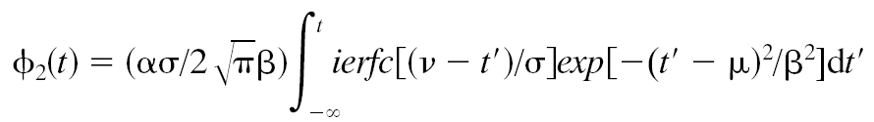
(eq. 1, the average PPB in the lysed bacteria at t)

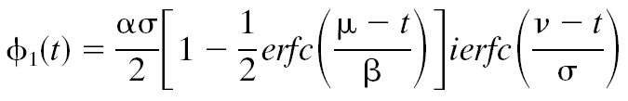
(eq. 2, the average PPB in non-lysed bacteria at t)

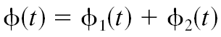

(eq. 3, the total PPB)

and a “destruction parameter” of chloroform (used to disrupt the infected cells thus exposing the eclipse period).

2.2 Rate of adsorption
Rod-shaped, bacillary bacterial cells such as E. coli extend by elongation and divide in a perpendicular plane at steady states of growth [10]. The faster they grow (in richer media, but not in higher temperature), the larger they are [8]. Maintaining an approximate constant aspect ratio [11], both cell dimensions are larger at faster rates [12], and hence the ratios between surface area to volume or to mass (cell density is constant) are smaller. This allowed us to calculate the relative density of phage receptors from data of adsorption rates under a variety of well-known physiological conditions and various experimental treatments [2].

2.3 Timing of cell lysis
A full understanding of the lysis process, whether theoretical or experimental, is still missing [13]. Neither measurement of the chemical processes occurring at the cell envelope by lysosyme nor extensive temporal measurements of the lysis in these systems have yet been carried out. Our analysis [4] simulated the action of lysosyme on cell surface to corrosion action by chemicals on vessels under pressure using statistics of extremes. Contributions were considered of cell size, envelope thickness and eclipse time of lysosyme to the final probability distribution of lysis in cell cultures.

Under these circumstances, the piercing probability, 1–F_{T}(d), depends on the corrosive influence on a unit area
1 – F_{T}(d) = 1 – exp(-e^{-u}) , (eq. 4)
where u is a parameter that is a function of total cell surface and envelope thickness.

3. Results

  - One-step growth experiments
Results of the analyses of experimental data with T4 infecting E. coli under different growth and other physiological conditions [1, 2], that were performed with eqs 1-3, are displayed in Table 1: all three parameters (α, μ, ν), together with the disruption factor ζ and the derived burst size B are tabulated.

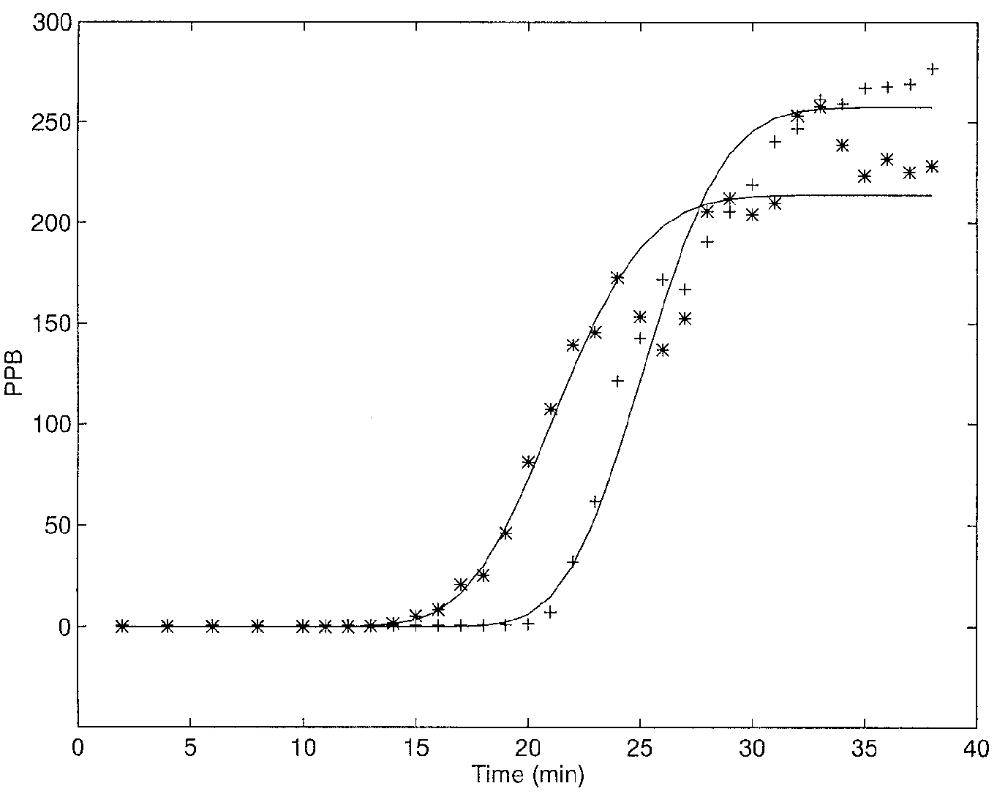

Fig. 2. Comparison between the model (lines) and results of a “classical experiment” [6] with a moving average (3-points) technique.
*, samples titered after chloroform treatment (r²=97.4);
+, naturally released phage (r²=97.8). (From [1].)
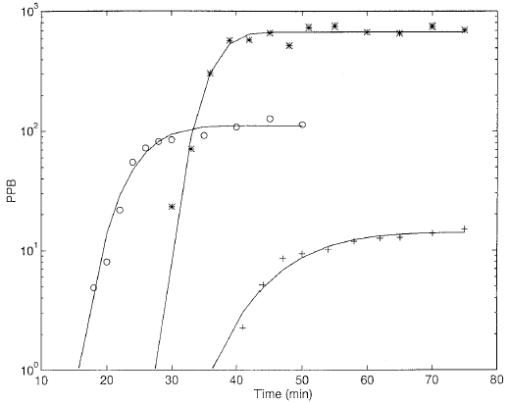

Fig. 3. Comparisons [1] between the model (lines) and results of three experiments [2]. Steady-state cultures grown in
LBG (o) and succinate-minimal medium (+);
*, LB-grown cells, Penicillin-treated, then super-infected.

Comparison of the model to results of “the classical experiment” in LB rich medium [6] is presented (Fig. 2) at a higher measured accuracy. The three examples displayed in Fig. 3 were selected among those of Table 1 to cover the whole range of burst sizes (between 13 and 720) obtained.

3.2 Relation with pre-infection states of growth
The cell-dependent parameters (all but ζ) can indeed be described as functions of the host culture doubling time τ before infection. The dependence on τ of these (Figs. 4 and 5), derived by a best-fit analysis, was used to calculate burst size values (Fig. 6). The latter agree well with the experimental results. The dependence of the derived parameters on growth conditions can be used to predict phage development under other experimental conditions.

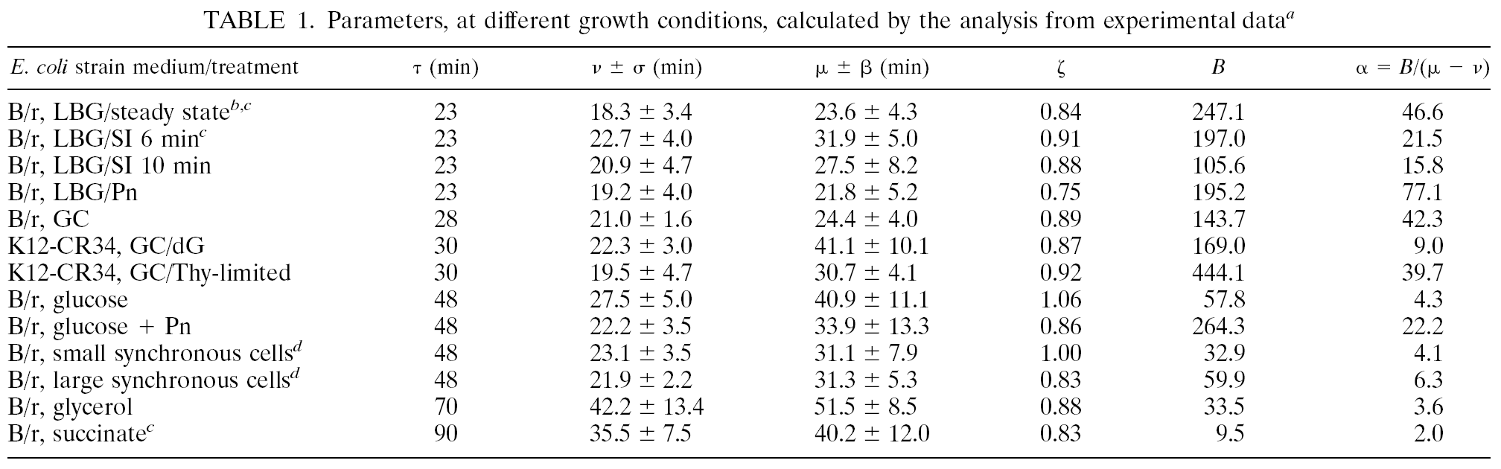
ª, Taken from [1] and [2].

3.3 Adsorption kinetics
Rates of adsorption increased with faster growth rates (decreasing τ) in richer media [2], and ranged between 0.71 – 3.36 x 10⁷ phage ml⁻¹. Adsorption rates were significantly higher (4.68 x 10⁷ phage ml⁻¹) after treatment with low concentrations of penicillin (Pn), which specifically block cell division [14], to distinguish between likely effects of medium composition and those of cell size.
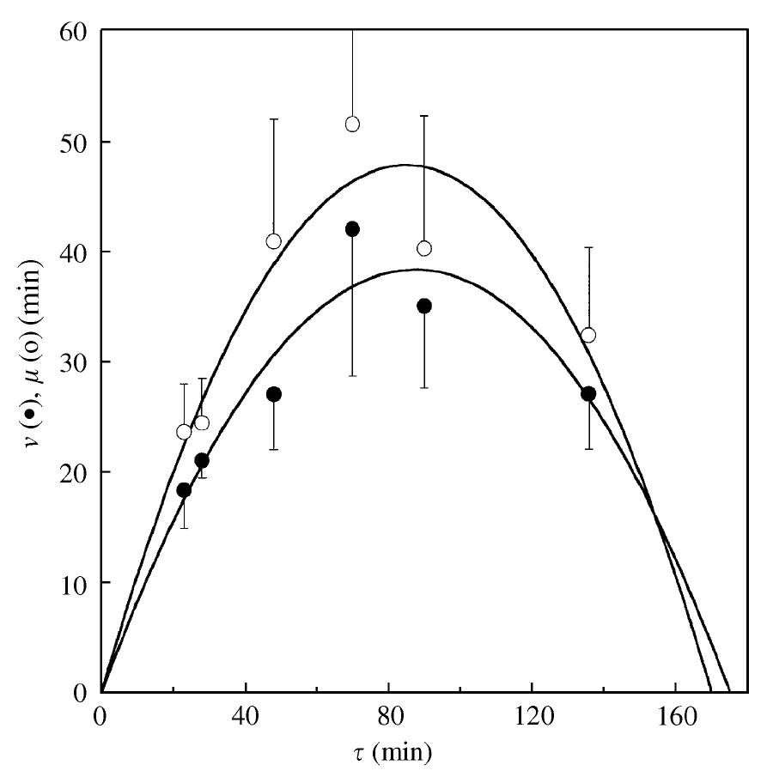
Fig. 4. Eclipse ν (closed circles) and latent μ periods (open circles) as functions of the culture doubling time τ: The lines represent theoretical fits according to eq. 1 in [3]. (From [3].)
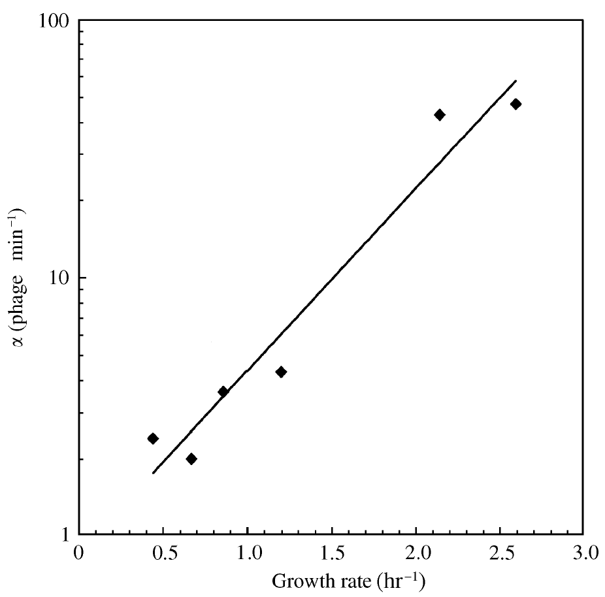
Fig. 5. Rate of intracellular phage maturation during the rise period (α) as a function of bacterial growth rate (1/τ). Curve from eq. 1 in [3]. (From [3]).

The rate of T4 adsorption per unit surface area was calculated according to an experimental equation [15], derived from the known dimensions of the same bacterial strain [16], and found to be constant (Fig. 7).

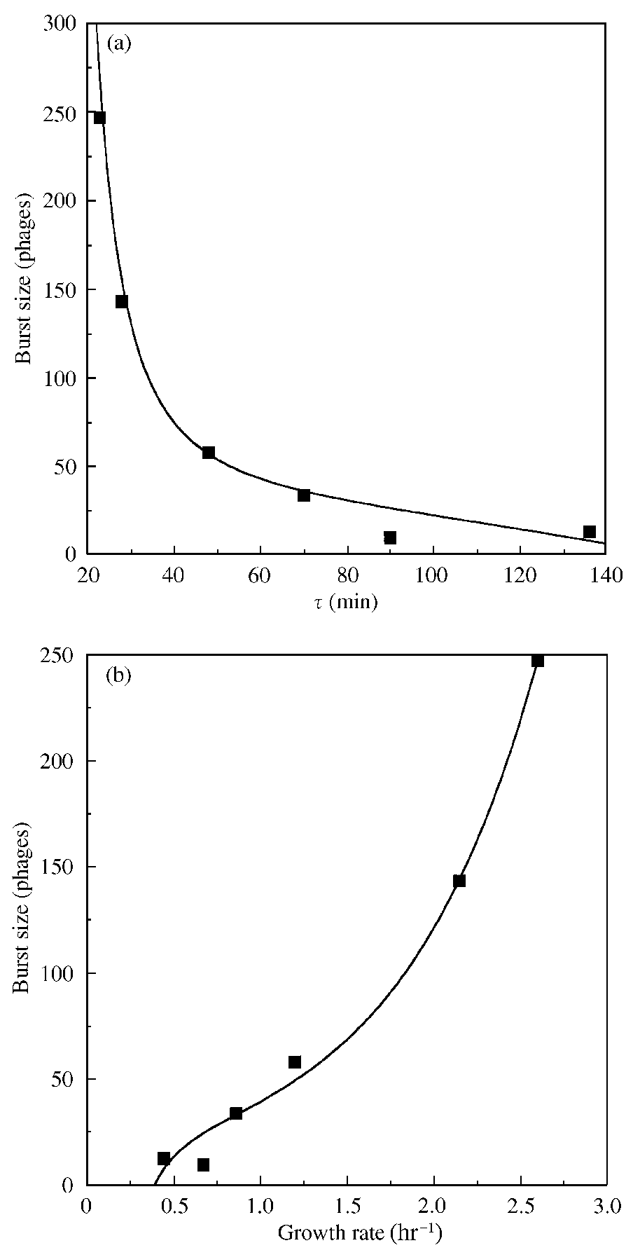
Fig. 6. Burst size B as a function of τ (a) and 1/τ (b): closed squares, “experimental” values obtained in [2]; lines, calculated values from eq. 2 in [3]. (From [3]).

3.4 Timing of lysis
The model described in 2.3 predicts the probability of bacterial survival (inverse of lysis) at a constant time as a function of S/a, where S is cellular surface area and a is a constant which depends on the membrane parameters such as its thickness ([4]; Fig. 8), a prediction that can readily be tested.

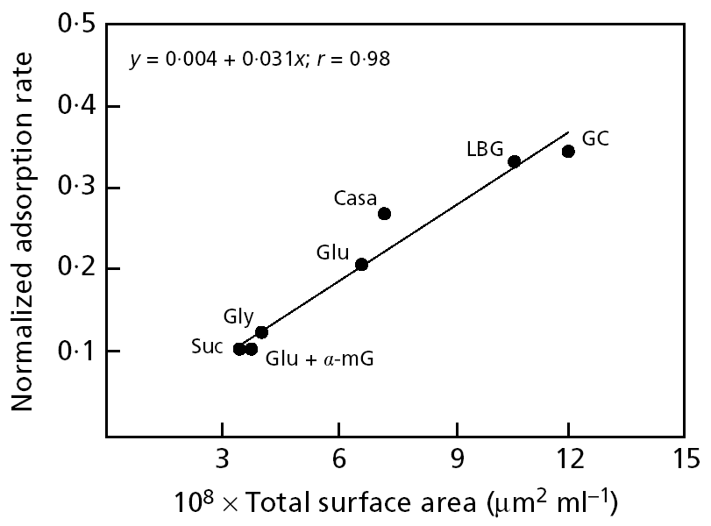
Fig. 7. Adsorption rate as a function of total surface area of infected cells in the indicated media: Succinate, Glycerol Casein and Glucose, alone or with LB, Casein, LB or α-Methyl Glucose. (From [2]).
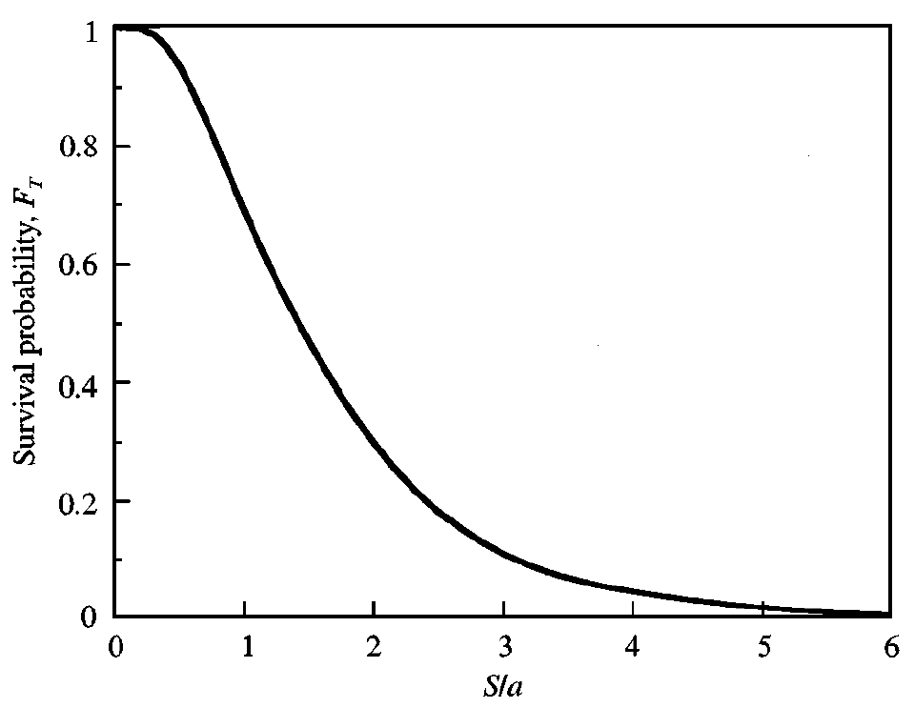
Fig. 8. Expected survival probability for the system E. coli/T4 as a function of S/a. (From [4]).

4. Discussion

Experimental analysis of our model (Fig. 1; eqs. 1-3) proved rewarding (Table 1; Figs. 2-7; [2, 3]). Phage T4 seems to interact with its host E. coli as predicted under a wide range of cultivation conditions, hence the model can be useful to predict behavior under additional treatments provided their effects on host’s physiology are well understood. The dependence of phage multipli-cation parameters on bacterial state of growth and molecular composition is divided in several aspects as follows.

4.1 Adsorption and receptors’ density
The constant rate of T4 adsorption per unit surface area of the cells, irrespective of the bacterial growth rate over a wide range (Fig. 7) indicates a constant density over the cell surface area of the receptor for the irreversible stage of phage adsorption despite the dramatic change of cell dimensions with physiology [8, 11-18]. And since peptidoglycan is the envelope component whose density remains constant [15], it is likely to be the major anchor for the T4 baseplates.

4.2 Rate of phage maturation
The qualitative indication [1, 2], that the rate of phage synthesis and assembly (α) is proportional to the size of the protein-synthesizing system (PSS) in the cell upon infection was rigorously confirmed ([3]; Fig. 5). This is so because the PSS concentration under steady state exponential growth conditions is closely correlated with growth rate 1/τ [8, 17].
This conclusion was substantiated by raising cell size (and hence the PSS) using certain experimental manipulations that do not affect PSS concentration [2]: (a) specific inhibition of cell division by Pn [15]; (b) delay in cell division by thymine limitation of thyA mutants [18]; (c) letting synchronous “baby cells” selected after division to grow before infection [19].

4.3 Eclipse and latent periods
These two parameters must be dependent on each other, at least in the sense that the latent period (μ) cannot exceed the eclipse (ν) for the phage species to survive. The question whether the difference between them (Fig. 4) approaches null at very fast or very slow bacterial growth rates remains moot. Detailed studies on the mechanism that governs cell lysis are still missing [13]. Evolution of latent period has recently been considered and discussed in ecological terms [20, 21] but it must in parallel be translated into molecular understanding of lysosyme and holin syntheses and activities [4, 13]. If our lysis model [4] is supported experimentally, by estimating the proportion of bursting bacteria of a certain size as a function of time for example, it would provide predictions of time of cell lysis (that is, μ) or, at least of (μ–ν).

4.4 Burst size
The number of progeny ensuing of a cell infected by one phage, which is the outcome of (μ–ν) multiplied by α [1], can be modified by either of the multipliers. The change affected by host cell physiology is most dramatic in the rate of phage maturation α, which varies over 20–30 fold (Table 1; Fig. 5), while μ and ν seem to change by less than 2-fold (Table 1; Fig. 4). The latter two can however be modified [2] by phage super-infection [22, 23] as well.
Burst size was demonstrated not to be limited by cellular DNA content or concentration nor cell size per se [2], but mainly by α and (μ–ν). While the data is fully consistent with the notion that α changes systematically with PSS, a molecular explanation to the dependence of (μ–ν) on cell growth conditions is still sorely lacking [13]. It will have to do with the regulation of early and late gene expression (for ν), of lysosyme and holin synthesis and the mechanism of their action to burst the host (for μ). Studies such as described in [24, 25] are pioneering in this direction and are likely to disclose this dependence if extended.

4.5 Other data
Results obtained with T7 phage [26] are consistent with ours in the T4/E. coli system. Extension of these studies was obtained by the finding [24] that burst size of the temperate E. coli phage λ (rather than the virulent T4) is larger in faster growing host cultures.
References:
[1] Rabinovitch, A., Hadas, H., Einav, M., Melamed, Z., Zaritsky, A. Model for bacteriophage development in Escherichia coli, 1999, J Bacteriol 181:1677-1683.
[2] Hadas, H., Einav, M., Fishov, I., Zaritsky, A. Bacteriophage T4 development depends on the physiology of its host Escherichia coli, 1997, Microbiology 143:179-185.
[3] Rabinovitch, A., Fishov, I., Hadas, H., Einav, M., Zaritsky, A. Bacteriophage T4 development in Escherichia coli is growth rate dependent, 2002, J Theor Biol 216:1-4.
[4] Rabinovitch, A., Zaritsky, A., Fishov, I., Einav, M., Hadas, H. Bacterial Lysis by phage—a theoretical model, 1999, J Theor Biol 201:209-213.
[5] Cairns, J., Stent, G.S., Watson J.D. (ed). Phage and the Origins of Molecular Biology. Cold Spring Harbor Lab, Cold Spring Harbor, N.Y., 1966.
[6] Ellis, E.L., Delbrück, M. The growth of bacteriophage, 1939, J Gen Physiol 22:365-384.
[7] Doermann, A.H. The intracellular growth of bacteriophage, 1948, Carnegie Inst Wash Year Book 47:176-182.
[8] Schaechter, M., Maaløe, O., Kjeldgaard, N.O. Dependency on medium and temperature of cell size and chemical composition during balanced growth of Salmonella typhimurium, 1958, J Gen Microbiol 19:592-606.
[9] Neidhardt, F.C., Curtiss, R. III, Ingraham, J.L., Lin, E.C.C., Low, K.B., Magasanik, B., Reznikoff, W.S., Riley, Schaechter, M., Umbarger, H.E. (ed). Escherichia coli and Salmonella: Cellular and Nolecular Biology, 2nd ed. Amer Soc Microbiol, Wash, D.C., 1996.
[10] Trueba, F.J. A morphometric analysis of E. coli and other rod-shaped bacteria, 1981, Ph.D. Thesis, University of Amsterdam, 125 pp.
[11] Zaritsky, A. On dimensional determination of rod-shaped bacteria, 1975, J Theor Biol 54: 243-248.
[12] Zaritsky, A., Woldringh, C.L., Grover, N.B., Naaman, J., Rosenberger, R.F. Growth and form in bacteria, 1982, Comm Mol Cell Biophys 1: 237-260.
[13] Young, R. Bacteriophage lysis: mechanism and regulation, 1992, Microbiol Rev 56:430-481.
[14] Hadas, H., Einav, M., Fishov, I., Zaritsky, A. Division inhibition capacity of penicillin in Escherichia coli is growth-rate dependent, 1995, Microbiology 141: 1081-1083.
[15] Zaritsky, A., Woldringh, C.L., Mirelman, D. Constant peptidoglycan density in the sacculus of Escherichia coli B/r growing at different rates, 1979, FEBS Lett 98: 29-32.
[16] Woldringh, C.L., de Jong, M.A., van den Berg, W., Koppes, L. Morphological analysis of the division cycle of two E. coli substrains during slow growth, 1977, J Bacteriol 131: 270-279.
[17] Bremer, H., Dennis, P.P. Modulation of chemical composition and other parameters of the cell by growth rate. In [9].
[18] Zaritsky, A., Pritchard, R.H. Changes in cell size and shape associated with changes in the replication time of the chromosome of Escherichia coli, 1973, J Bacteriol, 114: 824-837.
[19] Helmstetter, C.E. Methods to study the microbial division cycle, 1969, Methods Microbiol 1: 327-364.
[20] Abedon, S.T., Herschler, T.D., Stopar, D. Bacteriophage latent-period evolution as a response to resource availability, 2001, Appl Environ Microbiol 67: 4233-4241.
[21] Abedon, S.T., Hyman, P., Thomas, C. Experimental examination of bacteriophage latent-period evolution as a response to bacterial availability, 2003, Appl Environ Microbiol 69: 7499-7506.
[22] Bode, W. Lysis inhibition in Escherichia coli infected with bacteriophage T4, 1967, J Virol 1: 948-955.
[23] Abedon, S.T. Bacteriophage T4 resistance to lysis inhibition collapse, 1999, Genet Res Camb 74: 1-11.
[24] Gabig, M., Obochowski, M., Wegrzyn, A., Szalewska-Palasz, A., Thomas, M.S., Wegrzyn, G. Excess production of phage λ delayed early proteins under conditions supporting high Escherichia coli growth rates, 1998, Microbiology 144: 2217-2224.
[25] Wegrzyn, A., Czyz, A., Gabig, M., Wegrzyn, G. ClpP/ClX-mediated degradation of the bacteriophage λ O protein and regulation of λ phage and λ plasmid replication, 2000, Arch Microbiol 174: 89-96.
[26] You, L., Suthers, P.F. & Yin, J. Effects of E. coli physiology on growth of T7 in vivo and in silico, 2002, J Bacterial 184: 1888-1894.

