Cellular Automata - Critical Densities on Forest Fire Dispersion

SIRIPORN SUPRATID
Information Technology faculty,
Rangsit University, Pathumthani 12000, Thailand
RAMAKOTI SADANANDA
Computer Science Program, Asian Institute of
Technology, P.O.Box4, Pathumthani , Thailand

Abstract : - Cellular automata offer excellent modeling paradigms for the study of global behavior from local interactions. Instead of focusing on a physical model of forest fires, this paper considers possible models of artificial ones with the point of view of global parameters given local interactions rules. A set of possible rules for fire ignition, is assumed for the purpose of local interactions. These examine the empirical results and enquire if there are critical densities for various kinds of initial configurations and rules of interactions. It is found that there exists the association between $λ$99, the parameter developed in this study, and the rules set. This leads to the certain relationship among an initial density of a dynamic state of a forest, a global phenomenon, and a local interactions.

Keywords: Two-dimensional cellular automata, Moore neighborhood, Local interactions, Critical density, and Forest fire.

1 Introduction
Cellular automata are well-suited tools for artificially modeling natural systems. They are described as massive collections of relatively simple objects interacting locally with one another. Since Von Neumann first attempted to model a self-reproducing system with CAs. The basic element of CAs is a cell. The cells are arranged in a one or a higher dimensional configuration. At any time, a cell assumes one of the several states. The state changes take place at discrete time intervals depending on the current state of the cell itself and of those cells in the adjacent neighborhood. In the two–dimensional configuration, the neighborhood, defined as Von Neumann neighborhood, is assigned as those comprising the cell itself and the one on the immediate East, West, North, and South. Some variations such as Moore neighborhood have eight adjacent neighbors plus the cell itself. It is obtained by including the other four of adjacent diagonals cells to the neighborhood.
The initial and the final time step are generally defined respectively as the time the evolutionary process starts, and the time of no more changes in the state of each cell. The state transition function often termed “rules set” which represents “local interactions”. According to a global pattern through time, starting from a random configuration, Wolfram [12, 13] classified one-dimensional, binary-state CAs into four classes. However, Langton [6] attempted to define the local interactions in terms of $λ$. There have been several CAs researches relevant to a density issue [7,8,9]. The density is defined as the number of a certain state in a configuration as a ratio of the total number of cells, computed at the initial time step. It is interesting to find out if there are critical densities for various kinds of initial configurations and rules of interactions. The related works concentrating on the critical density belong to Packard [8] and Mitchell et al. [7].
Two-dimensional CAs have been used as simplified models for studying emergent cooperative or collective behavior as shown by Dorigo et al. [4]; and Boccara and Fuks [2]. Forest fires are another such complex phenomena. There have been so many efforts in modeling forest fires spread, such as Fowell [5]; Andrews [1]; and Cheney [3]. Most of these studies are based on deterministic models. The best-known and studied model is Rothermel [10]’s semiempirical model. A more recent approach to simulation of fire spread has been done by Resnick [9]. His simplified world produced some interesting forest-fire-like project on two-dimensional, 3-states CAs. The results showed that the small changes from the critical densities caused the significant quantitative changes.
This paper concerns with experimenting on a simple artificial system such as forest fires that exhibits complicated dynamic behaviors of natural phenomena. Unlike those aforementioned studies, this study aims to understand how complex macroscopic outcomes arise as a result of a self-organizing pattern emerged from the local interactions among individual components.

2 Critical Density
The density computation is trivial if there is global information. In CAs, it is simple to count any one state and take the ratio of it. However, if there is only the local interactions allowed and the memory limited to state changes, it is non-trivial. The critical density is based on the density definition plus an important property: the small change from the critical density leads to the significant quantitative changes for the global system. According to this paper, these examine the empirical results and enquire if there are critical densities for various kinds of initial configurations and rules of interactions

3 A Study Case Model - Forest Fires
Two-dimensional, three-state CAs are employed for representing an artificial world of forest fires. Three possible states associated to a cell, one at a time, are a living tree represented by 1 or gray color with alphabet ‘T’ inside, a burning tree represented by 2 or black color, and an empty space represented by 0 or white color. Moore neighborhood strategy is chosen.
The fire spread through all possible directions.
The factors of the fire spread such as land height, wind, moisture, temperature, etc, are not accounted here. This is because rules possibly vary according to the involved factors. In addition, this paper concentrates on the effect of the global configuration outcome that is limited to only the local interactions and the initial density of the living trees.
The initial and the final time steps are defined
successively as the time just before the fire starts, and the time of no more changes in the state of each cell. There is a constraint that an empty space and a burning tree always maintain the same state. A living tree is the only changeable state. No periodic behavior is applied here. The existence of an empty space would hinder the fire spread; but the living tree paths help to expand fire. The fires start from a column of cells at the left edge of the configuration.
Each artificial forest has a uniform set of rules associated with each cell. Eight simple sets of transition rules are chosen as close to those intuitively plausible. They are different in terms of a number of burning neighbors that enable the center cell to get fired. Each set of rules is identified in terms of k which is defined as the minimum integer number of burning neighboring cells required to burn the center cell;
1 k 8. The transitions are depicted in Fig. 1.

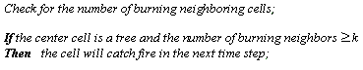

Fig. 1 The state transitions during evolutionary steps, using rules set k = 1

Fig. 1 simply denotes that once a living tree gets burned, it would perpetually remain in the same state, a burning state, so would an empty space.
To understand how the rules set works on each cell, the theoretical backgrounds of a finite state machine, FSM [14], is in consideration. The state of the center cell C at time step t +1, depends on the state at time step t of the cell itself, and the state of the eight adjacent neighbors. Thus, an FSM should be defined in a form of transition function, f as shown in Eq.(1):

s^{t+1} (C) = f( s^{t} (C), s^{t} (N), s^{t} (S), s^{t} (E), s^{t} (W), s^{t} (NE), s^{t} (NW), s^{t} (SE), s^{t} (SW) ) (1)

The transition function, f, in Eq.(1) represents a generic form of all CAs rules using Moore neighborhood.

4 Local Interactions as Characterized by $λ$99
$λ$99 is developed in the following ways:
- Langton [8]’s$λ$is employed with one-
dimensional, binary-state, i.e., 0 and 1, CAs; According to a cell, each state can change to the other one. $λ$denotes a proportion of the number of 1s in the next state results of the transition rules table. Unlike $λ$, $λ$99 is employed with two-dimensional, 3-state CAs. It indicates a proportion of the transitions having the center cell of a living tree, resulting the next state of burning tree cells. According to the assumptions described in the previous section, there are four possible types of transitions shown in table 1. From table 1, the term $λ$99 denotes the number of type 3 transitions as a ratio of the whole number of transitions entries. Thus, $λ$99 represents the rate of a state changes in the local interactions

Table 1 Four possible types of transitions regarding to the assumption

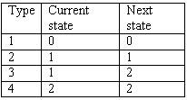

.
- A uniform, Q -state CAs, using $ω$ number
of neighborhood are employed in a mathematical forms of $λ$and $λ$99 as follows.
For $λ$, let the transition rules set contain m transitions to state 0. The remaining Q${}^{ω}$- m transitions in the rules set be filled by picking over state 1s. This results in Eq.(2) [3]:
$λ$ = $\frac{(Q^{ω}\text{ - m})}{Q^{ω}}$ (2)
-m , the numerator of Eq.(2), expresses that there attempts to remove the transitions having the next state of 0 from all transitions. For $λ$99, Q ${}^{ω}$ refers to the number of all transitions in the rules set, 3⁹. Unlike $λ$, $λ$99 concentrates on type 3, regarding to table 1. The other types: 1, 2, and 4 would be removed in order to obtain the remaining transitions. This results in Eq.(3). Unlike Eq.(2), this equation is a non-linear one.

$λ$99 = $\frac{Q^{ω}\text{ - }(\text{n }+Q^{ω−1})}{Q^{ω}}$ (3)
n indicates the total number of transitions contained in the transition rules set, producing the next state of an empty space plus a living tree. Q${}^{ω−1}$denotes the number of transitions having a state of a burning tree at the center cell, always generating the next state of the same one. n + Q${}^{ω−1}$, thereby, refers to all transitions of type 1,2, and 4, which are to be removed with respect to Eq.(3), in order to obtain the number of type 3 transitions.
From Eq.(3), n can be generated by Eq.(4) and Eq.(5) depending on what rules set is used.
n = ${\text{Q }}^{ω−1}$ + (Q – 1) ${}^{ω−1}$ (4) n =${\text{Q }}^{ω−1}$ + (Q – 1) ${}^{ω−1}$ + $\sum_{a=1}^{k−1}{}$$\begin{aligned}\left(ω−1 | \right) \\ \end{aligned}$(Q – 1) ${}^{(ω−1)−a}$ (5)
With respect to Eq.(4), and Eq.(5), the first term, Q${}^{ω−1}$, here denotes the number of transitions having the current state of an empty space and generating the next state of the same one. To compute the number of transitions having the next state of a living tree, the cases of insufficient number of burning neighboring cells must be counted to make a center cell burned. One case is a current state of a living tree having either a living tree or an empty space as a state of neighboring cells. The second term,
(Q – 1) ${}^{ω−1}$, is applied to this case. This term denotes that it would maintain the next state of a living tree. The first and the second terms, therefore, are employed with all rules sets k, 1 k 8.
The third term in Eq.(4) is utilized in the cases having a current state of a living tree with one or more burning neighboring cells, still produces the next state of a living tree. $\begin{aligned}\left(ω−1 | \right) \\ \end{aligned}$is used to indicate all possible locations of cells which the burning neighbors can be sited. k is also specified in the third term, identifying one of the rules sets k, 2 k 8, which is being used. (Q – 1) ${}^{(ω−1)−a}$ denotes the number of neighboring cells with the state of a living tree or an empty space. It is seen from Eqs.(4) and (5) that the larger value of k is, the more value of n becomes. However, from Eq.(3), the increase of n leads to the reduction of $λ$99. Thus, the changes in the value of k associated with the rules set would vary $λ$99 in the opposite way.
- The maximum and minimum values of
$λ$are 0% and 100%. 0% means all transitions in the rules set are to state 0. 100% means no transitions in the rules set are to state 0. By the definition of ${\text{Q }}^{ω−1}$, and by considering table 2, the percentage of the number of type 1 transitions, as well as, that of type 4, is approximately 33.33% of all possible transitions. The remaining 33.33%, therefore, is the possible maximum percentage of the transitions with the current state of a living tree. This also implies the possible maximum percentage of $λ$99. Fig. 2 shows the relation between rules sets k and $λ$99 .
For rules set k = 1, $λ$99 is 32.03% which is very close to 33.33% (the possible maximum percentage it could be). This means almost all transitions of a living tree turn to a burning one. However, the value of $λ$99 decreases very fast when changing the rules sets applied from k = 1 to k = 2; then it gradually decreases. Finally, for the rules sets k, 4k8, $λ$99 changes only a very few bits. It is seen that there is much more chance for a forest to get globally burned when using rules set k = 1 than when using others. This is consistent with the real world.
4) $λ$is employed as an indicator to predict to which Wolfram [3,17,18]’s four classes the CA belongs: Here, there is a constraint that there can not be any periodic behavior, for instance, a burning tree will never reappear as a living one. Thus, $λ$99 is not suitable to be applicable with Wolfram’s four classes. However, as aforementioned,$λ$99 associated with a rules set would denote some dynamic characteristic of that rules set. This association leads to the certain relationship among an initial density of a dynamic state of a forest, a global phenomenon, and a local interaction.
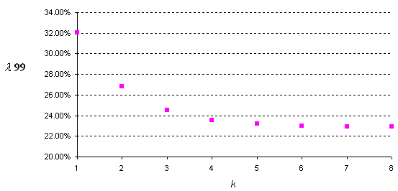

Fig. 2 The relation between the rules set k, and $λ$99

5 Experiment and Results
The experiment illustrates the chance to retain at least half of living trees given an initial tree density using a certain rules set.

Table 2. Parameters employed in the experiment

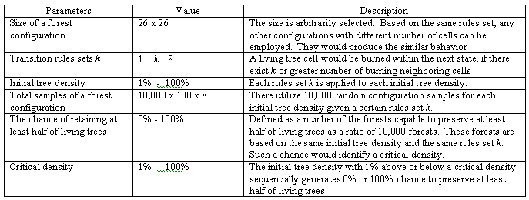

This chance would point to the critical densities for each rules set applied. The important parameters employed in the experiment are illustrated in table 2. The algorithms used in the experiment are defined in Fig. 3.
A certain rules set k, with a given value of initial tree density, are applied to 10,000 randomly selected configuration samples. There are a combinatory of $\begin{aligned}\left(\text{26}x\text{26} | \right) \\ \end{aligned}$ possible initial configurations, where L_{C} refers to the number of living tree cells. InitializeForestConfiguration() employs a random generator using uniform distribution. The random numbers, as limited by the forest size and the initial tree density, would be utilized to assign the living tree cell locations. The remaining locations are assigned to empty spaces.
EvolveForestConfiguration( ) calls GenerateNextTimeStep ( )for determining the state change of a cell. When the forest accesses the stable state, these would consider whether or not there is preservation of at least half of living trees. If there is, the accumulation would be performed. Table 3 displays the results of the experiment on each of rules sets k, 1k 8 applied on various initial tree densities.
C₁ and C₂ denote the critical densities. 1% of initial density below C₁ and above C₂ respectively produces 100% and 0% chances to preserve at least half of the living trees. The experiment shows that under rules sets k, 4k8, there is none of any critical density. The state of all cells maintains the same for any tree density with any rules set applied. This is caused by two constraints based on the assumptions: Moore neighborhood strategy is employed; and the fire starts only at a column of cells at the left edge of the configuration
By these reasons, there is no possibility for any cell to have more than three burning neighboring cells at the initial time step. Consequently, the chance of half of the trees preservation would always be full.
For rules sets k, 1k3, each one produces two critical densities of the trees. It is seen from table 4 that 31%, 57%, and 79% are the critical densities under rules sets k=1, k=2, and k=3 respectively. The initial tree densities even by 1% smaller than each of these critical densities would produce 100% chance of preserving at least half of the living trees. Examples of some few steps of fire evolution having 30%, 56%, and 78% initial tree densities for rules set k, 1k3 are demonstrated in Fig. 4(a), (b), and (c).
Within a few evolutionary time steps, all three cases indicate the success over preserving at least half of the trees.
However, 51%, 74%, and 91% are also exhibited as critical densities sequentially using rules set k=1, k=2, and k=3. Even 1% of the initial tree density greater than the critical density produces no chance to preserve at least half of the living trees. Some examples of a few steps with 52%, 75%, and 92% initial tree density, using rules set k, 1k3 are shown in Fig.5 5(a), (b), and (c).
From Fig. 5, the final time step shows that all of the examples fail on preserving half of the trees. It is also noticeable that there is more numbers of connection tree paths than that with the corresponding rules set shown in Fig. 4.
From table 3. it is possible to view the relationship between an initial density of a living tree, which is only a dynamic state here, and a global behavior with respect to local interactions. Fig. 6 is generated for illustrating this relationship.
The critical densities, the sharp transition points, are shifted from the left to the right when employing rules set k, 1k3. These show that rules set k=1 produces the minimum critical densities. Rules set k = 2, and k = 3 respectively generated higher critical densities.

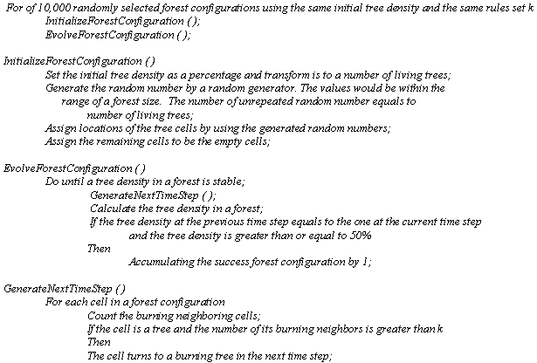
Fig. 3 The algorithms employed in the experiment

Table 3. Chances of preserving at least half of the trees at each initial tree density
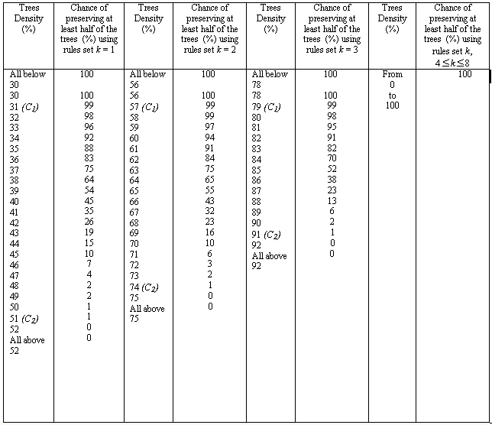

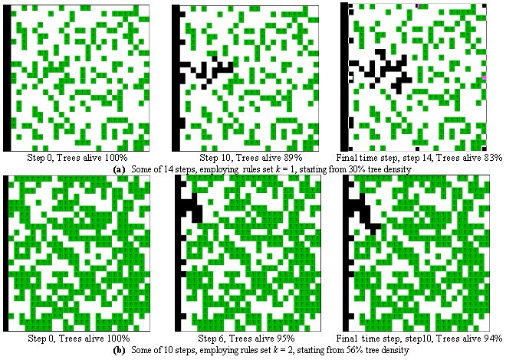
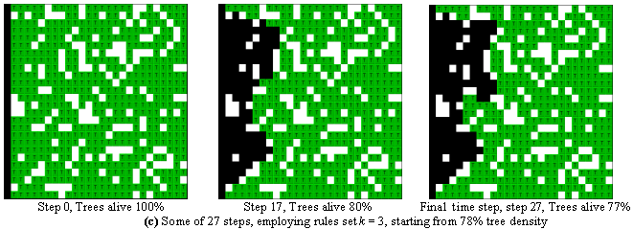

Fig. 4 Some evolutionary steps executed

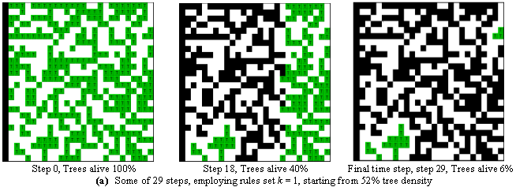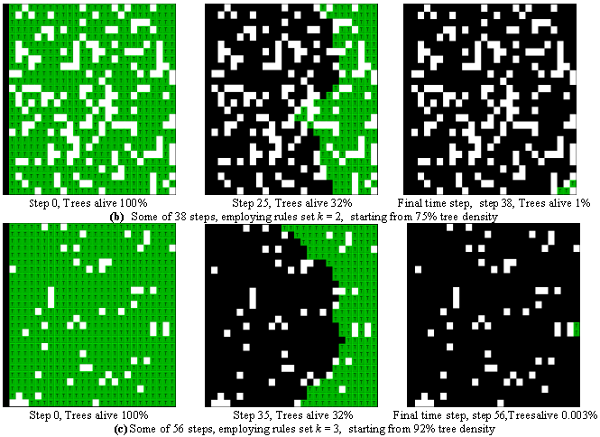
Fig. 5 Some evolutionary steps executed

Determining Figs. 2, and 6, the rate of changing from a living tree to a burning one, as specified by $λ$99, is the highest for rules set k = 1. $λ$99 decreases when using rules set k = 2 and k = 3. This is consistent with the change in critical densities produced by the three rules sets k in the opposite way.

It is also seen from Figs. 2 and 6 that, with respect to the corresponding rules set, the reduction rate of the increase of the critical densities complies with the reduction rate of the decrease of $λ$99. This denotes that the rate of changes in critical densities is consistent with that in $λ$99. By these reasons, how changes and rate of changes of the critical density between the rules sets would be, depend on changes and rate of changes of $λ$99. However, the changes of the critical density and $λ$99 are pursued in the opposite way.
In addition, Fig. 6 exhibits the transition from one critical density point to another within the same rules set. The rules set with high critical tree densities would have higher reduction rate of the chance of trees preservation than the rules set with low critical tree densities. On the other hand, although $λ$99, associated with the rules sets k, 4k8, are around 23%, which is greater than half of 33.33%, there exists none of the critical density.

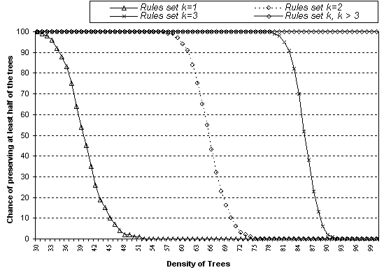
Fig. 6 Chances of preserving at least half of the trees at each initial tree density under rules set k, 1k8

6 Conclusions
The proposed study illustrates that the rules set with high critical tree densities would have higher reduction rate of the chance of trees preservation than the rules set with low critical tree densities. $λ$99, the parameter developed in this study indicates the rate of changes of a dynamic state with regards to the rules set. Therefore, $λ$99 denotes the different characteristics among the different rules sets k. There also exists some association between critical densities and $λ$99, although the changes of the critical density and those of $λ$99 are pursued in the opposite way. The associations among $λ$99, the rules set, and critical densities lead to the certain relationship among an initial density of a dynamic state of a forest, a global phenomenon, and a local interaction. However, there are hopes that these empirical results can imply some characteristics of critical densities related to other automata with such differences as fire starting location. Experimenting on such different cases and also other systems such as dispersion problems, cancer, etc. would be interesting to be the continuing study

Acknowledgement: We would like to express our gratitude thankfulness to Dr. Moshe Sipper

References:
[1] P.L. Andrews, “Use of the Rothermel Fire Spread Model for Fire Danger Rating and Fire Behavior Prediction in the United States”, in Proceeding of the Conference on Bushfire Modeling and Fire Danger Rating Systems, edited by Cheney, N.P. & Gill, A.M., CSIRO Division of Forestry, Australia, 1991, pp.1 – 8.
[2] N. Boccara and H. Fuks่, “Critical behavior of a cellular automaton highway traffic model”, Journal of Physics A: Mathematical and General 33,2000, pp. 3407-3415.
[3] N.P. Cheney, “Models Used for Fire Danger Rating in Australia, in Proceeding of the Conference on Bushfire Modeling and Fire Danger Rating Systems”, edited by N.P. Cheney & A.M. Gill, CSIRO Division of Forestry, Australia, 1991, pp.19 – 28.
[4] Dorigo M., V. Maniezzo & A. Colorni, “ The Ant System: Optimization by a Colony of Cooperating Agents”, IEEE Transactions on Systems, Man, and Cybernetics-Part B, 26(1), 1996, pp. 29-41.
[5] A.J. Fowell, “The Role of ASTM in Fire Modeling, Mathematical Modeling of Fires”, Special Technical Publication 983, PA 19103, pp.1 – 6, 1988.
[6] C.G. Langton, “Studying Artificial Life with Cellular Automata”, Physica D, 22, 1986, pp.120-149.
[7] M. Mitchell, J.P Crutchfield, and P.T.
Hraber, “ Evolving cellular automata to
perform computations: Mechanism
and impediments”, Physica D, 75, 1994, pp. 361 – 391.
[8] N.H. Packard, “Adaptation toward the edge of chaos”, in Dynamic Patterns in Complex Systems, J.A.S. Kelso, A.J. Mandell, and M.F. Shlesinger, Eds. Singapore: World Scientific, pp. 293-301, 1988
[9] M. Resnick, “Turtles, Termites, and Traffic Jams; Explorations in Massively Parallel Microworlds”, The MIT Press, Cambridge, Massachusettes, USA, 1994
[10] R. Rothermel, “How to predict the spread and intensity of forest and range fires”, Gen.Tech. Rep. INT-143. Ogden, UT: U.S. Department of Agriculture, Forest Service, Intermountain Forest and Range Experiment Station, 1983
[11] H.S. Stone, “Discrete Mathematical Structure and Theirs Applications. Science Research Associates, New York, pp. 51-58, 1973
[12] S. Wolfram, “Cellular Automata and
Complexity “, Addison – Wesley
Publishing Company, 1994
[13] S. Wolfram, “A new kind of Science”,
Wolfram Media, Inc., 2002

